**Resume**

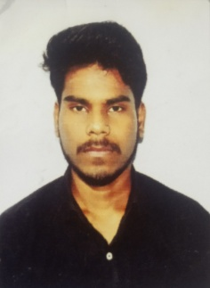Abhay kumar

**Address**: 107/73 Kacchi sadak Daraganj

Prayagraj Uttar pradesh ( 211006)

**Mob:** 9305745824

**Email id** : [abhay.prg000@gmail.com](mailto:abhay.prg000@gmail.com)

**Career objective**

* To achieve a career in a progressive work environment where I can devote creative & professional abilities to satisfy my urge for excellence and grows with honesty and loyalty for organization.

**QUALIFICATIONS**

* 10TH passed from UP Board Prayagraj in 2016 with 71.5%
* 12th passed from UP Board Prayagraj in 2018 with 52%
* B.A - L.L.B (graduation) from Allahabad State University Board is under process in the batch of 2020 to 2025.

**EXTRA QUALIFICATION**

* CCC Exam passed form NIELIT in march 2020 with C grade

**PERSONAL DETAILS**

Father’s Name : Prem prakash

Date of Birth : 19th june 2002

Martial Status : Single

Language Known : Hindi, English

Gender : Male

Religion : Hindu

Nationality : Indian

Hobbies : * Reading books

* listening to music

* Traveling

**BEHAVIOURAL CHARACTERISTICS**

* Commitment to quality & result.
* Ability to take challenge, work under pressure & achieve targets.
* Self motivation, confident, responsibility.
* Sincere and positive attitude.
* Excellent problem solving skills
* Ability to work continuously with high energy level.

**DECLARATION**

I do hereby declare that above information is true, correct and complete to the best of my knowledge and belief. I understood, if any information found false or incorrect, my candidature will be canceled.

**Date :**  25 june 2021

**Place** : Prayagraj

**(Abhay kumar)**