RESUME

VIPIN PANDEY 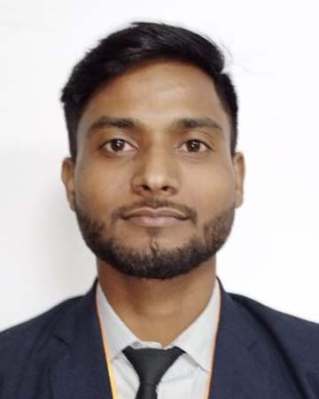

[EMAIL: Vipinpandey7065@gmail.com](mailto:tiwarivimlesh46@gmail.com)

CONTACT NO: +917309043734 , 9120387864

**Career Objective:**

To be a part of reputed organization that provides steady career growth and job satisfaction.

Give the valuable contribution in the regular growth of the organization.

Educational Qualification:

|  |  |  |  |  |
| --- | --- | --- | --- | --- |
| Course | Affiliation | Institute Name | Year Of  Passing | Percentage |
| MBA | AKTU  (Lucknow) | Shambhunath Institute Of Engineering And Technology | 2022 | 70% |
| B.COM | Mahatma Gandhi Kashi Vidyapith , Varansi (U.P.) | Kashi Naresh Govt P.G. College Gyanpur,Bhadohi | 2019 | 50.10 % |
| Intermediate | UP Board | Hindu Inter college Mungra Badshahpur, Jaunpur(U.P.) | 2016 | 62.6 % |
| High School | UP Board | S.G.S.T.Inter college Nibapuhr, Jaunpur(U.P.) | 2014 | 74 % |

**Technical Skill**

* Ms Office (word , excel, Power Point)

**Soft skill**

* Communication skill
* Creative skill
* Leadership skill

**Certification Course**

* Digital Marketing
* Financial Modeling and valuation Training
* CCC

**Hobbies:**

* Playing Volleyball
* New Historical places visiting

**Strength:**

* Self motivated.
* Tolerant and flexible with different situations.
* Flexible and quick learner.
* Punctuality.

**Personal Details** :

Father’s Name : Mr. Ashok Kumar Pandey

Mother’s Name : Mrs. Kiran Pandey

Date of Birth : 15-12-1998

Nationality : Indian

Gender : Male

Marital Status : Unmarried

Languages Known : Hindi &English

**Declaration:** I Hereby Declare That The Above Information Is Correct And Also Best For My knowledge

# 

# Date:

Place: Vipin Pandey