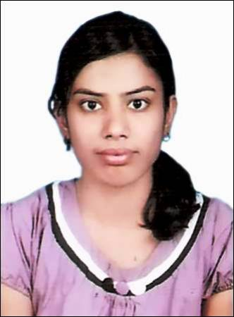
ISHITA TRIPATHI
61H/4 OM GAYATRI NAGAR, TELIYARGANJ, ALLAHABAD
TELEPHONE NO: +919936985954
ishita.tripathi91@gmail.com
CAREER OBJECTIVE:
To frame a career that allows me to compatible in any competitive environment and also boost up my capabilities, knowledge and energy.
ACADEMIC PROFILE:
COURSE | BOARD/UNIVERSITY | COLLEGE | YEAR OF COMPLETION | PERCENTAGE
Bachelor of Technology | Uttar Pradesh Technical University | Shambhunath Institute of Engineering & Technology | 2014 | 73.2%(till 6th semester)
Intermediate | Central Board of Secondary Education | Kendriya Vidyalaya | 2009 | 78.6%
High School | Central Board of Secondary Education | Maharishi Vidya Mandir | 2007 | 81.4%

TRAINING:
- 4 week Vocational Training on Digital Hierarchies in “ITI” from 14.06.12 to 11.07.12.
- 4 Week Summer Training on “Embedded System” in “CETPA InfoTech Private Limited” from 15.06.13 to 12.07.13.
AREA OF INTEREST:
- Network Theory.
- Basic Electronics.

EXTRA CURRICULAR ACTIVITIES:
- Won 1st prize in Parikalpana in Eureka MMX’3 2013
- Won 1st prize in Non-Technical quiz and 2nd prize in Video Visualization in Meister Quiz Competition.
- Volunteered in PSCPICE event in EUREKA MMX’3 2013.
- Attended 2 days’ workshop on RF planning and optimization by RADS.
- Participated in Robotics in EUREKA 2012.
- Member of Institution of Electronics and Telecommunication Engineers
- Presentation on ‘GSM’ in Seminar.
STRENGTHS:
- Ability to cope with failures and try to learn from them.
- Punctuation and Hardworking
- Disciplined and willing to learn new things
PERSONAL DETAILS
- Father’s Name: Mr. K.P.Tripathi
- Date of Birth: 20th August 1992
- Gender: Female
- Marital Status: Unmarried
- Language Proficiency: Hindi, English
- Permanent Address:61H/4 Om Gayatri Nagar ,Teliyarganj, Allahabad
DECLARATION:
I hereby declare that all information furnished by me is true to best of my knowledge.
PLACE: Allahabad
DATE: 20 Aug 2013
Signature:
(ISHITA TRIPATHI)

