CURRICULAM VITAE
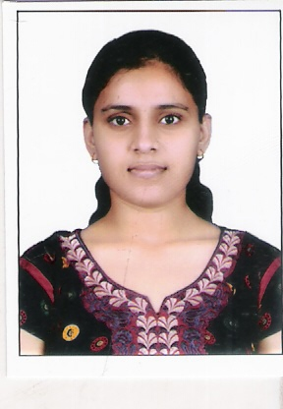

JYOTI TRIPATHI Contact No. 8896217516 E-mail- honey09101992@gmail.com
Add-82c/1, Madhuban Vihar Colony Dhoomanganj Allahabad
- Career Objective:
* To make effective use of my knowledge and skills in organization for achiving goals with building strong human capitals.

- Academic Qualification:
- Intermediate from UP Board in 2010 with 1st Div. (68.4%)
- High School from UP Board in 2008 with 1st Div. (68.%)

- Professional Qualification:
- Pursuing Bachelor of technology (B.Tech) with Mechanical Engineering from Shambhunath Institute Of Engineering and Technology ,Allahabad affiliated to GBTU University, Lucknow
1st year-64.2 %
2nd year-71.5 %
3rd year -67.15%

- Summer Training:
- 1st Summer Vocational Training in BPCL(Bharat Pump And Compressor Limited), Allahabad in 2012
- 2nd Summer Vocational Training in IFFCO PHULPUR , Allahabad in 2013.

- Computer Skills

- MS-Office,
- Windows Operating System
- Internet Application

- Strength

- Self-motivated and hard working.
  - Ability to deal with people, willingness to learn.

- Hobbies
- Surfing net.
- Taking part in Co-curricular activities
- Interacting with people

- PERSONAL DETAILS

Father’s Name : Pradeep Ku. Tripathi

Date of Birth : 09-10-1992

Present Address : 82c/1 Madhuban Vihar Colony Dhoomanganj Allahabad

Gender : Female

Marital Status : Single

Nationality : Indian

Language Known : Hindi, English

- DECLARATION

I hereby declare that the information giving above is mentioned true & correct to the best of my knowledge & belief.
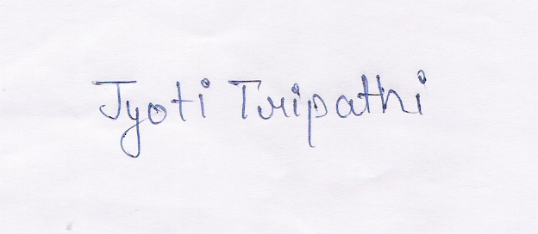

Date:09-11-2013
Place:ALLAHABAD (Jyoti Tripathi)

