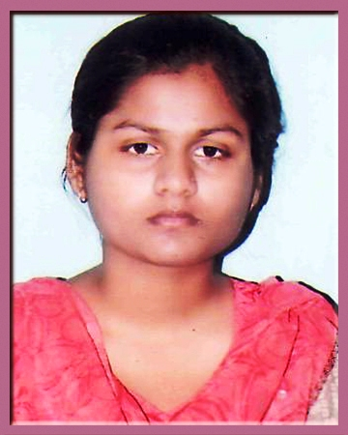  EKTA SINGH  Correspondence address:  346/149D Chakiya Allahabad  Mobile:  +919451374440  Email id: ektasingh9451@gmail.com | CURRICULLUM VITAE  Objective  To associate with progressive organization that provides me opportunity to enhance my knowledge and skills according to the latest trends, and to be a part of a team that works towards the growth of the organization.  Academic Profile  Training/Projects  - Summer training of 4 weeks from CETPA INFOTEC PRIVATE LIMITED at SIET, Allahabad.(June-July 2013)  - Objective: To study of “Embedded System”.  - In summer training I have studied the introduction, programming and application of Embedded system.  - Project topic-Electronic Voting Machine.  - Summer training of 6 weeks at ITI NAINI ALLAHABAD in (June-July2012)  - Objective: To study of “DIGITAL HEIRARCHY”.  - In the summer training I have studied the working, various modes and structure of the optical fiber cable.
  Education | Board/ University | College | Year of completion | Score
  B-Tech  (EC) | Gautam  Buddh Technical University | Shambhunath Institute of Engineering and Technology | 2014 | 77.6% (till 6th semester)
  12th | U.P. Board | Crosthwait Girls Inter College | 2010 | 78.8%
  10th | U.P. Board | Vidyawati Darbari Girls Inter college | 2008 | 72.8%
Personality Traits:  - Punctual  - Positive attitude  - Eager to learn  - Cope with failure  Software skills /computer skill:  - Operating Systems: Windows (98, 2000, XP, 2003, 2008, Vista) and Linux.  - MS Office -Word, Excel, Power Point  Area of Interests:  - Control  - Network Theorem  - Basic electronics |  | Achievements and Extra curricular activities  - Participated in “TECHNICAL EVENT” in Eureka 2010.  - Participated in “ROBOTICS” in Eureka 2012.  - Secured 3rd position at college level in the GBTU, 2nd year.  - Participated in 2 days workshop on “RED HAT SYSTEM ADMINISTRATION”  - Participated in 2 days workshop on “RF PLANNING AND OPTIMIZATION”.  - Presented seminar on “Introduction to CDMA (Code Division Multiple Access)” in college, 6th semester.  - Got 3rd position in “MICREA ISLEMCI CLAIR” event in Eureka MMX’3 2013.  - Volunteered in “XIVSOFT (PSPICE)” event in Eureka MMX’3 2013.  - Got 1st prize in non-technical quiz and 2nd prize in video visualization in IETE event.  Personal Information  - Name: Ekta Singh  - Father’s Name: Mr. Suresh Singh  - Date of Birth: 21-07-1992  - Gender: Female  - Marital Status: Unmarried  - Language Proficiency: English, Hindi  - Permanent Address: 346/149D Chakiya Allahabad  Declaration  I hereby declare that all the information mentioned above is true to the best of my knowledge.  Date: (Ekta Singh)

