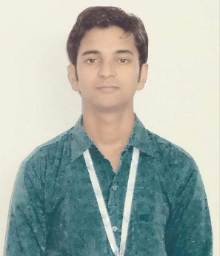**ASHOK KUMAR YADAV**

**EMAIL id:ashokyaduwansi@gmail.com**

**Contact number: +918427414985**

**Career objective:**

To seeking a challenging career position in order to used my business (**MBA**) and technical   
(**B.TECH**) skills that make significant contribution to the organization. Where my potentials can be exploited to the maximum, ensuring my future progress with the growth of the organization.

**Educational Qualification:**

|  |  |  |  |  |
| --- | --- | --- | --- | --- |
| Qualifications | Institutes | Board | Year | %age |
| * Master in Business   Administration (MBA) | Shambhunath Institute of Engineering  and Technology | U.P. | 2020 | Pursuing  (72%) |
| * Batcher of Technology   (B.Tech) | Lovely Professional University  Jalandhar Punjab | Punjab | 2018 | 63% |
| * Intermediate   (Science) | Janta Inter College, Deoria | U.P. | 2014 | 85% |
| * High School   (Math) | S.BV.M. Inter College, Kushinagar | U.P. | 2012 | 75% |

**Certification:**

* Participated in events like **Stall Mart** during (AVISHKAR’18) held in Motilal Nehru Institute of Technology Allahabad, 2018
* Participated in event “**Techfest Ureka**” Held at Shambhunath Institute of Engineering and Technology.
* Participated in **Chanakaya Neeti** held at Shambhunath Institute of Engineering and Technology.
* Participated in events like **One India & One World** at Lovely Professional University Jalandhar, 2015-2018

**Summer Internship:**

I have done my 45 days summer internship in **APPONWARD** in the field of **HUMAN**  **RESOURCE** (Recruitment & Selections) from Noida.

**Extracurricular activities:**

* Actively Participated in Business Plan.
* Participated in National Talent Hunt competition.
* Participated in Photography.
* Participated in cricket tournament competition.

**Skills:**

|  |  |
| --- | --- |
| **Management Skills** | **Technical Skills** |
| * Communication skills | * Web-Developing |
| * Team work | * Blogging |
| * Event management | * Application Developing |
| * Adaptability | * 3D modeling |
| * Time management | * Automobile |

**Personal Profile:-**

Father’s Name : Mr.Babulal Yadav

Nationality : Indian

Permanent Address : Ghaghwa Jagdish Kushinagar, Pincode: - 274406

**Declaration:-**

I hereby declare that above mentioned information is correct up you my knowledge and I bear the responsibility for the correctness of the above mentioned particulars.

Place: Prayagraj

As on; Signature

**(ASHOK KUMAR YADAV)**