**UNIT 1**

1. **INTRODUCTION TO MICROCONTROLLERS AND EMBEDDED SYSTEMS**

Microcontrollers have only been with us for a few decades but their impact (direct or indirect) on our lives is profound. Usually these are supposed to be just data processors performing exhaustive numeric operations. But their presence is unnoticed at most of the places like

* At supermarkets in Cash Registers, Weighing Scales, etc.
* At home in Ovens, Washing Machines, Alarm Clocks, etc.
* At play in Toys, VCRs, Stereo Equipment, etc.
* At office in Typewriters, Photocopiers, Elevators, etc.
* In industry in Industrial Automation, safety systems, etc.
* On roads in Cars, Traffic Signals, etc.

**What inside them makes these machines smart?** The answer is microcontroller. Creating applications for the microcontrollers is different than any other development job in electronics and computing. Before selecting a particular device for an application, it is important to understand what the different options and features are and what they can mean with regard to developing the application. The microcontroller incorporates all the features that are found in microprocessor. The microcontroller has built in ROM, RAM, Input Output ports, Serial Port, timers, interrupts and clock circuit. A microcontroller is an entire computer manufactured on a single chip. Microcontrollers are usually dedicated devices embedded within an application. For example, microcontrollers are used as engine controllers in automobiles and as exposure and focus controllers in cameras. In order to serve these applications, they have a high concentration of on-chip facilities such as serial ports, parallel input output ports, timers, counters, interrupt control, analog-to-digital converters, random access memory, read only memory, etc. The I/O, memory, and on-chip peripherals of a microcontroller are selected depending on the specifics of the target application. Since microcontrollers are powerful digital processors, the degree of control and programmability they provide significantly enhances the effectiveness of the application. The 8051 is the first microcontroller of the MCS-51 family introduced by Intel Corporation at the end of the 1970s. The 8051 family with its many enhanced members enjoys the largest market share, estimated to be about 40%, among the various microcontroller architectures.

**1.1 Microcontrollers**

* Microcontroller (MC) may be called computer on chip since it has basic features of microprocessor with internal ROM, RAM, Parallel and serial ports within single chip. Or we can say microprocessor with memory and ports is called as microcontroller. This is widely used in washing machines, vcd player, microwave oven, and robotics or in industries.
* Microcontroller can be classified on the basis of their bits processed like 8bit MC, 16bit MC.
* 8 bit microcontroller means it can read, write and process 8 bit data. Ex. 8051 microcontroller. Basically 8 bit specifies the size of data bus. 8 bit microcontroller means 8 bit data can travel on the data bus or we can read, write process 8 bit data.
  1. **Embedded Controller**

Simply an embedded controller is a controller that is embedded in a greater system. One can define an embedded controller as a controller (or computer) that is embedded into some device for some purpose other than to provide general purpose computing. Is an embedded controller is the same as a microcontroller? The answer is definitely no. One can state devices such as 68000, 32032, x86, Z80, and so on that are used as embedded controllers but they aren’t microcontrollers.

We might be correct by stating that an embedded controller controls something (for example controlling a device such as a microwave oven, car braking system or a cruise missile). An embedded controller may also embed the on-chip resources like a microcontroller. Microcontrollers and microprocessors are widely used in embedded systems. Though, microcontrollers are preferred over microprocessors for embedded systems due to low power consumption.

* + - 1. **Criteria for Selection of a Microcontroller in Embedded System**

Criteria for selection of microcontroller in any embedded system are as following:

1. Meeting the computing needs of task at hand efficiently and cost effectively

* Speed of operation
* Packing
* Power consumption
* Amount of RAM and ROM on chip
* No. of I/O pins and timers on chip
* Cost

1. Availability of software development tools such as compiler, assembler and debugger.
   1. **EMBEDDED AND EXTERNAL MEMORY MICROCONTROLLERS**

**Embedded Microcontrollers**

When an embedded system has a microcontroller unit that has all the functional blocks (including program as well as data memory) available on a chip is called an embedded microcontroller. For example, 8051 having Program & Data Memory, I/O Ports, Serial Communication, Counters and Timers and Interrupt Control logic on the chip is an embedded microcontroller.

**External Memory Microcontrollers**

When an embedded system has a microcontroller unit that has not all the functional blocks available on a chip is called an external memory microcontroller. In external memory microcontroller, all or part of the memory units are externally interfaced using an interfacing circuit called the glue circuit. For example, 8031 has no program memory on the chip is an external memory microcontroller.

* 1. **MICROCONTROLLERS AND MICROPROCESSORS**

A controller is used to control some process. At one time, controllers were built exclusively from logic components, and were usually large, heavy boxes. Later on, microprocessors were used and the entire controller could fit on a small circuit board. This is still common– one can find many controllers powered by one of the many common microprocessors (including Zilog Z80, Intel 8088, Motorola 6809, and others).

As the process of miniaturization continued, all of the components needed for a controller were built right onto one chip. A one chip computer or microcontroller was born. A CPU built into a single VLSI chip is called microprocessor. The simplified block diagram of the CPU is shown in the Fig. 2. It contains arithmetic and logic unit (ALU), Instruction decodes and control unit, Instruction register, Program counter (PC), clock circuit (internal or external), reset circuit (internal or external) and registers. For example, Intel 8085 is 8-bit microprocessor and Intel 8086/8088 is 16-bit microprocessor. Microprocessor is general-purpose digital computer central processing unit (CPU). The microprocessor is general-purpose device and additional external circuitry is added to make it microcomputer.

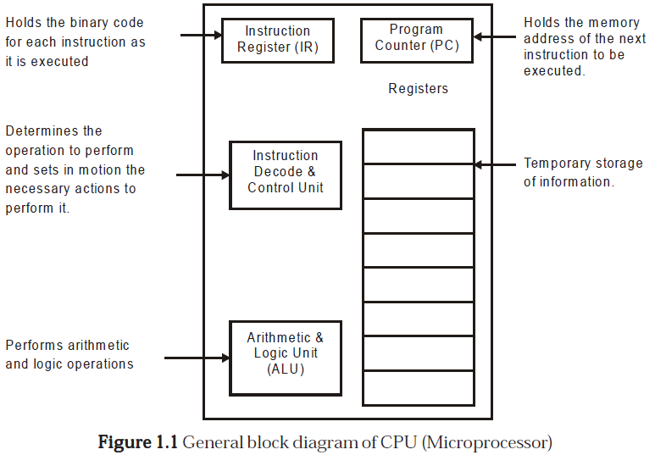

A digital computer having microprocessor as the CPU along with I/O devices and memory is known as microcomputer. The block diagram in the Fig. 3 shows a microcomputer.

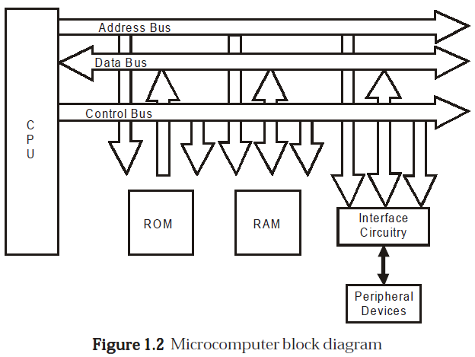

A microcontroller is a highly integrated chip, which includes on single chip, all or most of the parts needed for a controller. The microcontroller typically includes: CPU (Central Processing Unit), RAM (Random Access Memory), EPROM/PROM/ROM (Erasable Programmable Read Only Memory), I/O (input/output) – serial and parallel, timers, interrupt controller. For example, Intel 8051 is 8-bit microcontroller and Intel 8096 is 16-bit microcontroller.

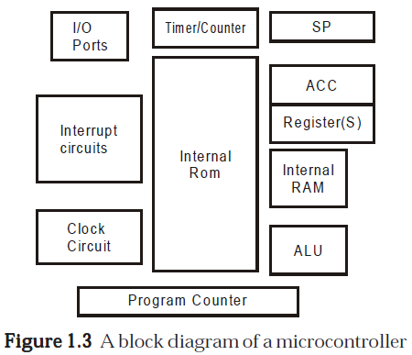

By only including the features specific to the task (control), cost is relatively low. A typical microcontroller has bit manipulation instructions, easy and direct access to I/O (input/output), and quick and efficient interrupt processing. Figure 1.3 shows the block diagram of a typical microcontroller.

**1.3.1 Comparing Microcontroller and Microprocessor**

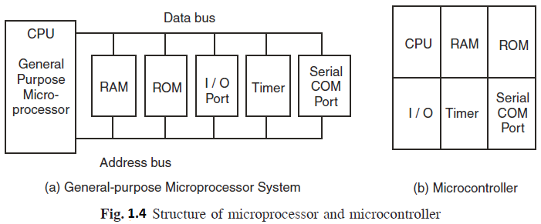

It is very clear from figure that in microprocessor we have to interface additional circuitry for providing the function of memory and ports, for example we have to interface external RAM for data storage, ROM for program storage, programmable peripheral interface (PPI) 8255 for the Input Output ports, 8253 for timers, USART for serial port. While in the microcontroller RAM, ROM, I/O ports, timers and serial communication ports are in built. Because of this it is called as “system on chip”. So in micro-controller there is no necessity of additional circuitry which is interfaced in the microprocessor because memory and input output ports are inbuilt in the microcontroller. Microcontroller gives the satisfactory performance for small applications. But for large applications the memory requirement is limited because only 64 KB memory is available for program storage. So for large applications we prefer microprocessor than microcontroller due to its high processing speed.

* Microprocessor is a single chip CPU, microcontroller contains, a CPU and much of the remaining circuitry of a complete microcomputer system in a single chip.
* Microcontroller includes RAM, ROM, serial and parallel interface, timer, interrupt schedule circuitry (in addition to CPU) in a single chip.
* RAM is smaller than that of even an ordinary microcomputer, but enough for its applications.
* Interrupt system is an important feature, as microcontrollers have to respond to control oriented devices in real time. E.g., opening of microwave oven’s door cause an interrupt to stop the operation. (Most microprocessors can also implement powerful interrupt schemes, but external components are usually needed).
* Microprocessors are most commonly used as the CPU in microcomputer systems. Microcontrollers are used in small, minimum component designs performing control-oriented activities.
* Microprocessor instruction sets are “processing intensive”, implying powerful addressing modes with instructions catering to large volumes of data. Their instructions operate on nibbles, bytes, etc. Microcontrollers have instruction sets catering to the control of inputs and outputs. Their instructions operate also on a single bit. E.g., a motor may be turned ON and OFF by a 1-bit output port.

Before going in to details of microcontrollers it will be beneficial to go through common and frequently used terminology encountered in the description of microcontrollers.

1. **Central Processing Unit (CPU)**

CPU is the brain of the computer system, administers all activity in the system and performs all operations on data. It continuously performs two operations: fetching and executing instructions. It understands and executes instructions based on a set of binary codes called the instruction set.

**Machine Cycle**

To execute an instruction–the processor must:

1. Fetch the instruction from memory

2. Decode the instruction

3. Execute the instruction

4. Store the result back in the memory. These four steps refer to Machine Cycle.

Generally one machine cycle = X clock cycles (_X_ depends on the particular instruction being executed). Shorter the clock cycle, lesser the time it takes to complete one machine cycle, so instructions are executed faster hence, faster the processor.

1. **Fetching And Executing An Instruction**

Fetching involves the following steps:

(a) Contents of PC are placed on address bus.

(b) READ signal is activated.

(c) Data (instruction opcode) are read from RAM and placed on data bus.

(d) Opcode is latched into the CPU’s internal instruction register.

(e) PC is incremented to prepare for the next fetch from memory.

While execution involves decoding the opcode and generating control signals to gate internal registers in and out of the ALU and to signal the ALU to perform the specified operation.

1. **The Buses: Address, Data, And Control**

A BUS is a collection of wires carrying information with a common purpose. For each read or write operation, the CPU specifies the location of the data or instruction by placing an address on the address bus, then activates a signal on the control bus indicating whether the operation is read or write.

* READ OPERATIONS retrieve a byte of data from memory at the location specified and place it on the data bus. CPU reads the data and places it in one of its internal registers.
* WRITE OPERATIONS put data from CPU on the data bus and store it in the location specified.

**Address Bus** carries the address of a specified location. For n address lines, 2n locations can be accessed. E.g., A 16-bit address bus can access 216 = 65,536 locations or 64K locations (210 = 1024 = 1K, 26 = 64).

**Data Bus** carries information between the CPU and memory or between the CPU and I/O devices.

**Control Bus** carries control signals supplied by the CPU to synchronize the movement of information on the address and data bus.

1. **Control/Monitor (Input/output) Devices**

**Control Devices** are outputs, or actuators, that can affect the world around them when supplied with a voltage or current.

**Monitoring Devices** are inputs, or sensors, that are stimulated by temperature, pressure, light, motion, etc. and convert this to voltage or current read by the computer. Note: The interface circuitry converts the voltage or current to binary data, or vice versa.

1. **TYPES OF MICROCONTROLLERS**

Microcontrollers can be classified on the basis of internal bus width, architecture, memory and instruction set. Figure 1.4 shows the various types of microcontrollers.

**2.1 The 8, 16 and 32-Bit Microcontrollers**

THE 8-BIT MICROCONTROLLER

When the ALU performs arithmetic and logical operations on a byte (8-bits) at an instruction, the microcontroller is an 8-bit microcontroller. The internal bus width of 8-bit microcontroller is of 8-bit. Examples of 8-bit microcontrollers are Intel 8051 family and Motorola MC68HC11 family.

THE 16-BIT MICROCONTROLLER

When the ALU performs arithmetic and logical operations on a word (16-bits) at an instruction, the microcontroller is an 16-bit microcontroller. The internal bus width of 16-bit microcontroller is of 16-bit. Examples of 16-bit microcontrollers are Intel 8096 family and Motorola MC68HC12 and MC68332 families. The performance and computing capability of 16 bit microcontrollers are enhanced with greater precision as compared to the 8-bit microcontrollers.

THE 32-BIT MICROCONTROLLER

When the ALU performs arithmetic and logical operations on a double word (32- bits) at an instruction, the microcontroller is an 32-bit microcontroller. The internal bus width of 32-bit microcontroller is of 32-bit. Examples of 32-bit microcontrollers are Intel 80960 family and Motorola M683xx and Intel/Atmel 251 family. The performance and computing capability of 32 bit microcontrollers are enhanced with greater precision as compared to the 16-bit microcontroller

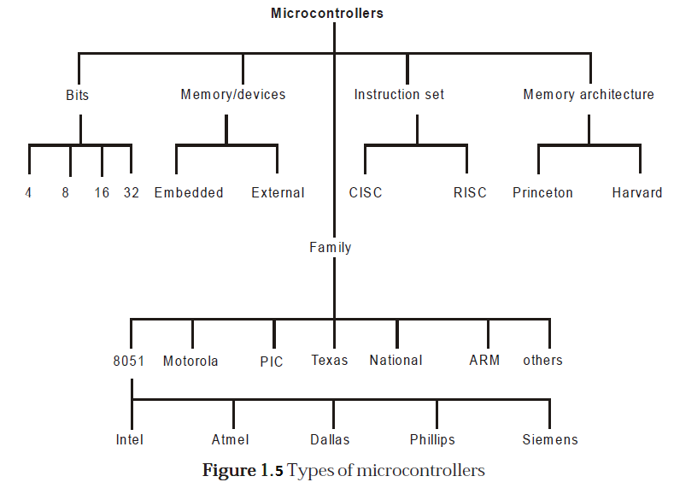

1. **MICROCONTROLLER 8051 ARCHITECTURE**

It is 8-bit microcontroller, means MC 8051 can Read, Write and Process 8 bit data. This is mostly used microcontroller in the robotics, home appliances like mp3 player, washing machines, electronic iron and industries. Mostly used blocks in the architecture of 8051 are as follows:

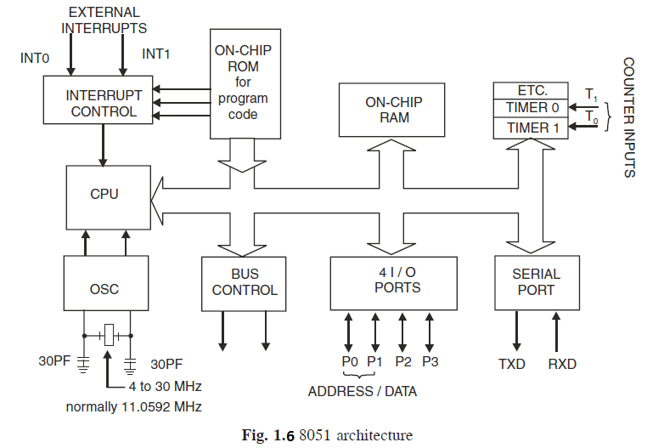

**3.1 128 Byte RAM for Data Storage**

MC 8051 has 128 byte Random Access memory for data storage. Random access memory is non volatile memory. During execution for storing the data the RAM is used. RAM consists of the register banks, stack for temporary data storage. It also consists of some special function register (SFR) which are used for some specific purpose like timer, input output ports etc. Normally microcontroller has 256 byte RAM in which 128 byte is used for user space which is normally Register banks and stack. But other 128 byte RAM which consists of SFRs. We will discuss the RAM in detail in next section. Now what is the meaning of 128 byte RAM. What are address range which is provided for data storage. We will discuss here. We know that 128 byte = 27 byte

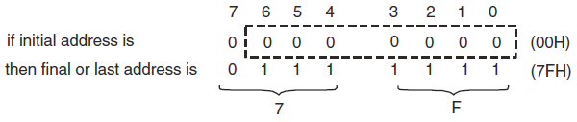

Since 27 bytes so last 7 bits can be changed so total locations are from 00H to 7F H. This procedure of calculating the memory address is called as **“*memory*** ***mapping*”.** We can save data on memory locations from 00H to 7FH. Means total 128 byte space from 00H to 7FH is provided for data storage.

**3.2 4KB ROM**

In 8051, 4KB read only memory (ROM) is available for program storage. This is used for permanent data storage. Or the data which is not changed during the processing like the program or algorithm for specific applications.

* This is volatile memory; the data saved in this memory does not disappear after power failure.
* We can interface up to 64KB ROM memory externally if the application is large. These sizes are specified different by their companies.
* **Address Range of PC:** Address range of PC means program counter (which points the next instruction to be executing) can be moved between these locations or we can save the program from this location to this location. The address range can be calculated in the same way just like the RAM which is discussed in previous section.

**4KB = 22. 210 B (since 1KB = 210 B)**

***=* 212 Byte**

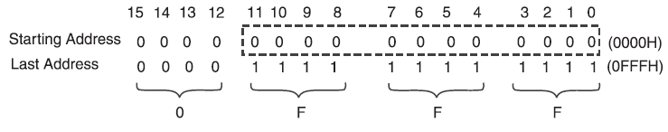

Address range of PC is 0000H to 0FFFH means total 4KB locations are available from 0000H to 0FFFH. At which we can save the program.

**Difference between RAM and ROM**

* RAM is used for data storage while ROM is used for program storage.
* Data of RAM can be changed during processing while data of ROM can’t be changed during processing.
* We can take an example of calculator. If we want to perform addition of two numbers then we type the two numbers in calculator, this is saved in the RAM, but the Algorithms by which the calculation is performed is saved in the ROM. Data which is given by us to calculator can be changed but the algorithm or program by which calculation is performed can’t be changed.
  1. **Timers and Counters**

Timer means which can give the delay of particular time between some events. For example, on or off the lights after every 2 sec. This delay can be provided through some assembly program but in microcontroller two hardware pins are available for delay generation. These hardware pins can be also used for counting some external events. How much times a number is repeated in the given table is calculated by the counter.

* In MC8051, two timer pins are available T0 and T1, by these timers we can give the delay of particular time if we use these in timer mode.
* We can count external pulses at these pins if we use these pins in counter mode.
* 16 bits timers are available. Means we can generate delay between 0000H to FFFFH.
* Two special function registers are available.

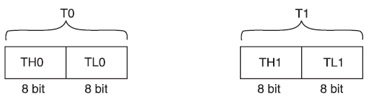

* If we want to load T0 with 16 bit data then we can load separate lower 8 bit in TL0 and higher 8 bit in TH0.
* In the same way for T1. TMOD, TCON registers are used for controlling timer operation.
  1. **Serial Port**
* There are two pins available for serial communication TXD and RXD.
* Normally TXD is used for transmitting serial data which is in SBUF register, RXD is used for receiving the serial data.
* SCON register is used for controlling the operation.
  1. **Input Output Ports**
* There are four input output ports available P0, P1, P2, P3.
* Each port is 8 bit wide and has special function register P0, P1, P2, P3 which are bit addressable means each bit can be set or reset by the Bit instructions (SETB for high, CLR for low) independently.
* The data at any port which is transmitting or receiving is in these registers.
* The port 0 can perform dual works. It is also used as Lower order address bus (A0 to A7) multiplexed with 8 bit data bus P0.0 to P0.7 is AD0 to AD7 respectively the address bus and data bus is demultiplex by the ALE signal and latch which is further discussed in details.
* Port 2 can be used as I/O port as well as higher order address bus A8 to A15.
* Port 3 also have dual functions it can be worked as I/O as well as each pin of P3 has specific function.

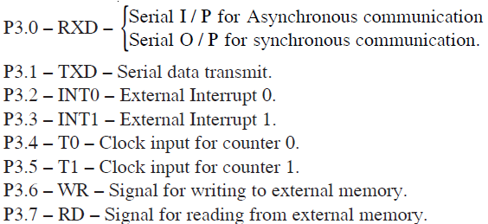

When external memory is interfaced with 8051 then P0 and P2 can’t be worked as I/O port they works as address bus and data bus, otherwise they can be accessed as I/O ports.

* 1. **Oscillator**
* It is used for providing the clock to MC8051 which decides the speed or baud rate of MC.
* We use crystal which frequency varies from 4MHz to 30 MHz, normally we use 11.0592 MHz frequency.
  1. **Interrupts**
* Interrupts are defined as requests because they can be refused (masked) if they are not used, that is when an interrupt is acknowledged. A special set of events or routines are followed to handle the interrupts. These special routines are known as interrupt handler or interrupt service routines (ISR). These are located at a special location in memory.
* INT0 and INT1 are the pins for external interrupts.

1. **ARCHITECTURE OF 8051**

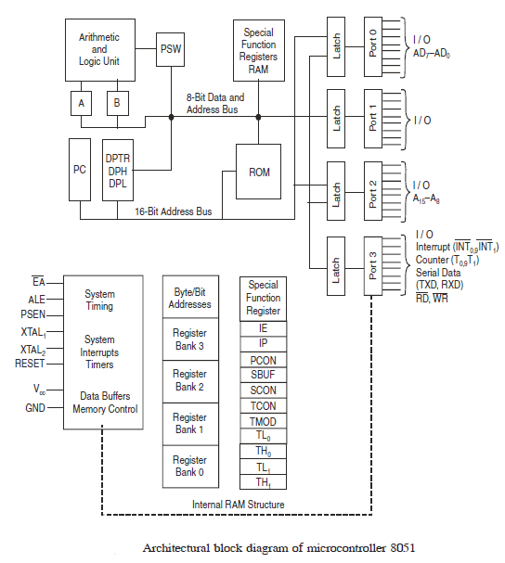

Each block will be discussed step by step:

**4.1 ALU — Arithmetic Logical Unit**

This unit is used for the arithmetic calculations.

**4.2 A-Accumulator**

This register is used for arithmetic operations. This is also bit addressable and 8 bit register.

**4.3 B-Register**

This register is used in only two instructions MUL AB and DIV AB. This is also bit addressable and 8 bit register.

**4.4 PC-Program Counter**

* Points to the address of next instruction to be executed from ROM
* It is 16 bit register means the 8051 can access program address from 0000H to FFFFH. A total of 64KB of code. 16 bit register means.



* Initially PC has 0000H
* ORG instruction is used to initialize the PC ORG 0000H means PC initialize by 0000H
* PC is incremented after each instruction.

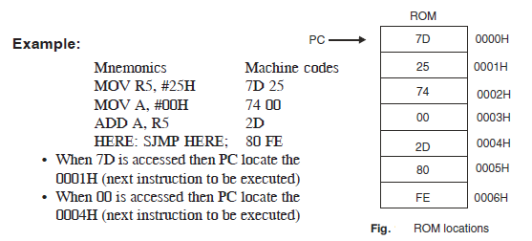

**4.5 ROM Memory Map in 8051**

* 4KB, 8KB, 16KB, 32KB, 64KB on chip ROM is available.
* Max ROM space is 64 KB because 16 bit address line is available in 8051.
* Starting address for ROM is 0000H (because PC which points the ROM is 16 bit wide).

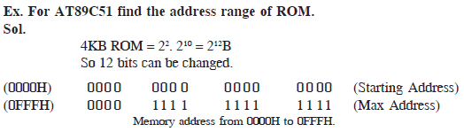

**4.6 8051 Flag Bits and PSW Register (Special Function Registers)**

* Used to indicate the Arithmetic condition of ACC.
* Flag register in 8051 is called as program status word (PSW). This special function register PSW is also bit addressable and 8 bit wide means each bit can be set or reset independently.

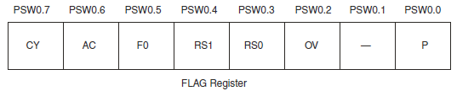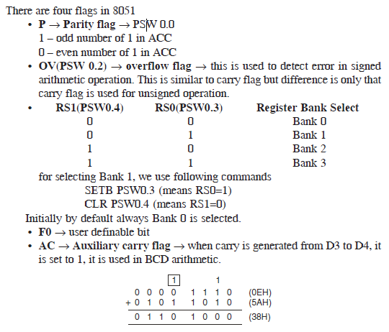

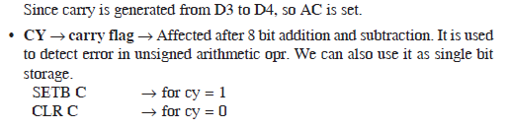

**4.7 Structure of RAM or 8051 Register Bank and Stack**

* 128 byte RAM is available in 8051
* 128 byte = 27 B

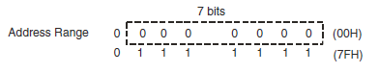

**Address range of RAM is 00H to 7FH.**

* In MC8051, 128 byte visible or user accessible RAM is available which is shown in figure. Extra 128B RAM which is not user accessible. 80H to FFH used for storage of SFR (special function register)

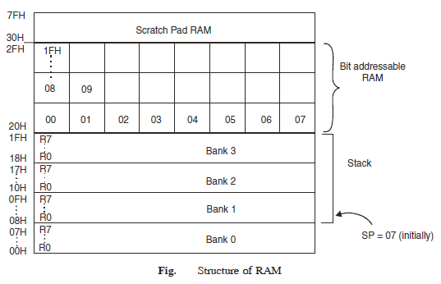

**Four Register Banks**

* There are four register banks, in each register bank there are eight 8 bit register available from R0 to R7
* By default Bank 0 is selected.

For Bank 0, R0 has address 00H

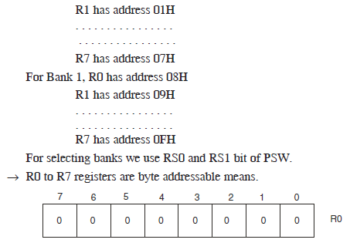

If we want to set the bit 3 of R0 then we can’t use SETB R0.3

We use MOV R0, #08H;

For changing single bit we can modify all the other bits of R0.

* Locations 20H to 2FH is bit addressable RAM means each bit from 00H to FFH in this we can set or reset CF rather than changing whole byte.
* Locations 30H to 7FH is used as scratch pad means we can use this space for data reading and writing or for data storage.

**4.8 Stack in 8051**

* RAM locations from 08H to 1FH can be used as stack. Stack is used to store the data temporarily.

Stack is last in first out (LIFO)

* Stack pointer (SP) →
* 8bit register
* It indicate current RAM address available for stack or it points the top of stack.
* Initially by default at 07H because first location of stack is 08H.
* After each PUSH instruction the SP is incremented by one while in MC after PUSH instruction SP is decremented.
* After each POP instruction the SP is decremented.

**Example:**

**MOV R6,#25H;**

**MOV R1,#12H;**

**MOV R4,#OF3H;**

**PUSH 06H;**

**PUSH 01H;**

**POP 04H;**

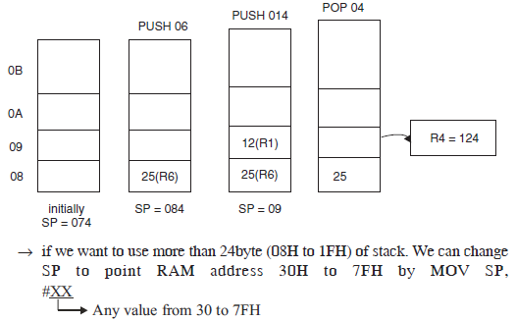

**4.8.1 *Conflicting of Register Banks and Stack***

* We know locations from 08H to 1FH is used as stack and it is also used as register bank.
* If in the program, we use the Register Bank 1 to 3 and also use the stack then conflicts exist and error can be possible.

For removing this situation we use the stack from location 30H to 7FH by shifting SP to 2FH.

**MOV SP,#2FH;**

**4.9 DPTR**  **Data Pointer in 8051**

* 16 bit register, it is divided into two parts DPH and DPL.
* DPH for Higher order 8 bits, DPL for lower order 8 bits.
* DPTR, DPH, DPL these all are SFRs in 8051.

**4.10 Special Function Register**

* (See in the following figure) RAM scratch pad, there is extra 128 byte RAM which is used to store the SFRs
* Following figure shows special function bit address, all access to the four I/O ports CPU register, interrupt control register, timer/counter, UART, power control are performed through registers between 80H and FFH.

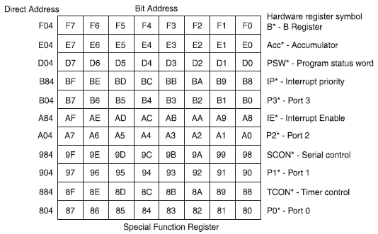

**Byte Addressable SFR with byte address**

**SP:** Stack printer – 81H

**DPTR:** Data pointer 2 bytes

**DPL:** Low byte – 82H

**DPH:** High byte – 83H

**TMOD**: Timer mode control – 89H

**TH0:** Timer 0 Higher order bytes – 8CH

**TL0:** Timer 0 Low order bytes – 8AH

**TH1:** Timer 1 High bytes = 80H

**TL1:** Timer 1 Low order byte = 86H

**SBUF:** Serial data buffer = 99H

**PCON:**  Power control – 87H.

1. **PIN DIAGRAM OF 8051**

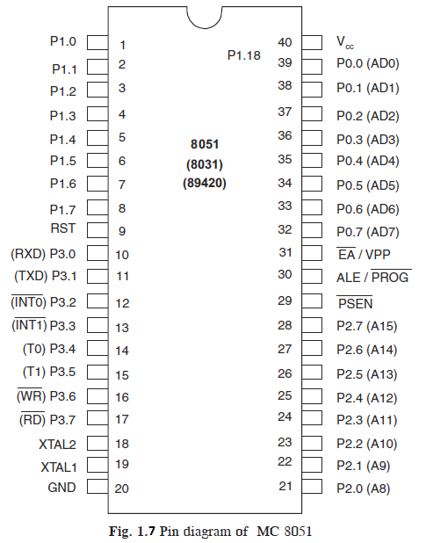

**Description of each pin is discussed here:**

* VCC → 5V supply
* VSS → GND
* XTAL2/XTALI are for oscillator input
* Port 0 – 32 to 39 – AD0/AD7 and P0.0 to P0.7
* Port 1 – 1 to 8 – P1.0 to P1.7
* Port 2 – 21 to 28 – P2.0 to P2.7 and A 8 to A15
* Port 3 – 10 to 17 – P3.0 to P3.7
* P 3.0 – RXD – Serial data input – SBUF
* P 3.1 – TXD – Serial data output – SBUF
* P 3.2 – INT0 – External interrupt 0 – TCON 0.1
* P 3.3 – INT1 – External interrupt 1 – TCON 0.3
* P 3.4 – T0 – External timer 0 input – TMOD
* P 3.5 – T1 – External timer 1 input – TMOD
* P 3.6 –WR – External memory write cycle – Active LOW
* P 3.7 – RD – External memory read cycle – Active LOW
* RST – for Restarting 8051
* ALE – Address latch enable

**1** – Address on AD 0 to AD 7

**0** – Data on AD 0 to AD 7

* PSEN – Program store enable

1. **MICROCONTROLLER ARCHITECTURAL FEATURES**

There are mainly two categories of processors, namely, Von-Neuman (or Princeton) architecture and Harvard Architecture. These two architectures differ in the way data and programs are stored and accessed.

* 1. **VON-NEUMAN ARCHITECTURE**

Microcontrollers based on the Von-Neuman architecture have a single data bus that is used to fetch both instructions and data. Program instructions and data are stored in a common main memory. When such a controller addresses main memory, it first fetches an instruction, and then it fetches the data to support the instruction. The two separate fetches slows up the controller’s operation. Figure 1.7 shows the Von-Neuman Architecture. The Von-Neuman architecture’s main advantage is that it simplifies the microcontroller design because only one memory is accessed. In microcontrollers, the contents of RAM can be used for data storage and program instruction storage. For example, the Motorola 68HC11 microcontroller Von- Neuman architecture.

**Example:** An Instruction “Read a byte from memory and store it in the accumulator” as follows:

Cycle 1:- Read instrution

Cycle 2:- Read data out of RAM and put into Accumulator

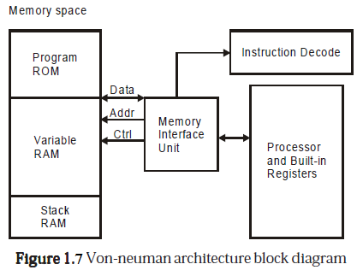

* 1. **HARVARD ARCHITECTURE**

Microcontrollers based on the Harvard Architecture have separate data bus and an instruction bus. This allows execution to occur in parallel. As an instruction is being “pre-fetched”, the current instruction is executing on the data bus. Once the current instruction is complete, the next instruction is ready to go. This pre-fetch theoretically allows for much faster execution than Von-Neuman architecture, on the expense of complexity. Figure 1.8 shows the Harvard Architecture.The Harvard Architecture executes instructions in fewer instruction cycles than the Von-Neuman architecture. For example,the intel MCS-51 family of microcontrollers and PIC microcontrollers uses Harvard Architecture.

The same instruction (as shown under Von-Newman architecture) would be executed as follows:

**Cycle 1:** Complete previous instructio

Read the “Move Data to Accumulator” instruction

**Cycle 2:** Execute “Move Data to Accumulator” instruction

Read next instruction

Hence each instruction is effectively executed in one instruction cycle.

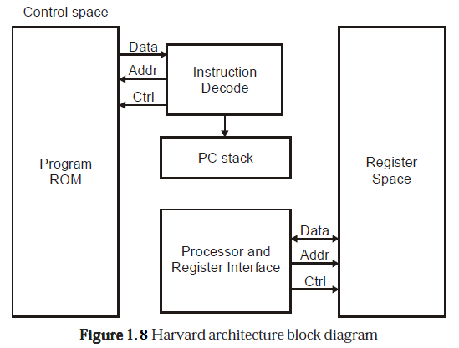

* 1. **CISC (COMPLEX INSTRUCTION SET COMPUTER) ARCHITECTURE MICROCONTROLLERS**

Almost all of today’s microcontrollers are based on the CISC (Complex Instruction Set Computer) concept. When a microcontroller has an instruction set that supports many addressing modes for the arithmetic and logical instructions, data transfer and memory accesses instructions, the microcontroller is said to be of CISC architecture. The typical CISC microcontroller has well over 80 instructions, many of them very powerful and very specialized for specific control tasks. It is quite common for the instructions to all behave quite differently. Some might only operate on certain address spaces or registers, and others might only recognize certain addressing modes. The advantages of the CISC architecture are that many of the instructions are macro like, allowing the programmer to use one instruction in place of many simpler instructions.

An example of CISC architecture microcontroller is Intel 8096 family.

* 1. **RISC (REDUCED INSTRUCTION SET COMPUTER) ARCHITECTURE**

**MICROCONTROLLERS**

The industry trend for microprocessor design is for Reduced Instruction Set Computers (RISC) designs. When a microcontroller has an instruction set that supports fewer addressing modes for the arithmetic and logical instructions and for data transfer instructions, the microcontroller is said to be of RISC architecture.

The benefits of RISC design simplicity are a smaller chip, smaller pin count, and very low power consumption.

Some of the typical features of a RISC processor- Harvard architecture are

1. Allows simultaneous access of program and data.
2. Overlapping of some operations for increased processing performance.
3. Instruction pipelining increases execution speed.
4. Orthogonal (symmetrical) instruction set for programming simplicity.
5. Allows each instruction to operate on any register or use any addressing mode.
   1. **SISC (SPECIFIC INSTRUCTION SET COMPUTER)**

Actually, a microcontroller is by definition a Reduced Instruction Set Computer. It could really be called a Specific Instruction Set Computer (SISC). The basic idea behind the microcontroller was to limit the capabilities of the CPU itself, allowing a complete computer (memory, I/O, interrupts, etc) to fit on the single chip. At the expense of the more general purpose instructions that make the standard microprocessors (8088, 68000, 32032) so easy to use, the instruction set was designed for the specific purpose of control (powerful bit manipulation, easy and efficient I/O, and so on).

1. **8051 ADDRESSING MODES**

The CPU can access data in various ways, which are called addressing modes:

* Immediate
* Register
* Direct

Accessing Memories

* Register indirect
* Indexed

1. **Immediate Addressing Mode**:

* The source operand is a constant
* The immediate data must be preceded by the pound sign, “#”
* Can load information into any registers, including 16-bit DPTR register
  + DPTR can also be accessed as two 8-bit registers, the high byte DPH and low byte DPL

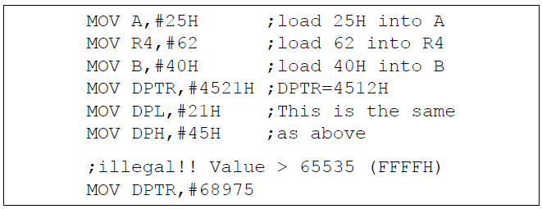

* We can use EQU directive to access immediate data

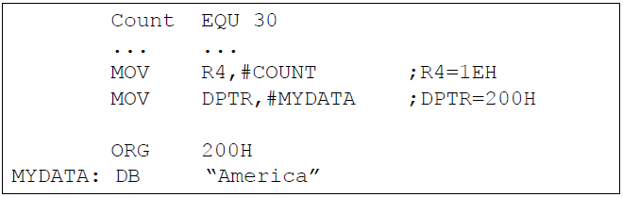

* We can also use immediate addressing mode to send data to 8051 ports



1. **Register Addressing Mode**

* Use registers to hold the data to be manipulated

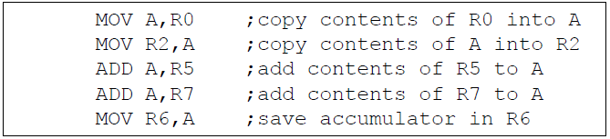

* The source and destination registers must match in size
  + MOV DPTR,A will give an error

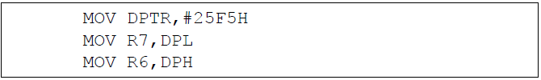

* The movement of data between Rn registers is not allowed
  + MOV R4, R7 is invalid

**ACCESSING MEMORY**

1. **Direct Addressing Mode**

* It is most often used the direct addressing mode to access RAM locations 30 – 7FH
* The entire 128 bytes of RAM can be accessed
* The register bank locations are accessed by the register names

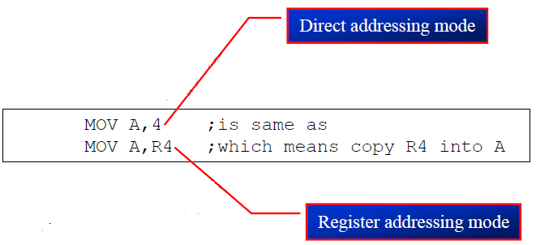

* Contrast this with immediate addressing mode
* There is no “#” sign in the operand

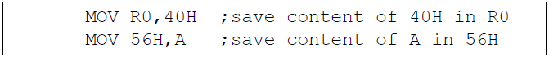

1. **SFR Registers and Their Addresses**

* The SFR (Special Function Register) can be accessed by their names or by their addresses

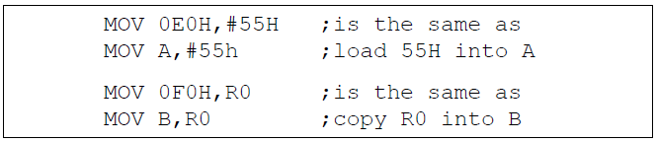

* The SFR registers have addresses between 80H and FFH
  + - * Not all the address space of 80 to FF is used by SFR
      * The unused locations 80H to FFH are reserved and must not be used by the 8051 programmer

**Special Function Register (SFR) Addresses**

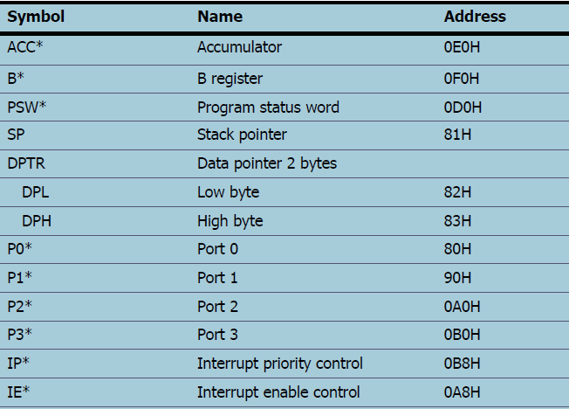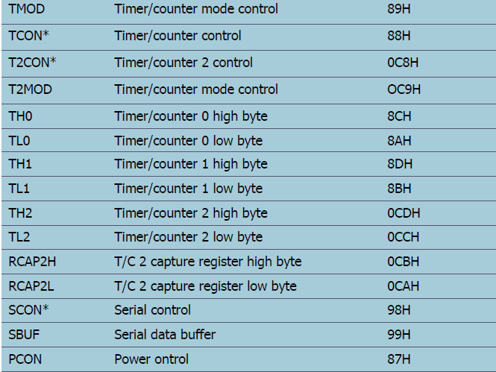

**\* Bit addressable**

**Example 1**

Write code to send 55H to ports P1 and P2, using

(a) Their names (b) their addresses

**Solution:**

1. MOV A,#55H ;A=55H

MOV P1,A ;P1=55H

MOV P2,A ;P2=55H

1. From above Table , P1 address= 90H; P2 address= 0A0H

MOV A,#55H ;A=55H

MOV 90H,A ;P1=55H

MOV 0A0H,A ;P2=55H

1. **Stack and Direct Addressing Mode**

* Only direct addressing mode is allowed for pushing or popping the stack
* PUSH A is invalid
* Pushing the accumulator onto the stack must be coded as PUSH 0E0H

**Example 2**

Show the code to push R5 and A onto the stack and then pop them back them into R2 and B, where B = A and R2 = R5

**Solution:**

PUSH 05 ;push R5 onto stack

PUSH 0E0H ;push register A onto stack

POP 0F0H ;pop top of stack into B

;now register B = register A

POP 02 ;pop top of stack into R2

;now R2=R6

1. **Register Indirect Addressing Mode**

* A register is used as a pointer to the data
  + Only register R0 and R1 are used for this purpose
  + R2 – R7 cannot be used to hold the address of an operand located in RAM
* When R0 and R1 hold the addresses of RAM locations, they must be preceded by the “@” sign

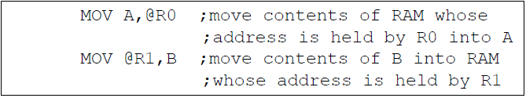

**Example 3**

Write a program to copy the value 55H into RAM memory locations 40H to 41H using

(a) direct addressing mode, (b) register indirect addressing mode without a loop, and (c) with a loop

**Solution:**

1. MOV A,#55H ;load A with value 55H

MOV 40H,A ;copy A to RAM location 40H

MOV 41H.A ;copy A to RAM location 41H

1. MOV A,#55H ;load A with value 55H

MOV R0,#40H ;load the pointer. R0=40H

MOV @R0,A ;copy A to RAM R0 points to

INC R0 ;increment pointer. Now R0=41h

MOV @R0,A ;copy A to RAM R0 points to

1. MOV A,#55H ;A=55H

MOV R0,#40H ;load pointer.R0=40H,

MOV R2,#02 ;load counter, R2=3

AGAIN: MOV @R0,A ;copy 55 to RAM R0 points to

INC R0 ;increment R0 pointer

DJNZ R2,AGAIN ;loop until counter = zero

* The advantage is that it makes accessing data dynamic rather than static as in direct addressing mode
  + Looping is not possible in direct addressing mode

**Example 4**

Write a program to clear 16 RAM locations starting at RAM address 60H

**Solution:**

CLR A ;A=0

MOV R1,#60H ;load pointer. R1=60H

MOV R7,#16 ;load counter, R7=16

AGAIN: MOV @R1,A ;clear RAM R1 points to

INC R1 ;increment R1 pointer

DJNZ R7,AGAIN ;loop until counter=zero

**Example 5**

Write a program to copy a block of 10 bytes of data from 35H to 60H

**Solution:**

MOV R0,#35H ;source pointer

MOV R1,#60H ;destination pointer

MOV R3,#10 ;counter

BACK: MOV A,@R0 ;get a byte from source

MOV @R1,A ;copy it to destination

INC R0 ;increment source pointer

INC R1 ;increment destination pointer

DJNZ R3,BACK ;keep doing for ten bytes

* R0 and R1 are the only registers that can be used for pointers in register indirect addressing mode
* Since R0 and R1 are 8 bits wide, their use is limited to access any information in the internal RAM
* Whether accessing externally connected RAM or on-chip ROM, we need 16-bit pointer
* In such case, the DPTR register is used

1. **Indexed Addressing Mode and On-chip ROM Access**

* Indexed addressing mode is widely used in accessing data elements of look-up table entries located in the program ROM
* The instruction used for this purpose is **MOVC A,@A+DPTR**
* Use instruction MOVC, “C” means code
* The contents of A are added to the 16-bit register DPTR to form the 16-bit address of the needed data

**Example 6**

In this program, assume that the word “USA” is burned into ROM locations starting at 200H. And that the program is burned into ROM locations starting at 0. Analyze how the program works and state where “USA” is stored after this program is run.

**Solution:**

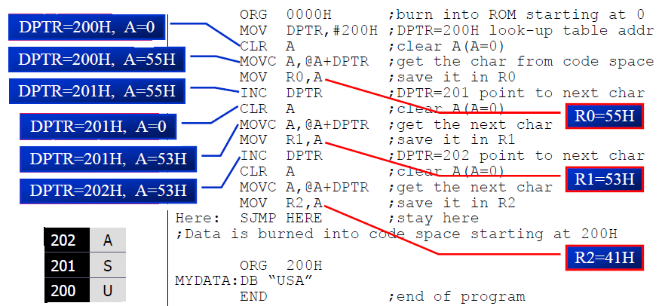

* The look-up table allows access to elements of a frequently used table with minimum operations.

**Example 5-8**

Write a program to get the x value from P1 and send x2 to P2, continuously

**Solution:**

ORG 0

MOV DPTR,#300H ;LOAD TABLE ADDRESS

MOV A,#0FFH ;A=FF

MOV P1,A ;CONFIGURE P1 INPUT PORT

BACK: MOV A,P1 ;GET X

MOV A,@A+DPTR ;GET X SQAURE FROM TABLE

MOV P2,A ;ISSUE IT TO P2

SJMP BACK ;KEEP DOING IT

ORG 300H

XSQR_TABLE:

DB 0,1,4,9,16,25,36,49,64,81

END