VPN ( Virtual Private Network):-
A VPN ( Virtual Private Network) is a way of creating a secure connection ‘to’ and ‘from’ a network or a computer. The VPN uses strong encryption and restricted, private data access which keeps the data secure from the other users of the underlying network which could often be a public network like the Internet. VPNs have been used for years, but they have become more robust . They are more affordable & also much faster.
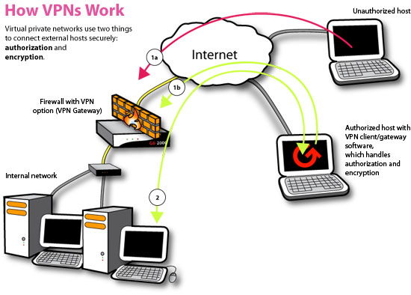

Types of VPN
There are many different types of VPNs available. Let’s take a look at most common types.

1. PPTP VPN
This is the most common and widely used VPN protocol. They enable authorized remote users to connect to the VPN network using their existing Internet connection and then log on to the VPN using password authentication. They don’t need extra hardware and the features are often available as inexpensive add-on software. PPTP stands for Point-to-Point Tunneling Protocol. The disadvantage of PPTP is that it does not provide encryption and it relies on the PPP (Point-to-Point Protocol) to implement security measures.

2. Site-to-Site VPN
Site-to-site is much the same thing as PPTP except there is no “dedicated” line in use. It allows different sites of the same organization, each with its own real network, to connect together to form a VPN. Unlike PPTP, the routing, encryption and decryption is done by the routers on both ends, which could be hardware-based or software-based.

3. L2TP VPN
L2TP or Layer to Tunneling Protocol is similar to PPTP, since it also doesn’t provide encryption and it relies on PPP protocol to do this. The difference between PPTP and L2TP is that the latter provides not only data confidentiality but also data integrity. L2TP was developed by Microsoft and Cisco.

4. IPsec
Tried and trusted protocol which sets up a tunnel from the remote site into your central site. As the name suggests, it’s designed for IP traffic. IPSec requires expensive, time consuming client installations and this can be considered an important disadvantage.

5. SSL
SSL or Secure Socket Layer is a VPN accessible via https over web browser. SSL creates a secure session from your PC browser to the application server you’re accessing. The major advantage of SSL is that it doesn’t need any software installed because it uses the web browser as the client application.

6. MPLS VPN
MPLS (Multi-Protocol Label Switching) are no good for remote access for individual users, but for site-to-site connectivity, they’re the most flexible and scalable option. These systems are essentially ISP-tuned VPNs, where two or more sites are connected to form a VPN using the same ISP. An MPLS network isn’t as easy to set up or add to as the others, and hence bound to be more expensive.

7. Hybrid VPN
A few companies have managed to combine features of SSL and IPSec & also other types of VPN types. Hybrid VPN servers are able to accept connections from multiple types of VPN clients. They offer higher flexibility at both client and server levels and bound to be expensive.
Digital Signature:-
A digital signature is a mathematical technique used to validate the authenticity and integrity of a message, software or digital document.
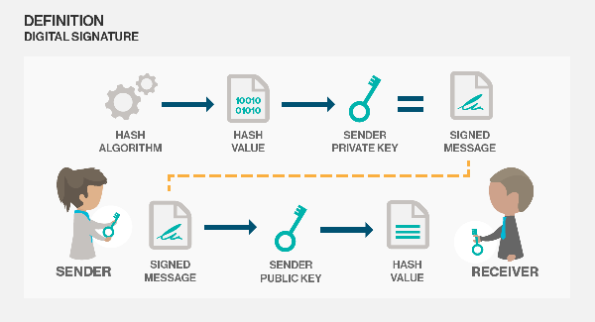
The digital equivalent of a handwritten signature or stamped seal, but offering far more inherent security, a digital signature is intended to solve the problem of tampering and impersonation in digital communications. Digital signatures can provide the added assurances of evidence to origin, identity and status of an electronic document, transaction or message, as well as acknowledging informed consent by the signer.
How digital signatures work
Digital signatures are based on public key cryptography, also known as asymmetric cryptography. Using a public key algorithm such as RSA, one can generate two keys that are mathematically linked: one private and one public. To create a digital signature, signing software (such as an email program) creates a one way hash of the electronic data to be signed. The private key is then used to encrypt the hash. The encrypted hash along with other information, such as the hashing algorithm is the digital signature. The reason for encrypting the hash instead of the entire message or document is that a hash function can convert an arbitrary input into a fixed length value, which is usually much shorter. This saves time since hashing is much faster than signing.
A digital signature can be used with any kind of message whether it is encrypted or not simply so the receiver can be sure of the sender's identity and that the message arrived intact. Digital signatures make it difficult for the signer to deny having signed something (non-repudiation) assuming their private key has not been compromised as the digital signature is unique to both the document and the signer, and it binds them together. A digital certificate, an electronic document that contains the digital signature of the certificate-issuing authority, binds together a public key with an identity and can be used to verify a public key belongs to a particular person.

