**Endocrine system**

The **endocrine system** is the collection of glands that produce hormones that regulate metabolism, growth and development, tissue function, sexual function, reproduction, sleep, and mood, among other things.

**Endocrine organs secreting the Hormones**:

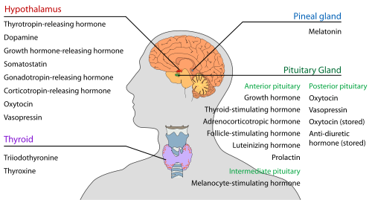

**Digestive:**

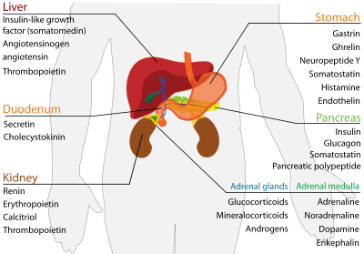

**Reproductive:**

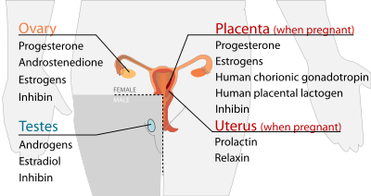

**Calcium regulation**:

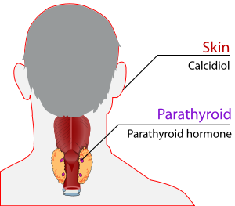 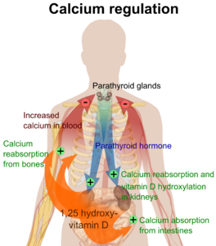

A **gland** is a group of cells that produces and secretes, or gives off, chemicals. A gland selects and removes materials from the blood, processes them, and secretes the finished chemical product for use somewhere in the body.

Some types of glands release their secretions in specific areas. For instance, **exocrine**(pronounced: EK-suh-krin) **glands**, such as the sweat and salivary glands, release secretions in the skin or inside the mouth. **Endocrine glands**, on the other hand, release more than 20 major hormones directly into the bloodstream where they can be transported to cells in other parts of the body.

The major glands that make up the human endocrine system include the:

* hypothalamus
* pituitary gland
* thyroid
* parathyroids
* adrenal glands
* pineal body
* reproductive glands (which include the ovaries and testes)
* pancreas

**Hypothalamus**

The **hypothalamus** , a collection of specialized cells that is located in the lower central part of the brain, is the main link between the endocrine and nervous systems. Nerve cells in the hypothalamus control the pituitary gland by producing chemicals that either stimulate or suppress hormone secretions from the pituitary.

**Pituitary**

Although it is no bigger than a pea, the **pituitary** **gland**, located at the base of the brain just beneath the hypothalamus, is considered the most important part of the endocrine system. It's often called the "master gland" because it makes hormones that control several other endocrine glands.

The production and secretion of pituitary hormones can be influenced by factors such as emotions and changes in the seasons. To accomplish this, the hypothalamus provides information sensed by the brain (such as environmental temperature, light exposure patterns, and feelings) to the pituitary.

The tiny pituitary is divided into two parts: the anterior lobe and the posterior lobe. The **anterior lobe** regulates the activity of the thyroid, adrenals, and reproductive glands. The anterior lobe produces hormones such as:

* **Growth hormone** :which stimulates the growth of bone and other body tissues and plays a role in the body's handling of nutrients and minerals
* **Prolactin** : which activates milk production in women who are breastfeeding
* **Thyrotropin** : which stimulates the thyroid gland to produce thyroid hormones
* **Corticotropin** : which stimulates the adrenal gland to produce certain hormones

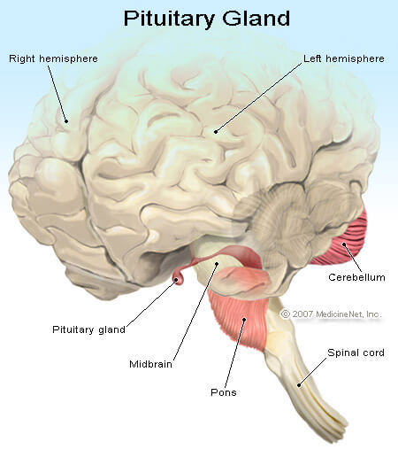

The pituitary also secretes **endorphins** , chemicals that act on the nervous system and reduce feelings of pain. In addition, the pituitary secretes hormones that signal the reproductive organs to make sex hormones. The pituitary gland also controls ovulation and the menstrual cycle in women.

The **posterior lobe** of the pituitary releases **antidiuretic** **hormone**, which helps control the balance of water in the body. The posterior lobe also produces **Oxytocin** , which triggers the contractions of the uterus in a woman having a baby.

**Thyroid**

The **thyroid** (pronounced: THY-royd), located in the front part of the lower neck, is shaped like a bow tie or butterfly and produces the thyroid hormones **thyroxine** (pronounced: thy-RAHK-sin) and **tri-iodothyronine** (pronounced: try-eye-oh-doe-THY-ruh-neen). These hormones control the rate at which cells burn fuels from food to produce energy.

The production and release of thyroid hormones is controlled by **thyrotropin** , which is secreted by the pituitary gland. The more thyroid hormone there is in a person's bloodstream, the faster chemical reactions occur in the body.

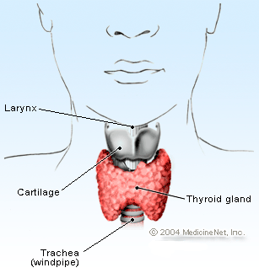

**Importance of thyroid hormones:**

They help kids' and teens' bones grow and develop, and they also play a role in the development of the brain and nervous system in kids.

**Parathyroids**

Attached to the thyroid are four tiny glands that function together called the **parathyroids** .They release **parathyroid hormone**, which regulates the level of calcium in the blood with the help of **calcitonin** , which is produced in the thyroid.

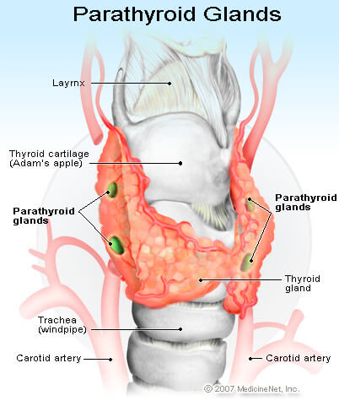

**Adrenal Glands**

The body also has two triangular **adrenal** **glands**, one on top of each kidney.

The adrenal glands have two parts, each of which produces a set of hormones and has a different function:

1. The outer part, the **adrenal cortex**, produces hormones called **corticosteroids**  that influence or regulate salt and water balance in the body, the body's response to stress, metabolism, the immune system, and sexual development and function.
2. The inner part, the **adrenal medulla** , produces **catecholamines** such as **epinephrine** .Also called adrenaline, epinephrine increases blood pressure and heart rate when the body experiences stress.

### Pineal

The **pineal** **body**, also called the pineal gland, is located in the middle of the brain. It secretes **melatonin**(pronounced: meh-luh-TOE-nin), a hormone that may help regulate when you sleep at night and when you wake in the morning.

### Reproductive Glands

The **gonads** are the main source of sex hormones. Most people don't realize it, but both guys and girls have gonads.

The male gonads or **testes** are located in the scrotum. They secrete hormones called **androgens**, the most important of which is **testosterone** .These hormones tell a guy's body when it's time to make the changes associated with [puberty](http://kidshealth.org/en/teens/puberty.html), like penis and height growth, deepening voice, and growth in facial and pubic hair. Working with hormones from the pituitary gland, testosterone also tells a guy's body when it's time to produce sperm in the testes.

Female gonads, the **ovaries**, are located in her pelvis. They produce eggs and secrete the female hormones **estrogen** and **progesterone**. Estrogen is involved when a girl begins to go through puberty. During puberty, a girl will experience breast growth, will begin to accumulate body fat around the hips and thighs, and will have a growth spurt. Estrogen and progesterone are also involved in the regulation of a girl's menstrual cycle. These hormones also play a role in pregnancy.

Although the endocrine glands are the body's main hormone producers, some other organs not in the endocrine system — such as the brain, heart, lungs, kidneys, liver, and skin — also produce and release hormones.

### Pancreas

The **pancreas** is also part of the body's hormone-secreting system, even though it is also associated with the digestive system because it produces and secretes digestive enzymes.

The pancreas produces (in addition to others) two important hormones, **insulin** and **glucagon**. They work together to maintain a steady level of glucose, or sugar, in the blood and to keep the body supplied with fuel to produce and maintain stores of energy.

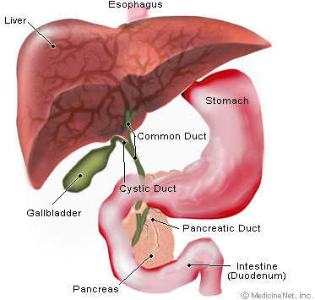

**Other Hormone Producing Organs**  
 In addition to the glands of the endocrine system, many other non-glandular organs and tissues in the body produce hormones as well.

* **Heart**: The cardiac muscle tissue of the [**heart**](http://www.innerbody.com/image/card01.html) is capable of producing the hormone atrial natriuretic peptide (ANP) in response to [**high blood pressure**](http://www.innerbody.com/diseases-conditions/hypertension) levels. ANP works to reduce blood pressure by triggering vasodilation to provide more space for the blood to travel through. ANP also reduces blood volume and pressure by causing water and salt to be excreted out of the blood by the kidneys.
* **Kidneys**: The [**kidneys**](http://www.innerbody.com/image_urinov/dige05-new.html) produce the hormone erythropoietin (EPO) in response to low levels of oxygen in the blood. EPO released by the kidneys travels to the red bone marrow where it stimulates an increased production of red blood cells. The number of red blood cells increases the oxygen carrying capacity of the blood, eventually ending the production of EPO.
* **Digestive System**: The hormones cholecystokinin (CCK), secretin, and gastrin are all produced by the organs of the gastrointestinal tract. CCK, secretin, and gastrin all help to regulate the secretion of pancreatic juice, bile, and gastric juice in response to the presence of food in the stomach. CCK is also instrumental in the sensation of satiety or “fullness” after eating a meal.
* **Adipose:** Adipose tissue produces the hormone leptin that is involved in the management of appetite and energy usage by the body. Leptin is produced at levels relative to the amount of adipose tissue in the body, allowing the brain to monitor the body’s energy storage condition. When the body contains a sufficient level of adipose for energy storage, the level of leptin in the blood tells the brain that the body is not starving and may work normally. If the level of adipose or leptin decreases below a certain threshold, the body enters starvation mode and attempts to conserve energy through increased hunger and food intake and decreased energy usage. Adipose tissue also produces very low levels of estrogens in both men and women. In obese people the large volume of adipose tissue may lead to abnormal estrogen levels.
* **Placenta**: In pregnant women, the placenta produces several hormones that help to maintain pregnancy. Progesterone is produced to relax the uterus, protect the fetus from the mother’s [**immune system**](http://www.innerbody.com/image/lympov.html), and prevent premature delivery of the fetus. **Human chorionic** **gonadotropin (HCG**) assists progesterone by signaling the ovaries to maintain the production of estrogen and progesterone throughout pregnancy.
* **Local Hormones**: Prostaglandins and leukotrienes are produced by every tissue in the body (except for blood tissue) in response to damaging stimuli. These two hormones mainly affect the cells that are local to the source of damage, leaving the rest of the body free to function normally.   
   Prostaglandins cause swelling, inflammation, increased pain sensitivity, and increased local body temperature to help block damaged regions of the body from infection or further damage. They act as the body’s natural bandages to keep pathogens out and swell around damaged joints like a natural cast to limit movement.

Leukotrienes help the body heal after prostaglandins have taken effect by reducing inflammation while helping white blood cells to move into the region to clean up pathogens and damaged tissues.

**Physiology of the endocrine system:**

**Endocrine System vs. Nervous System Function**  
The endocrine system works alongside of the nervous system to form the control systems of the body. The nervous system provides a very fast and narrowly targeted system to turn on specific glands and muscles throughout the body. The endocrine system, on the other hand, is much slower acting, but has very widespread, long lasting, and powerful effects. Hormones are distributed by glands through the bloodstream to the entire body, affecting any cell with a receptor for a particular hormone. Most hormones affect cells in several organs or throughout the entire body, leading to many diverse and powerful responses.     
  
**Hormone Properties**  
Once hormones have been produced by glands, they are distributed through the body via the bloodstream. As hormones travel through the body, they pass through cells or along the plasma membranes of cells until they encounter a receptor for that particular hormone. Hormones can only affect target cells that have the appropriate receptors. This property of hormones is known as specificity. Hormone specificity explains how each hormone can have specific effects in widespread parts of the body.  
  
 Many hormones produced by the endocrine system are classified as tropic hormones. A tropic hormone is a hormone that is able to trigger the release of another hormone in another gland. Tropic hormones provide a pathway of control for hormone production as well as a way for glands to be controlled in distant regions of the body. Many of the hormones produced by the pituitary gland, such as TSH, ACTH, and FSH are tropic hormones.  
  
**Hormonal Regulation**  
The levels of hormones in the body can be regulated by several factors. The nervous system can control hormone levels through the action of the hypothalamus and its releasing and inhibiting hormones. For example, TRH produced by the hypothalamus stimulates the anterior pituitary to produce TSH. Tropic hormones provide another level of control for the release of hormones. For example, TSH is a tropic hormone that stimulates the thyroid gland to produce T3 and T4. Nutrition can also control the levels of hormones in the body. For example, the thyroid hormones T3 and T4 require 3 or 4 iodine atoms, respectively, to be produced. In people lacking iodine in their diet, they will fail to produce sufficient levels of thyroid hormones to maintain a healthy metabolic rate. Finally, the number of receptors present in cells can be varied by cells in response to hormones. Cells that are exposed to high levels of hormones for extended periods of time can begin to reduce the number of receptors that they produce, leading to reduced hormonal control of the cell.   
  
**Classes of Hormones**  
Hormones are classified into 2 categories depending on their chemical make-up and solubility: water-soluble and lipid-soluble hormones. Each of these classes of hormones has specific mechanisms for their function that dictate how they affect their target cells.

* **Water-soluble hormones**: Water-soluble hormones include the peptide and amino-acid hormones such as insulin, epinephrine, HGH, and oxytocin. As their name indicates, these hormones are soluble in water. Water-soluble hormones are unable to pass through the phospholipid bilayer of the plasma membrane and are therefore dependent upon receptor molecules on the surface of cells. When a water-soluble hormone binds to a receptor molecule on the surface of a cell, it triggers a reaction inside of the cell. This reaction may change a factor inside of the cell such as the permeability of the membrane or the activation of another molecule. A common reaction is to cause molecules of cyclic adenosine monophosphate (cAMP) to be synthesized from adenosine triphosphate (ATP) present in the cell. cAMP acts as a second messenger within the cell where it binds to a second receptor to change the function of the cell’s physiology.
* **Lipid-soluble hormones**: Lipid-soluble hormones include the steroid hormones such as testosterone, estrogens, glucocorticoids, and mineralocorticoids. Because they are  soluble in lipids, these hormones are able to pass directly through the phospholipid bilayer of the plasma membrane and bind directly to receptors inside the cell nucleus. Lipid-soluble hormones are able to directly control the function of a cell from these receptors, often triggering the transcription of particular genes in the DNA to produce "messenger RNAs (mRNAs)" that are used to make proteins that affect the cell’s growth and function

## Diseases of the endocrine system

Hormone levels that are too high or too low indicate a problem with the endocrine system. Hormone diseases also occur if your body does not respond to hormones in the appropriate ways. Stress, infection, and changes in the blood's fluid and electrolyte balance can also influence hormone levels, according to the [National Institutes of Health](http://www.nlm.nih.gov/medlineplus/endocrinediseases.html).

The most common endocrine disease in the United States is [diabetes](http://www.livescience.com/43477-diabetes-symptoms-types.html), a condition in which the body does not properly process glucose, a simple sugar. This is due to the lack of insulin or, if the body is producing insulin, because the body is not working effectively.

Hormone imbalances can have a significant impact on the reproductive system, particularly in women.

Another disorder, hypothyroidism, occurs when the thyroid gland does not produce enough thyroid hormone to meet the body’s needs. that insufficient thyroid hormone can cause many of the body's functions to slow or shut down completely.

Thyroid cancer begins in the thyroid gland and starts when the cells in the thyroid begin to change, grow uncontrollably and eventually form a tumor.

Hypoglycemia, also called low blood glucose or low blood sugar, occurs when blood glucose drops below normal levels. This typically happens as a result of treatment for diabetes when too much insulin is taken. While noted that the condition can occur in people not undergoing treatment for diabetes, such an occurrence is fairly rare.

## Causes and treatment of endocrine diseases

Diabetes, the most common disease of the endocrine system, can be linked to obesity, diet and family history, according to Dr. Alyson Myers of [North Shore-LIJ Health System](http://www.northshorelij.com/). "To diagnose diabetes, we do an oral glucose tolerance test with fasting."

It is also important to understand the patient's health history as well as the family history, Myers noted.

Tumors — both benign and cancerous — can also disrupt the functions of the endocrine system, Myers explained. Infections and medications such as blood thinners can also cause adrenal deficiencies.

Diabetes is treated with pills or insulin injections. Managing other endocrine disorders typically involves stabilizing hormone levels with medication or, if a tumor is causing an overproduction of a hormone, by removing the tumor. Treating endocrine disorders takes a very careful and personalized approach, Myers said, as adjusting the levels of one hormone can impact the balance of other hormones.

**Cushing's syndrome (hypercortisolism)**

**Cushing's syndrome (hypercortisolism) is a collection of symptoms caused by very high levels of a hormone called cortisol in the body.**

The [symptoms of Cushing's syndrome](http://www.nhs.uk/Conditions/Cushings-syndrome/Pages/Symptoms.aspx) include:

* Weight gain
* Reddish-purple stretch marks on the thighs, stomach, buttocks, arms, legs or breasts
* Fat deposits that develop in the face, causing it to become round
* Muscle or bone weakness
* decreased interest in sex [(loss of libido)](http://www.nhs.uk/conditions/loss-of-libido/Pages/Introduction.aspx)
* [High blood pressure](http://www.webmd.com/hypertension-high-blood-pressure/default.htm)
* High [blood sugar](http://www.webmd.com/diabetes/blood-glucose) levels
* [Depression](http://www.webmd.com/depression/default.htm) and [anxiety](http://www.webmd.com/anxiety-panic/default.htm)
* [Osteoporosis](http://www.webmd.com/osteoporosis/default.htm)
* [Kidney stones](http://www.webmd.com/kidney-stones/default.htm)
* [Sleep](http://www.webmd.com/sleep-disorders/default.htm) problems
* Extra [hair](http://www.webmd.com/skin-problems-and-treatments/picture-of-the-hair) growth on your body and face
* [Irregular periods](http://www.webmd.com/infertility-and-reproduction/guide/absence-periods)

**Causes :**

Cushing's syndrome often develops as a side effect of treatment with [corticosteroids](http://www.nhs.uk/conditions/Corticosteroid-(drugs)/Pages/Introduction.aspx). Corticosteroids are widely used to reduce inflammation and treat autoimmune conditions (where the immune system malfunctions and attacks healthy tissue).

People taking high doses of corticosteroids long-term often have a build-up of cortisol in their blood. This type of Cushing's syndrome is sometimes called iatrogenic Cushing's syndrome.

A less common cause of Cushing's syndrome is where a tumour (growth) develops inside one of the body's glands, causing it to produce an excessive amount of hormones. This is known as endogenous Cushing's syndrome.

**Diagnosis:**

Cushing's syndrome can be difficult to diagnose because the symptoms are similar to those of other more common conditions,

* An [underactive thyroid gland](http://www.nhs.uk/Conditions/Thyroid-under-active/Pages/Introduction.aspx)
* [High blood pressure](http://www.nhs.uk/conditions/Blood-pressure-(high)/Pages/Introduction.aspx).
* Blood [cortisol levels](https://medlineplus.gov/ency/article/003693.htm)
* [Blood sugar](https://medlineplus.gov/ency/article/003482.htm)
* Saliva cortisol levels
* [Dexamethasone suppression test](https://medlineplus.gov/ency/article/003694.htm)
* 24-hour urine for [cortisol](https://medlineplus.gov/ency/article/003703.htm) and [creatinine](https://medlineplus.gov/ency/article/003610.htm)
* [ACTH level](https://medlineplus.gov/ency/article/003695.htm)
* [ACTH stimulation test](https://medlineplus.gov/ency/article/003696.htm) (rarely)
* Tests to determine the cause or complications may include:
* [Abdominal CT](https://medlineplus.gov/ency/article/003789.htm)
* ACTH
* [Pituitary MRI](https://medlineplus.gov/ency/article/003791.htm)
* [Bone mineral density](https://medlineplus.gov/ency/article/007197.htm)

**Treatment**

To decrease or withdraw the use of corticosteroids. However, this must be done gradually to avoid any unpleasant side effects.

For endogenous Cushing's syndrome, surgery to remove the tumour is usually recommended. If surgery is unsuccessful or it's not possible to remove the tumour safely, medication can be used to counter the effects of the high cortisol levels.

* Stopping the medicine suddenly can be dangerous.
* If you cannot stop taking the medicine because of disease, your high blood sugar, high cholesterol levels, and bone thinning or [osteoporosis](https://medlineplus.gov/ency/article/000360.htm) should be closely monitored.

With Cushing syndrome caused by a pituitary or a tumor that releases ACTH (Cushing disease), you may need:

* Surgery to remove the tumor.
* Radiation after removal of a pituitary tumor in some cases.
* Cortisol replacement therapy after surgery and possibly for the rest of your life.

With Cushing syndrome due to an adrenal tumor or other tumors:

* You may need surgery to remove the tumor.
* If the tumor cannot be removed, you may need medicines to help block the release of cortisol.

## Prevention

If you take a corticosteroid, know the signs and symptoms of Cushing syndrome. Getting treated early can help prevent any long-term effects of Cushing syndrome. If you use inhaled steroids, you can decrease your exposure to the steroids by using a spacer and by rinsing your mouth after breathing in the steroids.

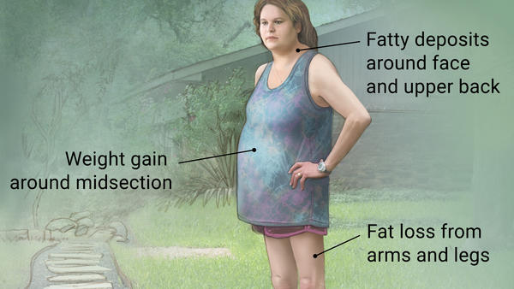

## Possible complications

If you don’t get treatment for it, Cushing’s syndrome can lead to:

* bone loss
* bone fractures
* muscle loss and weakness
* high blood pressure
* type 2 diabetes
* infections
* enlargement of a pituitary tumor
* kidney stones

Cushing’s syndrome due to pituitary tumors can interfere with the production of other hormones.

## Diabetes mellitus

Diabetes comes from Greek, and it means a "siphon". Aretus the Cappadocian, a Greek physician during the second century A.D., named the condition *diabainein*. He described patients who were passing too much water (polyuria) - like a siphon. The word became "diabetes" from the English adoption of the Medieval Latin diabetes.

Diabetes, often referred to by doctors as **diabetes mellitus**, describes a group of metabolic diseases in which the person has high blood glucose (blood sugar), either because insulin production is inadequate, or because the body's cells do not respond properly to insulin, or both. Patients with high blood sugar will typically experience polyuria (frequent urination), they will become increasingly thirsty (polydipsia) and hungry (polyphagia).

Type 2 diabetes mellitus consists of an array of dysfunctions characterized by hyperglycemia and resulting from the combination of resistance to insulin action, inadequate insulin secretion, and excessive or inappropriate glucagon secretion.

[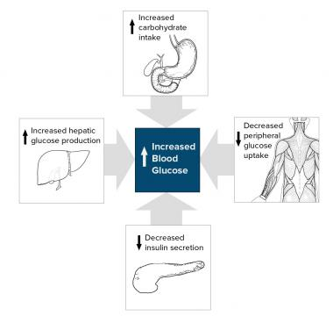](javascript:refimgshow(1))

**Simplified scheme for the pathophysiology of type 2 diabetes mellitus**.

**Signs and symptoms**

Many patients with type 2 diabetes are asymptomatic. Clinical manifestations include the following:

* Classic symptoms: Polyuria, polydipsia, polyphagia, and weight loss
* Blurred vision
* Yeast infections (e.g, balanitis in men)
* Weight gain,
* Unusual weight loss,
* **Fatigue**,
* Cuts and bruises that do not heal,
* Male sexual dysfunction, numbness
* Tingling in hands and feet

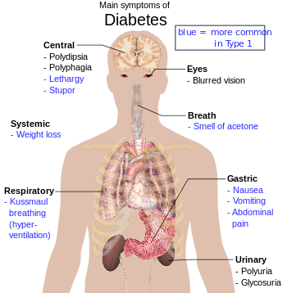

**Diagnosis**

Diagnostic criteria by the American Diabetes Association (ADA) include the following:

* A fasting plasma glucose (FPG) level of 126 mg/dL (7.0 mmol/L) or higher, *or*
* A 2-hour plasma glucose level of 200 mg/dL (11.1 mmol/L) or higher during a 75-g oral glucose tolerance test (OGTT), *or*
* A random plasma glucose of 200 mg/dL (11.1 mmol/L) or higher in a patient with classic symptoms of hyperglycemia or hyperglycemic crisis

Whether a hemoglobin A1C (HbA1c) level of 6.5% or higher should be a primary diagnostic criterion or an optional criterion remains a point of controversy.

Indications for diabetes screening in asymptomatic adults includes the followings

* Sustained blood pressure >135/80 mm Hg
* Overweight and 1 or more other risk factors for diabetes (eg, first-degree relative with diabetes, BP >140/90 mm Hg, and HDL < 35 mg/dL and/or triglyceride level >250 mg/dL)
* ADA recommends screening at age 45 years in the absence of the above criteria

## How to determine whether you have diabetes, prediabetes or neither

Doctors can determine whether a patient has a normal metabolism, prediabetes or diabetes in one of **three different** ways - there are **three possible** tests:

* **The A1C test**  
  At least 6.5% means diabetes  
  between 5.7% and 5.99% means prediabetes.  
  Less than 5.7% means normal
* **The FPG (fasting plasma glucose) test**  
  - at least 126 mg/dl means diabetes  
  - between 100 mg/dl and 125.99 mg/dl means prediabetes.  
  - less than 100 mg/dl means normal  
  *An abnormal reading following the FPG means the patient has impaired fasting glucose (IFG)*
* **The OGTT (oral glucose tolerance test)**  
  - at least 200 mg/dl means diabetes  
  - between 140 and 199.9 mg/dl means prediabetes  
  - less than 140 mg/dl means normal  
  An abnormal reading following the OGTT means the patient has impaired glucose tolerance (IGT)

#### Pathogenesis and Pathophysiology of Diabetes Mellitus

There is a direct link between [**hyperglycemia**](http://www.omicsgroup.org/journals/hypoglycemia-and-hyperglycemia-in-hospitalized-patients-receiving-insulin-2167-1052-1000195.php?aid=65798)and physiological & behavioral responses. Whenever there is hyperglycemia, the brain recognizes it and send a message through nerve impulses to pancreas and other organs to decrease its effect.

**Type 1 diabetes mellitus**

Type 1 Diabetes is characterized by autoimmune destruction of insulin producing cells in the pancreas by CD4+ and CD8+ T cells and macrophages infiltrating the islets. Several features characterize type 1 diabetes mellitus as an autoimmune disease:

* Presence of immune-competent and accessory cells in infiltrated pancreatic islets;
* Association of susceptibility to disease with the class II (immune response) genes of the major histocompatibility complex (MHC; human leucocyte antigens HLA);
* Presence of islet cell specific auto antibodies;
* Alterations of T cell mediated immunoregulation, in particular in CD4+ T cell compartment;
* The involvement of monokines and TH1 cells producing interleukins in the disease process;
* Response to immunotherapy and;
* Frequent occurrence of other organ specific auto- immune diseases in affected individuals or in their family members.

Approximately 85% of patients have circulating islet cell antibodies, and the majorities also have detectable anti-insulin antibodies before receiving insulin therapy. Most islet cell antibodies are directed against glutamic acid decarboxylase (GAD) within pancreatic B cells.

The autoimmune destruction of pancreatic β-cells, leads to a deficiency of insulin secretion which results in the metabolic derangements associated with T1DM. In addition to the loss of [**insulin**](http://www.omicsonline.org/open-access/nonalcoholic-fatty-liver-disease-and-its-association-with-insulinresistance-a-study-from-bangladeshi-newly-diagnosed-impaired-gluc-2155-6156-1000688.php?aid=77014)secretion, the function of pancreatic α-cells is also abnormal and there is excessive secretion of glucagons in T1DM patients. Normally, hyperglycemia leads to reduced glucagons secretion, however, in patients with T1DM, glucagons secretion is not suppressed by hyperglycemia. The resultant inappropriately elevated glucagons levels exacerbate the metabolic defects due to insulin deficiency. Although insulin deficiency is the primary defect in T1DM, there is also a defect in the administration of insulin. Deficiency in insulin leads to uncontrolled lipolysis and elevated levels of free fatty acids in the plasma, which suppresses glucose metabolism in peripheral tissues such as skeletal muscle. This impairs glucose utilization and insulin deficiency also decreases the expression of a number of genes necessary for target tissues to respond normally to insulin such as glucokinase in liver and the GLUT 4 class of glucose transporters in adipose tissue explained that the major metabolic derangements, which result from insulin deficiency in T1DM are impaired glucose, lipid and protein metabolism.

**Type 2 diabetes mellitus**

In type 2 diabetes these mechanisms break down, with the consequence that the two main pathological defects in type 2 diabetes are impaired insulin secretion through a dysfunction of the pancreatic β-cell, and impaired insulin action through insulin resistance. In situations where resistance to insulin predominates, the mass of β-cells undergoes a transformation capable of increasing the insulin supply and compensating for the excessive and anomalous demand. In absolute terms, the plasma insulin concentration (both fasting and meal stimulated) usually is increased, although “relative” to the severity of insulin resistance, the plasma insulin concentration is insufficient to maintain normal glucose homeostasis. Keeping in mind the intimate relationship between the secretion of insulin and the sensitivity of hormone action in the complicated control of glucose homeostasis, it is practically impossible to separate the contribution of each to the etiopathogenesis of DM2.

Insulin resistance and hyperinsulinemia eventually lead to impaired glucose tolerance . Except for maturity onset diabetes of the young (MODY), the mode of inheritance for type 2 diabetes mellitus is unclear. MODY, inherited as an autosomal dominant trait, may result from mutations in glucokinase gene on chromosome 7p. MODY is defined as hyperglycemia diagnosed before the age of twenty-five years and treatable for over five years without insulin in cases where islet cell antibodies (ICA) are negative.

**Insulin resistance**

The primary events are believed to be an initial deficit in insulin secretion and in many patients relative insulin deficiency in association with peripheral insulin resistance. Resistance to the action of insulin will result in impaired insulin mediated glucose uptake in the periphery (by muscle and fat), incomplete suppression of hepatic glucose output and impaired triglyceride uptake by fat. To overcome the insulin resistance, islet cells will increase the amount of insulin secreted. Endogenous glucose production is accelerated in patients with type 2 diabetes or impaired fasting [**glucose**](http://www.omicsonline.org/open-access/involvement-of-amp-kinase-in-glucose-uptake-and-palmitate-oxidation-inl6-muscle-cell-cultures-2153-0769-1000133.php?aid=77596). Because this increase occurs in the presence of hyper insulinemia, at least in the early and intermediate disease stages, hepatic insulin resistance is the driving force of hyperglycemia of type 2 diabetes

**Pathophysiology:**

[Insulin](https://en.wikipedia.org/wiki/Insulin) is the principal hormone that regulates the uptake of [glucose](https://en.wikipedia.org/wiki/Glucose) from the blood into most cells of the body, especially liver, muscle, and adipose tissue. Therefore, deficiency of insulin or the insensitivity of its [receptors](https://en.wikipedia.org/wiki/Receptor_(biochemistry)) plays a central role in all forms of diabetes mellitus.

The body obtains glucose from three main places: the intestinal absorption of food, the breakdown of [glycogen](https://en.wikipedia.org/wiki/Glycogen), the storage form of glucose found in the liver, and [gluconeogenesis](https://en.wikipedia.org/wiki/Gluconeogenesis" \o "Gluconeogenesis), the generation of glucose from non-carbohydrate substrates in the body.Insulin plays a critical role in balancing glucose levels in the body. Insulin can inhibit the breakdown of glycogen or the process of gluconeogenesis, it can stimulate the transport of glucose into fat and muscle cells, and it can stimulate the storage of glucose in the form of glycogen.

Insulin is released into the blood by [beta cells](https://en.wikipedia.org/wiki/Beta_cells) (β-cells), found in the [islets of Langerhans](https://en.wikipedia.org/wiki/Islets_of_Langerhans) in the pancreas, in response to rising levels of blood glucose, typically after eating. Insulin is used by about two-thirds of the body's cells to absorb glucose from the blood for use as fuel, for conversion to other needed molecules, or for storage. Lower glucose levels result in decreased insulin release from the beta cells and in the breakdown of glycogen to glucose. This process is mainly controlled by the hormone [glucagon](https://en.wikipedia.org/wiki/Glucagon), which acts in the opposite manner to insulin.

If the amount of insulin available is insufficient, if cells respond poorly to the effects of insulin ([insulin insensitivity](https://en.wikipedia.org/wiki/Insulin_insensitivity) or [insulin resistance](https://en.wikipedia.org/wiki/Insulin_resistance)), or if the insulin itself is defective, then glucose will not be absorbed properly by the body cells that require it, and it will not be stored appropriately in the liver and muscles. The net effect is persistently high levels of blood glucose, poor protein synthesis, and other metabolic derangements, such as [acidosis](https://en.wikipedia.org/wiki/Acidosis).

When the glucose concentration in the blood remains high over time, the [kidneys](https://en.wikipedia.org/wiki/Kidneys) will reach a threshold of [reabsorption](https://en.wikipedia.org/wiki/Reabsorption" \o "Reabsorption), and glucose will be excreted in the [urine](https://en.wikipedia.org/wiki/Urine) ([glycosuria](https://en.wikipedia.org/wiki/Glycosuria" \o "Glycosuria)). This increases the [osmotic pressure](https://en.wikipedia.org/wiki/Osmotic_pressure) of the urine and inhibits reabsorption of water by the kidney, resulting in increased urine production ([polyuria](https://en.wikipedia.org/wiki/Polyuria" \o "Polyuria)) and increased fluid loss. Lost blood volume will be replaced osmotically from water held in body cells and other body compartments, causing [dehydration](https://en.wikipedia.org/wiki/Dehydration) and increased thirst ([polydipsia](https://en.wikipedia.org/wiki/Polydipsia" \o "Polydipsia)).

## Prevention

There is no known preventive measure for type 1 diabetes. Type 2 diabetes — which accounts for 85-90% of all cases — can often be prevented or delayed by maintaining a [normal body weight](https://en.wikipedia.org/wiki/Normal_body_weight), engaging in physical exercise, and consuming a healthful diet. Higher levels of physical activity reduce the risk of diabetes by 28%. Dietary changes known to be effective in helping to prevent diabetes include maintaining a diet rich in [whole grains](https://en.wikipedia.org/wiki/Whole_grain) and [fiber](https://en.wikipedia.org/wiki/Dietary_fiber), and choosing good fats, such as the [polyunsaturated fats](https://en.wikipedia.org/wiki/Polyunsaturated_fat) found in nuts, vegetable oils, and fish. Limiting sugary beverages and eating less red meat and other sources of [saturated fat](https://en.wikipedia.org/wiki/Saturated_fat) can also help prevent diabetes. Tobacco smoking is also associated with an increased risk of diabetes and its complications, so [smoking cessation](https://en.wikipedia.org/wiki/Smoking_cessation) can be an important preventive measure as well.

The relationship between type 2 diabetes and the main modifiable risk factors (excess weight, unhealthy diet, physical inactivity and tobacco use) is similar in all regions of the world. There is growing evidence that the underlying determinants of diabetes are a reflection of the major forces driving social, economic and cultural change: globalization, urbanization, population ageing, and the general [health policy](https://en.wikipedia.org/wiki/Health_policy) environment.

## Management

Goals of treatment are as follows:

* Microvascular (ie, eye and kidney disease) risk reduction through control of glycemia and blood pressure
* Macrovascular (ie, coronary, cerebrovascular, peripheral vascular) risk reduction through control of lipids and hypertension, smoking cessation
* Metabolic and neurologic risk reduction through control of glycemia

Diabetes mellitus is a [chronic disease](https://en.wikipedia.org/wiki/Chronic_disease), for which there is no known cure except in very specific situations. Management concentrates on keeping blood sugar levels as close to normal, without causing low blood sugar. This can usually be accomplished with a healthy diet, exercise, weight loss, and use of appropriate medications (insulin in the case of type 1 diabetes; oral medications, as well as possibly insulin, in type 2 diabetes).

Learning about the disease and actively participating in the treatment is important, since complications are far less common and less severe in people who have well-managed blood sugar levels. The goal of treatment is an HbA1C level of 6.5%, but should not be lower than that, and may be set higher. Attention is also paid to other health problems that may accelerate the negative effects of diabetes. These include [smoking](https://en.wikipedia.org/wiki/Tobacco_smoking), [elevated cholesterol](https://en.wikipedia.org/wiki/Hypercholesterolemia) levels, [obesity](https://en.wikipedia.org/wiki/Obesity), [high blood pressure](https://en.wikipedia.org/wiki/Hypertension), and lack of regular [exercise](https://en.wikipedia.org/wiki/Exercise). [Specialized footwear](https://en.wikipedia.org/wiki/Orthotics) is widely used to reduce the risk of ulceration, or re-ulceration, in at-risk diabetic feet. Evidence for the efficacy of this remains equivocal, however.[[68]](https://en.wikipedia.org/wiki/Diabetes_mellitus#cite_note-pmid15150815-68)

### Lifestyle

People with diabetes can benefit from education about the disease and treatment, good [nutrition](https://en.wikipedia.org/wiki/Nutrition) to achieve a normal body weight, and exercise, with the goal of keeping both short-term and long-term blood glucose levels [within acceptable bounds](https://en.wikipedia.org/wiki/Diabetes_management#Glycemic_control). In addition, given the associated higher risks of cardiovascular disease, lifestyle modifications are recommended to control blood pressure.

### Medications

Medications used to treat diabetes do so by lowering [blood sugar levels](https://en.wikipedia.org/wiki/Glucose). There are a number of different classes of anti-diabetic medications. Some are available by mouth, such as [metformin](https://en.wikipedia.org/wiki/Metformin" \o "Metformin), while others are only available by injection such as [GLP-1 agonists](https://en.wikipedia.org/wiki/GLP-1_agonist). Type 1 diabetes can only be treated with insulin, typically with a combination of regular and NPH [insulin](https://en.wikipedia.org/wiki/Insulin), or synthetic [insulin analogs](https://en.wikipedia.org/wiki/Insulin_analogs).

[Metformin](https://en.wikipedia.org/wiki/Metformin) is generally recommended as a first line treatment for type 2 diabetes, as there is good evidence that it decreases mortality. It works by decreasing the liver's production of glucose. Several other groups of drugs, mostly given by mouth, may also decrease blood sugar in type II DM. These include agents that increase insulin release, agents that decrease absorption of sugar from the intestines, and agents that make the body more sensitive to insulin.When insulin is used in type 2 diabetes, a long-acting formulation is usually added initially, while continuing oral medications.Doses of insulin are then increased to effect.

Since [cardiovascular disease](https://en.wikipedia.org/wiki/Cardiovascular_disease) is a serious complication associated with diabetes, some have recommended blood pressure levels below 130/80 mmHg. However, evidence supports less than or equal to somewhere between 140/90 mmHg to 160/100 mmHg; the only additional benefit found for blood pressure targets beneath this range was an isolated decrease in stroke risk, and this was accompanied by an increased risk of other serious adverse events. A 2016 review found potential harm to treating lower than 140 mm Hg.Among [medications that lower blood pressure](https://en.wikipedia.org/wiki/Antihypertensive), [angiotensin converting enzyme inhibitors](https://en.wikipedia.org/wiki/Angiotensin_converting_enzyme_inhibitors" \o "Angiotensin converting enzyme inhibitors) (ACEIs) improve outcomes in those with DM while the similar medications [angiotensin receptor blockers](https://en.wikipedia.org/wiki/Angiotensin_receptor_blockers" \o "Angiotensin receptor blockers) (ARBs) do not. [Aspirin](https://en.wikipedia.org/wiki/Aspirin) is also recommended for people with cardiovascular problems, however routine use of aspirin has not been found to improve outcomes in uncomplicated diabetes.

### Surgery

A [pancreas transplant](https://en.wikipedia.org/wiki/Pancreas_transplant) is occasionally considered for people with type 1 diabetes who have severe complications of their disease, including [end stage kidney disease](https://en.wikipedia.org/wiki/Chronic_kidney_disease) requiring [kidney transplantation](https://en.wikipedia.org/wiki/Kidney_transplantation).

[Weight loss surgery](https://en.wikipedia.org/wiki/Bariatric_surgery) in those with [obesity](https://en.wikipedia.org/wiki/Obesity) and type two diabetes is often an effective measure. Many are able to maintain normal blood sugar levels with little or no medications following surgery and long-term mortality is decreased. There however is some short-term mortality risk of less than 1% from the surgery. The [body mass index](https://en.wikipedia.org/wiki/Body_mass_index) cutoffs for when surgery is appropriate are not yet clear. It is recommended that this option be considered in those who are unable to get both their weight and blood sugar under control.

Early initiation of pharmacologic therapy is associated with improved glycemic control and reduced long-term complications in type 2 diabetes. Drug classes used for the treatment of type 2 diabetes include the following:

* Biguanides
* Sulfonylureas
* Meglitinide derivatives
* Alpha-glucosidase inhibitors
* Thiazolidinediones (TZDs)
* Glucagonlike peptide–1 (GLP-1) agonists
* Dipeptidyl peptidase IV (DPP-4) inhibitors
* Selective sodium-glucose transporter-2 (SGLT-2) inhibitors
* Insulins
* Amylinomimetics
* Bile acid sequestrants
* Dopamine agonists

### Biguanides

Metformin is the only biguanide in clinical use. Another biguanide, phenformin, was taken off the market in the United States in the 1970s because of its risk of causing lactic acidosis and associated mortality (rate of approximately 50%). Metformin has proved effective and safe.

Metformin lowers basal and postprandial plasma glucose levels. Its mechanisms of action differ from those of other classes of oral antidiabetic agents; metformin works by decreasing hepatic gluconeogenesis production. It also decreases intestinal absorption of glucose and improves insulin sensitivity by increasing peripheral glucose uptake and utilization. Unlike oral sulfonylureas, metformin rarely causes hypoglycemia.

Patients on metformin have shown significant improvements in hemoglobin A1c and their lipid profile, especially when baseline values are abnormally elevated. In addition, metformin is the only oral diabetes drug that reliably facilitates modest weight loss. In the UKPDS, it was found to be successful at reducing macrovascular disease endpoints in obese patients.The results with concomitant sulfonylureas in a heterogeneous population were conflicting,but overall, this drug probably improves macrovascular risk.

### Sulfonylureas

Sulfonylureas (eg, glyburide, glipizide, glimepiride) are insulin secretagogues that stimulate insulin release from pancreatic beta cells and probably have the greatest efficacy for glycemic lowering of any of the oral agents. However, that effect is only short-term and quickly dissipates. Sulfonylureas may also enhance peripheral sensitivity to insulin secondary to an increase in insulin receptors or to changes in the events following insulin-receptor binding.

Sulfonylureas are indicated for use as adjuncts to diet and exercise in adult patients with type 2 diabetes mellitus. They are generally well-tolerated, with hypoglycemia the most common side effect. The first-generation sulfonylureas are acetohexamide, chlorpropamide, tolazamide, and tolbutamide; the second-generation agents are glipizide, glyburide, and glimepiride. The structural characteristics of the second-generation sulfonylureas allow them to be given at lower doses and as once-daily regimens.

### Meglitinide derivatives

Meglitinides (eg, repaglinide, nateglinide) are much shorter-acting insulin secretagogues than the sulfonylureas are, with preprandial dosing potentially achieving more physiologic insulin release and less risk for hypoglycemia.Although meglitinides are considerably more expensive than sulfonylureas, they are similar in their glycemic clinical efficacy.

Meglitinides can be used as monotherapy; however, if adequate glycemic control is not achieved, then metformin or a thiazolidinedione may be added. Meglitinides may be used in patients who have allergy to sulfonylurea medications. They have a similar risk for inducing weight gain as sulfonylureas do but possibly carry less risk for hypoglycemia.

### Alpha-glucosidase inhibitors

These agents delay sugar absorption and help to prevent postprandial glucose surges. Alpha-glucosidase inhibitors prolong the absorption of carbohydrates, but their induction of flatulence greatly limits their use. They should be titrated slowly to reduce gastrointestinal (GI) intolerance.

### Thiazolidinediones

TZDs (eg, pioglitazone [Actos], rosiglitazone [Avandia]) act as insulin sensitizers; thus, they require the presence of insulin to work. They must be taken for 12-16 weeks to achieve maximal effect.

These agents are used as monotherapy or in combination with sulfonylurea, metformin, meglitinide, DPP-4 inhibitors, GLP-1 receptor agonists, or insulin. They are the only antidiabetic agents that have been shown to slow the progression of diabetes (particularly in early disease).

Pioglitazone was found to reduce the progression to frank diabetes by 72% in patients with IGT.However, the drug was associated with significant edema and weight gain.