Respiratory System

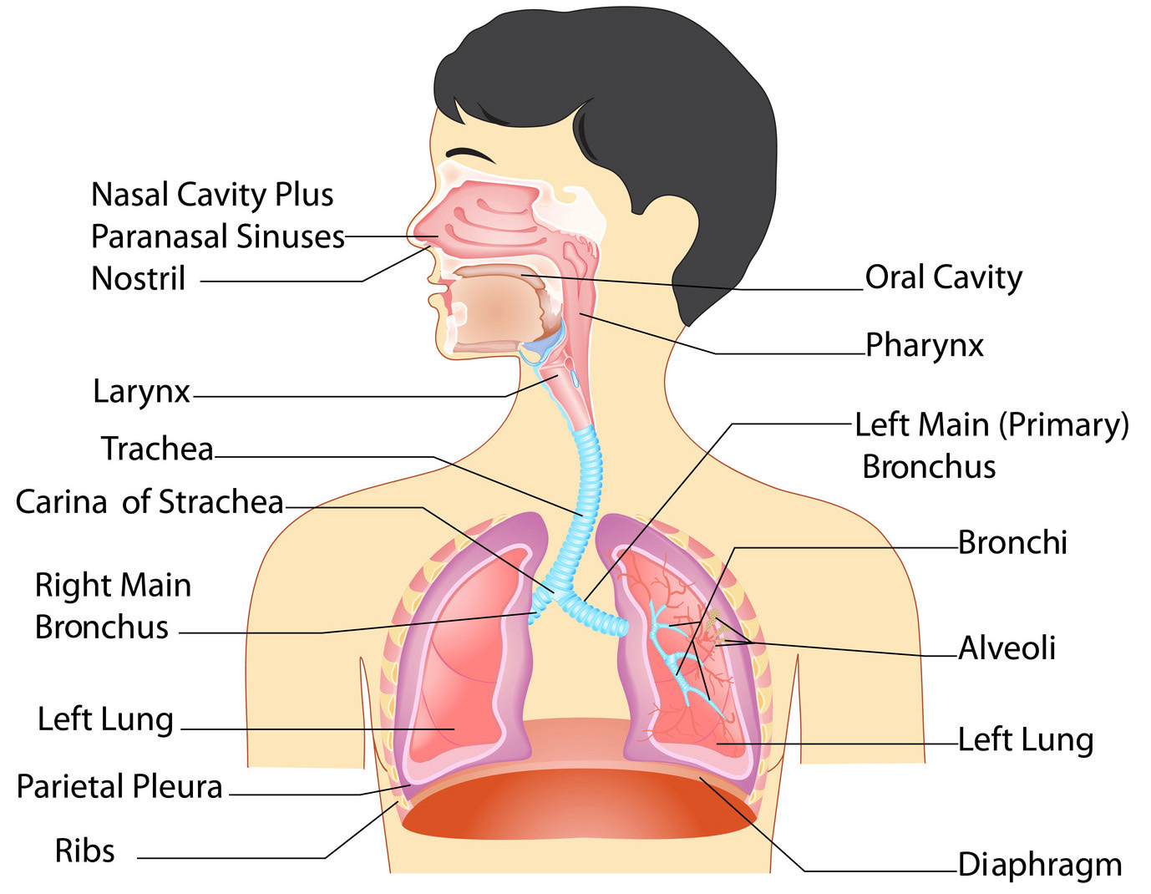

The respiratory system is a complex biological system comprised of several organs that facilitate the inhalation and exhalation of oxygen and carbon dioxide in living organisms (or, in other words, breathing).

**Anatomy OF Respiratory Organs:**

Anatomically, the respiratory system can be divided into upper and lower sections. The **upper respiratory system** includes the mouth, nose, nasal cavity, sinuses, and the pharynx. The **lower respiratory system** begins with the larynx or voice box, and includes the trachea, or wind pipe, [bronchi](http://study.com/academy/lesson/bronchi-anatomy-function-definition.html), [bronchioles](http://study.com/academy/lesson/bronchioles-definition-function-quiz.html), and alveoli within the lungs

**1. Nose and Nasal Cavity**

The nose and nasal cavity constitute the main external opening of the respiratory system. They represent the entryway to the respiratory tract – a passage through the body which air uses for travel in order to reach the lungs. The nose is made out of bone, muscle, cartilage and skin, while the nasal cavity is, more or less, hollow space. Although the nose is typically credited as being the main external breathing apparatus, its role is actually to provide support and protection to the nasal cavity. The cavity is lined with mucus membranes and little hairs that can filter the air before it goes into the respiratory tract. They can trap all harmful particles such as dust, mold and pollen and prevent them from reaching any of the internal components. At the same time, the cold outside air is warmed up and moisturized before going through the respiratory tract. During exhalation, the warm air that is eliminated returns the heat and moisture back to the nasal cavity, so this forms a continuous process.

**2. Oral cavity**

The oral cavity, more commonly referred to as the mouth, is the only other external component that is part of the respiratory system. In truth, it does not perform any additional functions compared to the nasal cavity, but it can supplement the air inhaled through the nose or act as an alternative when breathing through the nasal cavity is not possible or exceedingly difficult. Normally, breathing through nose is preferable to breathing through the mouth. Not only does the mouth not possess the ability to warm and moisturize the air coming in, but it also lacks the hairs and mucus membranes to filter out unwanted contaminants. On the plus side, the pathway leading from the mouth is shorter and the diameter is wider, which means that more air can enter the body at the same speed.

**3. Pharynx**

The pharynx is the next component of the respiratory tract, even though most people refer to it simply as the throat. It resembles a funnel made out of muscles that acts as an intermediary between the nasal cavity and the larynx and esophagus. It is divided into three separate sections: nasopharynx, oropharynx and laryngopharynx. The nasopharynx is the upper region of the structure, which begins at the posterior of the nasal cavity and simply allows air to travel through it and reach the lower sections. The oropharynx does something similar, except it is located at the posterior of the oral cavity. Once the air reaches the laryngopharynx, something called the epiglottis will divert it to the larynx. The epiglottis is a flap that performs a vital task, by switching access between the esophagus and trachea. This ensures that air will travel through the trachea, but that food which is swallowed and travels through the pharynx is diverted to the esophagus.

**4. Larynx**

The larynx is the next component, but represents only a small section of the respiratory tract that connects the laryngopharynx to the trachea. It is commonly referred to as the voice box, and it is located near the anterior section of the neck, just below the hyoid bone. The aforementioned epiglottis is part of the larynx, as are the thyroid cartilage, the cricoid cartilage and the vocal folds. Both cartilages offer support and protection to other components, such as the vocal folds and the larynx itself. The thyroid cartilage also goes by a more common name – the Adam’s apple – although, contrary to popular belief, it is present in both men and women. It is typically more pronounced in adult males. The vocal folds are mucous membranes that tense up and vibrate in order to create sound, hence the term voice box. The pitch and volume of these sounds can be controlled by modifying the tension and speed of the vocal folds.

**5. Trachea**

The trachea is a longer section of the respiratory tract, shaped like a tube and approximately 5 inches in length. It has several C-shaped hyaline cartilage rings which are lined with pseudostratified ciliated columnar epithelium. (2) Those rings keep the trachea open for air all the time. They are C-shaped in order to allow the open end to face the esophagus. This allows the esophagus to expand into the area normally occupied by the trachea in order to permit larger chunks of food to pass through. The trachea, more commonly referred to as the windpipe, connects the larynx to the bronchi and also has the role of filtering the air prior to it entering the lungs. The epithelium which lines the cartilage rings produces mucus which traps harmful particles. The cilia then move the mucus upward towards the pharynx, where it is redirected towards the gastrointestinal tract in order for it to be digested.

**6. Bronchi**

The lower end of the trachea splits the respiratory tract into two branches that are named the primary bronchi. These first run into each of the lungs before further branching off into smaller bronchi. These secondary bronchi continue carrying the air to the lobes of the lungs, then further split into tertiary bronchi. The tertiary bronchi then split into even smaller sections that are spread out throughout the lungs called bronchioles. Each one of these bronchioles continues to split into even smaller parts called terminal bronchioles. At this stage, these tiny bronchioles number in the millions, are less than a millimeter in length, and work to conduct the air to the lungs’ alveoli. The larger bronchi contain C-shaped cartilage rings similar to the ones used in the trachea to keep the airway open. As the bronchi get smaller, so do the rings that become progressively more widely spaced. The tiny bronchioles do not have any kind of cartilage and instead rely on muscles and elastin.

This system creates a tree-like pattern, with smaller branches growing from the bigger ones. At the same time, it also ensures that air from the trachea reaches all the regions of the lungs. Besides simply carrying the air, the bronchi and bronchioles also possess mucus and cilia that further refine the air and get rid of any leftover environmental contaminants. The walls of the bronchi and bronchioles are also lined with muscle tissue, which can control the flow of air going into the lungs. In certain instances, such as during physical activity, the muscles relax and allow more air to go into the lungs.

**7. Lungs**

The lungs are two organs located inside the thorax on the left and right sides. They are surrounded by a membrane that provides them with enough space to expand when they fill up with air. Because the left lung is located lateral to the heart, the organs are not identical: the left lung is smaller and has only 2 lobes while the right lung has 3. Inside, the lungs resemble a sponge made of millions and millions of small sacs that are named alveoli. These alveoli are found at the ends of terminal bronchioles and are surrounded by capillaries through which blood passes. Thanks to an epithelium layer covering the alveoli, the air that goes inside them is free to exchange gasses with the blood that goes through the capillaries.

**8. Muscles of Respiration**

The last component of the respiratory system is a muscle structure known as the muscles of respiration. These muscles surround the lungs and allow the inhalation and exhalation of air. The main muscle in this system is known as the diaphragm, a thin sheet of muscle that constitutes the bottom of the thorax. It pulls in air into the lungs by contracting several inches with each breath. In addition to the diaphragm, multiple intercostal muscles are located between the ribs and they also help compress and expand the lungs.

**Physiology of the Respiratory System**

The respiratory system has a complex physiology and is responsible for multiple functions. There are multiple roles performed by the respiratory system: pulmonary ventilation, external respiration, internal respiration, transportation of gases and homeostatic control of respiration. (3) Here is a brief description of each of those functions.

**Pulmonary Ventilation**

Pulmonary ventilation is the main process by which air flows in and out of the lungs. This is done through the contraction of muscles, as well as through a negative pressure system that is accomplished by the pleural membrane covering the lungs. When the lungs are completely sealed in this membrane, they remain at a pressure that is slightly lower than the pressure of the lungs at rest. As a result of this, the air passively fills the lungs until there is no more pressure difference. At this point, if necessary, additional air can be inhaled by contracting the diaphragm as well as the surrounding intercostal muscles. During exhalation, the muscles relax and this reverses the pressure dynamic, increasing the pressure on the outside of the lungs and forcing air to escape them until both pressures equalize again. Thanks to the elastic nature of the lungs, they revert back to their state at rest and the entire process repeats itself.

**External Respiration**

External respiration is a process that allows an exchange of gases to take place between the air located in the alveoli and the blood that is traveling through the capillaries. This is possible through a difference in pressure between the oxygen and carbon dioxide located in the air, and the oxygen and carbon dioxide in the blood. As a result of this, oxygen from the air is transferred to the blood while carbon dioxide from the blood goes into the air. The useful oxygen is then carried out throughout the body while the carbon dioxide is dispelled through exhalation.

**Internal Respiration**

Internal respiration is a similar process except it involves gas exchange between the blood in the capillaries and body tissue. Again, a difference in pressure allows oxygen to leave the blood and enter the tissue while carbon dioxide does the opposite.

**Transportation of Gases**

This function of the respiratory system enables oxygen and carbon dioxide to travel throughout the body to wherever they are needed. Most of the gases are carried through blood attached to transport molecules such as hemoglobin, although blood plasma will also have a minimal content of gas. Almost 99% of the entire oxygen found in the human body is transported by hemoglobin. Most of the carbon dioxide is transported from all areas of the body back to the lungs by plasma in the form of bicarbonate ions. This is created from a catalytic reaction (caused by a carbonic anhydrase enzyme) between water and carbon dioxide, which combine to form carbonic acid. The carbonic acid then splits into hydrogen and bicarbonate ions, with the latter eventually being transformed into carbon dioxide again, taken to the lungs and exhaled.

**Homeostatic Control of Respiration**

The last physiological role of the respiratory system is the homeostatic control of respiration or, in other words, the body’s ability to maintain a steady breathing rate. This is termed eupnea. This state should remain constant until the body has a demand for increased oxygen and carbon dioxide levels due to increased exertion, most likely caused by physical activity. When this happens, chemoreceptors will pick up on the increased partial pressure of the oxygen and carbon dioxide and send triggers to the brain. The brain will then signal the respiratory center to make adjustments to the breathing rate and depth in order to face the increased demands

**Mechanics of Breathing**

To take a breath in, the ***external intercostal*** *muscles* contract, moving the ribcage up and out. The ***diaphragm*** moves down at the same time, creating negative pressure within the thorax. The lungs are held to the thoracic wall by the ***pleural membranes***, and so expand outwards as well. This creates negative pressure within the lungs, and so air rushes in through the upper and lower airways.

Expiration is mainly due to the natural elasticity of the lungs, which tend to collapse if they are not held against the thoracic wall. This is the mechanism behind lung collapse if there is air in the pleural space (*pneumothorax*).

|  |
| --- |
|  |

**Physiology of Gas Exchange**



Each branch of the bronchial tree eventually sub-divides to form very narrow terminal bronchioles, which terminate in the **alveoli**. There are many millions of alveloi in each lung, and these are the areas responsible for gaseous exchange, presenting a massive surface area for exchange to occur over.

Each alveolus is very closely associated with a network of capillaries containing deoxygenated blood from the pulmonary artery. The capillary and alveolar walls are very thin, allowing rapid exchange of gases by***passive diffusion along concentration gradients***.   
CO2 moves *into* the alveolus as the concentration is much lower in the alveolus than in the blood, and O2 moves *out of* the alveolus as the continuous flow of blood through the capillaries prevents saturation of the blood with O2 and allows maximal transfer across the membrane.