**NHU-601: INDUSTRIAL MANAGEMENT**

**UNIT-I**

**1.1 Introduction:** Concept of Industrial Management

1.2 Development of Industrial Management

1.3 Application and Scope of Industrial Management

**1.4 Productivity:** Definition of Productivity

1.5 Measurement of Productivity

1.6 Productivity Index

1.7 Types of Production System

1.8 Industrial Ownership

* 1. **INTRODUCTION:**

Industrial Management is the combination of two words – Industrial and Management. Industrial means industry and industry may be defined as the application of complex and sophisticated methods to the production of economic goods and services. On the other hand, management means planning, organizing, coordinating, controlling, motivating and directing various activities in an organization.

**CONCEPT OF INDUSTRIAL MANAGEMENT**

The combination of these two words results in a new branch of engineering. Thus;

***“Industrial management - the branch of engineering that deals with the creation and management of systems that integrate people and materials and energy in productive ways.”***

According to the concept of industrial management, some important points are as follows:

1. Industrial management term applied to highly organize modern methods of carrying on industrial, especially manufacturing and operations.
2. It involves the environment which includes man, materials, money, and information.
3. The environment with physical and mathematical sciences, humanities and engineering creates an approach for the industrial management and engineering.
4. Industrial management is a process of planning, organizing, directing, controlling, and managing the activities of any industry.
5. It combines and transforms various resources used in the system and subsystem of the organization into value added product in a controlled manner.
6. Industrial Engineering and Management aims to uncover and solve organizational issues by attempting to establish a desirable allocation of management resources through the use of technologies.

**OBJECTIVES OF INDUSTRIAL MANAGEMENT:**

The ultimate objectives of industrial management are to produce the right quantity of right quality goods at right time. These are attained through:

1. **Manufacturing Costs:**

Efforts should be made for the followings:

1. Reduction in variable costs
2. Reduction in fixed costs
3. Increase volume of production
4. The allocation of the fixed overheads should be made on scientific basis
5. **Machinery and Equipment:**
6. Selection and acquisition of machinery and equipment according to production process
7. Utilization of machinery and equipment
8. **Materials:**

It must be prescribed in terms of units, rupee value and space requirements.

1. **Manpower:**

Manpower must be closely allied with the objectives of selection, placement, training, rewarding and utilization of manpower. Usually, these objectives are considered in terms of employee turnover rates, safety measurements, industrial relations, absenteeism, etc.

1. **Manufacturing Services:**

Proper objectives should be set for the installation of important facilities such as power, water supply, material handling, etc.

1. **Product Quality:**

A proper balance must be maintained between quality and cost as well as quantity and time schedule.

1. **Manufacturing Schedule:**

Time schedule objective directly affects the cost, quality and the goodwill of the business in terms of regularity of shipment. Manufacturing schedules such as operating cycle time, inventory turnover rate, machine utilization rate, direct and indirect man-hours per unit, capacity utilization, machine and labour idle time, set-up, repair and maintenance time, etc.

**1.2 EVOLUTION OF INDUSTRIAL MANAGEMENT**

**The Rise of Factories:**

Before the Industrial Revolution, people worked with hand tools, manufacturing articles in their own homes or in small shops. In the third quarter of the 18th century steam power was applied to machinery, and people and machines were brought together under one roof in factories, where the manufacturing process could be supervised. This was the beginning of shop management. In the next hundred years factories grew rapidly in size, in degree of mechanization, and in complexity of operation. The growth, however, was accompanied by much waste and inefficiency. In the developed countries many engineers, spurred by the increased competition of the post-Civil War era, began to seek ways of improving plant efficiency.

**THE DEVELOPMENT OF INDUSTRIAL MANAGEMENT**

Industrial management has been recognized as an important factor in any country’s economic growth from last two centuries. The industrial management began in eighteenth century when *Adam Smith* recognized the economic benefits of specialization of labour. He recommended breaking of jobs down into subtasks and recognizes workers to specialized tasks in which they would become highly skilled and efficient. In the early twentieth century, F.W. Taylor implemented Smith’s theories and developed scientific management. From then till 1930, many techniques were developed prevailing the traditional view.

**Industrial Management of the Machine:** Industrial management also involves studying the performance of machines as well as people. Specialists are employed to keep machines in good working condition and to ensure the quality of their production. When a new article is to be manufactured it is given a design that will make it suitable for machine production, and each step in its manufacture is planned, including the machines and materials to be used.

**1.3 APPLICATION AND SCOPE OF INDUSTRIAL MANAGEMENT**

**APPLICATION OF INDUSTRIAL MANAGEMENT**

Applications of industrial management are summarized in the following departments of industry:

1. Managing and arranging the location of facilities

2. Design of Plant layouts

3. Management of material handling systems

4. Supply chain management.

5. Production and Planning control

6. Quality control & Total quality management

7. Inventory & Materials management

8. Maintenance management

9. Operations management

10. Labor management

**SCOPE OF INDUSTRIAL MANAGEMENT**

As far as the scope of industrial management is concerned it is applicable in all segments of industry as well as in daily life. As in daily life, we plan our activities; we coordinate available resources and control our activities to achieve certain goals in the most economical way. In the same way any organization must follow the Principles of Management for its survival and growth and to be economically viable. These management principles are applicable to all activities in industry also.

Reading and learning Industrial Management will enable one to be capable of solving the problems of the organization, may be in a Production Shop, Hospital, Departmental shop, an Educational Institution or even a coffee shop. The problems a manager faces in various organizations are more or less similar to that of Production department but smaller in magnitude. Hence the knowledge of Industrial Management will help anybody managing business activities, tackle the problems encountered.

**SCOPE OF INDUSTRIAL MANAGEMENT**

1. **Activities relating to industrial system designing**
2. Human factor
3. Research and development activities
4. **Activities relating to analysis and control of industrial system**
5. Production planning
6. Production control
7. Quality control
8. Coordination with other departments
9. Dependent services and departments

**IMPORTANCE OF INDUSTRIAL MANAGEMENT**

The efficient Industrial Management will give benefits to the various sections of the society. They are:

**(i) Consumer** benefits from improved industrial productivity, increased use value in the product. Products are available to him at right place, at right price, at right time, in desired quantity and of desired quality.

**(ii) Investors:** They get increased security for their investments, adequate market returns, and creditability and good image in the society.

**(iii) Employee** gets adequate wages, job security, improved working conditions and increased Personal and Job satisfaction.

**(iv) Suppliers** will get confidence in management and their bills can be realized without any delay.

**(v) Community:** community enjoys benefits from economic and social stability.

**(vi) The Nation** will achieve prospects and security because of increased productivity and healthy industrial atmosphere.

**PROBLEMS OF INDUSTRIAL MANAGEMENT**

1. Problem of location
2. Problem of selection of production method
3. Problem of plant layout
4. Problem of designing of product
5. Problem of production and inventory control
6. Problem of quality control
7. Labour Problem
8. Problem of cost control

**1.4 PRODUCTIVITY: DEFINITION OF PRODUCTIVITY**

**DEFINITION of 'Productivity'**

Productivity is commonly defined as a ratio between the output volume and the volume of inputs. In other words, it measures how efficiently production inputs, such as labour and capital, are being used in an economy to produce a given level of output.

***Productivity = Output/Input***

**Meaning:** Productivity is a measure of the efficiency of a person, machine, factory, system, etc., in converting inputs into useful outputs. Productivity is computed by dividing average output per period by the total costs incurred or resources (capital, energy, material, personnel) consumed in that period. Productivity is a critical determinant of cost efficiency.

This can be achieved by

1. Either producing more output with the same inputs
2. Or using fewer inputs for the same outputs

Productivity is a common measure of how well a country, industry or business unit is doing using its resources or factors of production.

**Productivity and Production**

Production refers to absolute measure of output whereas productivity is a relative term.

**Productivity and Profitability**

Profitability is the ratio of difference of revenue and cost to investment, i.e. **profitability = (Revenue- cost)/investment**. Profitability can be increased by reducing costs which in turn also increases productivity. However, productivity is a necessary but not a sufficient condition. For example, profitability can be increased by increasing selling price. This may not increase productivity since revenue is not related to productivity. A decrease in the price of the product may lead to decreasing profitability even though productivity may be rising.

**Productivity and Efficiency:** Productivity is often confused with efficiency. Efficiency is generally seen as the ratio of the time needed to perform a task to some predetermined standard time. However, doing unnecessary work efficiently is not exactly being productive. It would be more correct to interpret productivity as a measure of effectiveness (doing the right thing efficiently), which is outcome-oriented rather than output-oriented.

**1.5 MEASUREMENT OF PRODUCTIVITY**

Depending upon who is defining it-whether it is an economist, accountant, manager, politician, union leader, or industrial engineer-you will get a slightly different definition of the term productivity. Productivity as a measure of effectiveness (doing the right thing efficiently), which is outcome-oriented rather than output-oriented. Productivity may also be defined as an index that measures output (goods and services) relative to the input (labour, materials, energy, etc., used to produce the output). As such, it can be expressed as:

**Productivity = Output/ Input**

There are three major types of productivity measures:

1. **Partial Productivity**
2. **Total Factor Productivity**
3. **Total productivity**

**(1) Partial-Factor Productivity**

The standard definition of productivity is actually what is known as a partial factor measure of productivity, in the sense that it only considers a single input in the ratio. The formula then for partial-factor productivity would be the ratio of total output to a single input.

Other partial factor measure options could appear as output/labour, output/machine, output/capital, or output/energy. It is the ratio of output to one class of input. For example, labour productivity (the ratio of output to labour input) is a partial productivity measure.

**Advantages**

1. Easy to understand.Easy to obtain the data.
2. Easy to compute the productivity indices
3. Some partial productivity indicator data is available industry wide.
4. Good diagnostic tools to pinpoint areas for productivity improvement, if used along with total productivity indicators.

**Limitations**

1. If used alone, can be very misleading and may lead to costly mistakes.
2. Do not have the ability to explain overall cost increases.
3. Tend to shift the blame to the wrong areas of management control.
4. Profit control through partial productivity measures can be a hit- and-miss approach.

**(2) Total-factor productivity (Multiple Factor Productivity)**

It is the ratio of net output to the sum of associated labour and capital (factor) inputs. By “net output,” we mean total output minus intermediate goods and services purchased. Notice that the denominator of this ratio is made up of only the labour and capital input factors.

**Multifactor Productivity = Net Output / Labour Input + Capital Input**

**Advantages**

1. The data from company records are relatively easy obtained.
2. Usually appealing from a corporate economist’s viewpoint.

**Limitations**

1. Does not capture the impact of materials and energy inputs.
2. The value-added approach to defining the output is not very appropriate in a company setting because it is difficult for operational managers to relate the value-added output to production efficiency.
3. Not appropriate when material costs from a sizable portion of total product costs since the impact of material input is not directly shown in this productivity measure.

**(3) Total productivity:**

It is the ratio of total output to the sum of all input factors. Thus, a total productivity measure reflects the joint impact of all the inputs in producing the output. As such the formula would appear as:

**Total Factor Productivity = Total output/ Total Input**

One example is a ratio computed by adding standard hours of labour actually produced, plus the standard machine hours actually produced in a given time period divided by the actual hours available for both labour and machines in the time period.

**Advantages**

1. Considers all the quantifiable output and input factors; therefore, is a more accurate representation of the real economic picture of a company.
2. Profit control through the use of total factor productivity indices is a tremendous benefit to top management.
3. If used in conjunction with partial measures, can direct management attention in an effective manner.
4. Sensitivity analysis is easier to perform; Easily related to total costs.

**Limitations**

1. Data for computations are relatively difficult to obtain at product and customer levels, unless data collection systems are designed for this purpose.
2. As with the partial and total- measures, does not consider intangible factors of output and input in a direct sense.

**Example:** Consider the ABC Company. The data for output produced and inputs consumed for a particular time period are given below.

Output = $1000

Human input = 300

Material input = 200

Capital input = 300

Energy input = 100

Other expense input = 50

It is assumed that these values are in constant dollars with respect to a base period. Then the partial, total-factor, and total productivity values are computed as follows:

Partial productivities:

Human productivity = output/human input = 1000/300 = 3.33

Material productivity = output/material input = 1000/200 = 5

Capital productivity = output/capital input = 1000/300 = 3.33

Energy productivity = output/energy input = 1000/100 = 10

Other expense productivity = output/other expense input = 1000/50 = 20

Assume that the company purchases all its materials and services, including the energy, machinery and equipment (on lease), and other services, such as marketing, advertising, information processing, consulting, etc.

**1.6 PRODUCTIVITY INDEX**

Since productivity is a relative measure, for it to be meaningful or useful it must be compared to something. For example, businesses can compare their productivity values to that of similar firms, other departments within the same firm, or against past productivity data for the same firm or department (or even one machine). This allows firms to measure productivity improvement over time, or measure the impact of certain decisions such as the introduction on new processes, equipment, and worker motivation techniques.

**Productivity Index = Productivity during the current year/**

**Productivity during the base period**

In order to have a value for comparison purposes, organizations compute their productivity index. A productivity index is the ratio of productivity measured in some time period to the productivity measured in a base period.

For example, if the base period's productivity is calculated to be 1.75 and the following period's productivity is calculated to 1.93, the resulting productivity index would be 1.93/1.75 = 1.10.

This would indicate that the firm's productivity had increased 10 percent. If the following period's productivity measurement fell to 1.66 the productivity index of 1.66/1.75 = 0.95 it would indicate that the organization's productivity has fallen to 95 percent of the productivity of the base period. By tracking productivity indexes over time, managers can evaluate the success, or lack thereof, of projects and decisions.

**FACTORS AFFECTING PRODUCTIVITY**

There is quite a variety of factors which can affect productivity, both positively and negatively. These include:

1. capital investments in production, technology, equipment&facilities
2. economies of scale
3. workforce knowledge and skill resulting from training and experience
4. technological changes; work methods
5. procedures; systems
6. quality of products&processes
7. quality of management
8. legislative and regulatory environment
9. general levels of education
10. social environment
11. geographic factors

The first 6 factors are highly controllable at the company or project level. Numbers 7 and 8 are marginally controllable, at best. Numbers 9 and 10 are controllable only at the national level, and 11is uncontrollable.

**PROCEDURES FOR IMPROVING PRODUCTIVITY**

Productivity improvement can be achieved in a number of ways. If the level of output is increased faster than that of input, productivity will increase. Conversely, productivity will be increased if the level of input is decreased faster than that of output. Also, an organization may realize a productivity increase from producing more output with the same level of input. Finally, producing more output with a reduced level of input will result in increased productivity.

1. Improving the Existing Method of Plant Operations
2. Purpose of Operation; Design of Part
3. Tolerance and Specifications
4. Effective Utilization of Methods
5. Process of Manufacturing
6. Set up and Tools; Working Conditions.
7. Material Handling; Plant Layout

As a cautionary word, organizations must be careful not to focus solely on productivity as the driver for the organization. Organizations must consider overall competitive ability. Firm success is categorized by quality, cycle time, reasonable lead time, innovation, and a host of other factors directed at improving customer service and satisfaction.

**1.7 PRODUCTION SYSTEMS:**

Production system involves in producing goods with the help of an efficient management, utilizing land, lobour, machines, capital and materials. A production system constitutes an efficient process with an organized procedure for accomplishing the transformation of input elements to useful output products.

**TYPES OF PRODUCTION SYSTEM**

The types of production system are grouped under two categories viz.,

**I. Continuous Production System**

1. Mass Production
2. Process Production
   1. Analytical Production
   2. Synthetic Production
3. Assembly Line

**II. Intermittent Production System**

1. Job Production
2. Batch Production

Now let's discuss in detail each of the above-mentioned categories.

**I. CONTINUOUS PRODUCTION SYSTEM:**

Under this method, production remains continuous in anticipation of future demand. Standardization is the basis of mass production. In this method, the production activity continues for 24 hours or on three shifts a day basis. A steel plant, for **example**, belongs to this type. Other examples include bottling plant, soft drink industry, fertilizer plant, power plant, etc.

**Characteristics:**

The continuous production possesses the following characteristics.

1. It is very highly automated (process automation), and highly capital intensive.
2. Items move from one stage to another automatically in a continuous manner.
3. The products, tools, materials and methods are standardised.
4. Production is done in anticipation of demand.
5. Each machine in the system is assigned a definite nature of work.
6. Any fault in flow of production is immediately corrected otherwise it will stop the whole production process.

**Advantages of Continuous production**:

A properly planned flow production method, results in the following advantages:

1. It gives better quality, large volume but less variety of products.
2. The product is standardised and any deviation in quality etc. is detected at the spot.
3. There will be accuracy in product design and quality.
4. It will help in reducing direct labour cost.
5. A weakness in any operation comes to the notice immediately.
6. There may not be any need of keeping work-in-progress, hence storage cost is reduced.
7. As the raw materials are purchased on a large scale, higher margin of profit can be made on purchase.

**Disadvantages**

1. During the period of less demand, heavy losses on invested capital may take place.
2. Because all the machines are dedicated and special purpose type, the system is not changeable to other type of production.
3. Most of the workers handle only a particular operation repetitively, which can make them feel monotonous.
4. As this type of production is on the large scale, it cannot fulfill individual taste.

**The types of continuous production system** include:

1. Mass production flows, and
2. Process production flows.
3. Assembly Line Production

They are explained below:

**(1) Mass production:** In this type, a large number of identical items are produced; however, the equipment need not be designed to produce only this type of items. Both plant and equipment are flexible enough to deal with other products needing the same production processes. For **example,** a highly mechanized presses shop that can be utilized to produce different types of components or products of steel metal without the need of major changes.

**(2) Process or Flow production:** Flow production is the manufacture of a product by a series of operations, each article going on to a succeeding operation as soon as possible. There is no time gap between the work done at one process and the starting at the next. The flow of production is continuous and progressive. Some famous **examples** are automobiles, engines, house-hold machinery, chemical plants, petroleum, medicines etc.

* 1. **Analytical Production:** Here a raw material is broken down into different products. For examples, crude oil is analyzed into gas, petrol, kerosene and diesel oil etc.
  2. **Synthetic Production:** It involves mixing of two or more materials to manufacturing a product. For example, lauric acid, myristic acid, plasmatic acid, stearic acid, linoleic acids are synthesized to manufacturing soap.

**(3) Assembly Line Production:**

It was developed in the automobiles industry in USA. Assembly line is a particularly useful when a limited variety of similar products is to be produced on a mass scale or in fairly large batches on a continuous basis. The design of assembly line involves the proper balancing of technology and other manufacturing facilities so as to develop a rational approach of optimization of results.

**II. INTERMITTENT PRODUCTION SYSTEM**

Intermittent means something that starts (initiates) and stops (halts) at irregular (unfixed) intervals (time gaps).

In the intermittent production system, goods are produced ***based on customer's orders***. These goods are produced on a small scale. The flow of production is intermittent (irregular). In other words, the flow of production is not continuous. In this system, large varieties of products are produced. These products are of different sizes.

The types of intermittent production system include:

1. Job Production
2. Batch Production

**(i) Job Production**:

Under this method peculiar, special or non-standardized products are produced in accordance with the orders received from the customers. As each product is non- standardized varying in size and nature, it requires separate job for production. The machines and equipment’s are adjusted in such a manner so as to suit the requirements of a particular job. It is also popularly known as ‘job-shop or Unit’ production.

Some of the **examples** include manufacturing of aircrafts, ships, space vehicle, bridge and dam construction, ship building, boilers, turbines, machine tools, things of artistic nature, die work, etc. Some of the features of this system are as follows**:**

**Characteristics (Advantages):**

The job production possesses the following characteristics.

1. A large number of workers conversant with different jobs will have to be employed.
2. This system has a lot of flexibility of operation, and hence general purpose machines are required.
3. It deals with ‘low volume and large variety’ production. It can cater to specific customer order or job of one kind at a time.
4. The movement of materials through the process is intermittent.
5. Low risk of loss to the factory adopting this type of production. Due to flexibility, there is no chance of failure of factory due to reduction in demand. It can always get one or the other job orders to keep it going.

**Limitations:**

Job production has the following limitations:

1. The economies of large scale production may not be attained because production is done in short-runs.
2. The demand is irregular for some products.
3. For handling different types of jobs, only workers with multiple skills are needed. This increases the labor cost.

**(ii) Batch production:**The *batch production system* is generally adopted in medium size enterprises. Batch production is a stage in between **mass production** and **job-shop** production. It is that form of production where identical products are produced in lots or batches at regular interval, on the basis of demand of customers’ or of expected demand for products.

This method is generally similar to job production except the quantity of production. This method is generally adopted in case of biscuit and confectionery and motor manufacturing, medicines, tinned food and hardware’s like nuts and bolts etc.

The batch production method possesses the following **characteristics** (**Advantages**):

1. A batch production turns into flow production when the rest period vanishes. In flow production, the processing of materials is continuous and progressive.
2. Batch production is bigger in scale than job production, but smaller than that of mass production.
3. Material handling may be automated by robots as in case of CNC machining centers.
4. Plant capacity generally is higher than demand.
5. The work is of repetitive nature.

**Disadvantages**

1. As the raw materials to be purchased are in smaller quantity than in case of mass production, the benefits of discount due to large lot purchasing are not possible.
2. It needs specially designed jigs and fixtures.

**1.8 INDUSTRIAL OWNERSHIP**

To start a business enterprise the most important thing required is the capital if the capital is provided by single individual, it is known as individual ownership, if it is supplied by two or more persons, if refers to partnership organisation. If it is provided by many persons in the form of show to an institute with a legal entity, it is called a joint stock company.

**Types of ownership**

1. **Single ownership (Sole proprietorship)**
2. **Partnership**
3. **Joint Hindu Undivided Family**
4. **Joint Stock Company:**
5. **Public Sector**
6. **Co-operative societies:**
7. **Joint Sector**

**1.8.1 Single ownership (Sole proprietorship)**

Business owned by one man is called single ownership. It is called single ownership when an individual exercises and enjoys these rights in his owner interest. eg: Printing pears, auto repair shop, wood working plant etc.

**Advantages:**

1. Simple in nature and easy to manage.
2. Beginning a business need no legal formalities.
3. Owner is free to take quick decision and speedy action.
4. It is easy to maintain secrets of business.
5. Better employee relationship is possible.
6. The owner takes all the projects-no need to share.
7. More the owner works, more benefit he reaps.
8. It is easy to liquidate this company.

**Disadvantages:**

1. Due to limited capital, it is not possible to expand the business, even if it is profitable.
2. Life of single ownership is limited.
3. Employees get no extra benefit from higher benefits small time business men cannot compute with big time business men.

**1.8.2 Partnership**

When the capital required financing the business become too big or when the size of the enterprises grows, a single person may wish to associate himself with more persons either for male capital or for some skills and knowledge to run the business. A partnership business is owned by two or more person (up to 20) who shares the powers, responsibilities and profit according to an agreement reached among them.

Partnership can be formed there verbally or written agreement, but to avoid any problems at a later stage, it is better to have a written agreement. The written agreement in called partnership deed, end has to be registered under the Indian partnership Act, 1932. Thus a partnership deed enjoys legal status and helps is setting day disputes in future between the partners.

**General duties of partners**

(i) be faithful to each other

(ii) Give true accounts and full information

(iii) Co-operate and accommodate each other

**Types of partners:**

**(i) Active or managing partners:**

They take part in the management of activities and formulation of policies. Some tines they get salaries in addition to the normal profits as partakers.

**(ii) Sleeping or silent partners:**

They do not take active part in the business. They simply get their share of profit from the firm according to their investment. But they are liable fare all the company debts.

**(iii) Nominal Partners:**

They lend their name to enhance company’s repetition. They do not invest money and do not take any active part in the management but enjoy a small predefined share of the profit. They are not liable for company debts.

**Advantages:**

1. Formation is easy. Registration is not compulsory.
2. Adequate capital is available for investment and expansion programs.
3. Work is divided and responsibility is reduced among partners.
4. There is less possibility of errors in decisions.
5. Persons having different abilities and skills may come together as partners giving specialization.

**Disadvantages:**

1. Each partner has unlimited liability.
2. It is difficult to maintain the secrets of the company.
3. Possibility of misunderstanding between partners is high.

**Applications:**For small and medium size business, e.g., small scale industries, warehousing, transport services, more production trading in stock market etc.

**1.8.3 JOINT HINDU FAMILY or HINDU UNDIVIDED FAMILY**

An **HUF** is a separate entity that can be created by members of a **family**, wherein the members are lineal ascendants or descendants. **Hindus**, Buddhists, Jains and Sikhs can open HUFs. A single person cannot create an **HUF**.

**Family structure**

Historically, for generations India had a prevailing tradition of the *joint family system* or *undivided family*. Joint family system is an extended family arrangement prevalent throughout the Indian subcontinent, particularly in India, consisting of many generations living in the same home, all bound by the common relationship. A patrilineal joint family consists of an older man and his wife, his sons and daughters and his grandchildren from his sons and daughters.

**FEATURES OF THE JOINT HINDU FAMILY BUSINESS**

1. **Membership by birth:** It is not created by an agreement among family members.
2. **Management:** The management vests in the *Karta.*
3. **Liability:** The *Karta* has unlimited liability, i.e. even his personal assets can be used for payment of business dues.
4. **No Maximum limit:** There is no restriction on the number of coparceners of the HUF business.
5. **Minor members:** A male child at the time of birth becomes a coparcener.
6. **Unaffected by death:**The HUF business continues even after the death of a coparcener including the *Karta.*

**MERIT OF JOINT HINDU FAMILY BUSINESS**

1. Economic security and status to the members
2. Continuity of business
3. Family pride

**LIMITATIONS OF JOINT HINDU FAMILY BUSINESS**

1. Unlimited liability
2. Limited access to capital
3. Karta too powerful

**1.8.4 JOINT STOCK COMPANY:**

With the advent of factory system and consequent mass production, the individual ownership and partnership firms with their limited capital, short life span and limited managerial skill could not meet the demand of the industry. This resulted in the evolution of joint stock Company in England in 1855.

The person who purchase the shares are called shareholders and the highest managing body known as Board of directors is elected by the shareholders.

The companies so forced have to be registered under the Indian **Companies Act, 2013**. (Earlier it was called **Companies Act, 1956**)

**Types of joint stock companies:**

(i) Private Limited Company

(ii) Public Limited Company

**(i) Private Limited Company:**

A private limited company is a bigger and improved version of partnership. But here the member of shareholders may be upto 200 excluding the employees. The registration of the company is also compulsory according to the Indian Companies Act, 2013.

A private limited company need not obtain a business commencement certificate from the Registrar of the joint stock companies. If also need not circulate the Balance sheet, profit and loss account etc., among its members. But it has to hold an annual general meeting and place the financial statements in such a meeting.

**Application**

Companies like Bharati Enterprises, Bata Shoe Company etc.

**(ii) Public Limited Company: -** A private limited Company is formed where the capital is collected from general public by issuing Shares usually having a face value like Rs.10, 20, 50,100. The minimum number of persons required to form a public limited company is 7 but there is no limit. Companies can advertise and attract the general public to buy its shares which are transferable and can be sold to anybody at any price without any price approval. The affairs of the company are managed by a group of members called. Board of directors who are elected by the shareholders. One of the directors usually is selected as the Managing directors who has enormous powers to been the company, but is answerable to the Board of Directors. The board of directors formulates the plans and policies of the company, takes for reaching decision and generally adviser the Managing director on the administrative aspects of the company. The managing director implements these plans and policies and is in charge of the major activities of the company like production, planning and sales. He is responsible for the smooth functioning of the company.

**Advantages**

1. Large amount of capital can be raised.
2. Shares are transferable.
3. Shareholders liability is limited to the shares they hold.
4. It creates huge employment possibilities.
5. Risks of losses are spread out to many shareholders.
6. Shareholders are protected by Government restriction on the company on the company.
7. Business can be run efficiently by employing professionals.

**Application**

Companies like Infosys, TISCO, L & T, Hindustan lever, Reliance are all public limited companies.

**1.8.5 PUBLIC SECTOR**

If public sector organisation is one which is owned and managed by the state or central government. In some cases the public sector enterprises are also controlled and operated in association with private enterprises. But the ultimate control remains with the government.

**Types of government owned or public sector organizations**

**(i) Government departments:**

These are wholly owned and managed by the State or Central Governments and generally provide service to the nation in various areas. They come under their respective ministries.

eg: Indian railways, P & T, JSRO, BARC, et.

**(ii) Government industries:**

These are wholly managed and owned by the State or Central Governments but are in the manufacturing sector. They generally manufacture and supply products to the various government owned organisations like Indian Railways, Indian Navy, KEB, Indian Army etc.

**(iii) Public Sector undertakings:**

Public sector undertakings are those industries which are jointly owned by the Central Government and State Government. Normally the majority of the holdings rest with Central government, while the State will be a minor partner.

**(iv) Public Corporation:**

A public Corporation is exactly like a public sector undertaking in its structure but is normally in the service sector instead of in the manufacturing sector.

e.g.: Life insurance corporation, Indian finance corporation, Indian Airlines.

**Advantages of Public Sector Organizations:**

1. Profit goes to the government and the society at large is benefited.
2. Government can afford to wait for a long time before profit is realized unlike private sectors.
3. Consumer interests are better safeguarded.
4. Service to society is the motto, not a profit.
5. Capital, fuel, raw material, power and transport all easily made available to them.

**1.8.6 CO-OPERATIVE SOCIETIES:**

Co-operative Society is a form of collective ownership where a number of people associate together for obtaining the necessities of everybody life at a rate less than the market rate.

The members of the Society Supply the capital manage the business and share all profits and losses. Equality, mutual trust, mutual supervision, self-reliance and laid works are the five pillars of a stable and successful co-operative organisation. If continues the features of large partnership as well as some features of joint stock company. This form of ownership was first developed in Germany due to two important reasons.

* 1. The poor were exploited through long working hour’s poor wages, bad working condition etc.; by the capitalists who owned large scale industries.
  2. Too many middlemen between the producers and end users increased the prices of the products and reduced the profit of the produces.

**Advantages of Co-operative Societies**

1. Daily needs of life are available at low rates.
2. It is a democratic form of ownership.
3. Middlemen are avoided and so both produces and consumers are benefited.
4. Holding of stocks and blade marketing are eliminated
5. Once head costs are reduced because of honorary services by the members.

**1.8.7 JOINT SECTOR**

Joint sector refers to the enterprise owned and managed by the private sector and government / public sector undertakings. According to Duff Committee, joint sector is defined in the following way ‘Joint Sector would in one view, include units in which both public and private sector, investments have taken place and where the slates takes an active part in direction and control.

**The main objectives and advantages of joint sector are**.

1. To stop the concentration of economic power.
2. Social control of industry
3. Acceleration of economic development.
4. Promotion of mixed economy
5. Widening the base of entrepreneurship.

|  |  |  |  |  |  |  |  |
| --- | --- | --- | --- | --- | --- | --- | --- |
| **Sl.**  **No.** | **Factor** | **Sole**  **Ownership** | **Joint Hindu**  **Family** | **Partnership** | **Private Ltd. Co.** | **Public Ltd. Co.** | **Cooperative Society** |
| 1 | **Ownership** | Single | Family | 2≤ members ≤20 | 2≤members | Members ≤7; No upper Limit | Members≥10; no upper limit |
| 2. | **Separate Legal Status** | None | none | none | yes | yes | yes |
| 3. | **Capital Required** | Small or Limited | limited | limited | large | Very large | Not substantial |
| 4. | **Management** | By owner quick decisions | By owner | By owner and shared | By hired experts or owner | Separate from owner | Few elected members |
| 5. | **Government Regulation** | no | no | Fairly low | Fairly high | Highly regulative | Moderate regulative |
| 6. | **Owners liability** | Unlimited, full risk | unlimited | unlimited | unlimited | unlimited | Governed by laws |
| 7. | **Profit Sharing** | Completely by owners | Completely by owners | Shared among partners | Proportionate to share being held | Proportionate to share being held | Based on volume of business by members |
| 8. | **Transfer of ownership** | Any time at will | After death of father to son | Relatively difficult, with mutual consent only | Difficult and restricted by article of association | Very easy by transfer of shares | restricted |
| 9. | **Audit** | no | no | no | must | must | must |
| 10. | **Stability** | Life of owner | After the death of owner passed to the son | Depends upon all partners will | continuous | continuous | Comparatively short life |

**UNIT-II**

**2.1 Management Function**

2.2 Principle of Management

2.3 Time and Motion Study

2.4 Work Simplification

2.5 Process Charts and Flow Diagrams

2.6 Production Planning

**2.1 MANAGEMENT FUNCTION**

**MANAGEMENT**

Management is the process of reaching organizational goals by working with and through people and other organizational resources.

Management has the following 3 characteristics:

1. It is a process or series of continuing and related activities.
2. It involves and concentrates on reaching organizational goals.
3. It reaches these goals by working with and through people and other organizational resources.

**Why Is Management Important?**

* All organizations rely upon group efforts to achieve goals. And whenever two or more people are required to work together, management is necessary
* **Accomplish goals** – It is possible to accomplish goals without management, but it would be extremely difficult. With proper management, an organization is allowed to plan and balance their resources in such a way that every task is completed. This does not only relate to businesses, but it also applies to our lives.
* **Be more efficient** – There are only so many hours in a work day, so it beneficial to make the most of it. The last thing a company wants its employees to do is to waste time. With good time management skills, companies are able to get as much work done as possible with the time given to them.
* **Make better decisions** – The choices a business makes can make the difference between being successful to being a complete disaster. Therefore, making rational decisions is vital for a company if they want to do well. With good time management, they will have more time to weigh out the positives from the negatives in their decision making.
* **Earn more profit** – When all of the other benefits mentioned above are met, it will usually equal to an increase of profit for the company. The most successful and profitable businesses in the world attribute a lot of it to their management skills

**Five Functions of Management**

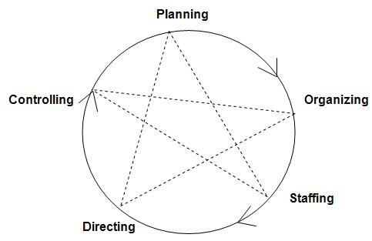Management has been described as a social process involving responsibility for economical and effective planning & regulation of operation of an enterprise in the fulfillment of given purposes. It is a dynamic process consisting of various elements and activities.There are more functions of management than the ones listed below, but these are considered the most important.

1. **Planning:** This is the core function of management because it is the foundation of the other four areas. Planning involves mapping out exactly how to achieve a specific goal. As a manager, he or she will need to map out detailed actions; **what** to do, **when** to do it and **how** it should be done. Think of it as bridging a gap for where we currently are and where we want to be.
2. **Organizing:** This function is also known to be the backbone of management. Immediately after planning, the manager needs to organize the team according to plan. This involves organizing all of the **company’s resources** to implement a course of action and determining the organizational structure of the group. And to figure out the best way to accomplish the tasks needed to reach their goals.
3. **Staffing:** The purpose of staffing is to control all recruitment and personnel needs of the organization. After management decides what they needs have, they may decide to hire more employees in a certain department. It is also responsible for training and development, promotions, transfers, and firing.
4. **Directing:** Supervision, motivation, leadership, and communication are all involved in the directing function. Management needs to be able to oversee and influence the behaviour of the staff and to achieve the company’s goals, whether that means assisting or motivating them.
5. **Controlling:** The last function of management deals with monitoring the company’s progress and ensuring that all of the other functions are operating efficiently. Since this is the last stage, there are bound to be some irregularities and complexity within the organization.

**POSDCORB:**

POSDCORB is an acronym that was first coined in a paper on ***Administrative Management Theory*** that was written for the ***Brownlow Committee*** by ***Luther Gulick***&***LyndallUrwick*** in 1937.

This essentially refers to the various steps or stages involved in a typical administrative process. POSDCORB stands for:

1. **Planning**: This essentially refers to establishing a broad sketch of the work to be completed and the procedures incorporated to implement them.
2. **Organizing**: Organizing involves formally classifying, defining and synchronizing the various sub-processes or subdivisions of the work to be done.
3. **Staffing**: This involves recruiting and selecting the right candidates for the job and facilitating their orientation and training while maintaining a favorable work environment.
4. **Directing**: This entails decision making and delegating structured instructions and orders to execute them.
5. **Coordinating**: This basically refers to orchestrating and interlinking the various components of the work.
6. **Reporting**: Reporting involves regularly updating the superior about the progress or the work related activities. The information dissemination can be through records or inspection.
7. **Budgeting**: Budgeting involves all the activities that under Auditing, Accounting, Fiscal Planning and Control.

**2.2 PRINCIPLE OF MANAGEMENT**

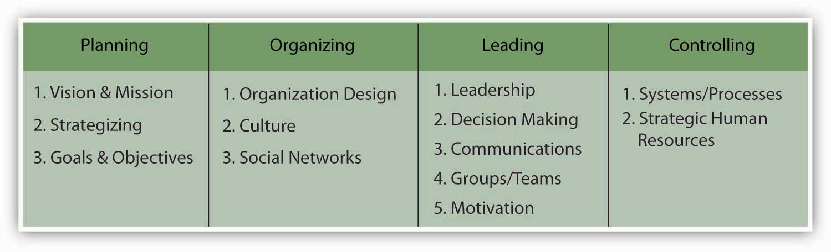Management principles are guidelines for the decisions and actions of managers.The Principles of Management are the essential, underlying factors that form the foundations of successful management.

According to ***Henri Fayol*** in his book***General and Industrial Management***(**1916**), there are fourteen **'Principles of Management'**.

1. **Division of Work:** According to this principle the whole work is divided into small tasks.The specialization of the workforce according to the skills of a person, creating specific personal and professional development within the labour force and therefore increasing productivity; leads to specialization which increases the efficiency of labour.
2. **Authority and Responsibility**: This is the issue of commands followed by responsibility for their consequences. Authority means the right of a superior to give enhances order to his subordinates; responsibility means obligation for performance.
3. **Discipline:** It is obedience, proper conduct in relation to others, respect of authority, etc. It is essential for the smooth functioning of all organizations.
4. **Unity of Command:** This principle states that each subordinate should receive orders and be accountable to one and only one superior. If an employee receives orders from more than one superior, it is likely to create confusion and conflict.
5. **Unity of Direction:** All related activities should be put under one group, there should be one plan of action for them, and they should be under the control of one manager.
6. **Subordination of Individual Interest to Mutual Interest:** The management must put aside personal considerations and put company objectives firstly. Therefore the interests of goals of the organization must prevail over the personal interests of individuals.
7. **Remuneration:** Workers must be paid sufficiently as this is a chief motivation of employees and therefore greatly influences productivity. The quantum and methods of remuneration payable should be fair, reasonable and rewarding of effort.
8. **The Degree of Centralization:** The amount of power wielded with the central management depends on company size. Centralization implies the concentration of decision making authority at the top management.
9. **Line of Authority/Scalar Chain:** This refers to the chain of superiors ranging from top management to the lowest rank. The principle suggests that there should be a clear line of authority from top to bottom linking all managers at all levels.
10. **Order:** Social order ensures the fluid operation of a company through authoritative procedure. Material order ensures safety and efficiency in the workplace. Order should be acceptable and under the rules of the company.
11. **Equity:** Employees must be treated kindly, and justice must be enacted to ensure a just workplace. Managers should be fair and impartial when dealing with employees, giving equal attention towards all employees.
12. **Stability of Tenure of Personnel:** Stability of tenure of personnel is a principle stating that in order for an organization to run smoothly, personnel (especially managerial personnel) must not frequently enter and exit the organization.
13. **Initiative:** Using the initiative of employees can add strength and new ideas to an organization. Initiative on the part of employees is a source of strength for organization because it provides new and better ideas. Employees are likely to take greater interest in the functioning of the organization.
14. **Esprit de Corps:** This refers to the need of managers to ensure and develop morale in the workplace; individually and communally. Team spirit helps develop an atmosphere of mutual trust and understanding. Team spirit helps to finish the task on time.

**2.3 TIME AND MOTION STUDY**

A time and motion study (or time-motion study) is a business efficiency technique combining the Time Study work of ***Frederick Winslow Taylor*** with the Motion Study work of ***Frank and Lillian Gilbreth (1911)***. It is a major part of scientific management (***Taylorism***). After its first introduction, time study developed in the direction of establishing standard times, while motion study evolved into a technique for improving work methods. The two techniques became integrated and refined into a widely accepted method applicable to the improvement and upgrading of work systems. This integrated approach to work system improvement is known as methods engineering and it is applied today to industrial as well as service organizations, including banks, schools and hospitals.

**MOTION STUDY:** It is a scientific way of determining the best method of doing a work with the help of a close scrutiny of the motions made by a worker or a machine.

**The best way of doing a work** is also known as **Therbligs.** Therbligs are analysis and breakdown of a task into basic elements of motion, elimination of unnecessary movements and combination of efficient and necessary movements into a standard method of work.

**TIME STUDY: It** is a direct and continuous observation of a task, using a timekeeping device (e.g., decimal minute stopwatch, computer-assisted electronic stopwatch, and videotape camera) to record the time taken to accomplish a task and it is often used when:

* there are repetitive work cycles of short to long duration,
* wide variety of dissimilar work is performed, or
* Process control elements constitute a part of the cycle.

Time study as “a work measurement technique consisting of careful time measurement of the task with a time measuring instrument, adjusted for any observed variance from normal effort or pace and to allow adequate time for such items as foreign elements, unavoidable or machine delays, rest to overcome fatigue, and personal needs”.

|  |  |  |
| --- | --- | --- |
| **Time Study vs. Motion Study** | | |
| **Basis of Comparison** | **Time Study** | **Motion Study** |
| **1. Meaning** | It involves in carrying out each element of operation | It involves the study of motions on an operation |
| **2. Purpose** | It aims at fixing the standard time for carrying out a job | Its main aim is to reduce wastage of time and materials scraping the unnecessary movements |
| **3. Technique** | It is conducted with a stop watch | It is conducted with a moving a camera |
| **4. Suitability** | Suitable for workers where quality is prime consideration | Suitable for all types of jobs |

**2.4 WORK SIMPLIFICATION**

**Work simplification**is the conscious seeking of the simplest, easiest, and quickest method of doing**work**. It is accomplishing more tasks within a given amount of time.

Some of the techniques used for motion and time studies are: the pathway chart, the process chart, the operation chart, and micro motion film analyses.

**Useful in following areas:**

1. High operating cost
2. High wastage and residual
3. More production bottlenecks
4. More rejections and rework
5. Complaints about quality
6. Complaints regarding poor conditions
7. Excessive movement of materials and workmen

**Objectives**

1. To eliminate unnecessary and inefficient motions
2. To remove repeating of efforts
3. To eliminate unnecessary fatigue and thereby effect economy in human effort
4. To improve product design and plant layout
5. To standardise work processes, working conditions, and tools or equipment’s and
6. To maximize the utilization of manpower, materials, machinery and other facilities

**2.5 PROCESS CHARTS AND FLOW DIAGRAMS**

The charting of work flows, working processes, systems and procedures is a useful way of recording the essential features of a work situation for subsequent analysis.

Process Charts are one of the simpler forms of workflow charting and are still in regular usage but are less common than they once were.

The common symbols (of which there are only **five**) were first promulgated by the ***American Society of Mechanical Engineers*** and have become known as the **ASME symbols**.

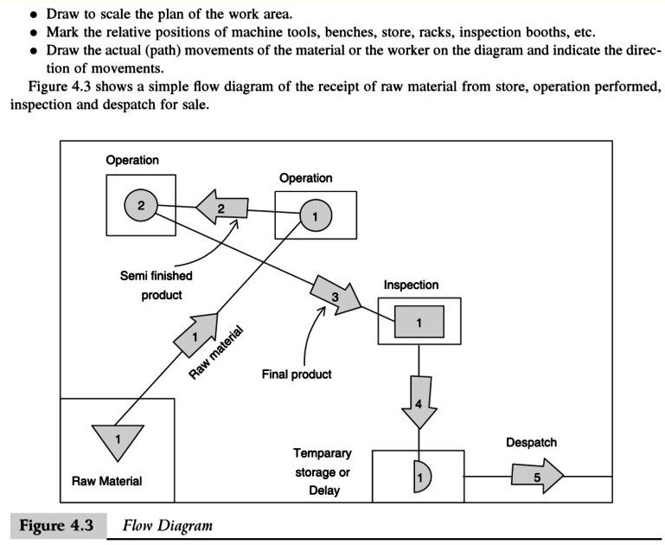**1. OPERATION:** a main step, where the part, material or product is usually modified or changed

**2. INSPECTION:**indicates a check for quality or quantity

**3. TRANSPORT:**the movement of workers, materials or equipment

**4. STORAGE:**controlled storage in which material is received into or issued from a store, or an item is retained for reference purposes

**5. DELAY or TEMPORARY STORAGE:** indicates a delay in the process, or an object laid aside until required

These symbols are simply linked together in a vertical chart representing the key stages in a process; it is usual to place a commentary in adjoining column recording contextual/ environmental information. e.g. against a Transport symbol would be recorded, start of journey, end of journey, distance and mode of transport.

The simplest form of process chart is known as an **outline process chart** and records an overview or outline of a process. Only those steps of a process that can be represented by the ASME symbols of operation and inspection are recorded.

Process charts may also be used at a more micro level of analysis. An example is the **two-handed process chart** which records the motions performed by both hands during a task. The sequence of motion of each hand is charted using the same symbols as before. There are slight changes to the meaning of the symbols, however. The delay symbol is used to indicate that the hand is waiting to carry out its next task. The storage symbol is used to indicate that the hand is holding on to a piece of material or a document. Two-handed process charts are usually drawn on a pre-formatted diagram.

**FLOW DIAGRAMS**

It is a diagrammatical representation of process chart. A flow diagram is a drawing indicating the paths of men, material or components, on a scale plan of work, area, department or factory. The path of movement can be better visualized by drawing flow diagram.

**2.6 PRODUCTION PLANNING**

Production planning is the planning of production and manufacturing modules in a company or industry. It utilizes the resource allocation of activities of employees, materials and production capacity, in order to serve different customers.

It co-ordinates supply and movement of materials and labor, ensures economic and balanced utilization of machines and equipment as well as other activities related with production to achieve the desired manufacturing results in terms of quantity, quality, time and place.

Production planning is used in companies in several different industries, including agriculture, industry, amusement industry, etc.

**Objective of Production Planning:**

* To ensure maximum utilization of all resources
* To ensure production quality products
* To minimize the product throughput time
* To maintain optimum level inventory
* To maintain flexibility in manufacturing operations

**Levels of Production Planning**

1. **Strategic Planning (Long range):** It is process of thinking though the organizations current mission and environment and setting a guide for future decisions and results e.g. Technology forecasting and choice of appropriate technology for the long range time horizon.
2. **Tactical Planning (Intermediate Range):** It is done over an intermediate term or medium range time horizon by middle level management. These plans focus on aggregate products rather than individual products.
3. **Operational Planning (Short Range):** It is done over a short range time span developed by junior level management. It is concern with utilization of existing facilities rather than creation of new facilities.

**Benefits of Production Planning:**

1. Production planning coordinates all the phases of production / Operating system.
2. An efficient plan results in higher quality,better utilization of resources, reduced inventories, and better customer services.
3. An efficient plan enables the firm to improve its sales turnover, market share and profitability.

**Limitations of Production Planning:**

1. Production planning function is based on certain assumptions or forecasts of customer’s demand, Plant capacity, availability of materials etc.
2. Employee may resist change in production levels set as per production plans.
3. This process is time consuming when we need to carry out routing and scheduling function for large products.
4. These functions become difficult when environmental factors changes rapidly.

**PROCESS /FUNCTIONS OF PRODUCTION PLANNING (and CONTROL):**

1. Planning/ Estimating
2. Routing
3. Scheduling
4. Loading
5. Dispatching
6. Follow up
7. Inspection
8. Corrective Measures

**1. PLANNING**

That may be defined as the technique of foreseeing every step in a long series of separate operations.Each step to be taken at the right time and in the right place and each operation to be performed in maximum efficiency.

**Planning Phase**

**I. Prior Planning (***Forecastin****g*):**

* Type, Quantity,Quality Product Design
* Specifications,Bill of Materials Order Writing
* To undertake a particular job.

**II. Active Planning*(****Process Planning and Routing):*

* Economic Process, How to do, Where to Work Materials and Tools Control
* Requirements, Controls Loading
* Assignment of Work, Manpower, Machinery Scheduling
* Time Phase, Sequence of Work

**III. Action Phase*(****Dispatching*):

* Ordering to start the working

**IV. Control Phase** (Progress Reporting):

* Data Reporting, Performance Comparison Corrective Phase
* Expediting, Preplanning

**2. ROUTING**

Under this operation, their path and sequence are established.The main aim of routing; determine the best and cheapest sequence of operations and to ensure that this sequence is strictly followed.Routing procedure involves following differentactivities;

* An analysis of the article to determine what tomake and what to buy
* To determine the quality and type of material
* Determining the manufacturing operations and their sequence
* An analysis of cost of the article
* Determination of scrap factors

**3. SCHEDULING**

It mainly concerns with time element and priorities of a job.The pattern of scheduling differs from one job toanother which is explained as below:

1. Production Schedule
2. Master Schedule
3. Manufacturing Schedule

**4. LOADING**

Defined as the relationship between load andcapacity, so as to assign the work for theproduction.

* **Capacity:** The time available for work at work-centers expressed in machine hours or in man hours.
* **Load:** To assign work to the capacity available at particular work-centers. It includes the assignment of the work to the operators at their machines or work places.

Loading determines; who will do the work asrouting determines; where and schedulingdetermines; when it shall be done.

**5. DISPATCHING**

Involves issue of production orders for starting theoperations.

* Movement of materials to different workstations
* Movement of tools and fixtures necessary for each operation
* Beginning of work on each operation
* Recording of time and cost involved in each operation
* Movement of work from one operation to another in accordance with the route sheet
* Inspecting or supervision of work

**6. FOLLOW UP**

It includes delays or deviations from the production plans.It helps to reveal detects in routing and scheduling, misunderstanding of orders and instruction, under loading or overloading of work.

**7. INSPECTION**

To ensure the quality of goods. It can be required as effective agency of production

**8. CORRECTIVE MEASURES**

Involve any of those activities of adjusting the route, rescheduling of work changing the workloads, repairs and maintenance of machinery or equipment, control over inventories of the cause of deviation is the poor performance of the employees

**UNIT-III**

**3.1 Inventory Control**

3.2 Inventory

3.3 Cost Deterministic Models

3.4 Introduction to Supply Chain Management

**3.1 INVENTORY**

* Inventory or stock refers to the goods and materials that a business holds for the ultimate purpose of resale (or repair).
* Inventory is the raw materials, work-in-process goods and completely finished goods that are considered to be the portion of a business's assets that are ready or will be ready for sale.
* Inventory means “ stock of goods” or “list of goods”
* Inventory can be defined as the stock of goods, commodities or other resources that are stored at any given period for future production.

|  |  |
| --- | --- |
| **Type of organization** | **Type of inventories held** |
| Manufacturer | Raw material, spare parts, semi furnished goods, furnished goods |
| Hospital | Number of beds, stock of drugs, specialized personnel |
| Bank | Cash reserves |
| Airline company | Seating capacity, spare parts, specialized maintenance crew |

**Types of Inventories**

The five common types of inventories are:

*1. Raw materials & purchased parts.*

*2. Partially completed goods called work in progress.*

*3. Finished-goods inventories:*

*a. (manufacturing firms) or*

*b. merchandise, (retail stores)*

*4. Goods-in-transit to warehouses or customers.*

*5. Replacement parts, tools, & supplies.*

**Reasons for keeping stock**

There are five basic reasons for keeping an inventory

1. **Time** - The time lags present in the supply chain, from supplier to user at every stage, requires that you maintain certain amounts of inventory to use in this lead time.
2. **Seasonal Demand**: Demands varies periodically, but producer’s capacity is fixed. This can lead to stock accumulation; consider for example how goods consumed only in holidays can lead to accumulation of large stocks on the anticipation of future consumption.
3. **Uncertainty:** Inventories are maintained as buffers to meet uncertainties in demand, supply and movements of goods.
4. **Economies of scale** - Ideal condition of "one unit at a time at a place where a user needs it, when he needs it" principle tends to incur lots of costs in terms of logistics. So bulk buying, movement and storing brings in economies of scale, thus inventory.
5. **Appreciation in Value** - In some situations, some stock gains the required value when it is kept for some time to allow it reach the desired standard for consumption, or for production.

All these stock reasons can apply to any owner or product. Also, some authors mentioned several reasons **not to keep high inventory levels**:

1. ***Obsolescence***: due to progress of technology, the bought inventory for future use may become obsolete.
2. ***Capital Investment***
3. ***Space Usage***
4. ***Complicated Inventory Control Systems***: Higher number of inventory items complicates the control and monitoring items.

**INVENTORY MANAGEMENT:**

Inventory management is a science primarily about specifying the shape and percentage of stocked goods. It is required at different locations within a facility or within many locations of a supply network to precede the regular and planned course of production and stock of materials against the random disturbance of running out of materials or goods.

**VARIOUS INVENTORY LEVELS**

The purpose behind setting of different stock levels is to ensure smooth operation of the enterprise and allocation of appropriate amount of monetary resources to different items in the inventory. A number of factors affect the determination of stock levels for different items. Some of these**determinants** are:

1. Rate of consumption
2. Lead time
3. Storage /warehousing /carrying costs
4. Insurance cost
5. Seasonal considerations
6. Price fluctuations
7. Economic Order Quantity (EOQ)
8. Quality of raw material
9. Availability of space
10. Availability of funds
11. Government and other legal and statutory requirements.

To ensure smooth running of production process, the materials department of an enterprise sets different levels for each item of inventory. These levels are:

1. *Maximum level*
2. *Minimum level*
3. *Danger or safety stock level*
4. *Reorder level*

Now let’s have a detailed discussion on each one of these.

**1. Maximum level:** This is the maximum quantity above which stock should never be held at any time. Maximum Level can be calculated as:

***Maximum Level***

***=Re-order Level + Re-order Quantity –(Minimum consumption × Minimum Re-order period)***

***= Re-order Level + Re-order Quantity -- Average Consumption × Lead Time***

**2. Minimum Level:** This is the minimum level below which an item of stock should never be allowed to fall. Minimum level is computed using the following formula:

***Minimum level = Re-order level – (Average consumption × Average reorder-period)***

**3. Danger or safety level:** Safety or reserve stock is fixed to avoid stock out conditions. Carefully fixed safety stock level helps in minimizing stock-out and carrying costs. However sometimes for preventive measures, this stock is fixed above minimum level.

Formula for calculating Danger level is:

***Danger/Safety level= Ordering Level–(Average rate of consumption × Re-order period)***

OR

***= (Maximum rate of consumption–Average rate of consumption)×Lead Time***

**4. Ordering Level:** Ordering Level is that level on reaching which, a fresh order is placed with the suppliers. Ordering level is calculated using the formula:

***Ordering Level= Minimum Level + consumption during lead period***

OR

***= Maximum consumption × Lead time + Safety stock***

OR

***= Maximum consumption × Maximum re-order period***

**INVENTORY COSTS**

The cost of holding goods in stock;expressed usually as a percentage of the inventory value, it includes capital, warehousing, depreciation, insurance, taxation, obsolescence, and shrinkage costs etc.

Inventory costs are basically categorized into three headings:

1. Purchase Cost
2. Ordering Cost
3. Carrying Cost
4. Shortage or stock out Cost

**1. Purchase Cost**

This is a nominal cost of inventory. It is the purchase price for the items that are bought from outside sources, and the production cost if the items are produced within the organisation. For a merchandiser this is the cost of merchandise purchased after deducting purchase returns, purchase allowances, and purchase discounts but after adding freight-in.

**2. Ordering Cost**

Ordering costs are the expenses incurred to create and process an order to a supplier. These costs are included in the determination of the economic order quantity for an inventory item.

Examples of ordering costs are:

1. Cost to prepare a purchase requisition
2. Cost to prepare a purchase order
3. Cost of the labor required to inspect goods when they are received
4. Cost to put away goods once they have been received
5. Cost to process the supplier invoice related to an order
6. Cost to prepare and issue a payment to the supplier

**3. Carrying Cost**

In marketing, carrying cost or carrying cost of inventory refers to the total cost of holding inventory. This includes warehousing costs such as rent, utilities and salaries, financial costs such as opportunity cost, and inventory costs related to perishability, pilferage, shrinkage and insurance.

**4. Shortage or stock out Cost**

Stock-out costs are costs associated with running out of stock

Examples of stock-out costs are:

* Lost contribution through the lost sale caused by the stock-out
* Loss of future sales as customers go elsewhere
* Loss of customer goodwill
* Cost of production stoppages caused by stock-out of work-in-progress or raw materials
* Labour frustration over stoppages
* Extra costs associated with urgent, often small quantity, replenishment purchases.

**3.2 INVENTORY CONTROL**

The goal of inventory control is to generate the maximum profit from the least amount of inventory investment without intruding upon customer satisfaction levels.Inventory Control or Stock control can be broadly defined as "the activity of checking a shop’s stock". More specifically inventory control may refer to:

* In operations management, logistics and supply chain management, the technological system and the programmed software necessary for managing inventory
* In economics and operations management, the inventory control problem, which aims to reduce overhead cost without hurting sales? It answers the 3 basic questions of any supply chain: ***When? Where? How much?***
* In the field of loss prevention, systems designed to introduce technical barriers to shoplifting

Inventory control is also about knowing where all your stock is and ensuring everything is accounted for at any given time.Modern inventory control systems often rely upon ***barcodes and radio-frequency identification (RFID)*** tags to provide automatic identification of inventory objects. Inventory objects could include any kind of physical asset: merchandise, consumables, fixed assets, circulating tools, library books, or capital equipment.

**Scope of Inventory Control:**

* Determination of Inventory Policies
* Determining Various Stock Levels
* Determining EOQ
* Determining Safety or Buffer Stock
* Determining Lead Time

**Essentials of a Good Inventory Control System:**

1. Proper co-ordination
2. Proper Classification
3. Use of Standard Forms
4. Internal Check System
5. Proper Storing System
6. Fixing of Various Stock Levels
7. Determination of EOQ
8. Regular Reporting System

**3.3 COST DETERMINISTIC MODELS**

Inventorycontrol is crucial for every company. Reducing on-hand inventory level meansreducing costs and thus increases the cash flow. On the other hand frequent stock outsmay dissatisfy the customers. Thus a company must make a balance betweenlow and high inventory levels. The major factor to be considered in achieving thisbalance is the cost minimization.

There are two fundamental decisions that we have to make when controllinginventory:

* How much to order or produce?
* When to order?

The major objective in controlling inventory is to minimize the total inventorycosts which include:

* Cost of the items (purchase cost or material cost),
* Cost of ordering,
* Cost of carrying or holding inventory and
* Cost of stock outs.

Commonly used inventory analyses are:

1. EOQ Analysis
2. ABC Analysis
3. FSN Analysis
4. VED Analysis
5. SDE Analysis
6. HML Analysis

**1. ECONOMIC ORDER QUANTITY**

The economic order quantity (EOQ) is the order quantity that minimizes total holding and ordering costs for the year. This is the basic model in achieving an optimal ordering quantity whichminimizes the total inventory costs. However there are some assumptions to beupheld:

1. Demand is known and constant.
2. The lead time, the time between the placement of order and the receipt of the order, is known and constant.
3. The receipt of inventory is instantaneous.
4. Quantity discounts are not possible.
5. The only variable costs are the ordering cost and the holding or carrying cost.
6. Orders are placed so that stock outs or shortages are avoided completely.

EOQ= $\sqrt{\frac{2DO}{CH}}$

Where D= Annual Consumption/ Demand

O= Cost of placing an order/ Ordering Cost

C= Cost Per Unit

H= Holding/ Storage/ Carrying Cost

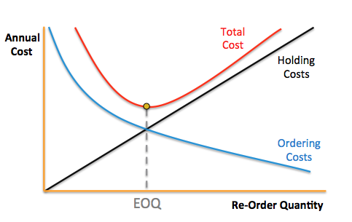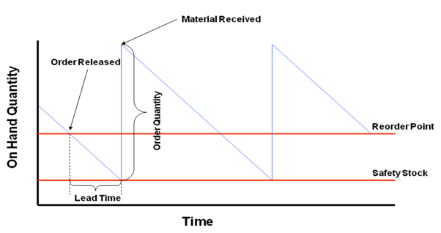

**Advantagesof EOQ**

* Constant or uniform demand: The demand or usage is even through-out the period
* Known demand or usage: Demand or usage for a given period is known i.e. deterministic
* Constant unit price: Per unit price of material does not change and is constant irrespective of the order size
* Constant Carrying Costs: The cost of carrying is a fixed percentage of the average value of inventory
* Constant ordering cost: Cost per order is constant whatever be the size of the order

**Limitations of EOQ** are:

* Only Applicable to Non-Perishable products with staple demand.
* Ignores Delivery Quantities & Discounts.
* Assumes Storage space is unlimited.
* Assumes retailer controls delivery Scheduling.

**2. ABC Analysis:-**

***Classification Based on Consumption***:

ABC analysis divides an inventory into three categories- "A items" with very tight control and accurate records, "B items" with less tightly controlled and good records, and "C items" with the simplest controls possible and minimal records.

**Pareto principle:** The significant items in a given group normally constitute a small portion of the total items in a group and the majority of the items in the total will, in aggregate, be of minor significance.

This way of classification is known as ABC classification.

* **CLASS A**: 10% of total spares contributing towards 70% of total consumption value.
* **CLASS B**: 20% of total spares which account for about 20% of total consumption value.
* **CLASS C**: 70% of total spares which account for only 10% of total consumption value.

|  |  |  |
| --- | --- | --- |
| **Distribution of ABC class** | | |
| **ABC class** | **Number of items** | **Total amount required** |
| **A** | **10%** | **70%** |
| **B** | **20%** | **20%** |
| **C** | **70%** | **10%** |
| **Total** | **100%** | **100%** |

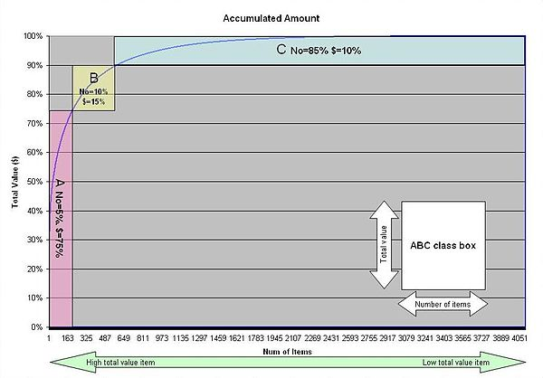

**3. FSN Analysis:**

***Classification based on Frequency of Issues/Use***:-

F, S & N stand for ***Fast-moving***, ***Slow-moving*** and ***Non-movin***g items. This form of classification identifies the items frequently issued; less frequently issued for use and the items which are not issued for longer period, say, 2 years. For instance, the items can be classified as follows:

* **Fast Moving (F)** = Items that are frequently issued say more than once a month.
* **Slow Moving (S)** = Items that are issued less than once a month.
* **Non-Moving (N)** = Items that are not issued\used for more than 2 years.

**4. SDE Analysis:-**

***Classification based on the lead time:***

This classification is carried out based on the lead time required to procure the spare part. The classification is as follows:

* **Scarce (S):** Items which are imported and those items which require more than 6 months' lead time.
* **Difficult (D):** Items which require more than a fortnight but less than 6 months' lead time.
* **Easily available (E)**: Items which are easily available i.e., less than a fortnights' lead time.

This classification helps in reducing the lead time required at least in case of vital items. Ultimately, this will reduce stock-out costs in case of stock-outs.

**5. VED Analysis:-**

***Classification Based On Criticality***:

Several factors contribute to the criticality of a spare part. If spares required for fighter aircraft at the time of war could be of great value in terms of fighting capability. In general, criticality of a spare part can be determined from the production downtime loss, due to spare being not available when required.

Based on criticality, spare parts are conventionally classified into three classes, viz. vital, essential and desirable.

* **VITAL (V)**: A spare part will be termed vital, if on account of its non-availability there will be very high loss due to production downtime and/or a very high cost will be involved if the part is procured on emergency basis. For example, bearings for a kiln in a cement plant will be considered vital.
* **ESSENTIAL (E):** A spare part will be considered essential if, due to its non-availability, moderate loss is incurred. For example, bearings for motors of auxiliary pumps will be classified as essential.
* **DESIRABLE (D):** A spare part will be desirable if the production loss is not very significant due to its non-availability. Most of the parts will fall under this category. For example, gaskets for piping connection.

**6. HML Analysis:-**

***Classification based on unit price***:

This classification is as follows:

* **High Cost (H)**: Item whose unit value is very high, say, Rs.1000/- and above.
* **Medium Cost (M):** Item whose unit value is of medium value, say, above Rs.100/- but less than Rs.1000/-.
* **Low Cost (L)**: Item whose unit value is low, say, less than Rs.100/-.

This type of analysis helps in exercising control at the shop floor level i.e., at the use point. Proper authorization should be there for replacing a high value spare. Efforts may be necessary to find out the means for prolonging the life of high value parts through reconditioning and repair. Also, it may be worthwhile to apply the techniques of value analysis to find out a less expensive substitute.

**3.4 INTRODUCTION TO SUPPLY CHAIN MANAGEMENT**

**SUPPLY CHAIN:**

A supply chain is actually a complex and dynamic supply and demand network. Supply chain activities involve the transformation of natural resources, raw materials, and components into a finished product that is delivered to the end customer.

**SUPPLY CHAIN MANAGEMENT:**

Supply chain management (SCM) is the management of the flow of goods and services. It includes the movement and storage of raw materials, work-in-process inventory, and finished goods from point of origin to point of consumption.

* The management of upstream and downstream value-added flows of materials, final goods, and related information among suppliers, company, resellers, and final consumers.
* The systematic, strategic coordination of traditional business functions and tactics across all business functions within a particular company and across businesses within the supply chain, for the purposes of improving the long-term performance of the individual companies and the supply chain as a whole.

**PROCESSES of SCM:**

The Global Supply Chain Forumidentified eight key processes that make upthe core of supply chain management:

* Customer Relationship Management
* Customer Service Management
* Demand Management
* Order Fulfillment
* Manufacturing Flow Management
* Procurement
* Product Development and Commercialization
* Returns

**Main functions of Supply Chain Management** are as follows:

1. Inventory Management
2. Distribution Management
3. Channel Management
4. Payment Management
5. Financial Management
6. Supplier Management
7. Transportation Management
8. Customer Service Management

**JUST IN TIME:**

Its origin and development in Japan, largely in the 1960s and 1970s and particularly at Toyota, Just-In-Time (JIT) is a very simple idea but one that is essential in modern supply chain management. JIT sets out to cut costs by reducing the amount of goods and materials a firm holds in stock.

Toyota motor company identifies seven wastes as being the targets of continuous improvement in production processes. By attending these wastes, improvement is achieved. They are:

1. Waste of Overproduction
2. Waste of Waiting
3. Waste of Transportation
4. Waste of Processing itself
5. Waste of Stocks
6. Waste of Motion
7. Waste of Making Defective Products

**ADVANTAGES**:

* There should be minimal amounts of inventory obsolescence,
* The very low inventory levels mean that inventory holding costs (such as warehouse space) are minimized.
* The company is investing far less cash in its inventory, since fewer inventories is needed.
* Fewer inventories can be damaged within the company,
* Production mistakes can be spotted more quickly and corrected

**KANBAN – Just in Time Production**

Kanban is derived from the combination of two Japanese words, “Kan” meaning visual and “ban” meaning card or board. Kanban is a process relating to lean and just in time production, it is a scheduling system that helps determine what to produce, when to produce and how much to produce.

**TOYOTA'S SIX RULES:**

Toyota has formulated six rules for the application of kanban:

1. Later process picks up the number of items indicated by the kanban at the earlier process.
2. Earlier process produces items in the quantity and sequence indicated by the kanban.
3. No items are made or transported without a kanban.
4. Always attach a kanban to the goods.
5. Defective products are not sent on to the subsequent process. The result is 100% defect-free goods.
6. Reducing the number of kanban increases the sensitivity.

***Traditional Manual KANBAN card***

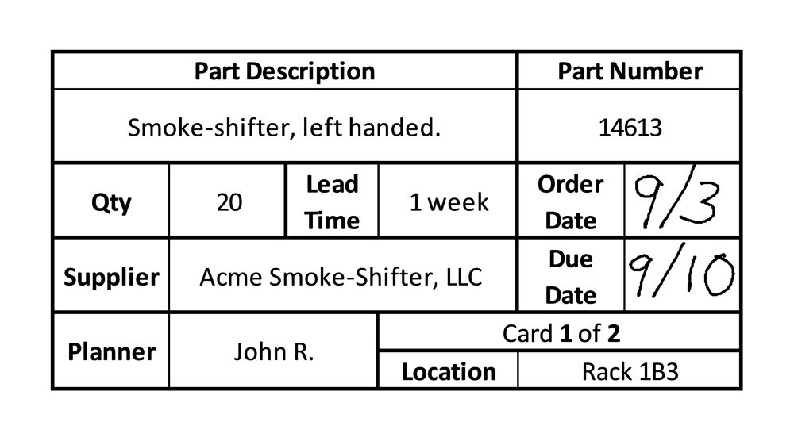

***Auto Generated KANBAN card***

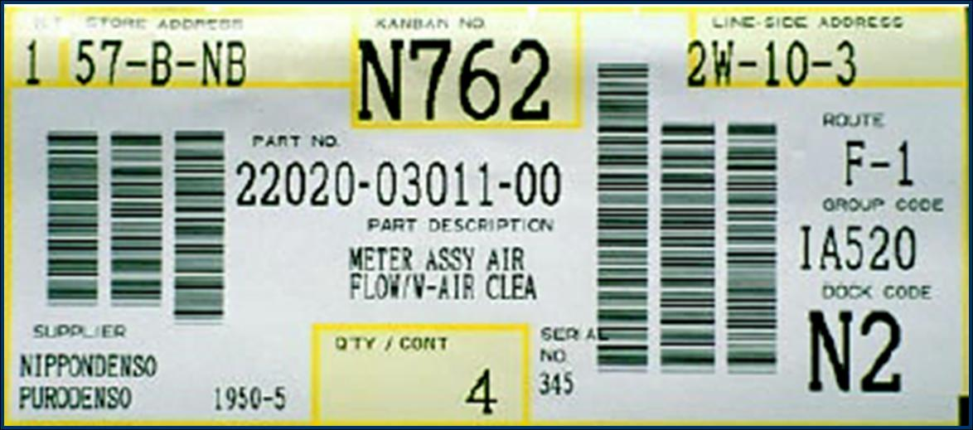

**UNIT-IV**

**4.1 Quality Control**

4.2 Process Control

4.3 SQC

4.4 Control Charts

4.5 Single, Double and Sequential Sampling

4.6 Introduction to TQM

**4.1 QUALITY CONTROL**:

**Quality:**

It may refer to the Quality of the process (i.e., men, material, and machines) and even that of management. Where is the quality of manufactured product referred as or defined as ‘‘Quality of product as the degree in which it fulfills the requirement of the customer”.It is usually determined by some characteristics namely design, size, material, chemical composition, mechanical functioning workmanship, finish and other properties. Quality characteristics can be classified as follows:

(1) Quality of design

(2) Quality of conformance with specifications

(3) Quality of performance.

**Control**

The process through which the standards are established and met with standardsis called control. This process consists of observing our activity performance, comparingthe performance with some standard and then taking action if the observed performanceis significantly too different from the standards.

The control process involves a universal sequence of steps as follows:

(1) Choose the control subject.

(2) Choose a unit of measure.

(3) Set a standard value i.e., specify the quality characteristics

(4) Choose a sensing device which can measure.

(5) Measure actual performance.

(6) Interpret the difference between actual and standard.

(7) Taking action, if any, on the difference.

**QUALITY CONTROL**

Quality control can be defined as that Industrial Management technique by meansof which product of uniform acceptable quality is manufactured.

**Factors Affecting Quality**

(1) Men, Materials and Machines

(2) Manufacturing conditions

(3) Market research in demand of purchases

(4) Money in capability to invest

(5) Management policy for quality level

(6) Production methods and product design

(7) Packing and transportation

(8) After sales service

**Objectives of Quality Control**

(1) To decide about the standard of Quality of a product that is easily acceptable to thecustomer.

(2) To check the variation during manufacturing.

(3) To prevent the poor quality products reaching to customer.

**4.2 PROCESS CONTROL**

Process control is an engineering discipline that deals with architectures, mechanisms and algorithms for maintaining the output of a specific process within a desired range. For instance, the temperature of a chemical reactor may be controlled to maintain a consistent product output.

Process control may either use feedback or it may be open loop. Control may also be continuous (automobile cruise control) or cause a sequence of discrete events, such as a timer on a lawn sprinkler (on/off) or controls on an elevator (logical sequence).

**Types of processes using process control**

Processes can be characterized as one or more of the following forms:

1. **Discrete –** Found in many manufacturing, motion and packaging applications. Robotic assembly, such as that found in automotive production, can be characterized as discrete process control. Most discrete manufacturing involves the production of discrete pieces of product, such as metal stamping.
2. **Batch** – Some applications require that specific quantities of raw materials be combined in specific ways for particular durations to produce an intermediate or end result. Batch processes are generally used to produce a relatively low to intermediate quantity of product per year (a few pounds to millions of pounds).
3. **Continuous** – Often, a physical system is represented through variables that are smooth and uninterrupted in time. The control of the water temperature in a heating jacket, for example, is an example of continuous process control. Some important continuous processes are the production of fuels, chemicals and plastics.

**4.3STATISTICAL QUALITY CONTROL(SQC)**

A Quality control system performs inspection, testing and analysis to concludewhether the quality of each product is as per laid quality standard or not. It’s called‘‘Statistical Quality Control’’ when statistical techniques are employed to control quality orto solve quality control problem. SQC makes inspection more reliable and at the sametime less costly. It controls the quality levels of the outgoing products.

SQC should be viewed as a kit of tools which may influence related to the functionof specification, production or inspection.

A successful SQC programme is expected to yield the following results:

1. Improvement of quality.
2. Reduction of scrap and rework.
3. Efficient use of men and machines.
4. Economy in use of materials.
5. Removing production bottle-necks.
6. Decreased inspection costs.
7. Reduction in cost/unit.
8. Scientific evaluation of tolerance.
9. Scientific evaluation of quality and production.
10. Quality consciousness at all levels.
11. Reduction in customer complaints.

**TOOLS OF SQC**

The principle tools of SQC are as follows:

1. Frequency distribution.
2. Control charts for measurement and attribute data.
3. Acceptance sampling techniques.
4. Regression and correlation analysis.
5. Tests of significance.
6. Design of experiments.

|  |  |  |
| --- | --- | --- |
| **Terminology** | **Approximate year of first use** | **Description** |
| Statistical quality control  (SQC) | 1930s | The application of statistical methods (specificallycontrol chartsandacceptance sampling) to quality control. |
| Total quality control (TQC) | 1956 | Popularized byArmand V. Feigenbaumin aHarvard Business Reviewarticleand book of the same name.Stresses involvement of departments in addition to production (e.g., accounting, design, finance, human resources, marketing, purchasing, sales). |
| Statistical process control(SPC) | 1960s | The use ofcontrol chartsto monitor an individual industrial process and feedback performance to the operators responsible for that process. Inspired bycontrol systems. |
| Total Quality Management(TQM) | 1985 | Quality movement originating in theUnited States Department of Defensethat uses (in part) the techniques of statistical quality control to drive continuous organizational improvement. |
| Six Sigma(6σ) | 1986 | Statistical quality control applied to business strategy.Originated byMotorola. |

**4.4 CONTROL CHARTS**

If a single quality characteristic has been measured or computed from a sample, the control chart shows the value of the quality characteristic versus the sample number or versus time. In general, the chart contains a center line that represents the mean value for the in-control process. Two other horizontal lines, called the upper control limit (UCL) and the lower control limit (LCL), are also shown on the chart. These control limits are chosen so that almost all of the data points will fall within these limits as long as the process remains in-control. The figure below illustrates this.

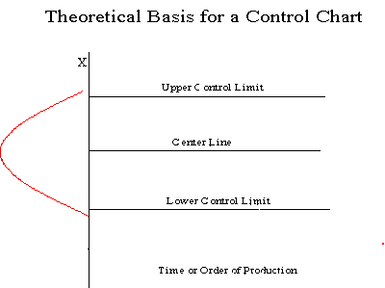

**TYPES OF DATA**

**1. Variable Data**

* Product characteristic that can be measured
* Length, size, weight, height, time, velocity

**2. Attribute Data**

* Product characteristic evaluated with a discrete choice
* Good/bad, yes/no, Colour, Look, Appearance.

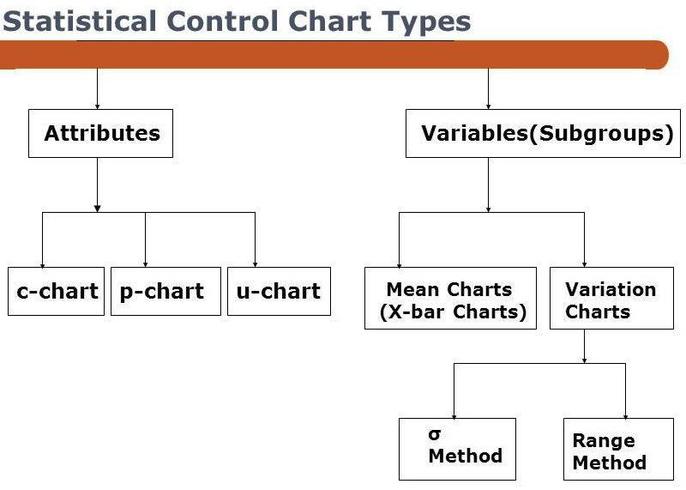

**Control Charts for VARIABLES**

***Mean chart ( X-Chart)***–Measures central tendency of a sample

***Range chart (R-Chart)***–Measures amount of dispersion in a sample

Each chart measures the process differently. Both theprocess average and process variability must be in controlfor the process to be in control.**Constructing a Control Chart for Variables**

1. Define the problem
2. Select the quality characteristics to be measured
3. Choose a rational subgroup size to be sampled
4. Collect the data
5. Determine the trial centerline for the X-chart
6. Determine the trial control limits for the X-chart
7. Determine the trial control limits for the R chart
8. Examine the process: control chart interpretation
9. Revise the charts
10. Achieve the purpose

**ATTRIBUTES DATA**

Data that can be classified into one of several categories or classifications is known asattribute data.

Classifications such as conforming and nonconforming are commonly used in qualitycontrol.

**Types of attributes control chart**:

**1. Control chart of fraction (*p*-chart)**

This chart shows the fraction of nonconforming or defective product produced by amanufacturing process.It is also called the control chart for fraction nonconforming. In this chart each item is classified as good (non-defective) or bad (defective). This chart is used to control the general quality of the component parts. In this chart

Central line**= $\overline{p}= \frac{Total number of pieces found defective}{Total number of pieces inspected}$ = $\frac{Σd}{K}$**

Where d= defective pieces

K= sample size

Upper control limit (UCL) is given by

**UCL= $\overline{p}+$ 3 $\sqrt{\frac{\overline{p} (1-\overline{p})}{K}}$**

The lower control limit (LCL) is given by

**LCL= $\overline{p}-$ 3 $\sqrt{\frac{\overline{p} (1-\overline{p})}{K}}$**

**2. Control chart of defective items (*np*-chart)**

This chart shows the number of nonconforming. Almost the same as the p chart.

$n\overline{p}= \frac{Total number of defective items in all samples}{Total number of samples inspected}$**= $\frac{Σd}{nK}$**

**= $\frac{Total no. of defects}{Total number of samples × Sample Size}$**

Where d= defective pieces

n= no. of samples

K= sample size

**UCL= $n\overline{p}+3\sqrt{n\overline{p} (1-\overline{p})}$**

**LCL= $n\overline{p}-3\sqrt{n\overline{p} (1-\overline{p})}$**

**3. Control chart of number of defects per unit (*C-*chart):**

This shows the number of defects or nonconformities produced by a manufacturing process. In this control chart numbers of defects in a place or a sample are plotted. It control number of defects observed per unit or per sample. In *C*-chart, sample size is constant.

This chart is used where average numbers of defects are much less than the number of defects which would occur.

**Central line = $C= \frac{Total defects in all items inspected}{Total number of items inspected}$**

**UCL= $\overline{C}+3\sqrt{\overline{C}}$**

**LCL = $\overline{C}-3\sqrt{\overline{C}}$**

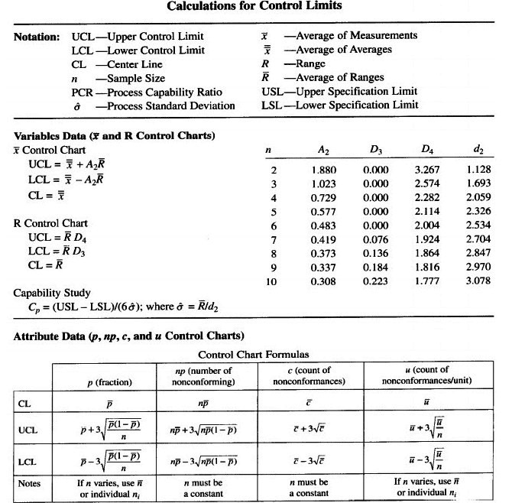

**4.5 SINGLE, DOUBLE AND SEQUENTIALSAMPLING**

**SAMPLING PLAN**

Sampling plan is detailed outline of measurements to be taken. A sampling plan is a detailed outline of which measurements will be taken at what times, on which material, in what manner, and by whom.

The decision, based on counting the number of defectives in a sample, can be to accept the lot, reject the lot, or even, for multiple or sequential sampling schemes, to take another sample and then repeat the decision process.

**1. SINGLE SAMPLING PLANS**: One sample of items is selected at random from a lot and the disposition of the lot is determined from the resulting information. These plans are usually denoted as (n,c) plans for a sample size n, where the lot is rejected if there are more than c defectives. These are the most common (and easiest) plans to use although not the most efficient in terms of average number of samples needed.

**2. DOUBLE SAMPLING PLANS**: After the first sample is tested, there are three possibilities:

* Accept the lot
* Reject the lot
* No decision

If the outcome is (**3)**, and a second sample is taken, the procedure is to combine the results of both samples and make a final decision based on that information.

Double and multiple sampling plans were invented to give a questionable lot another chance. For example, if in double sampling the results of the first sample are not conclusive with regard to accepting or rejecting, a second sample is taken. Application of double sampling requires that a first sample of size **n1** is taken at random from the (large) lot. The number of defectives is then counted and compared to the first sample's acceptance number **a1** and rejection number **r1**. Denote the number of defectives in sample 1 by **d1** and in sample 2 by **d2**, then:

If **d1≤a1**, the lot is accepted.

If **d1≥r1**, the lot is rejected.

If **a1<d1<r1**, a second sample is taken.

If a second sample of size **n2** is taken, the number of defectives, **d2**, is counted. The total number of defectives is **D2=d1+d2**. Now this is compared to the acceptance number **a2** and the rejection number **r2** of sample 2. In double sampling, **r2=a2+1** to ensure a decision on the sample.

If **D2≤a2**, the lot is accepted.

If **D2≥r2**, the lot is rejected.

**3. MULTIPLE SAMPLING PLANS**: This is an extension of the double sampling plans where more than two samples are needed to reach a conclusion. The advantage of multiple sampling is smaller sample sizes.

**4. SEQUENTIAL SAMPLING PLANS**: This is the ultimate extension of multiple sampling where items are selected from a lot one at a time and after inspection of each item a decision is made to accept or reject the lot or select another unit.

Sequential sampling is different from single, double or multiple sampling. Here one takes a sequence of samples from a lot. How many total samples looked at is a function of the results of the sampling process.

**Item-by-item and group sequential sampling:** The sequence can be one sample at a time, and then the sampling process is usually called item-by-item sequential sampling. One can also select sample sizes greater than one, in which case the process is referred to as group sequential sampling. Item-by-item is more popular so we concentrate on it.

**4.6 INTRODUCTION TO TOTAL QUALITY MANAGEMENT (TQM):**

The simple objective of TQM is “Do the right things, right the first time, every time.” TQM is infinitely variable and adaptable. Although originally applied to manufacturing operations, and for a number of years only used in that area, TQM is now becoming recognized as a generic management tool, just as applicable in service and public sector organizations. There are a number of evolutionary strands, with different sectors creating their own versions from the common ancestor. TQM is the foundation for activities, which include:

* Commitment by senior management and all employees
* Meeting customer requirements
* Reducing development cycle times
* Just in time/demand flow manufacturing
* Improvement teams
* Reducing product and service costs
* Systems to facilitate improvement
* Line management ownership
* Employee involvement and empowerment
* Recognition and celebration
* Challenging quantified goals and benchmarking
* Focus on processes / improvement plans
* Specific incorporation in strategic planning

This shows that TQM must be practiced in all activities, by all personnel, in manufacturing, marketing, engineering, R&D, sales, purchasing, HR, etc.

**Some other definitions of TQM:**

"TQM is both a philosophy and a set of guiding principles that represent the foundation for a continuously improving organization. TQM is the application of quantitative methods and human resources to improve the product and services supplied to an organization, and the degree to which the needs of the customers are met, now and in the future. TQM integrates fundamental management techniques, existing improvement efforts, and technical tools under a disciplined approach focused on continuous improvement.”

**Seven Important Principles of Total Quality Management**

**1. Quality can and must be managed**

Many companies have wallowed in a repetitive cycle of chaos and customer complaints. They believe that their operations are simply too large to effectively manage the level of quality. The first step in the TQM process, then, is to realize there is a problem and that it can be controlled.

**2. Processes, not people, are the problem**

If your process is causing problems, it won’t matter how many times you hire new employees or how many training sessions you put them through. Correct the process and then train your people on these new procedures.

**3. Don’t treat symptoms, look for the cure**

If you just patch over the underlying problems in the process, you will never be able to fully reach your potential. If, for example, your shipping department is falling behind, you may find that it is because of holdups in manufacturing. Go for the source to correct the problem.

**4. Every employee is responsible for quality**

Everyone in the company, from the workers on the line to the upper management, must realize that they have an important part to play in ensuring high levels of quality in their products and services. Everyone has a customer to delight, and they must all step up and take responsibility for them.

**5. Quality must be measurable**

A quality management system is only effective when you can quantify the results. You need to see how the process is implemented and if it is having the desired effect. This will help you set your goals for the future and ensure that every department is working toward the same result.

**6. Quality improvements must be continuous**

Total Quality Management is not something that can be done once and then forgotten. It’s not a management “phase” that will end after a problem has been corrected. Real improvements must occur frequently and continually in order to increase customer satisfaction and loyalty.

**7. Quality is a long-term investment**

Quality management is not a quick fix. You can purchase QMS software that will help you get things started, but you should understand that real results won’t occur immediately. TQM is a long-term investment, and it is designed to help you find long-term success.

**SIX SIGMA (6σ)**

Six Sigma is a set of techniques and tools for process improvement. It was introduced by engineer Bill Smith while working at Motorola in 1986.Today, it is used in many industrial sectors.

Six Sigma seeks to improve the quality of the output of a process by identifying and removing the causes of defects and minimizing variability in manufacturing and business processes. It uses a set of quality management methods, mainly empirical, statistical methods, and creates a special infrastructure of people within the organization, who are experts in these methods. Each Six Sigma project carried out within an organization follows a defined sequence of steps and has specific value targets, for example: reduce process cycle time, reduce pollution, reduce costs, increase customer satisfaction, and increase profits.

Six Sigma is a disciplined, data-driven approach and methodology for eliminating defects (driving toward six standard deviations between the mean and the nearest specification limit) in any process from manufacturing to transactional and from product to service.

|  |  |  |  |  |  |  |
| --- | --- | --- | --- | --- | --- | --- |
| **Sigma level** | **Sigma (with 1.5σ shift)** | **DPMO** | **Percent defective** | **Percentage yield** | **Short-term Cpk** | **Long-term Cpk** |
| 1 | −0.5 | 691,462 | 69% | 31% | 0.33 | −0.17 |
| 2 | 0.5 | 308,538 | 31% | 69% | 0.67 | 0.17 |
| 3 | 1.5 | 66,807 | 6.7% | 93.3% | 1.00 | 0.5 |
| 4 | 2.5 | 6,210 | 0.62% | 99.38% | 1.33 | 0.83 |
| 5 | 3.5 | 233 | 0.023% | 99.977% | 1.67 | 1.17 |
| **6** | **4.5** | **3.4** | **0.00034%** | **99.99966%** | **2.00** | **1.5** |
| 7 | 5.5 | 0.019 | 0.0000019% | 99.9999981% | 2.33 | 1.83 |

***DPMO = Defective Parts Per Million Opportunities***

**BENCHMARKING**

Benchmarking is the process of comparing one's business processes and performance metrics to industry bests and best practices from other companies. Dimensions typically measured are quality, time and cost. In the process of best practice benchmarking, management identifies the best firms in their industry, or in another industry where similar processes exist, and compares the results and processes of those studied (the "targets") to one's own results and processes. In this way, they learn how well the targets perform and, more importantly, the business processes that explain why these firms are successful.

Benchmarking is used to measure performance using a specific indicator (cost per unit of measure, productivity per unit of measure, cycle time of x per unit of measure or defects per unit of measure) resulting in a metric of performance that is then compared to others.

