INDUSTRIAL PSYCHOLOGY: UNIT-4
PERFORMANCE MANAGEMENT

INTRODUCTION

The ultimate goal of any organization is to make profit with taking care of society or nation. And for this reason organization make sure that their employees work hard with perfection for attaining that particular goal. For making employees more productive organization review the performance of their employees and make recommendation for better result. Performance management is the assessment of an employee’s effectiveness, usually as undertaken at regular intervals of time for analyzing their work and help in making their bright future. Performance management/appraisal is supposed to be an ongoing process throughout the year. If you as a manager really want your company and your employees to benefit the most from their appraisal, then you have to have regular meetings throughout the year. Those meetings are intended to discuss the employees’ performance, achievements, plusses and minuses. In this chapter, we discuss the objectives, process of performance appraisal and different methods of performance appraisal which are suitable of organization.

CONCEPT AND MEANING

Performance management is the process of obtaining, analyzing and recording information about the relative worth of an employee. The focal point of the performance appraisal is measuring and improving the actual performance of the employee and also the future potential of the employee.
According to Flippo, “Performance appraisal is the systematic, periodic and an impartial rating of an employee’s excellence in the matters pertaining to his present job and his potential for a better job.” Performance appraisal is a systematic way of reviewing and assessing the performance of an employee during a particular period of time and planning for his future.
Scoot, Clothier and Spriegel have defined merit rating or performance appraisal as the process of evaluating the employee’s performance on the job in terms of requirement of the job.
Performance appraisal is a systematic review of a person’s work and achievements over a recent period, usually leading to plans for the future.

OBJECTIVES OF PERFORMANCE MANAGEMENT

- It facilitates the relationship and communication between management and employees.
- To assess the performance of the employees over a given period of time.
- To give feedback to the employees about their past performance.
- To find out that any gap between the actual and the desired performance of the employees.
- Provide clarity of the expectations and responsibilities of the functions to be performed by the employees.
- To analyze the strengths and weaknesses of the employees so as to identify the training and development needs of the future.
- To plan career development, human resource planning based on potentialities.
- Performance appraisal can help in development of scientific basis for reward allocation, wage fixation, incentives etc.
- To reduce the grievances of the employees.

PROCESS OF RERFORMANCE MANAGEMENT

It is an ongoing process where organization review their employees performance in a particular period of time mainly once in a year. check their performance and suggest them how to improve their performance against set standards. performance appraisal process consists of six steps, first is, setting standards which are the base of the performance appraisal or simply say that performance will be judged on that standards. the standards set should be clear, easily understandable and in measurable terms for both appraiser and for appraisee. in case the performance of the employee cannot be measured, great care should be taken to describe the standards.
second, after setting standard now its time to communicate these standards to both appraiser and appraisee. for appraiser it is important because for fulfilling that standards which type of method is used, how the plan is executed, what are the constraint, all these question will be solved easily. for appraisee, they know at what parameter they are going to judge. this will help them to understand their roles and to know what exactly is expected from them. the advantage of this step is, if any modification is recommended by either appraiser or appraisee which is feasible, considered.

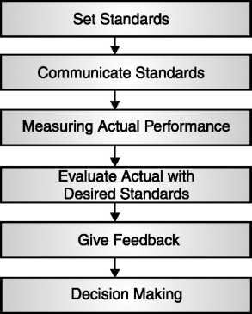

Process of Performance Management

Third step, It is a continuous process which involves monitoring the performance throughout the year. This stage requires the cautious while selection of the appropriate method of measurement, taking care that personal bias does not affect the result of the process and providing assistance rather than interfering in an employees work.
Evaluating actual performance with the desired performance standards is the fourth step in performance appraisal process. The comparison tells the deviations in the performance of the employees if any, from the standards set.
At the next Step, whatever the result getting from comparing actual with desired performance is communicating to the respective employee and supervisor. The focus of this discussion is on communication and listening. The results, the problems and the possible solutions are discussed with the aim of problem solving and reaching consensus. The feedback should be given with a positive attitude as this can have an effect on the employees’ future performance. The purpose of the meeting should be to solve the problems faced and motivate the employees to perform better.
The final step is decision-making. Whatever the outcomes from appraisal process should be considered while making organizational plan. Decision related to promotion, rewards, incentives, bonus, transfer, demotion etc. are taken at this step.

APPROACHES TO PERFORMANCE DEVELOPMENT

TRADITIONAL APPROACH

- This approach was a past oriented approach which focussed only on the past performance of the employees during a past specified period of time.
- This approach did not consider the developmental aspects of the employee performance like his training and development needs or career developmental possibilities.
- The primary concern of the traditional approach is to judge the performance of the organization as a whole by the past performances of its employees.

MODERN APPROACH

- The modern approach to performance appraisals includes a feedback process that helps to strengthen the relationships between superiors and subordinates and improve communication throughout the organization.

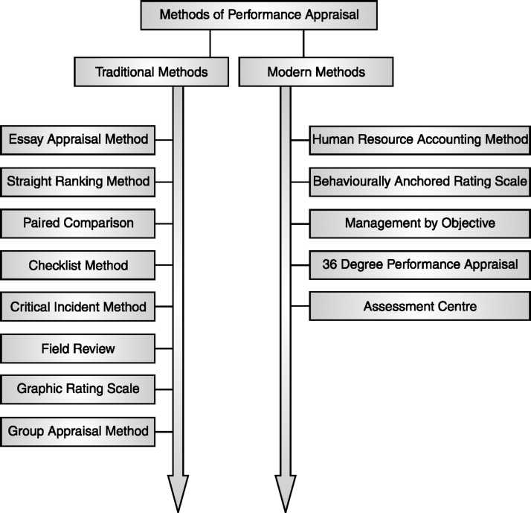
- Appraisals have become ongoing and periodic activity in the organizations.The results of performance appraisals are used to take various other HR decisions like promotions, demotions, transfers, training and development, reward outcomes.

METHODS OF PERFORMANCE MANAGEMENT

TRADITIONAL METHODS

- Essay Appraisal Method: It is also known as “free essay method”. Under this method immediate supervisor is playing a role of appraiser and he appraises their subordinates on their past performance. Supervisor writes feedback in their own hand writing. The description is always as realistic and actual as possible. It is easy and can be done without any adequate preparation is the benefit of this method. A major drawback of the method is the inseparability of the bias of the evaluator.
- Straight Ranking Method: In this method an appraiser appraise the appraisee on their whole contribution in the organization. They rank employees from the best to the poorest. It is one of the oldest and simplest methods of performance appraisal. This is the simplest method of differentiate efficient from least efficient and quite easy to develop and apply. But the limitation of this method is to become difficult when the large number of employees should be ranked and this method tells employee relation to the others in a group but it does not identify how much better or worse he/she is than other.
- Paired Comparison: This method is overcome the limitation of straight ranking method. Under this, individual is compared on the basis of every trait with other individuals in their group. After all the comparisons on the basis of the overall comparisons, the employees are given the final rankings. From this method judgements become easier and simple than other ordinary ranking method. This method is not applicable where the number of individuals is large.
- Checklist Method: The appraiser is given a checklist of the descriptions of the behaviour of the employees on job. The checklist contains a list of statements on the basis of which the appraiser describes on the job performance of the employees. And the final rating is done by the personnel department. The major drawback of this method is personal bias on the part of the appraiser and also it is difficult to develop checklist for different classes of job.
- Critical Incident Method: The employee performance would be checked on certain events that occur in the performance of the ratee’s job. The assessor rates the employee on the basis of critical events and how the employee behaved during those incidents. The supervisor keeps a written record of the events that can be recalled and used easily. Limitation of this method is, unfavourable incidents are generally more noticeable, and may supervisor forget to record the concerned employee behaviour.
- Field Review: Under this method, a training officer basically appointed by or even from HR department discusses and interviews the supervisor about how they appraise them respective subordinates. The supervisor is required to give his view about the level of performance, progress, weakness, ability, promotability and others of respective employee. This method reduces the supervisor biasing.
- Graphic Rating Scale: In this method, an employee’s quality and quantity of work is assessed in a graphic scale indicating different degrees of a particular trait. The factors taken into consideration include both the personal characteristics (like leadership, co-cooperativeness, loyalty, devotion, attitude, creative ability, initiative etc.) and characteristics related to the on-the-job performance (like responsibility, attendance, quality of work, etc.) of the employees. For example a trait like Job Knowledge may be judged on the range of unsatisfactory, average, above average, outstanding.
- Group Appraisal Method: As a name suggest, the appraisal should be done by the group of assessors. Which consist of their supervisor and few other supervisors who have some knowledge of respective subordinate performance. The immediate supervisor explains to the other assessors of the group the nature of his subordinates duties and responsibilities. The group then evaluates subordinate actual performance with the standards. If any deviations exist they suggest for future improvement. It is simple and very useful methods which remove any biasing but it is very time consuming.

MODERN METHODS

- Human Resource Accounting Method: Human resources are valuable assets for every organization. Human resource accounting method tries to find the relative worth of these assets in the terms of money. In this method the Performance appraisal of the employees is judged in terms of cost and contribution of the employees. The cost of employees include all the expenses incurred on them like their compensation, recruitment and selection costs, induction and training costs etc. whereas their contribution includes the total value added (in monetary terms). The difference between the cost and the contribution will be the performance of the employees. Ideally, the contribution of the employees should be greater than the cost incurred on them.
- Behaviourally Anchored Rating Scales (BARS): Under this method firstly critical incidents was set up which is based on some job performance qualities like inter-personal relationship, co-operation, reliability etc. than appraisal should be done on these critical incidents and evaluate on the graphical rating scale. Basically BARS is a relatively new technique which combines the graphic rating scale and critical incidents method. In this method, an employee’s actual job behaviour is judged against the desired behaviour by recording and comparing the behaviour with BARS. Developing and practicing BARS requires expert knowledge.
- Management By Objectives (MBO): The concept of ‘Management by Objectives’ (MBO) was first given by Peter Drucker in 1954. It can be defined as a process whereby the employees and the superiors come together to identify common goals, the employees set their goals to be achieved, the standards to be taken as the criteria for measurement of their performance and contribution and deciding the course of action to be followed. Management by objectives (MBO) is a systematic and organized approach that allows management to focus on achievable goals and to attain the best possible results from available resources.
MBO also described as “a process whereby the superior and subordinate managers of an organization jointly identify its common goals, define each individual’s major areas of responsibility in term as of result expected of him and use these measures as guides for operating the unit and assessing the contributions of each its members”. The main objective of MBO is to participative goal setting, alternatives course of action and decision-making. The performance will be measured on the basis of set standards. The subordinates have been involved with the goal setting and the choosing the course of action to be followed by them, so they are more likely to fulfill their responsibilities. And it also makes sure that everybody within the organization has a clear understanding of the aims, or objectives, of that organization, as well as awareness of their own roles and responsibilities in achieving those aims.
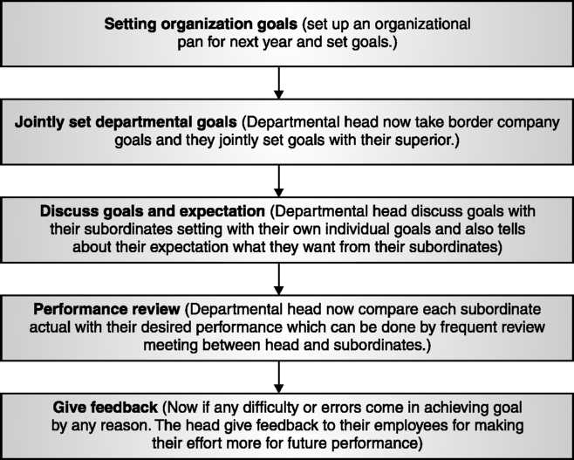
MBO Process

- 360 degree Performance Appraisal System: It was developed by the GE Company, USA in 1992. 360° feedback, also known as ‘multirater feedback’, is the most comprehensive appraisal where the feedback about the employees’ performance comes from all the sources that come in contact with the employee on his job. It may be their peers, superior, subordinates, team members, customers, suppliers/ vendors—anyone who comes into contact with the employee and can provide valuable insights and information or feedback regarding the “on-the-job” performance of the employee.

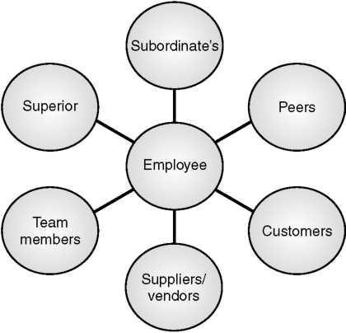

360 Degree Performance Appraisal
360° appraisal has four important elements—self appraisal, superior’s appraisal, subordinate’s appraisal and peer appraisal. (i) Self appraisal gives a chance to the employee to look at his/her strengths and weaknesses, his achievements, and judge his own performance. (ii) Superior’s appraisal forms the traditional part of the 360 degree appraisal where the employees’ responsibilities and actual performance is rated by the superior.
- Subordinates appraisal gives a chance to judge the employee on the parameters like communication and motivating abilities, superior’s ability to delegate the work, leadership qualities etc. (iv) Peers can help to find employees’ abilities to work in a team, co-operation and sensitivity towards others. It is also known as internal customer.
- Assessment Centre: The basis of this method is to test candidate in a social situation, with the group of assessors and with the variety of procedure. Assessment centres simulate the employee’s on-the-job environment and facilitate the assessment of their on-the-job performance. Usually, employees are given an assignment similar to the job they would be expected to perform if promoted. The trained evaluators observe and evaluate employees as they perform the assigned jobs and are evaluated on job related characteristics. The assessment is generally done with the help of paper-pencil test, interview, business games, psychometric tests and simulation exercise.

TRAINING AND DEVELOPMENT

INTRODUCTION

Training and development of workers is the crucial task for management. If workers not get proper training about the handling of tools and heavy machinery they not even harm that particular machinery but also themselves which is more valuable for organization. They train and develop their workers by the various means by giving simply demonstration or typically simulator or any other means. In present scenario it becomes more important because of introduction of new technologies. If they not cope with the latest technology than it will resultant into low production. From the workers psychological point of view if they are not getting the proper training and development from their concern according to the need of the worker and requirement of the employer than it will lead dissatisfaction. And it is also required that company must have a systematic programme, otherwise workers will try to lean the job by trial and error which may prove very costly for employers. In this chapter we discuss the training and development in detail like their definitions, objectives, methods, process and their effectiveness.

CONCEPT AND MEANING

Training is a learning process that involves the attainment of knowledge, sharpening of skills, concepts, rules, or changing of attitudes and behaviours to enhance the performance of workers. These are the activities which basically aim at providing the skills, knowledge and aptitudes necessary for employment in a particular occupation (or a group of related occupations) in any field of economic activity.
According to Flippo, “Training is the act of increasing the knowledge and skills of an employee for doing a particular job.”
According to Harris, “Training achieves the objectives of redirection or improvement of behaviour so that the performance of the trainees becomes more useful and productive for himself and for the organization of which he is a part.”
According to Blum & Naylor, “training is a process that develops and improves skills related performance. Effective training programme can result in increased production, reduced labour turnover and greater employee satisfaction.”
Training is a process by which a worker learns some new technical or psychological skill. Training leads to improve the performance of the existing workers and prepares them to perform higher specialized and more advance jobs in future.
Training is a process of learning a sequence of programmed behaviour and development cover those activities which improve job performance but also those which bring about overall growth of the personality.3 Development is broader, more encompassing function than training.
Development is the process of enhancing skills, abilities, knowledge and capacities of the individual of the company. Development not only includes improvement in job performance, it is also including individual growth in the organization. Development aims at making workers not only good performers but also better human being.
Development is an educational process utilizing a systematic and organized procedure by which managerial personnel learn conceptual and theoretical knowledge for general purpose. According to Flippo, “Management development process enables managers and executives to not only acquire skills and competencies but also develop future managerial abilities.”

BASIC PURPOSES OF TRAINING

The basic purpose or objective of training is to increase productivity.
By providing the training to the workers, organizations would improve the quality of work. It helps in creating skill inventory by which a company fulfils its future personnel needs. To improve organization climate which help in to creating and maintaining congenial working environment.
To improve health and safety of the workers as well as working conditions.
Training helps the workers to prevent against accident.
Last but not the least the one of the most important purpose of training is to improve the personal growth of the workers.

BASIC PURPOSES OF DEVELOPMENT

Improvement in supervision, command, direction and control at each level.
To create an understanding of the methods and problems of management.
To develop managers to perform better on their present assignments.
To prepare them for higher assignments.
To help them grow fast.
To create conditions and a climate which contribute to the growth process.
Inspiring junior executives to do better work.

Difference between Training and Development
Both terms are used for similar activity i.e. to improve the performance of workers by any means whether it is by giving the knowledge about the new skill or enhance their own capability for task performance. But there is a difference between the training and development.

Training | Development
Training is designed for non-managers as well as managers. | It involves only managerial personnel.
It is a short term process. | Long term in nature.
Managerial personnel learn technical knowledge and skills. | Managerial personnel learn conceptual and theoretical knowledge.
The objectives of training are specific job-related purpose. | The objectives have broader overview and consider general knowledge.
Training is concerned with the immediate improvement of the employee, i.e. the ways to make the employee more effective in his current role. | Development is a process to make the employee efficient enough to handle critical situations in the future, i.e. how well he can equip himself for the future demands.
Training means learning new things and refreshing old one. | Development means implementing the learned session and finding new ones.

IMPORTANCE OF TRAINING AND DEVELOPMENT

- Optimum Utilization of Workforce: Training and Development helps in optimizing the utilization of workforce that further helps the workers to achieve the organizational goals as well as their individual goals.
- Healthy Work-environment: Training and development helps in creating the healthy working environment. It helps to build good relationship among the workers and supervisors so that individual goals align with organizational goal.
- Productivity and Profitability: Training and development helps in increasing the productivity of the workers as well as the organization. It also leads to improved profitability and more positive attitudes towards profit orientation.
- Team Spirit: Training and development helps in inculcating the sense of team work, team spirit, and inter-team co-ordination. It helps in inculcating the enthusiasm to learn within the workers.
- Quality: Training and development helps in improving the quality of work and work-life.
- Development of Skills of Workers: Training and development helps in increasing the job knowledge and skills of workers at each level. It helps to enlarge the horizons of human intellect and an overall personality of the workers.
- Organization Culture: Training and development helps to develop and improve the organizational health culture and effectiveness. It helps in creating the learning culture within the organization.
- Organization Climate: Training and development helps building the positive perception and feeling about the organization. The employees get these feelings from leaders, subordinates, and peers.
- Morale: It helps in improving the morale of the work force. Training and development helps in developing leadership skills, motivation, loyalty, better attitudes, and other aspects that successful workers and managers usually display.

- Identify Training Needs: The training process started from the identification of the need of the training. Management firstly identify and analysis that their employees actually need any training or not. How these training help the growth of the organization? At what extent it will be beneficial for the workers? By giving particular training they are able to cope with the latest technology or environment? Whether the trained is for skilled, semi-skilled or for unskilled workers? All these questions should be answered at this primary level.
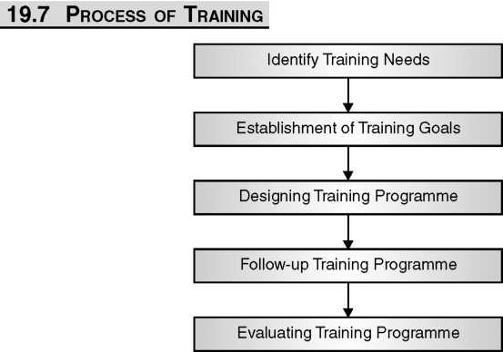

- Establishment of Training Goals: After identifying the need of the training the next step is to establishment of training goals or objective. Management sets a parameter and checks the performance of the workers after introducing training on those parameters.
- Designing Training Programme: This is the most important and critical exercise for the management. Here, management designs the whole training programme. Who are going to be training, who are going to provide training, where the training will executed, what are the methods adopted for training, what are the sequence used for training, how trainee evaluated and many other such types of task should be done at this stage.
- Follow-up Training Programme: Whatever management planned, execution should be done on this stage. If trainee and trainer follow-up the programme in proper sequence as per the management decided than they get maximum output or better results.
- Evaluating Training Programme: The last step in training process is evaluating the whole training process by the output. This can be done by various methods like reaction of trainees, by questionnaire method, by interviews and others. If any flaws or limitations found than it will be overcome as soon as possible. The evaluating of training process also help in designing future training programme more effective.

TYPES OF TRAINING

There is lots of method by which management train their employees. They choose methods according to requirement of the training. In general, training is of two types—on-the job training and off-the-job training.
Job Instruction Training (JIT)—In this method supervisors train operational workers. It consists of all the necessary steps with proper sequence which was required for a particular task. These steps not only explain what is to be done but also emphasis how it is to be done and why. It involves four steps (i) physically and psychologically prepare the trainees for instruction. (ii) presentation or demonstration of the particular task to the trainees, what are their responsibilities, description about the job etc. is included in this phase. (iii) at this phase trainees are tried out what they get understand from the instructions. (iv) this is the last phase of JIT where supervisors encourage trainees to solve their queries if any regarding particular task.

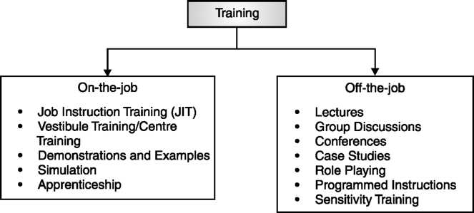

- Vestibule Training/Training Centre: In this method trainees are trained in the company classrooms. Where they get theoretical knowledge about the work which they are going to perform. This method is more useful when there is large number of trainees have to be trained for same kind of work at same time.
- Demonstrations and Examples: It is just opposite to classroom or vestibule training methods. Here supervisor describes and display something related to the job and also explains the step-by-step explanations of why and what supervisor or trainer is doing. Supervisor demonstrates to trainees with the help of lectures, picture, text material, power point presentation, discussions.
- Simulation: This method is used for more sophisticated task where errors if not minimized then it leads to heavy losses. It is generally duplicate setup of the workplace, where workers feel and touch the simulated equipments and make practice to use equipment without any problem.
- Apprenticeship: Apprenticeship refers to the period of service as a learner of a trade or handicraft. The apprentice, usually a boy at the beginning of his working life, was bound by a legal agreement to serve an employer for a fixed number of years during which the employer promised to instruct him. Carpenters, a machinist, weavers, jewelers, electricians, a draughtsman, a tool-maker, a printer, a pattern designer, diesinkers etc. are the field in which apprenticeship training is offered.
- Lectures: This method is used to create understanding of a topic or to influence behaviour, attitudes through lecture. A lecture can be in written or oral form. Lecture is telling someone about something. Lecture is given to enhance the knowledge of listener or to give him the theoretical aspect of a topic. Training is basically incomplete without lecture. It is less expensive and can be reached large number of people at same time.
- Group Discussions: This method is more useful than a lecture method. In this method the training is supported, elaborated, explains, or expanded on through interactions both among the trainees and between the trainer and the trainees. The interaction and the communication between these two make it much more effective and powerful than the lecture method. If this method is used with proper sequence i.e. lectures, followed by discussion and questioning, can achieve higher level knowledge objectives, such as problem solving and principle learning.
- Case Studies: This method is usually consisting of description of some events that occurred in the organization. The basic objective of case study is to find solution of a particular problem. The trainees review the case and find out the various alternatives and finally suggest the solution. This helps the learners to increase their observation power and broaden their view.
- Role Playing: The term role playing was originally coined in the 1920s by Jacob L. Moreno, a Viennese psychiatrist who surmised patients gained more from exploring their problems by acting them out than by talking about them.6 Oxford English Dictionary defines role playing as “the changing of one’s behaviour to fulfill a social role”. In this method, two or more trainees are assigned parts to play in front of others. These parts do not involve any rehearsals. They are simply informed the situation and the respective roles they have to play. The usual subjects involve in role playing are grievance handling, hiring, retrenchment, appraisal interview etc.
- Programmed Instructions: Programmed instruction is a computer- based training that comprises of graphics, multimedia, text that is connected to one another and is stored in memory. A programmed instruction involves breaking information down into meaningful units and it provides the trainee with content, information, asks questions, and based on the answer goes to the next level of information i.e. if the trainee gives the correct answer than they forward to the new information. And if the trainee gives the wrong answer then they are revert to their old position and review relevant information in more elaborate manner. This method is very useful because it gives immediate feedback, frequently review the information and it allows the trainee to learn according to their capability.
- Sensitivity Training: This is the method of group therapy in which the members of the group, under the guidance of a leader, seek a deeper understanding of themselves and others, as by the exchange of intimate feelings and experiences, physical contacts, etc. The main objective of sensitivity training is not to make trainees conform to a set of acceptable norms and ideas. It is designed for trainees to confront their own prejudices and biases and broadens their tolerance level. Sensitivity training involves varied methods like case studies, simulated excise, role playing etc.

EVALUATION OF TRAINING EFFECTIVENESS

There are various methods by which management check the effectiveness of their training programmes. Some are the:
- Reaction of Trainees;
- Learning;
- Behavioural Changes; and
- Impact on Organization Effectiveness and many more.
Reaction of trainee is one of the best methods by which management
can evaluate the effectiveness of the training programme. Under this method management tries to collect the response of the trainee. They take help of questionnaire, survey or simple interview by which they are asked certain specific question regarding the training programme and collect the responses.
The learning tendency of worker is more improved after taking training. If they can easily learn the new technologies, cope with surrounding all of this express the effectiveness of the training programme.
One of the ways suggested by Blum & Naylor8 is by comparing the change in performance of a group receiving training to the change in performance of a comparable group which did not receive the training. If two groups i.e. control group and experimental group are both evaluated before the training introduced. After imposing tests on the experimental group what are the changes seen in the experimental group compare with control group. If any difference is found in the same situation in both comparable groups it leads the importance and effectiveness of training.

