UNIT: 3

FORECASTING

Forecasts are a basic input in the decision processes of operations management because they provide information on future demand. The importance of forecasting to operations management cannot be overstated. The primary goal of operations management is to match supply to demand. Having a forecast of demand is essential for determining how much capacity or supply will be needed to meet demand. For instance, operations needs to know what capacity will be needed to make staffing and equipment decisions, budgets must be prepared, purchasing needs information for ordering from suppliers, and supply chain partners need to make their plans.

Two aspects of forecasts are important. One is the expected level of demand; the other is the degree of accuracy that can be assigned to a forecast (i.e., the potential size of forecast error). The expected level of demand can be a function of some structural variation, such as a trend or seasonal variation. Forecast accuracy is a function of the ability of forecasters to correctly model demand, random variation, and sometimes unforeseen events.

Forecasts are made with reference to a specific time horizon. The time horizon may be fairly short (e.g., an hour, day, week, or month), or somewhat longer (e.g., the next six months, the next year, the next five years, or the life of a product or service). Short-term forecasts pertain to ongoing operations. Long-range forecasts can be an important strategic planning tool. Long term forecasts pertain to new products or services, new equipment, new facilities, or something else that will require a somewhat long lead time to develop, construct, or otherwise implement.

Forecasts are the basis for budgeting, planning capacity, sales, production and inventory, personnel, purchasing, and more. Forecasts play an important role in the planning process because they enable managers to anticipate the future so they can plan accordingly.

Forecasts affect decisions and activities throughout an organization, in accounting, finance, human resources, marketing, and management information systems (MIS), as well as in operations and other parts of an organization. *Here are some examples of uses of forecasts in business organizations:*

**Accounting**- New product/process cost estimates, profit projections, cash management.

**Finance-** Equipment/equipment replacement needs timing and amount of funding / borrowing needs.

**Human resources -**  Hiring activities, including recruitment, interviewing, and training; layoff planning, including outplacement counselling.

**Marketing -** Pricing and promotion, e-business strategies, global competition strategies. **MIS**- New/revised information systems, Internet services.

**Operations-**Schedules, capacity planning, work assignments and workloads, inventory planning, make-or-buy decisions, outsourcing, project management.

**Product/service design** - Revision of current features, design of new products or services.

**Some Applications of Forecasting:**

Forecasts are vital to every business organization and for every significant management decision. Area in which forecasting is widely used are:

**Sales Forecasting**

Any company in selling goods needs to forecast the demand for those goods. Manufactures need to know how much to produce. Wholesalers and retailers need to know how much to stock. Substantially understanding demand is likely to lead to many lost sales, unhappy customers, and perhaps allowing the competition to gain the upper hand in the marketplace. On the other hand, significantly overestimating demand also is very costly due to (1) excessive inventory costs, (2) forced price reductions, (3) unneeded production or storage capacity, and (4) lost opportunities to market more profitable goods. Successful marketing and production managers understand very well the importance of obtaining good sales forecasts.

For the production managers these sales forecast are essential to help trigger the forecast for production which in turn triggers the forecasting of the raw materials needed for production.

**Forecasting the need for raw materials and spare parts**

Although effective sales forecasting is a key for virtually any company, some organizations must rely on other types of forecasts as well. A prime example involves forecasts of the need for raw materials and spare parts.

Many companies need to maintain an inventory of spare parts to enable them to quickly repair either own equipment or their products sold or leased to customers.

**Forecasting Economic Trends**

With the possible exception of sales forecasting, the most extensive forecasting effort is devoted to forecasting economic trends on a regional, national, or even international level.

**Forecasting Staffing Needs**

For economically developed countries there is a shifting emphasis from manufacturing to services. Goods are being produced outside the country (where labor is chapter) and then imported. At the same time, an increasing number of business firms are specializing in providing a service of some kind (e.g., travel, tourism, entertainment, legal aid, health services, financial, educational, design, maintenance, etc.). For such a company forecasting “sales” becomes forecasting the demand for services, which then translates into forecasting staffing needs to provide those services.

**Forecasting in education environment**

A good education institute typically plans its activities and areas concentration for the coming years based on the forecasted demand for its different activities. The institute may come out with a forecast that the future requirements of its students who graduate may be more in particular sector. This may call for the reorientation of the syllabus and faculty, development of suitable teaching materials/cases, recruitment of new faculty with specific sector-oriented background, experience and teaching skills. Alternatively, the management may decide that the future is more secure with the conventional areas of operation and it may continue with the original syllabus, etc.

**Forecasting in a rural setting**

Cooperative milk producers’, union operates in a certain district. The products it manufactures, the production capacities it creates, the manpower it recruits, and many more decisions are closely linked with the forecasts of the milk it may procure and the different milk products it may see. Milk is being a product which has a ready market, is not difficult to sell. Thus demand forecasting for products may not be a very dominant issue for the organization. However, the forecast of milk procurement is a crucial issue as raw milk is a highly perishable commodity and building up of adequate processing capacity is important for the dairy. The milk procurement forecast also forms an important input to the production planning process which includes making decisions on what to produce, how much and when to produce.

**Ministry of Petroleum**

The officials of this crucial ministry have to make decisions on the quantum of purchase to be made for various types of crude oils and petroleum products from different sources across the oil-exporting nations for the next few years. They also have to decide as to how much money has to be spent on development of indigenous sources. These decisions involve/need information on the future demand of different types of petroleum products and the likely change in the prices and the availability of crude oil and petroleum products in the country and the oil-exporting nations.

**Department of Technology**

The top officials of this department want to make decisions on the type of information technology to recommend to the union government for the next decade. But they are not very clear on the directions which will be taken by this year rapidly changing field. They decided to entrust this task to the information system group of a national management institute. The team leader decided to forecast the changing technology in this area with the help of a team of information technology experts throughout the country. This is again a forecasting problem although of a much different type. This field of forecasting is known as technological forecasting.

Forecasting is the basis of corporate long-run planning. In the functional areas of finance and accounting, forecasts provide the basis for budgetary planning and cost control. Marketing relies on sales forecasting to plan new products, compensate sales personnel, and make other key decisions. Productions and operations personnel use forecasts to make periodic decisions involving process selection, capacity planning, and facility layout, as well as for continual decisions about production planning, scheduling, and inventory.

**DEMAND FORECASTING**

**Demand and supply** are the key factors of economic activity all around the world. Demand can be defined as desire to purchase a product backed by the ability to do so. For any producer in this economic scenario, it is extremely important to know his market so as to utilize the resources to produce products efficiently and also to obtain right quantity of resources. This requirement of preparation and its benefits have lead to techniques of predicting demand. This study of predicting demand is called Demand Forecasting.

Demand forecasting is very important to firms. It may involve informal methods such as educated guesses of more formal methods employing scientific/mathematical methods of survey, statistical calculations, analysis of past markets and performance, etc. It is also critical in pricing the product, market entry decisions, publicity expenditure required for that product.

However demand forecasting should not be confused with sales forecasting.

Once a demand is predicted the results have a life-span up to which one can rely upon them. This way we have short term and long term demand forecasting.

**Necessity for demand forecasting:** Accurate demand forecasting is essential for a firm to enable it to produce the required quantities at the right time and arrange well in advance for the various factors of production, viz., raw materials, equipment, machine accessories, labor, buildings, etc.

**FEATURES / CHARACTERISTICS COMMON TO ALL FORECASTS**

A wide variety of forecasting techniques are in use. In many respects, they are quite different from each other, as you shall soon discover. Nonetheless, certain features are common to all, and it is important to recognize them.

1. Forecasting techniques generally assume that the same underlying causal system that existed in the past will continue to exist in the future.

Comment

A manager cannot simply delegate forecasting to models or computers and then forget about it, because unplanned occurrences can wreak havoc with forecasts. For instance, weather-related events, tax increases or decreases, and changes in features or prices of competing products or services can have a major impact on demand. Consequently, a manager must be alert to such occurrences and be ready to override forecasts, which assume a stable causal system.

2. Forecasts are not perfect; actual results usually differ from predicted values; the presence of randomness precludes a perfect forecast. Allowances should be made for forecast errors.

3. Forecasts for groups of items tend to be more accurate than forecasts for individual items because forecasting errors among items in a group usually have a canceling effect. Oppor­tunities for grouping may arise if parts or raw materials are used for multiple products or if a product or service is demanded by a number of independent sources.

4. Forecast accuracy decreases as the time period covered by the forecast—the time horizon—increases. Generally speaking, short-range forecasts must contend with fewer uncertainties than longer-range forecasts, so they tend to be more accurate.

***ELEMENTS OF A GOOD FORECAST:***

A properly prepared forecast should fulfil certain requirements:

1. The **forecast should be timely.** Usually, a certain amount of time is needed to respond to the information contained in a forecast. For example, capacity cannot be expanded overnight, nor can inventory levels be changed immediately. Hence, the forecasting horizon must cover the time necessary to implement possible changes.

2. The **forecast should be accurate**, and the degree of accuracy should be stated. This will enable users to plan for possible errors and will provide a basis for comparing alternative forecasts.

3. The **forecast should be reliable;** it should work consistently. A technique that sometimes provides a good forecast and sometimes a poor one will leave users with the uneasy feeling that they may get burned every time a new forecast is issued.

4. The **forecast should be expressed in meaningful units.** Financial planners need to know how many dollars will be needed, production planners need to know how many units will be needed, and schedulers need to know what machines and skills will be required. The choice of units depends on user needs.

5. The **forecast should be in writing**. Although this will not guarantee that all concerned are using the same information, it will at least increase the likelihood of it. In addition, a written forecast will permit an objective basis for evaluating the forecast once actual results are in.

**Types of Forecast by Time Horizon**

* Short-range forecast

Up to 1 year; generally less than 3 months

Job scheduling, worker assignments

* Medium-range forecast

3 months to 3 years

Sales and production planning, budgeting

* Long-range forecast

3+ years

New product planning, facility location or expansion

***STEPS IN THE FORECASTING PROCESS :***

There are six basic steps in the forecasting process:

1. **Determine the purpose of the forecast.** How will it be used and when will it be needed? This step will provide an indication of the level of detail required in the forecast, the amount of resources (personnel, computer time, and dollars) that can be justified, and the level of accuracy necessary.

2. **Establish a time horizon**. The forecast must indicate a time interval, keeping in mind that accuracy decreases as the time horizon increases.

3. Obtain, clean, and analyze appropriate data. Obtaining the data can involve significant effort. Once obtained, the data may need to be “cleaned” to get rid of outliers and obviously incorrect data before analysis.

4. Select a forecasting technique.

5. Make the forecast.

6. Monitor the forecast. A forecast has to be monitored to determine whether it is performing in a satisfactory manner. If it is not, re-examine the method, assumptions, and validity of data, and so on; modify as needed; and prepare a revised forecast.

Note too that additional action may be necessary. *For example, if demand was much less than the forecast, an action such as a price reduction or a promotion may be needed. Conversely, if demand was much more than predicted, increased output may be advantageous.*

***The following figure illustrates various methods of forecasting***

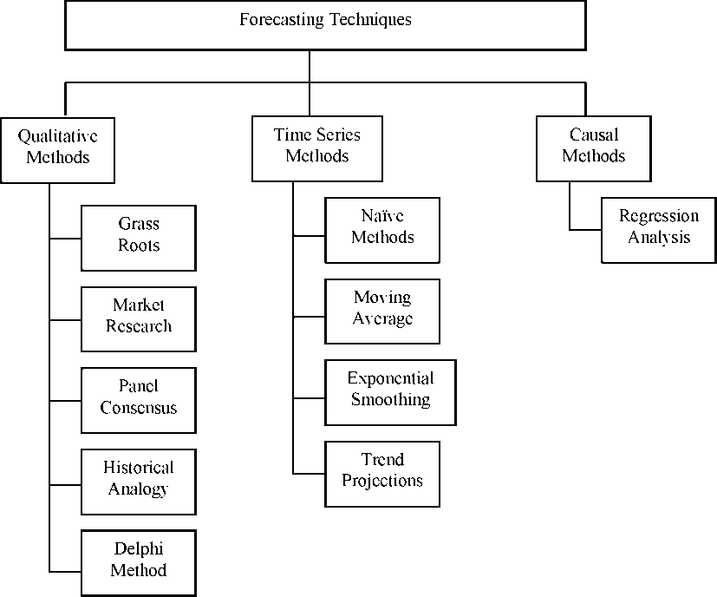

**Qualitative Techniques in Forecasting**

**Grass Roots (Bottom)**

Grass roots forecasting builds the forecast by adding successively from the bottom. The assumption here is that the person closest to the customer or end use of the product knows its future needs best. Though this is not always true, in many instances it is a valid assumption, and it is the basis for this method.

Forecasts at this bottom level are summed and given to the next higher level. This is usually a district warehouse, which then adds in safely stocks and any effects of ordering quantity sizes. This amount is then fed to the next level, which may be a regional warehouse. The procedure repeat until it becomes an input at the top level, which, in the case of a manufacturing firm, would be the input to the production system.

**Market Research**

Firms often hire outside companies that specialize in market research to conduct this type of forecasting. You may have been involved in market surveys through a marketing class. Certainly you have not escaped telephone calls asking you about product preferences, your income, habits, and so on.

Market research is used mostly for product research in the sense of looking for new product ideas, likes and dislikes about existing products, which competitive products within a particular class are preferred, and so on. (Data collection methods are primarily surveys and interviews.)

**Panel Consensus**

In a panel consensus, the idea that two heads are better than one is extrapolated to the idea that a panel of people from a variety of positions can develop a more reliable forecast than a narrower group. Panel forecasts are developed through open meetings with free exchange of ideas from all levels of management and individuals. The difficulty with this open style is that lower employee levels are intimidated by higher levels of management. For example, a salesperson in a particular product line may have a good estimate of future product demand but may not speak up to refute a much different estimate given by the vice president of marketing.

When decisions in forecasting are at a broader, higher level (as when introducing a new product line or concerning strategic product decisions such as new marketing areas) the term executive judgment is generally used. The term is self-explanatory: a higher level of management is involved.

**Historical Analogy**

The historical analogy method is used for forecasting the demand for a product or service under the circumstances that no past demand data are available. This may specially be true if the product happens to be new for the organization. However, the organization may have marketed product(s) earlier which may be similar in some features to the new product. In such circumstances, the marketing personnel use the historical analogy between the two products and derive the demand for the new product using the historical data of the earlier product. The limitations of this method are quite apparent. They include the questionable assumption of the similarity of demand behaviours, the changed marketing conditions, and the impact of the substitutability factor on the demand.

**Delphi Method**

We mentioned under panel consensus, a statement or opinion of a higher-level person will likely be weighted more than that of a lower-level person. The worst case is where lower level people feel threatened and do not contribute their true beliefs. To prevent this problem, the Delphi method conceals the identity of the individuals participating in the study. Everyone has the same weight. A moderator creates a questionnaire and distributes it to participants. Their responses are summed and given back to the entire group along with a new set of questions.

The Delphi method was developed by the Rand Corporation in the 1950s. The step-by-step procedure is

1) Choose the experts to participate. There should be a variety of knowledgeable people in different areas.

2) Through a questionnaire (or e-mail), obtain forecasts (and any premises or qualification captions for the forecasts) from all participants.

3) Summarize the results and redistribute them to the participants along with appropriate new questions.

4) Summarize again, refining forecasts and conditions, and again develop new questions.

5) Repeat Step 4 if necessary. Distribute the final results to all participants.

The Delphi technique can usually achieve satisfactory results in three rounds. The time required is a function of the number of participants, how much work is involved for them to develop their forecasts, and their speed in responding.

**Quantitative methods of forecasting**

**Time-Series Methods**

In many forecasting situations enough historical consumption data are available. The data may relate to the past periodic sales of products, demands placed on services like transportation, electricity and telephones. There are available to the forecaster a large number of methods, popularly known as the time series methods, which carry out a statistical analysis of past data to develop forecasts for the future. The underlying assumption here is that past relationships will continue to hold in the future. The different methods differ primarily in the manner in which the past values are related to the forecasted ones.

A time series refers to the past recorded values of the variables under consideration. The values of the variables under consideration in a time-series are measured at specified intervals of time. These intervals may be minutes, hours, days, weeks, months, etc. In the analysis of a time series the following four time-related factors are important.

**1) Trends:** These relate to the long-term persistent movements/tendencies/changes in data like price increases, population growth, and decline in market shares. An example of a decreasing linear trend is shown in figure below:

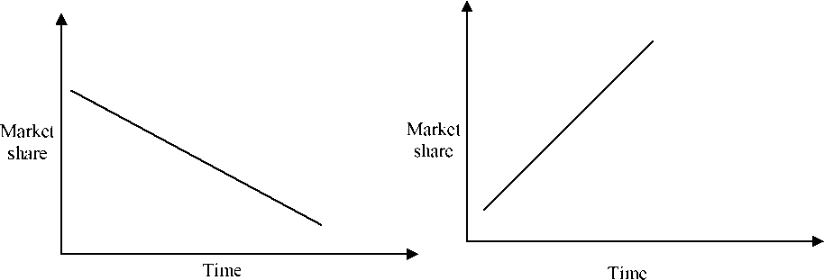

Figure: 1.1

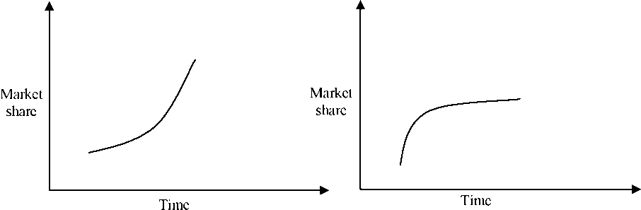

Figure: 1.2

**(2) Seasonal variations:** There could be periodic, repetitive variations in time-series which occur because of buying or consuming patterns and social habits, during different times of a year. The demand for products like soft drinks, woollens and refrigerators, also exhibits seasonal variations. An illustration of seasonal variations is provided in Fig. 1.3

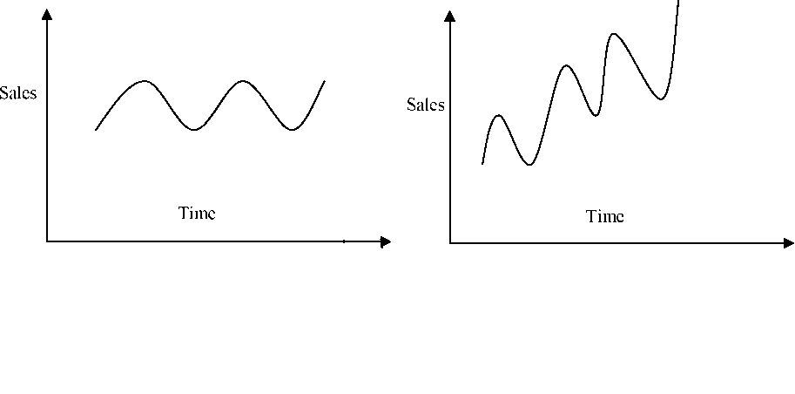

(3) **Cyclical variations:** These refer to the variations in time series which arise out of the phenomenon of business cycles. The business cycle refers to the periods of expansion followed by periods of contraction.

The period of a business cycle may vary from one year to thirty years. The duration and the level of resulting demand variation due to business cycles are quite difficult to predict.

(4) **Random or irregular variations:** These refer to the erratic fluctuations in the data which cannot be attributed to the trend, seasonal or cyclical factors. In many cases, the root cause of these variations can be isolated only after a detailed analysis of the data and the accompanying explanations, if any. Such variations can be due to a wide variety of factors like sudden weather changes, strike or a communal clash. Since these are truly random in nature, their future occurrence and the resulting impact on demand are difficult to predict. The effect of these events can be eliminated by smoothing the time series data. A graphical example of the random variations is given in Fig. 1.4.

**Demand**

**Time**

The historical time series, as obtained from the past records, contains all the four factors described earlier. One of the major tasks is to isolate each of the components, as elegantly as possible. This process of desegregating the time series is called decomposition. The main objective here is to isolate the trend in time series by eliminating the other components. The trend line can then be used for projecting into the future. The effect of the other components on the forecast can be brought about by adding the corresponding cyclical, seasonal and irregular variations.

In most short-term forecasting situations the elimination of the cyclical component is not attempted. Also, it is assumed that the irregular variations are small and tend to cancel each other out over time. Thus, the major objective, in most cases, is to seek the removal of seasonal variations from the time series.

There are a number of time-series-based methods. Not all of them involve explicit decomposition of the data. The methods extend from mathematically very simple to fairly complicated ones.

**Naive Methods**

The forecasting methods covered under this category are mathematically very simple. The simplest of them uses the most recently observed value in the time series as the forecast for the next period. Effectively, this implies that all prior observations are not considered. Another method of this type is the ‘free-hand projection method’. This includes the plotting of the data series on a graph paper and fitting a free-hand curve to it. This curve is extended into the future for deriving the forecasts. The ‘semi-average projection method’ is another naive method. Here, the time-series is divided into two equal halves, averages calculated for both, and a line drawn connecting the two semi averages. This line is projected into the future and the forecasts are developed.

**Simple Moving Average Method**

When demand for a product is neither growing nor declining rapidly, and if it does not have seasonal characteristics, a moving average can be useful in removing the random fluctuations for forecasting. Although moving averages are frequently centred, it is more convenient to use past data to predict the following period directly. To illustrate, a centred five-month average of January, February, March, April and May gives an average centred on March. However, all five months of data must already exist. If our objective is to forecast for June, we must project our moving average- by some means- from March to June. If the average is not centred but is at forward end, we can forecast more easily, through we may lose some accuracy. Thus, if we want to forecast June with a five-month moving average, we can take the average of January, February, March, April and May. When June passes, the forecast for July would be the average of February, March, April, May and June.

Although it is important to select the best period for the moving average, there are several conflicting effects of different period lengths. The longer the moving average period, the more the random elements are smoothed (which may be desirable in many cases). But if there is a trend in the data-either increasing or decreasing-the moving average has the adverse characteristic of lagging the trend. Therefore, while a shorter time span produces more oscillation, there is a closer following of the trend. Conversely, a longer time span gives a smoother response but lags the trend.

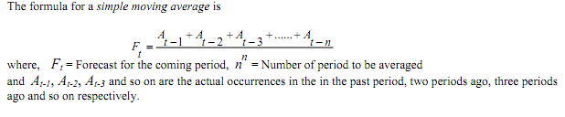

Illustration : The data in the first two columns of the following table depict the sales of a company. The first two columns show the month and the sales.

The forecast based on 3, 6 and 12 month moving average and shown in the next three columns. The 3 month moving average of a month is the average of sales of the preceding three months.

|  |  |  |  |  |
| --- | --- | --- | --- | --- |
| ***Past Sales of generators*** | | ***Forecasts Produced by*** | | |
| ***Month*** | ***Actual units sold*** | **3 month moving average** | **6 month moving average** | **12 month moving average** |
| **January** | 450 |  |  |  |
| **February** | 440 |
| **March** | 460 |
| **April** | 410 | 450+440+460)/3 = 450 |
| **May** | 380 | (440+460+410)/3 = 437 |
| **June** | 400 | (460+410+380)/3 = 417 |
| **July** | 370 | 397 | 423 |
| **August** | 360 | 383 | 410 |
| **September** | 410 | 377 | 397 |
| **October** | 450 | 380 | 388 |
| **November** | 470 | 407 | 395 |
| **December** | 490 | 443 | 410 |
| **January** | 460 | 470 | 425 | 424 |

The 6 month moving average is given by the average of the preceding 6 months actual sales.

For the month of July it is calculated as

July’s forecast = (Sum of the actual sales from January to June) / 6 = (450 + 440 + 460 + 410 + 380 + 400) / 6 = 423 (rounded)

For the forecast of January by the 12 month moving average we sum up the actual sales from January to

December of the preceding year and divide it by 12.

**Weighted Moving Average**

Whereas the simple moving average gives equal weight to each component of the moving average database, a weighted moving average allows any weights to be placed on each element, providing, of course, that the sum of all weights equals 1. For example, a department store may find that in a four-month period, the best forecast is derived by using 40 percent of the actual sales for the most recent month, 30 percent of two months ago, 20 percent of three months ago, and 10 percent of four months ago. If actual sales experience was:

|  |  |  |  |  |
| --- | --- | --- | --- | --- |
| ***Month 1*** | ***Month 2*** | ***Month 3*** | ***Month 4*** | ***Month 5*** |
| 100 | 90 | 105 | 95 | ? |

**The forecast for month 5 would be**

**F5 = 0.40(95) + 0.30(105) + 0.20(90) + 0.10(100)**

**= 38 + 31.5+ 18+ 10 = 97.5**

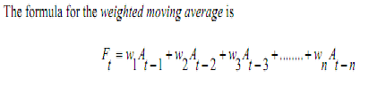

Where *Ft*= Forecast for the coming period, *n* = the total number of periods in the forecast.

*wi* = the weight to be given to the actual occurrence for the period *t-i*

*Ai* = the actual occurrence for the period *t-i*

Although many periods may be ignored (that is, their weights are zero) and the weighting scheme may be in any order (for example, more distant data may have greater weights than more recent data), the sum of all the weights must equal 1.



Suppose sales for month 5 actually turned out to be 110. Then the forecast for month 6 would be

F6 = 0.40(110) + 0.30(95) + 0.20(105) + 0.10(90)

= 44 + 28.5 + 21 + 9 = 102.5

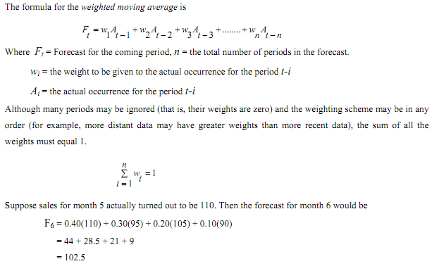**Exponential Smoothing**

In the previous methods of forecasting (simple and weighted moving average), the major drawback is the need to continually carry a large amount of historical data. (This is also true for regression analysis techniques, which we discuss later). As each new piece of data is added in these methods, the oldest observation is dropped, and the new forecast is calculated. In many applications (perhaps in most), the most recent occurrences are more indicative of the future than those in the more distant past. If this premise is valid - “that the importance of data diminishes as the past becomes more distant” - then exponential smoothing may be the most logical and easiest method to use.

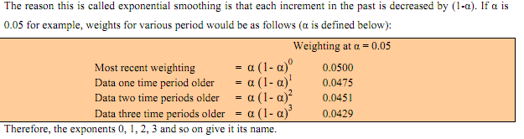

The method involves the automatic weighting of past data with weights that decrease exponentially with time, i.e. the most current values receive a decreasing weighting.

The exponential smoothing technique is a weighted moving average system and the underlying principle is that the

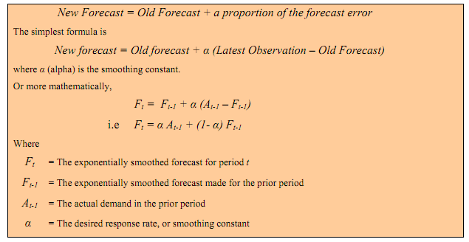

**The smoothing constant**

The value of *α* can be between 0 and 1. The higher value of *α* (i.e. the nearer to 1), the more sensitive the forecast becomes to current conditions, whereas the lower the value, the more stable the forecast will be, i.e. it will react less sensitively to current conditions. An approximate equivalent of alpha values to the number of periods’ moving average is given below:

|  |  |
| --- | --- |
| ***α value*** | ***Approximate periods in equivalent***  ***Moving Average*** |
| **0.1** | **19** |
| **0.25** | **7** |
| **0.33** | **5** |
| **0.5** | **3** |

The total of the weights of observations contributing to the new forecast is 1 and the weight reduces exponentially progressively from the alpha value for the latest observation to smaller value for the older observations. For example, if the alpha value was 0.3 and June’s sales were being forecast, then June’s forecast is produced from averaging past sales weighted as follows.

0.3 (May’s Sales) + 0.21 (April’s Sales) + 0.147 (March’s Sales)

+ 0.1029 (February Sales) + 0.072 (January Sales)

+ 0.050 (December Sales), etc

In the above calculation, the reader will observe that a (1- α)0= 0.3, a (1- α)1= 0.21, a (1- α)2= 0.147 α (1- α)3 = 0.1029 and so on.

From this it will be noted that the weightings calculated approach a total of 1.

Exponential smoothing is the most used of all forecasting techniques. It is an integral part of virtually all computerized forecasting programs, and it is widely used in ordering inventory in retail firms, wholesale companies, and service agencies.

**Characteristics of exponential smoothing**

1. Greater weight is given to more recent data
2. All past data are incorporated there is no cut-off point as with moving averages
3. Less data needs to be stored than with the longer period moving averages.
4. Like moving averages it is an adaptive forecasting system. That is, it adapts continually as new data becomes available and so it is frequently incorporated as an integral part of stock control and production control systems.
5. To cope with various problems (trend, seasonal factors, etc) the basic model needs to be modified
6. Whatever form of exponential smoothing is adopted, changes to the model to suit changing conditions can simply be made by altering the **a** value.
7. The selection of the smoothing constant **a** is done through trial-error by the researcher/analyst. It is done by testing several values of **a** (within the range 0 to 1) and selecting one which gives a forecast with the least error (one can take standard error). It has been found that values in the range 0.1 to 0.3 provide a good starting point.

**Trend Projections**

This time-series forecasting method fits a trend line to a series of historical data points and then projects the line into the future for medium- to long range forecasts. There are several mathematical trend equations that can be developed viz. linear, exponential, quadratic etc. Here we will concentrate only on the linear trends. Of the components of a time series, secular trend represents the long-term direction of the series. One way to describe the trend component is to fit a line visually to a set of points on a graph. Any given graph, however, is subject to slightly different interpretations by different individuals. We can also fit a trend line by the method of least squares. In our discussion, we will concentrate on the method of least squares because visually fitting a line to a time to series is not a completely dependable process.

**Reasons for Studying Trends**

There are three reasons why it is useful to study secular trends:

* The study of secular trends allows us to describe a historical pattern.
* Studying secular trends permits us to project past patterns, or trends, into the future.
* In many situations, studying the secular trend of a time series allows us to eliminate the trend component from the series.

**Linear Regression Analysis**

Regression can be defined as a functional relationship between two or more correlated variables. It is used to predict one variable given the other. The relationship is usually developed from observed data. The data should be plotted first to see if they appear linear or if at least parts of the data are linear. Linear regression refers to the special class of regression where the relationship between variables forms a straight line.

We illustrate the linear trend projection with a hand fit regression line.

The linear regression line is of the form **Y = a + bX,** where ***Y*** is the value of the dependent variable that we are solving for, **α** is the Y intercept, b is the slope, and ***X*** is the independent variable. (In time series analysis, **X** is units of time)

Linear regression is useful for long-term forecasting of major occurrences and aggregate planning. For example, linear regression would be very useful to forecast demands for product families. Even though demand for individual products within a family may vary widely during a time period, demand for the total product family is surprisingly smooth.

The major restriction in using linear regression forecasting is, as the name implies, that past data and future projections are assumed to fall about a straight line. Although this does limit its application, sometimes, if we use a shorter period of time, linear regression analysis can still be used. For example, there may be short segments of the longer period that are approximately linear.

Linear regression is used both for time series forecasting and for casual relationship forecasting. When the dependent variable (usually the vertical axis on the graph) changes as a result of time (plotted on the horizontal axis), it is time series analysis. When the dependent variable changes because of the change in another variable, this is a casual relationship (such as the demand of cold drinks increasing with the temperature).

We illustrate the linear trend projection with a hand fit regression line.

A firm’s sale for a product line during the 12 quarters of the past three years was as follows.

|  |  |  |  |
| --- | --- | --- | --- |
| ***Quarter*** | ***Sales*** | ***Quarter*** | ***Sales*** |
| 1 | 600 | 7 | 2600 |
| 2 | 1550 | 8 | 2900 |
| 3 | 1500 | 9 | 3800 |
| 4 | 1500 | 10 | 4500 |
| 5 | 2400 | 11 | 4000 |
| 6 | 3100 | 12 | 4900 |

Forecast the sales for the 13, 14, 15 and 16th quarters using a hand-fit regression equation.

Solution: The procedure is quite simple: Lay a straightedge across the data points until the line seems to fit well, and draw the line. This is the regression line. The next step is to determine the intercept ***α*** and slope ***b***. The following fig shows a plot of the data and the straight line we drew through the points.

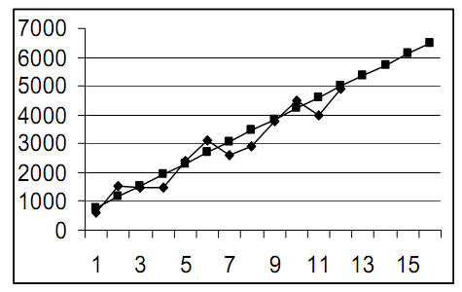

The intercept ***α***, where the line cuts the vertical axis, appears to be about 400. The slope ***b*** is the "rise" divided by the "run" (the change in the height of some portion of the line divided by the number of units in the horizontal axis). Any two points can be used, but two points some distance apart give the best accuracy because of the errors in reading values from the graph. We use values for the 1st and 12th quarters.

By reading from the points on the line, the Y values for quarter 1 and quarter 12 are about 750 and 4,950.

Therefore

b = (4950 - 750) / (12- 1) = 382

**The hand-fit regression equation is therefore**

Y = 400 + 382*X*

**The forecasts for quarters 13 to 16 are**

|  |  |
| --- | --- |
| ***Quarter*** | ***Forecast*** |
| 13 | 400+ 382 (13)= 5366 |
| 14 | 400+ 382 (14)= 5748 |
| 15 | 400+ 382 (15)= 6130 |
| 16 | 400+ 382 (16)= 6512 |

These forecasts are based on the line only and do not identify or adjust for elements such as seasonal or cyclical elements.

**Evaluating the forecast accuracy**

There are many ways to measure forecast accuracy. Some of these measures are the mean absolute forecast error, called the **MAD (Mean Absolute Deviation), the mean absolute percentage error (MAPE) and the mean square error (MSE)**

Error = Actual Observed value - Forecasted value

Absolute Percentage Error = (Error / Actual Observed Value) x 100

MAD = the average of the absolute errors

MAPE = the average of the Absolute Percentage Errors

MSE = the average of the squared errors

It is common for two forecasting models to be ranked differently depending on the accuracy measure used. For example, model A may give a smaller **MAD** but a larger **MSE** than model B. Why? Because the **MAD** gives equal weight to each error. The MSE gives more weight to large errors because they are squared.

It is up to the manager, not the management scientist to decide which accuracy measure is most appropriate for his or her application. The **MSE** is most often used in practice.

Given a preferred accuracy measure, how do we know when our forecasts are good, bad, or indifferent? One way to answer this question is to compare the accuracy of a given model with that of a benchmark model. A handy benchmark is the naive model, which assumes that the value of the series next period will be the same as it is this period; i.e ,say *Ft+1* = ***X****t*

Where ***F*** is the forecast and***X*** is the observed value. The subscript *t* is an index for the time period. The current period is *t* + *1.*

The first step in any forecasting problem should be to use the naive model to compute the benchmark accuracy. A model which cannot beat the naive model should be discarded. Checking model accuracy against that of the naive model may seem to be a waste of time, but unless we do so, it is easy to choose an inappropriate forecasting model.

The mean error measures are computed only for the last half of the data. The forecasting models are evaluated by dividing the data in to two parts. The first part is used to fit the forecasting model. Fitting consists of running the model through the first part of the data to get “warmed up.” We call the fitting data the warm-up sample. The second part of the data is used to test the model and is called the forecasting sample. Accuracy in the warm-up sample is really irrelevant. Accuracy in the forecasting sample is more important because the pattern of the data often changes over time. The forecasting sample is used to evaluate how well the model tracks such changes.

There are no statistical rules on where to divide the data into warm-up samples and forecasting samples. There may not be enough data to have two samples. A good rule of thumb is to put at least six non seasonal data points or two complete seasons of seasonal data in the warm-up sample. If there are fewer data than this, there is no need to bother with two samples. In a long time series, it is common practice simply to divide the data in half.

**Cost of Production**

Cost is analyzed from the producer’s point of view. Cost estimates are made in terms of money. Cost calculations are indispensable for management decisions.

In the production process, a producer employs different factor inputs. These factor inputs are to be compensated by the producer for the services in the production of a commodity. The compensation is the cost. The value of inputs required in the production of a commodity determines its cost of output. Cost of production refers to the total money expenses (Both explicit and implicit) incurred by the producer in the process of transforming inputs into outputs. In short, it refers total money expenses incurred to produce a particular quantity of output by the producer. The knowledge of various concepts of costs, cost-output relationship etc. occupies a prominent place in cost analysis.

**Managerial Uses of Cost Analysis**

A study of cost analysis is very useful for managerial decisions. It helps the management -

1. To find the most profitable rate of operation of the firm.

2. Determine the optimum quantity of output to be produced and supplied.

3. Determine in advance the cost of business operations.

4. To locate weak points in production management to minimize costs.

5. To fix the price of the product.

6. Decide what sales channel to use.

7. To have a clear understanding of alternative plans and the right costs involved in them.

8. Clarity about the various cost concepts.

9. Decide and determine the very existence of a firm in the production field.

10. Regulate the number of firms engaged in production.

11. To decide about the method of cost estimation or calculations.

**ELEMENTS OF COST**

A cost is composed of three elements - Materials, Labour and Expenses. Each of these can be direct or indirect.

**Material Cost:**

This is the cost of inputs supplied to an undertaking. For example, cotton used in a cotton mill is a direct material. However, in many cases, though material forms part of the finished product, yet it is not considered direct material. For example, nails used in furniture, threads used in stitching garments are indirect material. The value of these materials is so small that it is difficult and futile to count or measure them.

**Labour Cost:**

This is the cost of remuneration (wages, salaries, commission, bonus etc). Direct labour consists of wages paid to workers, directly, engaged in converting raw materials into finished products. These wages can be identified with a particular product. Wages paid to a machine operator is an example of direct wages. Indirect wages is of a general character and cannot be, conveniently, identified with a particular cost unit. In other words, indirect labour is not, directly, engaged in the production operation, but to assist or help in production operation. Labour engaged in cleaning the workshop is an example of indirect labour.

**Expenses**:

All costs other than materials and labour are termed as expenses. Direct expenses are those, which can be identified with and allocated to cost centres or units. Direct expenses are those expenses, which are specifically incurred in connection with a particular job or cost unit. Direct expenses are also known as chargeable expenses.

Indirect expenses are indirect costs, other than indirect materials and indirect labour costs. These cannot be, directly, identified with a particular job, process or work order and are common to cost units and cost centres.

Indirect expenses are also known as Overheads.

The chart below summarises the elements of cost.

1. Direct Material + Direct Labour + Direct Expenses **= Prime Cost**

2. Prime Cost + Production overhead = **Factory Cost or Works Cost**

3. Works Cost + Administration Overheads = **Cost of Production**

4. Cost of Production + Selling and Distribution Overheads **= Total Cost or Cost of Sales**

The difference between the cost of sales and selling price represents profit and loss.

**Illustration**

**Find the Prime Cost, Works Cost, Cost of production, total Cost and profit from the following:-**

Direct Materials Rs.20000;

Direct Labour Rs. 10000;

Factory Expenses Rs. 7000;

Administration Expenses Rs. 5000;

Selling Expenses Rs. 7000 and

Sales Rs.60,000

**Solution:**

**Prime Cost** = Direct Materials + Direct Labour = Rs.20, 000 + Rs.10, 000 = Rs.30, 000.

**Works Cost** = Prime Cost + Factory Expenses = Rs.30, 000 + Rs.7, 000 = Rs.37, 000.

**Cost of Production** = Works Cost + Administration Expenses=Rs.37000+ Rs.5, 000

= Rs.42, 000**.**

**Total Cost or Cost of sales**= Cost of Production + Selling Expenses

= Rs.42, 000+ Rs.7, 000 = Rs.49, 000.

**Profit** = Sales - Total Cost = Rs.60,000 - Rs.49,000=Rs.11, 000.

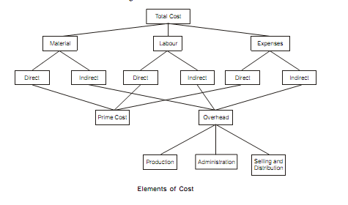it is required or not

**Different Kinds of Cost Concepts**

1. **Money Cost and Real Cost**

When cost is expressed in terms of money, it is called as money cost It relates to money outlays by a firm on various factor inputs to produce a commodity. In a monetary economy, all kinds of cost estimations and calculations are made in terms of money only. Hence, the knowledge of money cost is of great importance in economics. Exact measurement of money cost is possible. When cost is expressed in terms of physical or mental efforts put in by a person in the making of a product, it is called as real cost. It refers to the physical, mental or psychological efforts, the exertions, sacrifices, the pains, the discomforts, displeasures and inconveniences which various members of the society have to undergo to produce a commodity.

1. **Implicit or Imputed Costs and Explicit Costs**

Explicit costs are those costs which are in the nature of contractual payments and are paid by an entrepreneur to the factors of production [excluding himself] in the form of rent, wages, interest and profits, utility expenses, and payments for raw materials etc. They can be estimated and calculated exactly and recorded in the books of accounts.

Implicit or imputed costs are implied costs. They do not take the form of cash outlays and as such do not appear in the books of accounts. They are the earnings of owner-employed resources. For example, the factor inputs owned by the entrepreneur himself like capital can be utilized by him or can be supplied to others for a contractual sum if he himself does not utilize them in the business. It is to be remembered that the total cost is a sum of both implicit and explicit costs.

1. **Actual costs and Opportunity Costs**

Actual costs are also called as outlay costs, absolute costs and acquisition costs. They are those costs that involve financial expenditures at some time and hence are recorded in the books of accounts. They are the actual expenses incurred for producing or acquiring a commodity or service by a firm. For example, wages paid to workers, expenses on raw materials, power, fuel and other types of inputs. They can be exactly calculated and accounted without any difficulty. Opportunity cost of a good or service is measured in terms of revenue which could have been earned by employing that good or service in some other alternative uses. In other words, opportunity cost of anything is the cost of displaced alternatives or costs of sacrificed alternatives. It implies that opportunity cost of anything is the alternative that has been foregone. Hence, they are also called as alternative costs. Opportunity cost represents only sacrificed alternatives. Hence, they can never be exactly measured and recorded in the books of accounts.

The knowledge of opportunity cost is of great importance to management decision. They help in taking a decision among alternatives. While taking a decision among several alternatives, a manager selects the best one which is more profitable or beneficial by sacrificing other alternatives. For example, a firm may decide to buy a computer which can do the work of 10 labourers. If the cost of buying a computer is much lower than that of the total wages to be paid to the workers over a period of time, it will be a wise decision. On the other hand, if the total wage bill is much lower than that of the cost of computer, it is better to employ workers instead of buying a computer. Thus, a firm has to take a number of decisions almost daily.

1. **Direct costs and indirect costs**

Direct costs are those costs which can be specifically attributed to a particular product, a department, or a process of production. For example, expenses on raw materials, fuel, wages to workers, salary to a divisional manager etc are direct costs. On the other hand, indirect costs are those costs, which are not traceable to any one unit of operation. They cannot be attributed to a product, a department or a process. For example, expenses incurred on electricity bill, water bill, telephone bill, administrative expenses etc.

1. **Past and future costs**

Past costs are those costs which are spent in the previous periods. On the other hand, future costs are those which are to be spent in the future. Past helps in taking decisions for future.

1. **Marginal and Incremental costs**

Marginal cost refers to the cost incurred on the production of another or one more unit .It implies additional cost incurred to produce an additional unit of output. It has nothing to do with fixed cost and is always associated with variable cost.

Incremental cost on the other hand refers to the costs involved in the production of a batch or group of output. They are the added costs due to a change in the level or nature of business activity. For example, cost involved in the setting up of a new sales depot in another city or cost involved in the production of another 100 extra units.

1. **Fixed costs and variable costs**

Fixed costs are those costs which do not vary with either expansion or contraction in output. They remain constant irrespective of the level of output. They are positive even if there is no production. They are also called as supplementary or over head costs.

On the other hand, variable costs are those costs which directly and proportionately increase or decrease with the level of output produced. They are also called as prime costs or direct costs.

1. **Accounting costs and economic costs**

Accounting costs are those costs which are already incurred on the production of a particular commodity. It includes only the acquisition costs. They are the actual costs involved in the making of a commodity. On the other hand, economic costs are those costs that are to be incurred by an entrepreneur on various alternative programs. It involves the application of opportunity costs in decision making.

**Determinants of Costs**

Cost behaviour is the result of many factors and forces. But it is very difficult to determine in general the factors influencing the cost as they widely differ from firm to firm and even industry to industry. However, economists have given some factors considering them as general determinants of costs. They have enough importance in modern business set up and decision making process.

The following factors deserve our attention in this connection.

1. **Technology**

Modern technology leads to optimum utilization of resources, avoid all kinds of wastages, saving of time, reduction in production costs and resulting in higher output. On the other hand, primitive technology would lead to higher production costs.

1. **Rate of output: (the degree of utilization of the plant and machinery)**

Complete and effective utilization of all kinds of plants and equipments would reduce production costs and under utilization of existing plants and equipments would lead to higher production costs.

1. **Size of Plant and scale of production**

Generally speaking big companies with huge plants and machineries organize production on large scale basis and enjoy the economies of scale which reduce the cost per unit.

1. **Prices of input factors**

Higher market prices of various factor inputs result in higher cost of production and vice- versa.

1. **Efficiency of factors of production and the management**

Higher productivity and efficiency of factors of production would lead to lower production costs and vice-versa.

1. **Stability of output**

Stability in production would lead to optimum utilization of the existing capacity of plants and equipments. It also brings savings of various kinds of hidden costs of interruption and learning leading to higher output and reduction in production costs.

1. **Law of returns**

Increasing returns would reduce cost of production and diminishing returns increase cost.

1. **Time period**

In the short run, cost will be relatively high and in the long run, it will be low as it is possible to make all kinds of adjustments and readjustments in production process. Thus, many factors influence cost of production of a firm.

**METHODS OF COSTING**

The methods used for ascertainment of cost of production differ from industry to industry. Basically, there are two methods of costing. They are:

(A) Job Costing and

(B) Process Costing

All other methods of costing are improvements, extensions or combination of the above two methods. The principles in every method of costing are the same but the methods of analyzing and presenting the costs differ with the nature of business.

**Job Costing:**

Under this method, costs are collected and accumulated for each job or work order or project, separately. A job card is prepared for each job for cost accumulation. This method is suitable for printers, machine tool manufacturers, general engineering workshops, foundries etc.

**Batch Costing:**

Batch costing is a special type of job costing, where articles are manufactured in definite batches. For example, in a ready-made garment factory, shirts are made in suitable batches according to size and kept in stock for sale and it will not be worthwhile to maintain cost for each shirt made. The costing procedure is similar to job costing. Instead of a job, batch constitutes the cost unit for which costs are completed. Cost per unit is calculated by dividing total cost of a batch by the number of units produced in that batch. This method is mainly used in biscuit manufacture, garment manufacture and spare parts components manufacture industries.

**Process Costing:**

A process here refers to a stage of production. If a product passes through different stages, process costing is used to ascertain the cost of each stage or process. Normally, the finished product of one process becomes the raw material of the subsequent process and a final product is obtained in the last process. As the products are manufactured in continuous process, this is also known as Continuous Costing. Process costing is generally followed in textile units, chemical industries, refineries, tanneries, paper manufacturing etc.

**Operating Costing:** This is suitable for firms, which render services as distinct from those, which manufacture goods. This type of costing is applied to transport undertakings, power supply companies, gas, water works, hospitals and hotels etc. It is used to ascertain the cost of services rendered. There is, usually, a compound unit in such undertakings. Examples are passenger-kilometres in transport companies, kilo-watt-hour in power supply, patient- day in hospital etc.

**Multiple Costing:**

Where more than one method of costing is applied, it is called multiple costing. This is suitable for industries, where a number of components parts are, separately, produced, and later assembled into a final product. In such industries, materials and components used differ in the products manufactured. In other words, all components and materials are not used in all the products manufactured. So, it will be necessary to ascertain the cost of each component. Cost of component is calculated through the process costing. To ascertain the cost of final product, batch costing method is applied. This method is used in manufacturing cycles, automobiles, radios, typewriters, aeroplane and other complex products.

Methods of costing are different from techniques of costing

**TECHNIQUES OF COSTING**

To produce useful information to management, cost data collected is to be processed according to costing principles, using one or more costing techniques. The techniques of costing are used to link or relate costs to cost units or cost centres. Costing techniques are not independent. They are used along with various methods of costing. Costing techniques are not independent methods of cost ascertainment, such as job costing or operating costing.

**Important costing techniques are as follows:**

**Marginal Costing:**

Marginal Costing is a special technique of analysis and presentation of costs, which helps the management in decision-making. This technique enables the management to understand the effect of a change in volume of output on costs and profit. Its importance lies in solving the managerial problems.

*Marginal Costing is also known as Variable Costing.*

Marginal costing is not an independent system of costing similar to process costing, operating costing or Job costing. In marginal costing, the cost of a unit comprises only variable costs. Fixed costs are treated as period costs and written off to costing Profit and Loss Account. Consequently, finished goods and work in progress are valued at marginal cost i.e. Prime cost plus variable overheads.

**Absorption Costing:**

Absorption costing technique is also termed as Traditional or Full Cost Method. Under this method, the cost of a product is determined, after considering both fixed and variable costs. The variable cost, such as direct materials, direct labour, etc. is directly charged to the products. The fixed costs are apportioned on a suitable basis over different products, manufactured during a period.

Under absorption costing, all costs, both variable and fixed, are charged to the products for cost determination.

Thus, in case of Absorption costing, all costs are identified with the products manufactured. Both Fixed costs and Variable costs are also treated as product costs. The cost unit is made to bear the burden of full cost, irrespective of the current level of operations.

**Uniform Costing:**

Several undertakings follow the same costing principles and/or practices for common control or comparison. This technique facilitates inter-firm comparisons and help in establishing realistic pricing policies.

**Historical Costing:**

In historical costing, costs are ascertained, after they are actually incurred. It has a limited utility, though comparisons of different periods may yield good utility.

**Standard Costing:**

In standard costing, a comparison of actual cost is made with the predetermined costs. Any deviation, variance, is investigated by the management for the reasons of variances and suitable corrective action is taken.

**Budgetary Control:**

Budgetary control is the process of determining various budgeted figures for the enterprise and then comparing the actual performance with the budgeted figures for calculating the variances, if any. In this process, first budgets are to be prepared. Second, Actual results are to be recorded. Third, comparison is to be made, between the actual with the planned action for calculating the variances. Once the discrepancies are known, remedial measures are to be taken, at proper time. Then only, results planned can be achieved. A budget is a means and budgetary control is the end result.

Different methods of costing facilitate ascertainment of costs, while techniques of costing help the management in achieving the objective of controlling costs. Both methods of costing and techniques of costing go together to achieve the basic objective of improving the profitability of the firm.

**Cost-Output Relationship: Cost Function**

Cost and output are correlated. Cost output relations play an important role in almost all business decisions. It throws light on cost minimization or profit maximization and optimization of output. The relation between the cost and output is technically described as the “COST FUNCTION”. The significance of cost-output relationship is so great that in economic analysis the cost function usually refers to the relationship between cost and rate of output alone and we assume that all other independent variables are kept constant. Mathematically speaking TC = f (Q) where TC = Total cost and Q stands for output produced.

However, cost function depends on three important variables.

**1. Production function**

If a firm is able to produce higher output with a little quantity of inputs, in that case, the cost function becomes cheaper and vice-versa.

**2. The market prices of inputs**

If market prices of different factor inputs are high in that case, cost function becomes higher and vice- versa.

3. **Period of time**

Cost function becomes cheaper in the long run and it would be relatively costlier in the short run.

**Types of cost function**

Generally speaking there are two types of cost functions.

1. Short run cost function.

2. Long run cost function.

**Cost-Output Relation Ship and Cost Curves in the Short-Run**

It is interesting to note that the relationship between the cost and output is different at two different periods of time i.e. short-run and long run. Generally speaking, cost of production will be relatively higher in the short-run when compared to the long run. This is because a producer will get enough time to make all kinds of adjustments in the productive process in the long run than in the short run. When cost and output relationship is represented with the help of diagrams, we get short run and long run cost curves of the firm.

**MEANING OF SHORT RUN**

Short-run is a period of time in which only the variable factors can be varied while fixed factors like plant, machinery etc remains constant. Hence, the plant capacity is fixed in the short run. The total number of firms in an industry will remain the same. Time is insufficient either for the entry of new firms or exit of the old firms. If a firm wants to produce greater quantities of output, it can do so only by employing more units of variable factors or by having additional shifts, or by having over time work for the existing labor force or by intensive utilization of existing stock of capital assets etc. Hence, short run is defined as a period where adjustments to changed conditions are only partial.

The short run cost function relates to the short run production function. It implies two sets of input components - (a) fixed inputs and (b) variable inputs. Fixed inputs are unalterable. They remain unchanged over a period of time. On the other hand, variable factors are changed to vary the output in the short run. Thus, in the short period some inputs are fixed in amount and a firm can expand or contract its output only by changing the amounts of other variable inputs. The cost-output relationship in the short run refers to a particular set of conditions where the scale of operation is limited by the fixed plant and equipment. Hence, the costs of the firm in the short run are divided into fixed cost and variable costs.

1. **Fixed costs**

These costs are incurred on fixed factors like land, buildings, equipments, plants, superior type of labor, top management etc. Fixed costs in the short run remain constant because the firm does not change the size of plant and the amount of fixed factors employed. Fixed costs do not vary with either expansion or contraction in output. These costs are to be incurred by a firm even output is zero. Even if the firm close down its operation for some time temporarily in the short run, but remains in business, these costs have to be borne by it. Hence, these costs are independent of output and are referred to as unavoidable contractual cost.

Prof. Marshall called fixed costs as supplementary costs. They include such items as contractual rent payment, interest on capital borrowed, insurance premiums, depreciation and maintenance allowances, administrative expenses like manager’s salary or salary of the permanent staff, property and business taxes, license fees, etc. They are called as over-head costs because these costs are to be incurred whether there is production or not. These costs are to be distributed on each unit of output produced by a firm. Hence, they are called as indirect costs.

2. **Variable costs**

The cost corresponding to variable factors are discussed as variable costs. These costs are incurred on raw materials, ordinary labor, transport, power, fuel, water etc, which directly vary in the short run. Variable costs directly and proportionately increase or decrease with the level of output. If a firm shuts down for some time in the short run; then it will not use the variable factors of production and will not therefore incur any variable costs. Variable costs are incurred only when some amount of output is produced. Total variable costs increase with increase in the level of production and vice-versa. Prof. Marshall called variable costs as prime costs or direct costs because the volume of output produced by a firm depends directly upon them.

It is clear from the above description that production costs consist of both fixed as well as variable costs. The difference between the two is meaningful and relevant only in the short run. In the long run all costs become variable because all factors of production become adjustable and variable in the long run.

However, the distinction between fixed and variable costs is very significant in the short run because it influences the average cost behavior of the firm. In the short run, even if a firm wants to close down its operation but wants to remain in business, it will have to incur fixed costs but it must cover at least its variable costs.

**Cost-output relationship and nature and behavior of cost curves in the short run**

In order to study the relationship between the level of output and corresponding cost of production, we have to prepare the cost schedule of the firm. A cost-schedule is a statement of a variation in costs resulting from variations in the levels of output. It shows the response of cost to changes in output. A hypothetical cost schedule of a firm has been represented in the following table.

|  |  |  |  |  |  |  |  |
| --- | --- | --- | --- | --- | --- | --- | --- |
| **Output in units** | **TFC** | **TVC** | **TC** | **AFC** | **AVC** | **AC** | **MC** |
| 0 | 360 | -- | 360 | -- | -- | -- | -- |
| 1 | 360 | 180 | 540 | 360 | 180 | 540 | 180 |
| 2 | 360 | 240 | 600 | 180 | 120 | 300 | 60 |
| 3 | 360 | 270 | 630 | 120 | 90 | 210 | 30 |
| 4 | 360 | 315 | 675 | 90 | 78.75 | 168.75 | 45 |
| 5 | 360 | 420 | 780 | 72 | 84 | 156 | 105 |
| 6 | 360 | 630 | 990 | 60 | 105 | 165 | 210 |

On the basis of the above cost schedule, we can analyse the relationship between changes in the level of output and cost of production. If we represent the relationship between the two in a geometrical manner, we get different types of cost curves in the short run. In the short run, generally we study the following kinds of cost concepts and cost curves.

**1. Total fixed cost (TFC)**

TFC refers to total money expenses incurred on fixed inputs like plant, machinery, tools & equipments in the short run. Total fixed cost corresponds to the fixed inputs in the short run production function. TFC remains the same at all levels of output in the short run. It is the same when output is nil. It indicates that whatever may be the quantity of output, whether 1 to 6 units, TFC remain constant. The TFC curve is horizontal and parallel to OX-axis, showing that it is constant regardless of output per unit of time. TFC starts from a point on Y-axis indicating that the total fixed cost will be incurred even if the output is zero. In our example, Rs 300 is TFC. It is obtained by summing up the product or quantities of the fixed factors multiplied by their respective unit price.

**TFC=TC-TVC**

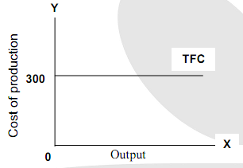

2. **Total variable cost (TVC)**

TVC refers to total money expenses incurred on the variable factors inputs like raw materials, power, fuel, water, transport and communication etc, in the short run. Total variable cost corresponds to variable inputs in the short run production function. It is obtained by summing up the production of quantities of variable inputs multiplied by their prices. The formula to calculate TVC is as follows. TVC = TC-TFC. TVC = f (Q) i.e. TVC is an increasing function of output. In other words TVC varies with output. It is nil, if there is no production. Thus, it is a direct cost of output. TVC rises sharply in the beginning, gradually in the middle and sharply at the end in accordance with the law of variable proportion. The law of variable proportion explains that in the beginning to obtain a given quantity of output, relative variation in factors needed are in less proportion, but after a point when the diminishing returns operate, variable factors are to be employed in a larger proportion to increase the same level of output.

TVC curve slope upwards from left to right. TVC curve rises as output is expanded. When output is Zero, TVC also will be zero. Hence, the TVC curve starts from the origin.

**TVC= TC-TFC**

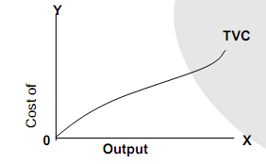

**3. Total cost (TC)**

The total cost refers to the aggregate money expenditure incurred by a firm to produce a given quantity of output. The total cost is measured in relation to the production function by multiplying the factor prices with their quantities. TC = f (Q) which means that the T.C. varies with the output. Theoretically speaking TC includes all kinds of money costs, both explicit and implicit cost. Normal profit is included in the total cost as it is an implicit cost. It includes fixed as well as variable costs. Hence, TC = TFC +TVC.

TC varies in the same proportion as TVC. In other words, a variation in TC is the result of variation in TVC since TFC is always constant in the short run.

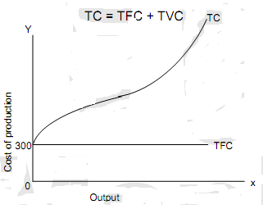

The total cost curve is rising upwards from left to right. In our example the TC curve starts form Rs. 300 because even if there is no output, TFC is a positive amount. TC and TVC have same shape because an increase in output increases them both by the same amount since TFC is constant. TC curve is derived by adding up vertically the TVC and TFC curves. The vertical distance between TVC curve and TC curve is equal to TFC and is constant throughout because TFC is constant.

**4. Average fixed cost (AFC)**

Average fixed cost is the fixed cost per unit of output. When TFC is divided by total units of output AFC is obtained, Thus, AFC = TFC/Q

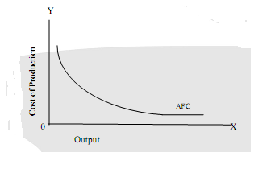

AFC and output have inverse relationship. It is higher at smaller level and lower at the higher levels of output in a given plant. The reason is simple to understand. Since AFC = TFC/Q, it is a pure mathematical result that the numerator remaining unchanged, the increasing denominator causes diminishing product. Hence, TFC spreads over each unit of output with the increase in output. Consequently, AFC diminishes continuously. This relationship between output and fixed cost is universal for all types of business concerns.

The AFC curve has a negative slope. The curve slopes downwards throughout the length. The AFC curve goes very nearer to X axis, but never touches axis. Graphically it will fall steeply in the beginning, gently in middle and tend to become parallel to OX-axis. Mathematically speaking as output increases, AFC diminishes. But AFC will never become zero because the TFC is a positive amount. AFC will never fall below a minimum amount because in the short run, plant capacity is fixed and output cannot be enlarged to an unlimited extent.

1. **Average variable cost: (AVC)**

The average variable cost is variable cost per unit of output. AVC can be computed by dividing the TVC by total units of output. Thus AVC = TVC/Q. The AVC will come down in the beginning and then rise as more units of output are produced with a given plant. This is because as we add more units of variable factors in a fixed plant, the efficiency of the inputs first increases and then it decreases.

The AVC curve is a U-shaped cost curve.

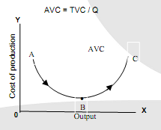

1. **Decreasing phase**

In the first phase from A to B, AVC declines, As output expands, AVC declines because when we add more quantity of variable factors to a given quantity of fixed factors, output increases more efficiently and more than proportionately due to the operation of increasing returns.

1. **Constant phase**

In the II phase, i.e. at B, AVC reaches its minimum point. When the proportion of both fixed and variable factors are the most ideal, the output will be the optimum. Once the firm operates at its normal full capacity, output reaches its zenith and as such AVC will become the minimum.

1. **Increasing phase**

In the III phase, from B to C, AVC rises when once the normal capacity is crossed, the AVC rises sharply. This is because additional units of variables factors will not result in more than proportionate output. Hence, greater output may be obtained but at much greater AVC. The old proverb “Too many cooks spoil the broth” aptly applies to this III stage. It is clear that as long as increasing returns operate, AVC falls and when diminishing returns set in, AVC tends to increase.

1. **Average total cost (ATC) or Average cost (AC)**

Ac refers to cost per unit of output. AC is also known as the unit cost since it is the cost per unit of output produced. AC is the sum of AFC and AVC. Average total cost or average cost is obtained by dividing the total cost by total output produced. AC = TC/Q Also AC is the sum of AFC and AVC.

In the short run AC curve also tends to be U-shaped. The combined influence of AFC and AVC curves will shape the nature of AC curve.

**ATC= AFC + AVC**

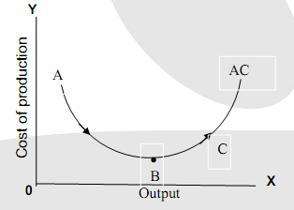

As we observe, average fixed cost begin to fall with an increase in output while average variable costs come down and rise. As long as the falling effect of AFC is much more than the rising effect of AVC, the AC tends to fall. At this stage, increasing returns and economies of scale operate and complete utilization of resources force the AC to fall.

When the firm produces the optimum output, AC becomes minimum. This is called as least - cost output level. Again, at the point where the rise in AVC exactly counter balances the fall in AFC, the balancing effect causes AC to remain constant.

In the third stage when the rise in average variable cost is more than drop in AFC, then the AC shows a rise, When output is expanded beyond the optimum level of output, diminishing returns set in and diseconomies of scale starts operating. At this stage, the indivisible factors are used in wrong proportions. Thus, AC starts rising in the third stage.

The short run AC curve is also called as “Plant curve”. It indicates the optimum utilization of a given plant or optimum plant capacity.

1. **Marginal Cost (MC)**

Marginal cost may be defined as the net addition to the total cost as one more unit of output is produced. In other words, it implies additional cost incurred to produce an additional unit.

For example, if it costs Rs. 100 to produce 50 units of a commodity and Rs. 105 to produce 51 units, then MC would be Rs. 5. It is obtained by calculating the change in total costs as a result of a change in the total output. Also MC is the rate at which total cost changes with output. Hence, MC = ∆ TC / ∆ TQ. Where ∆TC stands for change in total cost and ∆TQ stands for change in total output. Also MCn = TCn -TC n-1

It is necessary to note that MC is independent of TFC and it is directly related to TVC as we calculate the cost of producing only one unit. In the short run, the MC curve also tends to be U-shaped.

The shape of the MC curve is determined by the laws of returns. If MC is falling, production will be under the conditions of increasing returns and if MC is rising, production will be subject of diminishing returns.

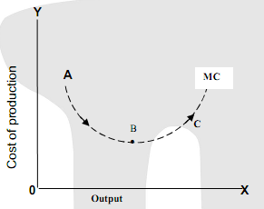

The table indicates the relationship between AC & MC

|  |  |  |  |
| --- | --- | --- | --- |
| **Output in units** | **TC in Rs.** | **AC in Rs.** | **Difference in Rs MC** |
| 1 | 150 | 150 | -- |
| 2 | 190 | 95 | 40 |
| 3 | 220 | 73.3 | 30 |
| 4 | 236 | 59 | 16 |
| 5 | 270 | 54 | 34 |
| 6 | 324 | 54 | 54 |
| 7 | 415 | 59.3 | 91 |
| 8 | 580 | 72.2 | 165 |

**Relation between AC and MC**

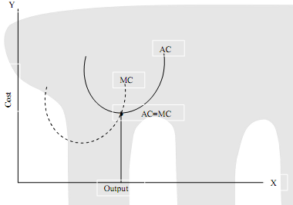

From the diagram it is clear that:

1. Both MC and AC fall at a certain range of output and rise afterwards.

2. When AC falls, MC also falls but at certain range of output MC tends to rise even though AC continues to fall. However, MC would be less than AC. This is because MC is attributed to a single unit where as in case of AC, the decreasing AC is distributed over all the units of output produced.

3. So long as AC is falling, MC is less than AC. Hence, MC curve lies below AC curve. It indicates that fall in MC is more than the fall in AC. MC reaches its minimum point before AC reaches its minimum.

4. When AC is rising, after the point of intersection, MC will be greater than AC. This is because in case of MC, the increasing MC is attributed to a single unit, where as in case of AC, the increasing AC is distributed over all the output produced.

5. So long as the AC is rising, MC is greater and AC. Hence, AC curve lies to the left side of the MC curve. It indicates that rise in MC is more than the rise in AC.

6. MC curve cuts the AC curve at the minimum point of the AC curve. This is because, when MC decreases, it pulls AC down and when MC increases, it pushes AC up. When AC is at its minimum, it is neither being pulled down nor being pushed up by the MC. Thus, When AC is minimum, MC = AC. The point of intersection indicates the least cost combination point or the optimum position of the firm. At output Q the firm is working at its “Optimum Capacity” with lowest AC. Beyond Q, there is scope for “Maximum Capacity” with rising cost.

**Cost Output Relationship In The Long Run**

Long run is defined as a period of time where adjustments to changed conditions are complete. It is actually a period during which the quantities of all factors, variable as well as fixed factors can be adjusted. Hence, there are no fixed costs in the long run. In the short run, a firm has to carry on its production within the existing plant capacity, but in the long run it is not tied up to a particular plant capacity. If demand for the product increases, it can expand output by enlarging its plant capacity. It can construct new buildings or hire them, install new machines, employ administrative and other permanent staff. It can make use of the existing as well as new staff in the most efficient way and there is lot of scope for making indivisible factors to become divisible factors. On the other hand, if demand for the product declines, a firm can cut down its production permanently. The size of the plant can also be reduced and other expenditure can be minimized. Hence, production cost comes down to a greater extent in the long run.

As all costs are variable in the long run, the total of these costs is total cost of production. Hence, the distinction between fixed and variables costs in the total cost of production will disappear in the long run. In the long run only the average total cost is important and considered in taking long term output decisions. Long run average cost is the long run total cost divided by the level of output. In brief, it is the per unit cost of production of different levels of output by changing the size of the plant or scale of production.

The long run cost - output relationship is explained by drawing a long run cost curve through short - run curves as the long period is made up of many short - periods as the day is made up of 24 hours and a week is made out of 7 days. This curve explains how costs will change when the scale of production is varied.

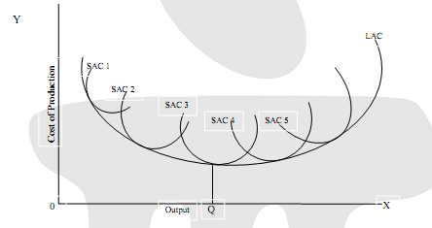

The long run -cost curves are influenced by the laws of return to scale as against the short run cost curves which are subject to the working of law of variable proportions.

In the short run the firm is tied with a given plant and as such the scale of operation remains constant. There will be only one AC curve to represent one fixed scale of output in the short run. In the long run as it is possible to alter the scale of production, one can have as many AC curves as there are changes in the scale of operations.

In order to derive LAC curve, one has to draw a number of SAC curves, each curve representing a particular scale of output. The LAC curve will be tangential to the entire family of SAC cures. It means that it will touch each SAC curve at its minimum point.

**Production cost difference in the short run and long run**

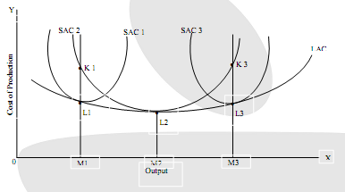

In the diagram, the LAC curve is drawn on the basis of three possible plant sizes. Consequently, we have three different SAC curves - SAC1, SAC2 and SAC3. They represent three different scales of output. For output OM3 the AC will be L2M2 in the short run as well as the long run.

When output is to be expanded to OM3, it can be obtained at a higher average cost of production. K3, M3 is the short run AC because, scale of production would remain constant in the short run. But the same output of OM3 can be produced at a lower AC of L3M3 in the long run since the scale of production can be modified according to the requirements. The distance between K3L3 represent difference between the cost of production in the short run and long run.

Similarly, when output is contracted to OM1 in the short run, K1M1 will become the short run AC and L1M1 will be the long run AC. Hence, K1L1 indicates the differences between short run and long run cost of production. If we join points L1, L2 and L3 we get LAC curve.

**Important features of long run AC curves**

1. **Tangent curve**

Different SAC curves represent different operational capacities of different plants in the short run.

LAC curve is locus of all these points of tangency. The SAC curve can never cut a LAC curve though they are tangential to each other. This implies that for any given level of output, no SAC curve can ever be below the LAC curve. Hence, SAC cannot be lower than the LAC in the long run. Thus, LAC curve is tangential to various SAC curves.

1. **Envelope curve**

It is known as Envelope curve because it envelopes a group of SAC curves appropriate to different levels of output.

1. **Flatter U-shaped or dish-shaped curve.**

The LAC curve is also U shaped or dish shaped cost curve. But It is less pronounced and much flatter in nature. LAC gradually falls and rises due to economies and diseconomies of scale.

1. **Planning curve.**

The LAC cure is described as the Planning Curve of the firm because it represents the least cost of producing each possible level of output. This helps in producing optimum level of output at the minimum LAC. This is possible when the entrepreneur is selecting the optimum scale plant.

Optimum scale plant is that size where the minimum point of SAC is tangent to the minimum point of LAC.

1. **Minimum point of LAC curve should be always lower than the minimum point of SAC curve.**

This is because LAC can never be higher than SAC or SAC can never be lower than LAC. The LAC curve will touch the optimum plant SAC curve at its minimum point.

A rational entrepreneur would select the optimum scale plant. Optimum scale plant is that size at which SAC is tangent to LAC, such that both the curves have the minimum point of tangency. In the diagram, OM2 is regarded as the optimum scale of output, as it has the least per unit cost. At OM2 output LAC = SAC.

LAC curve will be tangent to SAC curves lying to the left of the optimum scale or right side of the optimum scale. But at these points of tangency, neither LAC is minimum nor will SAC be minimum. SAC curves are either rising or falling indicating a higher cost

**Managerial Use of LAC**

The study of LAC is of greater importance in managerial decision making process.

1. It helps the management in the determination of the best size of the plant to be constructed or when a new one is introduced in getting the minimum cost output for a given plant. But it is interested in producing a given output at the minimum cost.

2. The LAC curve helps a firm to decide the size of the plant to be adopted for producing the given output. For outputs less than cost lowering combination at the optimum scale i.e., when the firm is working subject to increasing returns to scale, it is more economical to under use a slightly large plant operating at less than its minimum cost - output than to overuse smaller unit. Conversely, at output beyond the optimum level, that is when the firm experience decreasing return to scale, it is more economical to over use a slightly smaller plant than to under use a slightly larger one. Thus, it explains why it is more economical to over use a slightly small plant rather than to under use a large plant.

3. LAC is used to show how a firm determines the optimum size of the plant. An optimum size of plant is one that helps in best utilization of resources in the most economical manner.

**Long Run Marginal Cost**

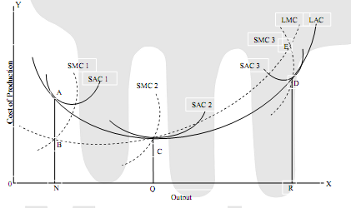

A long-run marginal cost curve can be derived from the long-run average cost curve. Just as the SMC is related to the SAC, similarly the LMC is related to the LAC and, therefore, we can derive the LMC directly from the LAC. In the diagram we have taken three plant sizes (for the sake of simplicity) and the corresponding three SAC and SMC curves. The LAC curve is drawn by enveloping the family of SAC curves. The points of tangency between the SAC and the LAC curves indicate different outputs for different plant sizes.

If the firm wants to produce ON output in the long run, it will have to choose the plant size corresponding to SAC1. The LAC curve is tangent to SAC1 at point A. For ON output, the average cost is NA and the corresponding marginal cost is NB If LAC curve is tangent to SAC1 curve at point A, the corresponding LMC curve will have to be equal to SMC1 curve at point B. The LMC will pass through point B. In other words, where LAC is equal to SAC curve (for a given output) the LMC will have to be equal to a given SMC.

If output OQ is to be produced in the long run, it will be done at point c which is the point of tangency between SAC2 and the LAC. At point C, the short -run average cost (SAC2) and the short-run marginal cost (SMC2) are equal and, therefore, the LAC for output OQ is QC and the corresponding LMC is also QC. The LMC curve will, therefore pass through point C.

Finally, for output OR, at point D the LAC is tangent to SAC3. For OR output at point E LMC is passing through SMC3. By connecting points B, C and E, we can draw the long-run marginal cost curve.

**COST OF PRODUCTION: FORMULAS**

* TC = cost per unit x total production. Or TC = TFC + TVC
* TFC = TC - TVC or AFC x Q
* TVC = TC - TFC or AVC x Q or addition of MC
* AFC = AC - AVC or TFC/Q
* AVC = AC - AFC or TVC/Q
* AC = AFC + AVC or TC/Q
* MC = TCn- TCn-1 or∆TC /∆TQ.

**COST ESTIMATION**

Estimating is the technique of calculating or computing the various quantities and the expected Expenditure to be incurred on a particular work or project.

In case the funds available are less than the estimated cost the work is done in part or by reducing it or specifications are altered, the following requirement are necessary for preparing an estimate

Need for estimation

1. Estimate gives an idea of the cost of the work and hence its feasibility can be determined i.e. whether the project could be taken up with in the funds available or not.

2. Estimate gives an idea of time required for the completion of the work.

3. Estimate is required to invite the tenders and Quotations and to arrange contract.

4. Estimate is also required to control the expenditure during the execution of work.

5. Estimate decides whether the proposed plan matches the funds available or not.

**Project Management Body of Knowledge (PMBOK), cost estimation is the iterative process of developing an approximation of the monetary resources needed to complete project activities. Project teams should estimate costs for all resources that will be charged to the project.** This includes but is not limited to:

* Labor
* Materials
* Equipment
* Services
* Software
* Hardware
* Facilities
* Contingency Costs

***The following list includes common tools and techniques used in project cost estimation:***

**• Expert Judgment -** use of knowledge gained from past project management experience. Expert judgment, in conjunction with objective estimation techniques, provides valuable information about the organizational environment and information from prior comparable projects.

**• Analogous Estimating -** use of the metrics from a previous, similar project as the basis of estimation for the current project. Analogous estimating takes the actual cost of previous, similar projects as a baseline and then adjusts for known differences (such as size, complexity, scope, duration, etc.).

**• Parametric Estimating -** use of a statistical relationship between historical data and other variables (for example, lines of code in software development) to calculate an estimate for activity parameters, such as scope, cost, budget, and duration. Used correctly, this technique can produce high levels of accuracy.

**• Bottom-Up Estimating -** estimating all individual work packages/activities with the greatest level of detail, summarizing higher-level estimates with the combination of the individual estimates. The accuracy of bottom-up estimating is optimized when individual work packages/activities are defined in detail.

**• Three-Point Estimates -** use of three estimates to determine a range for an activity’s cost: the best-case estimate, the most likely estimate, and the worst-case estimate.

**• Reserve Analysis -** determination of contingency reserves to account for cost uncertainty.

• **Project Management Estimating Software -** use of project management cost estimating software applications, computerized spreadsheets, simulation, and statistical tools. Such tools can allow for rapid consideration of multiple cost estimate alternatives.

**• Vendor Bid Analysis -** determination of what the project should cost based on a review of vendor bids/proposals. This technique may be used in conjunction with other cost estimation techniques to ensure that cost estimates are comprehensive.

Whereas the execution of appropriate cost estimation techniques certainly contributes to the accuracy of cost estimates, other project management knowledge areas also play an important role in cost estimation accuracy. For example:

**• Quality Management -** If team members do not agree clearly upon deliverable quality criteria early in the project, they may take longer to meet expectations, unnecessarily resulting in a schedule delay and corresponding cost overruns.

**• Communications Management -** If team members do not clearly understand their roles and responsibilities on the project, project work may take longer to complete, thus delaying the schedule and increasing costs.

**• Scope Management -** If requirements are ambiguous, team members may deliver products that do not meet expectations, resulting in unnecessary rework, schedule delays, and corresponding cost overruns.

**• Human Resource Management -** If team personnel do not possess the required skills or experience to perform project work, it may take them longer to complete the work, causing schedule delays and cost overruns.

**• Risk Management -** If team members do not proactively conduct risk management, cost- impacting issues that could have been prevented may emerge.

**• Procurement Management -** If procurements do not include terms and conditions that proactively mitigate State risk (such as fixed-price contracts and deliverable acceptance criteria), the project may experience increased costs later in the project due to changing project and market conditions.

**• Time Management -** If team members do not accurately estimate the time to perform activities, the project may experience schedule delays and cost overruns.

**STANDARD COST & VARIANCE ANALYSIS**

**Standard Cost**

The word “Standard” means a “Yardstick” or “Bench Mark.” The term “Standard Costs” refers to Pre-determined costs. ***Brown and Howard*** define Standard Cost as a Pre-determined Cost which determines what each product or service should cost under given circumstances. This definition states that standard costs represent planned cost of a product.

***Standard Cost as defined by the Institute of Cost and Management Accountant, London*** “is the Pre-determined Cost based on technical estimate for materials, labour and overhead for a selected period of time and for a prescribed set of working conditions.”

**Standard Costing**

***Chartered Institute of Management Accountants England defines Standard Costing as*** “the Preparation and use of standard costs, their comparison with actual costs and the analysis of variances to their causes and points of incidence.”

From the above definition, the technique of Standard Costing may be summarized as follows

(1) Determination of appropriate standards for each element of cost.

(2) Ascertainment of information about actual and use of Standard Costs.

(3) Comparison of actual costs with Standard Costs, the differences known as Variances.

(4) Analysis of Variances to find out the causes of Variances.

(5) Reporting to the responsible authority for taking remedial measures.

Standard Costing is a concept of accounting for determination of standard for each element of costs. These predetermined costs are compared with actual costs to find out the deviations known as “Variances.” Identification and analysis of causes for such variances and remedial measures should be taken in order to overcome the reasons for Variances.

Standard Costing guides as a measuring rod to the management for determination of “Variances” in order to evaluate the production performance. The term “Variances” may be defined as the difference between Standard Cost and actual cost for each element of cost incurred during a particular period. The term “Variance Analysis” may be defined as the process of analyzing variance by subdividing the total variance in such a way that management can assign responsibility for off-Standard Performance.

The variance may be favourable variance or unfavourable variance. When the actual performance is better than the Standard, it presents “Favourable Variance.” Similarly, where actual performance is below the standard it is called as “Unfavourable Variance.”

Variance analysis helps to fix the responsibility so that management can ascertain —

(a) The amount of the variance

(b)The reasons for the difference between the actual performance and budgeted performance

(c) The person responsible for poor performance

(d) Remedial actions to be taken

**MATERIAL VARIANCES**

Direct Material Variances are also termed as Material Cost Variances. The Material Cost Variance is the difference between the Standard cost of materials for the Actual Output and the Actual Cost of materials used for producing actual output. The Material Cost Variance is calculated as:

**Material Cost Variance = Standard Cost - Actual Cost**

**MCV = SC – AC**

(or)

**MCV = $\left\{\begin{aligned} Standard Standard \\ Quantity×Price \\ \end{aligned}\right\}-$ $\left\{\begin{aligned} Actual Actual \\ Quantity × Price \\ \end{aligned}\right\}$**

**= (SQ x SP) - (AQ x AP)**

**Note:** If the actual cost is more than standard cost the variance will be unfavourable or adverse variance and, on the other hand, if the actual cost is less than standard cost the variance will be favourable variance. The material cost variance is further classified into:

(1) Material Price Variance

(2) Material Usage Variance

(3) Material Mix Variance

(4) Material Yield Variance

**(1) Material Price Variance (MPV):**

Material Price Variance is that portion of the Material Cost Variance which is due to the difference between the Standard Price specified and the Actual Price paid for purchase of materials. Material Price Variance may be calculated by



(2) Material Usage Variance (MUV):

Material Usage Variance is that part of Material Cost Variance which refers to the difference between the standard cost of standard quantity of material for actual output and the Standard cost of the actual material used. Material Usage Variance is calculated as follows:

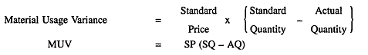

Note: This Variance will be favourable when standard cost of actual material is more than the Standard material cost for actual output, and Vice Versa.

(3) Material Mix Variance (MMV):

It is the portion of the material usage variance which is due to the difference between the Standard and the actual composition of mix. Material Mix Variance is calculated under two situations as follows:

(a) When actual weight of mix is equal to standard weight to mix

(b) When actual weight of mix is different from the standard mix .

***(a) When Actual Weight and Standard Weight of Mix are equal:***

(i)**The formula is used to calculate the Variance:**

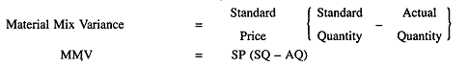

(ii) In case standard quantity is revised due to shortage of a particular category of materials, the formula will be changed as follows:

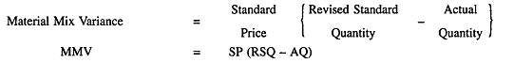

***(b) When Actual Weight and Standard Weight of Mix are different:***

(i) The formula used to calculate the Variance is:

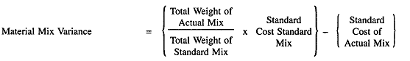

(ii) In case the standard is revised due to the shortage of a particular category of materials, the alternative formula will be as follows:

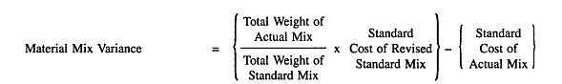

(4) Materials Yield Variance (MYV): It is the portion of Material Usage Variance. This variance arises due to spoilage, low quality of materials and defective production planning etc. Material Yield Variance may be defined as “the difference between the Standard Yield Specified and the Actual Yield Obtained.” This variance may be calculated as under:

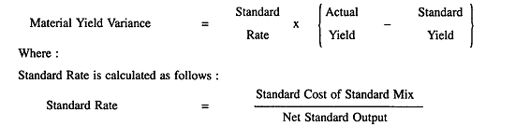

**The following equations may be used for verification of Material Cost Variances:**

**(1) Material Cost Variance = Material Price Variance + Material Usage Variance**

**(2) Material Usage Variance = Material Mix Variance - Material Yield Variance**

**(3) Material Cost Variance = Material Mix Variance + Material Yield Variance**

**Illustration: 1**

Calculate Material Cost Variance from the following information:

Standard Price of material per kg = Rs. 4

Standard Usage of materials = 800 kgs

Actual Usage of materials = 920 kgs

Actual Price of materials per kg = Rs. 3

Actual Cost of materials Rs. 2,760

Standard cost of material for actual production Rs. 3,200

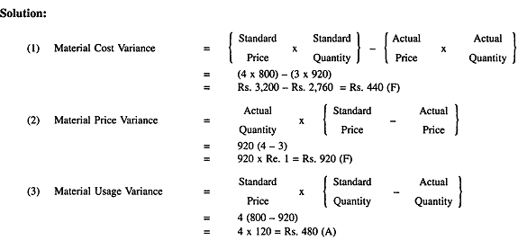

**BREAK EVEN ANALYSIS**

Break-even analysis establishes the relationship between revenues and costs with respect to volume. It indicates the level of sales at which total costs are equal to total revenues.

Breakeven analysis is a specific way of presenting information to management in a precise manner. Many a time, CVP analysis is popularly designated as break-even analysis. But, there is a narrow difference between the two.

***CVP analysis is concerned with the entire profit planning, while the breakeven analysis is one of the techniques used in that process.***

Break-even point: Break-even point is the point at which the firm makes no profit or loss. At the break-even point, the firm is in the stage of equilibrium. The equilibrium point is commonly known as break-even point. Break-even point is that point, where the revenue is just equal to total costs. It is the point where the firm makes neither profit nor loss. This is a zero position. After this level, if the firm makes production and sells above the variable cost, it earns profit. If the sales fall below this level, firm sustains loss. There are two approaches to calculate the break-even point. They are:

(A) Break-even Formulae Approach and

(B) Break-even Chart or Graphic Method Break-even Analysis

**(A) Break-even Formulae Approach:**

The break-even point can be calculated in terms of units, in terms of money value of sales volume or as a percentage of estimated capacity.

**Contribution**

When the selling price per unit is more than its variable cost, the excess is called contribution. Total contribution is calculated by multiplying the unit contribution with the number of units sold. Total contribution is the excess amount, after covering total fixed costs that is incurred by the firm. After covering fixed costs, the amount left out from total sales in the firm is gross margin. So, contribution covers total fixed costs and profit. If the contribution does not cover fixed costs, the difference is loss, sustained by the firm. Every firm looks to achieve break-even point, at the earliest. After the break-even level, whatever is sold that can leave in the form of contribution to the firm is a welcome decision. While making production and sales decisions, the firm chooses that product that gives the highest contribution. Contribution is vital in profit planning decision-making. Firm is always concerned to choose that product, where it can sell and achieve the highest amount of contribution. Contribution is important to the finance manager and, equally, to marketing manager to show impressive performance of the firm, in terms of profitability.

**The formulae for their calculation are**

**Contribution per unit = Selling price per unit - Variable cost per unit**

**Contribution per unit x Number of units sold = Total Contribution**

**Total Contribution = Total fixed costs + Profit**

**Profit = Total Contribution - Total fixed costs**

**Loss = Total fixed costs - Total contribution**

BEP in Terms of Units: The break-even point, in terms of units, can be computed by dividing fixed costs by contribution per unit. The formula for break-even point (BEP), in terms of units, is as follows:

**BEP (units) =** Total Fixed Cost

Selling price per unit – Variable cost per unit

or

**BEP (units) =** Total Fixed Cost

Contribution per unit

The above formula is useful to find out break-even point, in terms of number of units of sales.

From the above formula, it is evident that the selling price per unit should be higher than the variable cost per unit to have positive break-even point. Suppose, if the variable cost is higher than the selling price, a negative sales volume can be calculated, mathematically, to arrive at break-even point, but is of no help in the real life situation.

No Fixed Costs Situation: In case, a firm has no fixed costs, what is the break-even point to that firm? If the firm does not produce anything, it does not incur any loss. So, no production level is the first break-even point. This is the safest situation for the firm. At each level, total contribution is equal to profit. So, every sales level will be the break-even point to that firm, if there are no fixed costs to the firm.

Illustration No. 1

A firm produces a single product and its selling price is Rs.40. Its variable cost per unit is Rs. 32. Its fixed costs are Rs. 2, 40,000. What is its break-even point?

Selling price per unit = Rs. 40

Variable cost per unit = Rs. 32

Contribution per unit = 8

**BEP (units) =** Fixed Cost

Contribution per unit

= 2, 40,000

8

= 30,000 units

Proof:

Total Sales 30,000 * 40 = 12, 00,000

Total Variable cost 30,000 * 32 = 9, 60,000

Contribution 30,000 * 8 = 2, 40,000

Fixed costs 2, 40,000

Profit 0

**BEP in terms of Rupees:** The break-even point can be calculated with the following formula:

**BEP (in rupees) = BEP (in terms of units) x Selling price per unit**

**or**

**BEP (in rupees) =** Total Fixed Cost

1-(Variable cost per unit/Selling price per unit)

When we apply the same formula to the illustration No. 1, we can find out the BEP in terms of rupees:

**BEP (in rupees) =** Total Fixed Cost

1-(Variable cost per unit/Selling price per unit)

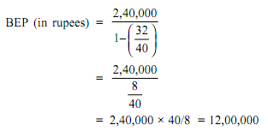

**PV Ratio or Contribution ratio**

PV Ratio is important for studying the profitability of operations of a business. This ratio establishes the relationship between contribution and sales value. PV ratio is useful to calculate the BEP, in terms of rupees. The term P represents Profit that is equivalent to contribution, when calculating BEP, in terms of rupees. The term V refers to Volume of sales.

**Contribution ratio =** Contribution per unit

Selling price per unit

or

**PV Ratio**

**Alternatively,**

**P/V Ratio =** Change in profit or Contribution × 100

Change in sales

PV Ratio can be used to calculate BEP and ascertain required sales to achieve a desired level of profit.

**BEP (in terms of rupees) =** **Fixed Cost**

**P/V Ratio**

**BEP to Achieve a Desired Amount of Profit:** The above formula requires a small change. In the numerator, the desired amount of profit is to be added. The formula is

**BEP (to achieve required amount of profit)**

**Total fixed cost + Desired Profit**

**=**

**P/V Ratio**

**Importance of PV Ratio:** Management is interested to know which product is more profitable. Organization wants to reward the department, which is working efficiently and pull up that one, that is not working to the level expected. Higher the PV Ratio, more will be the profit. Thus, aim of management is at increasing the PV Ratio, identifying where the action is needed.

PV Ratio indicates availability of margin on sales made. So, firm that enjoys higher PV Ratio stands to gain, when demand for the product is growing.

**Change in PV Ratio:** If selling price is reduced, P/V Ratio gets reduced. In consequence, Break-even point becomes higher and margin of safety becomes lower. So, the effect of a price reduction is always to reduce P/V Ratio that raises break-even point and shortens margin of safety.

The above concept is explained, with a simple example.

**Milk-man teaches break-even point:** Let us take the example of a milkman. He purchases milk packets @ Rs. 6 per packet and sells at Rs. 10. He distributes milk packets, hiring a motorcycle and the fixed hire charge is Rs. 100 per day. So, contribution per packet is Rs. 4. At this stage, his PV Ratio is 40% (contribution 4/ selling price 10). If he sells 25 packets, he becomes break-even. If he sells 60 packets, his margin of safety is 35 packets (Actual sales 60 - sales at break-even point 25).

Suppose, he reduces the selling price to Rs. 8 per packet and continues to sell 60 packets, as earlier. Now, his PV Ratio is 25% (contribution 2/ selling price 8). As fixed cost is Rs.100 and contribution is Rs. 2, break-even point is 50 packets. However, as he continues to sell 60 packets, his margin of safety is reduced to 10 packets (Actual sales 60 - sales at new break-even point 50).

Now, the margin of safety is reduced to 10 packets, which was at 35 packets, earlier. This explains reduction of selling price results in the following:

1. Reduction of PV Ratio (40% reduced to 25%)
2. Break-even point is increased (in place of 25 packets, 50 packets are needed) and
3. Margin of safety reduced (earlier 35 packets reduced to 10 packets)

This situation is explained through pictorial presentation.

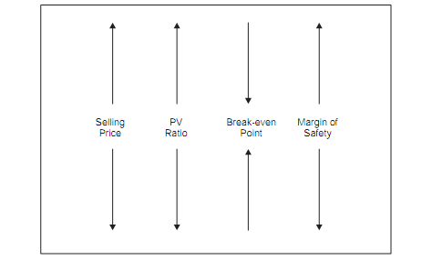

**Impact of selling Price on PV Ratio, BEP and Margin of Safety**

**Utility and Special Features: These are the following special features.**

1. It helps the management in ascertaining the total amount of contribution for a given volume of sales. Say, if sales are rupees four lakhs and PV Ratio is 25%, its contribution is rupees one lakh. It is so simple and easy to calculate contribution.

2. When the firm is engaged in producing more than one product, by calculating this ratio for each product, it can concentrate to produce that product, which has higher PV Ratio as it gives more profitability. Leaving products that have less PV Ratio, the firm can concentrate on those products, having higher PV Ratio to boost profitability.

3. Management can increase this ratio by increasing selling price or reducing variable cost of the products.

4. PV Ratio remains constant so long as the selling price and variable cost per unit remain constant or fluctuate in the same proportion.

5. This remains unaffected by any change in the level of activity. In other words, it remains the same whether the sales are 1,000 units or 2,000 units.

6. This ratio also remains unaffected with any change in fixed cost, as they are not considered. It means even if the fixed cost increases or decreases, PV ratio remains the same as fixed costs are not taken into account, while calculating.

7. The above formula is of immense use to calculate break-even point, when the firm is engaged in multiple products. A Multi-product firm experiences difficulty to calculate break-even point in terms of any common unit. Such firms can calculate break-even point, at the time of budgeting and actual sales, in terms of total rupee sales only.

**BEP in Terms of Capacity:**

Many firms compute the break-even point, in terms of estimated sales or capacity of the manufacturing unit. Dividing the break-even sales with estimated sales or full capacity sales could do this. If break-even sales are, say, rupees ten lakhs and the estimated sales are rupees forty lakhs, the break-even point is 25%.

**BEP (% of capacity) =** Sales at break- even point

Estimated Sales

Alternatively, if the total contribution at the estimated sales or full capacity is known, it can be calculated directly.

**BEP (% of capacity) =** Total Fixed Cost

Total contribution at the estimated sales

**Impact of Break-even Point: When two firms working with the same amount of sales and equal unit variable cost, with difference in fixed costs, which firm can withstand better?** A firm enjoying lower break-even point is always at an advantage as its fixed costs get recovered early and can withstand better compared to a firm with higher break-even point.

**Illustration No. 2**

Calculate the sales required to earn a profit of Rs.6, 00,000, from the following data:

Fixed Expenses = 1, 20,000

Variable cost per unit:

Direct Material = Rs. 4

Direct Labour = Rs. 2

Direct Overheads = 50% of Direct Labour

Selling price per unit = Rs. 14

Solution:

(Rs.)

|  |  |  |
| --- | --- | --- |
| Selling price per unit |  | 14 |
| Less: Direct Material | 4 |  |
| Direct Labour | 2 |  |
| Direct Overheads | 1 | 7 |
| Contribution per unit |  | 7 |

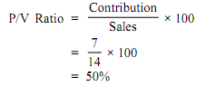

Sales required to earn a profit of Rs. 6, 00,000

**=** Total Fixed Expenses + Desired Profit

P/V Ratio

**=** 1, 20,000 + 6, 00,000

0.5

= 14, 40,000

Required sales are Rs. 14, 40,000 to make a profit of Rs. 6, 00,000

**(B) Break-even Chart or Graphic Method of Break-even Analysis**

The break-even point can be presented graphically. The pictorial presentation gives a better view of the relationship of cost, volume and profit. Graphical presentation gives immediate and clear understanding of the picture. This type of presentation always impresses the management as it gives instantaneous understanding of the situation.

The graphical chart of break-even analysis looks like this:

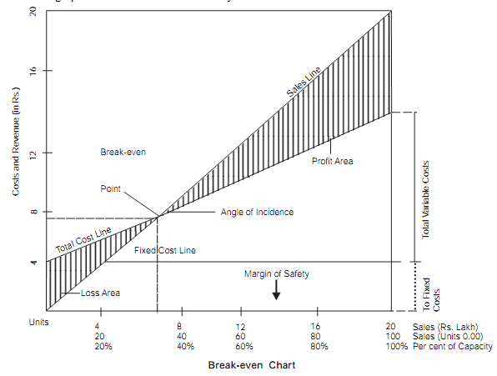

Following are the steps involved in preparing break-even chart:

1. Sales volume is plotted on the horizontal line i.e. X-axis. Sales volume may be expressed in terms of units, rupees or as a percentage of capacity.

2. Vertical line i.e. Y-axis is used to represent revenue, fixed costs and variable costs.

3. Both horizontal and vertical lines are spaced, equally, with the same distance.

4. Break-even point is the point of intersection between total cost line and sales line.

5. Sales revenue at the break-even point can be determined by drawing a perpendicular line to the X-axis from the point of above intersection.

6. Total sales line and Total cost line intersect forming an angle known as ‘Angle of Incidence’.

**Angle of Incidence**

The break-even point is indicated where the Total cost line and Total sales line intersect each other. The angle that is formed with their intersection is called ‘Angle of incidence’. **Larger the angle of incidence, lower is the break-even point and vice versa.** A lower break-even point is an indication that the firm can withstand, even if the sales fall. Firm does not go into loss immediately and remains, at least, with a small amount of profit.

**Area of Contribution:** Profit area is shown on the right side when total sales line is in excess of the total cost line, while loss area is shown when the total cost line is above the total sales line. The variable cost is represented by the gap between the total cost line and fixed cost line.

**ADVANTAGES OR USES OF BREAK-EVEN CHART**

**Following are the advantages or uses of break-even chart:**

1. It is simple to form. Even a layman can understand, clearly.

2. It helps the management to take managerial decisions because the effects of changes in fixed cost and variable cost, at various levels of output, can be depicted, in a meaningful manner. The effect of changes in selling price on profits can be better explained by graphical presentation.

3. It is used to study the comparative profitability of various products.

4. The break-even chart is a better managerial tool for forecasting, planning and control.

5. Besides determining the break-even point, profit at various levels of output can be determined with the help of break-even charts.

**ASSUMPTIONS OF BREAK-EVEN ANALYSIS**

**The break-even analysis is based on the following assumptions:**

1. Costs segregation: It is based on the assumption that all costs can be segregated into fixed costs and variable costs.

2. Constant Selling Price: The selling price remains constant. That is, selling price does not change with volume or other factors.

3. Constant Fixed costs: Fixed costs are constant, at all levels of activity. They do not change, with change in sales.

4. Constant Variable costs: Variable cost per unit is constant. So, variable costs fluctuate, directly, in proportion to changes in volume of output. In other words, they change in direct proportion to sales volume.

5. Synchronised production and sales: It is assumed production and sales are synchronised. That is, inventories remain the same in the opening stock and closing stock.

6. Constant sales mix: Only one product is manufactured. In case, more than one product is manufactured, sales mix of products sold does not change.

7. No Change in operating efficiency: There is no change in operating efficiency.

8. No other factors: The volume of output or production is the only factor that influences the cost. No other factors have any influence on break-even analysis.

**LIMITATIONS OF BREAK-EVEN ANALYSIS AND BREAK-EVEN CHART**

**Despite many advantages, break-even analysis and charts suffer from the following limitations:**

1. Number of Assumptions: Break-even analysis is based on several assumptions and they may not hold well, under all circumstances. Fixed costs are presumed to be constant, irrespective of the level of output. It does not happen. When the production increases, above the installed capacity, fixed costs change as new plant and machinery has to be installed for increased production. Variable costs do not vary in direct proportion to the change in volume of output, due to the laws of diminishing returns. Selling price that is supposed to be constant also changes due to increased competition.

2. Application in Short Run: Break-even analysis is a short run analysis. In long run, the cost analysis may not hold good as the assumptions may vary and situation may be, totally, different.

3. Applicable in Single Product line: This analysis is applicable for a single product only. If break-even point for each product is to be calculated, fixed costs have to be allocated to different products, which is a practical problem in the real life. Otherwise, BEP for the overall firm only is possible to calculate.

4. No Remedial Action: It does not suggest any remedy or action to the management for solving the problem.

5. Other Factors Ignored: Other important factors such as amount of investment, problems of marketing and policies of Government influence the problem. Break-even analysis does not consider them. This analysis focuses only on cost volume profit relationship.

6. Limited Information: Break-even charts provide limited information. If we want to study the effects of changes in fixed costs, variable costs and selling prices on profitability, a number of charts have to be drawn. It becomes rather more complicated and difficult to understand.

7. Static View: More often, a break-even chart presents a static view of the problem under consideration.

Despite the limitations, it has great application for the basic problem of understanding the interrelationship of cost, volume and price on profits.

**MARGIN OF SAFETY**

The excess of actual or budgeted sales over the break-even sales are called ‘Margin of safety’. It is the difference between actual sales minus break-even sales.

**Margin of safety = Estimated sales - Sales at Break-even point**

It represents the amount of safety to the firm. Suppose, if the firm is able to break-even at a sale level of rupees ten lakhs and its actual sales are rupees forty lakhs, its margin of safety is rupees thirty lakhs. It means if the sales fall by rupees thirty lakhs, still, the firm does not incur loss. Higher the margin of safety, it is better for the firm. When two firms are compared, the firm having higher margin of safety can withstand any adverse conditions such as fall in demand for the product or even recession.

**Margin of safety ratio can be calculated as under:**

**Margin of safety ratio =** **Actual Sales – Break even sales × 100**

**Actual Sales**

As margin of safety is the volume of sales beyond the break-even sales point, all the sales above the break-even point give some profit, which can be calculated as:

Profit = Margin of safety × P/V Ratio

OR

**Margin of Safety =** **Profit**

**P/V Ratio**

The size of margin of safety is an important indicator of the strength of business. If the margin of safety is large, the firm can withstand fall of sales and can continue to be in some profit. If the margin of safety is thin, decline of sales would, seriously, affect the profit of business and may run into losses.

**Steps to Improve Margin of Safety:** The margin of safety can be improved by taking the following steps:

1. Increasing the level of production and sales.

2. Increasing the selling price.

3. Reducing fixed costs.

4. Reducing the variable cost.

5. Substituting profitable products, with the unprofitable products

6. Changing the business mix to improve contribution and dropping unprofitable products.