**INDUSTRIAL PSYCHOLOGY: UNIT-2**

### 2.1 INDIVIDUAL IN WORKPLACE

* **Extrinsic motivation** is related to ‘tangible’ rewards such as salary and fringe benefits, security, promotion, contract of service, the work environment and conditions of work.
* **Intrinsic motivation** is related to ‘psychological’ rewards such as the opportunity to use one’s ability, a sense of challenge and achievement, receiving appreciation, positive recognition and being treated in a caring and considerate manner.

### 2.2 MOTIVATION AND JOB SATISFACTION

Motivation is the psychological processes that cause the stimulation direction, and determination of voluntary actions that are goal directed.

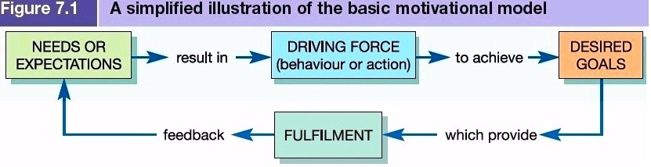

**Definition of Motivation**

* “Motivation is something that moves a person to action, and continues him in the course of action already initiated”.
* Acc. to Robert Dubin, “Motivation is the complex set of forces starting and keeping a person at work in an organisation”.

**Theories of Motivation**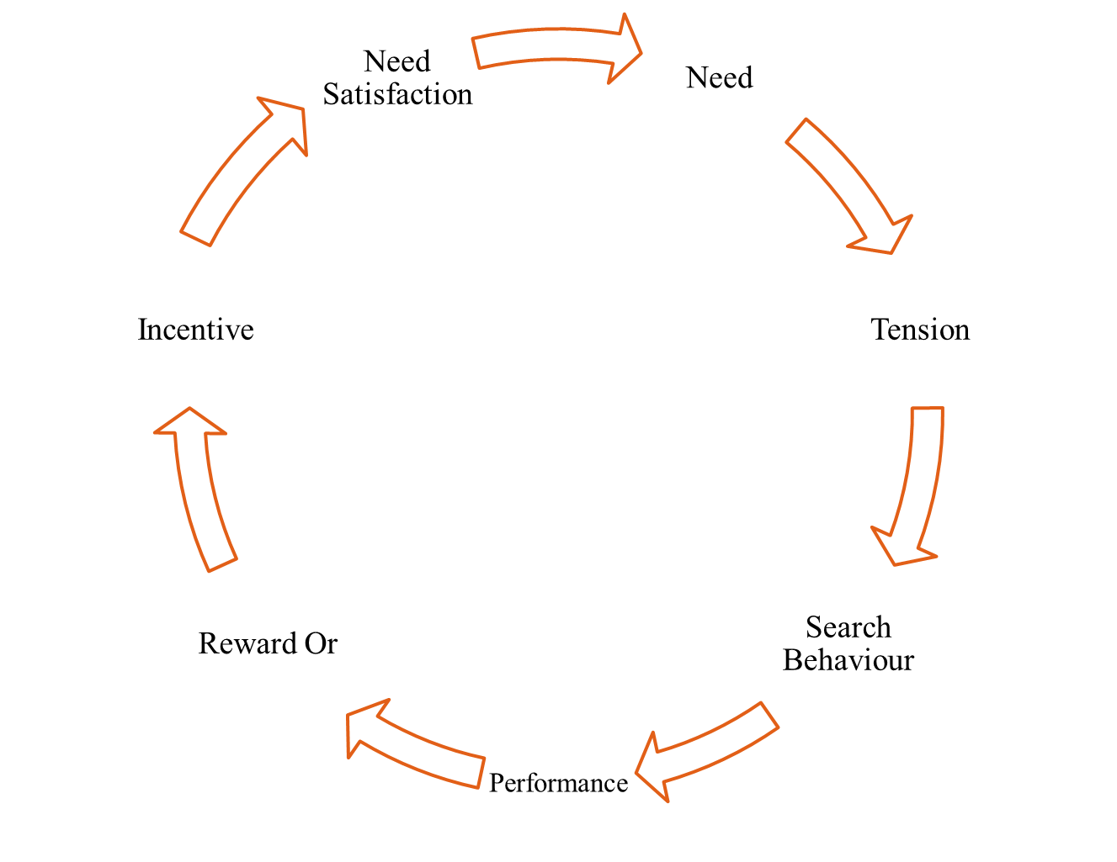

1. **Content theories** attempt to explain those specific things that actually motivate the individual at work. These theories are concerned with identifying people’s needs and their relative strengths, and the goals they pursue in order to satisfy these needs. Content theories place emphasis on the nature of needs and what motivates. For examples **Maslow, Alderfer, Herzberg and McClelland**.
2. **Process theories** attempt to identify the relationship among the dynamic variables that make up motivation. These theories are concerned more with how behaviour is initiated, directed and sustained. Process theories place emphasis on the actual process of motivation. For examples **Expectancy Theory, Equity theory, Goal theory, Attribution Theory.**

**(I) MASLOW’S HIERARCHY OF NEEDS THEORY**

1. **Physiological needs**. These include homeostasis (the body’s automatic efforts to retain normal functioning) such as satisfaction of hunger and thirst, the need for oxygen and to maintain temperature regulation. Also sleep, sensory pleasures, activity, maternal behaviour and, arguably, sexual desire.
2. **Safety needs**. These include safety and security, freedom from pain or threat of physical attack, protection from danger or deprivation, the need for predictability and orderliness.
3. **Social needs:** These include affection, sense of belonging, social activities, friendships, and both the giving and receiving of love.
4. **Esteem needs** (sometimes referred to as ego needs). These include both self-respect and the esteem of others. Self-respect involves the desire for confidence, strength, independence and freedom, and achievement. Esteem of others involves reputation or prestige, status, recognition, attention and appreciation.
5. **Self-actualization needs**. This is the development and realization of one’s full potential. Maslow sees this as ‘What humans can be, they must be’ or ‘becoming everything that one is capable of becoming’. Self-actualization needs are not necessarily a creative urge and may take many forms which vary widely from one individual to another.

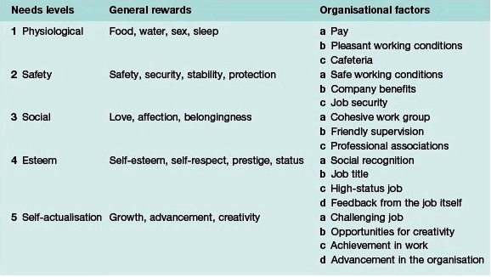

**(II) ALDERFER’S MODIFIED NEED HIERARCHY MODEL (ERG theory)**

A modified need hierarchy model has been presented by Maslow. This model condensesMaslow’s five levels of need into only three levels based on the core needs of Existence,Relatedness and Growth (ERG theory)

* **Existence needs** are concerned with sustaining human existence and survival and cover physiological and safety needs of a material nature.
* **Relatedness needs** are concerned with relationships to the social environment and cover love or belonging, affiliation and meaningful interpersonal relationships of a safety or esteem nature.
* **Growth needs** are concerned with the development of potential and cover self-esteem and self-actualization.

**(III) HERZBERG’S TWO-FACTOR THEORY**

The two-factor theory states that there are certain factors in the workplace that cause job satisfaction, while a separate set of factors cause dissatisfaction.

Two-factor theory distinguishes between:

**The Two Factors inthe Theory**

1. **Hygiene factors**are needed to ensure that an employee does not become dissatisfied. They do not cause higher levels of motivation, but without them there is dissatisfaction.
2. **Motivation factors**are needed in order to motivate an employee into higher performance. These factors result from internal generators in employees.

**Typical Hygiene Factors**

* Working conditions; Quality of supervision; Salary
* Status; Safety; Company; Job
* Company policies and administration
* Interpersonal relations

**Typical Motivation Factors**

* Achievement; Recognition for achievement
* Responsibility for task; Interesting job
* Advancement to higher level tasks; Growth

**Combining the hygiene and motivation factors results in four scenarios**

1. **High Hygiene + High Motivation**: The ideal situation where employees are highly motivated and have few complaints.
2. **High Hygiene + Low Motivation**: Employees have few complaints but are not highly motivated. The job is perceived as a paycheck.
3. **Low Hygiene + High Motivation**: Employees are motivated but have a lot of complaints. A situation where the job is exciting and challenging. However the salaries and work conditions are not OK.
4. **Low Hygiene + Low Motivation**: The worst situation. Employees are not motivated and have lots of complaints

**(IV) VROOM’S EXPECTANCY THEORY**

The Expectancy Theory (ET) of Victor Vroom deals with motivation and management. Vroom's theory assumes that behavior results from conscious choices among alternatives whose purpose it is to maximize pleasure and minimize pain.*Vroom* was the first person to propose an expectancy theory aimed specifically at workmotivation.His model is based on three key variables: **valence, instrumentality** and**expectancy.**

**M** = **E** x **I** x **V**

**Motivational Force (MF) = Expectancy x Instrumentality x Valence**

**1. Expectancy: Effort → Performance (E→P):** Expectancy is the belief that one's effort (E) will result in attainment of desired performance (P) goals.

1. ***Self-efficacy***- the person’s belief about their ability to successfully perform a particular behavior. The individual will assess whether they have the required skills or knowledge desired to achieve their goals.
2. ***Goal difficulty***- when goals are set too high or performance expectations that are made too difficult. This will most likely lead to low expectancy. This occurs when the individual believes that their desired results are unattainable.
3. ***Perceived control*** - Individuals must believe that they have some degree of control over the expected outcome. When individuals perceive that the outcome is beyond their ability to influence, expectancy, and thus motivation, is low.

**2. Valence (**Reward Preference= Emotions**):** The feeling about specific outcomes is termed **valence (**Emotions**).** This is the attractiveness of, or preference for, a particular outcome to the individual**.**Valence is the anticipated satisfaction from an outcome.The valence refers to the value the individual personally places on the rewards. -1 to +1; **-1= avoiding the outcome**

**0 = indifferent to the outcome**

**+1 = welcomes the outcome**

In order for the valence to be positive, the person must prefer attaining the outcome to not attaining it.

1. **Instrumentality: Performance → Outcome (P→O):** Instrumentality is the belief that a person will receive a reward if the performance expectation is met. This reward may present itself in the form of a pay increase, promotion, recognition or sense of accomplishment. Instrumentality is low when the reward is the same for all performances given.

**(V) THEORY X & THEORY Y (McGregor’s Motivational Theory)**

Douglas McGregor studied these questions and proposed two different views of employee motivation in his 1960 book '**The Human Side of Enterprise**'. These views are known as Theory X and Theory Y.

Theory X stresses the importance of strict supervision, external rewards, and penalties: in contrast, Theory Y highlights the motivating role of job satisfaction and encourages workers to approach tasks without direct supervision.

|  |  |
| --- | --- |
| **Comparisons Between Theory X and Theory Y** | |
| **Theory X**  **(Lower Level Management)** | **Theory Y**  **(Upper Level Management)** |
| 1. Humans inherently dislike working and try to avoid work. 2. Because people dislike work, they have to be made to work by putting pressure and controlling their activities closely. 3. An average person prefers to be directed by others. 4. Average people avoid taking responsibility. 5. Average people are unambitious and prefer security at work | 1. Work is an activity as natural to people as play and rest. 2. When suitably motivated people are self-directed to achieve organizational objectives. 3. Commitment of employees can be obtained by ensuring job satisfaction for them 4. People learn to accept responsibility and under suitable conditions actively seek responsibility. 5. People are imaginative and creative. |

**JOB SATISFACTION:**

The term ‘job satisfaction’ is commonly used in the context of human behaviour at work.In the words of Feldman and Arnold, “job satisfaction is the amounts of overall positive effect feelings that individual have towards their job”.

**Job satisfaction**: is a set of favorable or unfavorable feelings and emotions with which employees view their work. Job satisfaction is an affective attitude a feeling of relative like or dislike toward something.

**DETERMINANTS OF JOB SATISFACTION:**

* Nature of job
* Nature of supervision
* Working conditions
* Opportunities of promotion
* Work-group
* Employee morale.

|  |  |  |
| --- | --- | --- |
| **Basis For Comparison** | **Job Enlargement** | **Job Enrichment** |
| Meaning | **Job Enlargement** means enlarging the scope of the job by adding the similar tasks without enhancing responsibility. | A management tool used to motivate employees, by adding responsibilities in the job is known as Job Enrichment. It is more challenging and less repetitive work. |
| Concept | Quantitatively expanding the scope of a job. | Qualitatively extending the range of activities performed by a job. |
| Objective | To decreases the boredom in performing a redundant task. | To make the job more challenging, interesting and creative. |
| Expansion | Horizontal | Vertical |
| Supervision | More | Comparatively less |

### 2.3 STRESS MANAGEMENT

**What is Stress?**

“Stress is the emotional and physical strain caused by our response to pressure from the outside world.”

**Stress is also:**

* A necessary part of our daily lives.
* Defined as anything that stimulates us to act, think, or react.
* Simple or extreme.
* Necessary in order to force us to accomplish certain tasks.
* Without stress, our bodies wouldn't react at all, even in times of extreme danger.

**What is Employee Stress?**

**Employees stress** is a growing concern for organizations today. Stress can be defined as a lively circumstance in which people face constraints, opportunities, or loss of something they desire and for which the consequence is both unpredictable as well as crucial. Stress is the response of people to the unreasonable/excessive pressure or demands placed on them.

**Symptoms of Stress**

Some of the symptoms of stress at workplace are as follows-

* Absenteeism, escaping from work responsibilities, arriving late, leaving early, etc.
* Deterioration in work performance, more of error prone work, memory loss, etc.
* Cribbing, over-reacting, arguing, getting irritated, anxiety, etc.
* Deteriorating health, more of accidents, etc.
* Improper eating habits (over-eating or under-eating), excessive smoking and drinking, sleeplessness, etc.

**High levels of stress in the workplace can lead to**:

* Poor decision-making.
* An increase in mistakes which in turn may lead to more customer or client complaints. This in turn is likely to produce more stress.
* Increased sickness and absence.
* High staff turnover.
* Poor employee/work place relations.

**SOURCES/CAUSES OF STRESS**

The factors leading to stress among individual are called as stressors. Some of the factors/stressors acting on employees are-

**1. Organizational factors**: With the growth in organizational stress and complexity, there is increase in organizational factors also which cause stress among employees. Some of such factors are-

|  |  |
| --- | --- |
| * Discrimination in pay/salary structure * Strict rules and regulations * Ineffective communication * Peer pressure * Goals conflicts/goals ambiguity | * More of centralized and formal organization structure * Less promotional opportunities * Lack of employees participation in decision-making * Excessive control over the employees by the managers |

**2. Individual factors:** There are various expectations which the family-members, peer, superior and subordinates have from the employee. Failure to understand such expectations or to convey such expectations lead to role ambiguity/role conflict which in turn causes employee stress. Other individual factors causing stress among employees are inherent personality traits such as being impatient, aggressive, rigid, feeling time pressure always, etc. Similarly, the family issues, personal financial problems, sudden career changes all lead to stress.

**3. Job concerning factors**: Certain factors related to job which cause stress among employees are as follows-

|  |  |
| --- | --- |
| * Monotonous nature of job * Unsafe and unhealthy working conditions | * Lack of confidentiality * Crowding |

1. **Extra-organizational factors**: There are certain issues outside the organization which lead to stress among employees. In today’s modern and technology savvy world, stress has increased. Inflation, technological change, social responsibilities and rapid social changes are other extra-organizational factors causing stress.

**STRATEGIES FOR MANAGING STRESS**

Stress experienced by the employees in their job has negative impact on their health, performance and their behaviour in the organization. Thus, stress needs to be managed effectively so as to set off these harmful consequences. Strategies for managing stress are as follows-

1. **Organizational strategies for managing stress**

|  |  |
| --- | --- |
| 1. Encouraging more of organizational communication with the employees so that there is no role ambiguity/conflict. 2. Effective communication can also change employee views. Managers can use better signs and symbols which are not misinterpreted by the employees. 3. Encourage employees’ participation in decision-making. This will reduce role stress. 4. Grant the employees greater independence, meaningful and timely feedback, and greater responsibility. | 1. The organizational goals should be realistic, stimulating and particular. The employees must be given feedback on how well they are heading towards these goals. 2. Encourage decentralization. 3. Have a fair and just distribution of incentives and salary structure. 4. Promote job rotation and job enrichment. 5. Create a just and safe working environment. 6. Have effective hiring and orientation procedure. |

1. **Individual strategies for managing stress**
2. The employees should make a “to-do” list daily, prioritize the acts in the list and plan the acts accordingly. Take regular breaks during work to relax you. By effective time management, the employees can achieve their targets timely and can meet work pressures and, thus, avoid stress.
3. Do hard work. Strive to achieve your goals but do not do it to the harm of family, health, or peer.
4. Indulge in physical exercises. It helps in effective blood circulation, keeps you fit, diverts mind from work pressures.
5. Encourage a healthy lifestyle. Take a regular sleep, have plenty of water, have healthy eating habits. Promote relaxation techniques such as yoga, listening music and meditation.
6. The employees should have emotional intelligence at workplace. They should have self-awareness, self-confidence and self-control at workplace.

Employee counseling is a very good strategy to overcome employee stress. Through counseling, employees can become aware of their strengths and how to develop those strengths; their weaknesses and how to eliminate them; and they can develop strategies for changing their behaviour.

|  |  |
| --- | --- |
| **Type A** | **Type B** |
| |  | | --- | | 1. They enjoy achievement of goals, with greater enjoyment in achieving of more difficult goals. They are thus constantly working hard to achieve these. 2. They find it difficult to stop, even when they have achieved goals. 3. They feel the pressure of time, constantly working flat out. 4. They are highly competitive and will, if necessary create competition. 5. They hate failure and will work hard to avoid it. 6. They are generally pretty fit and often well-educated (a result of their anxiety). | | |  | | --- | | 1. They work steadily, enjoying achievements but not becoming stressed when they are not achieved. 2. When faced with competition, they do not mind losing and either enjoy the game or back down. 3. They may be creative and enjoy exploring ideas and concepts. 4. They are often reflective, thinking about the outer and inner worlds. |  1. They are even-tempered. 2. They typically live less stressful lives. |

### 2.4 ORGANIZATION CULTURE

**Organisational culture** is the totality of beliefs, customs, traditions, and values shared by the members of the organisation, which governs how people behave in organizations. These shared values have a strong influence on the people in the**organization**and dictate how they dress, act, and perform their jobs.

**Organizational culture** encompasses values and behaviors that "contribute to the unique social and psychological environment of an organization."

**Factors and elements which affects Organizational Culture:**

|  |  |
| --- | --- |
| 1. Individual Autonomy 2. Position Structure 3. Reward Orientation 4. Task Orientation | 1. Relations Orientation or Consideration 2. Job Satisfaction 3. Morale |

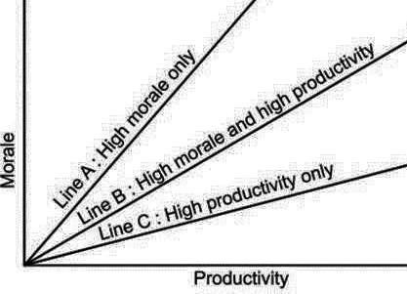These elements may overlap. Work environments reinforce culture on a daily basis by encouraging employees to exercise cultural values. Organizational culture is shaped by multiple factors, including the following:

* External environment
* Industry
* Size and nature of the organization's workforce
* Technologies the organization

uses

* The organization's history and

Ownership

**Types of Organisational Culture**

1. **Normative Culture:** In such a culture, the norms and procedures of the organization are predefined and the rules and regulations are set as per the existing guidelines.
2. **Pragmatic Culture:** Customer satisfaction is the main motive of the employees in a pragmatic culture.
3. **Academy Culture: H**ire skilled individuals,the roles and responsibilities are delegated according to the back ground, educational qualification and work experience of the employees.
4. **Baseball team Culture:** Advertising agencies, event management companies, financial institutions follow such a culture.
5. **Club Culture:** The high potential employees are promoted suitably and appraisals are a regular feature of such a culture.
6. **Fortress Culture:** There are certain organizations where the employees are not very sure about their career and longevity. Stock broking industries follow such a culture.
7. **Tough Guy Culture:** In a tough guy culture, feedbacks are essential. The employees are under constant watch in such a culture.
8. **Bet your company Culture:** Organizations which follow best your company culture take decisions which involve a huge amount of risk and the consequences are also unforeseen.
9. **Process Culture:** As the name suggests the employees in such a culture adhere to the processes and procedures of the organization. All government organizations follow such a culture.

### 2.5 LEADERSHIP

Leadership is the action of leading a group of people or an organization, or the ability to do this.Leadership involves:

1. establishing a clear vision,
2. sharing that vision with others so that they will follow willingly,
3. providing the information, knowledge and methods to realize that vision, and
4. Coordinating and balancing the conflicting interests of all members and stakeholders.

A leader steps up in times of crisis, and is able to think and act creatively in difficult situations.

**LEADERSHIP TRAITS (Characteristics of a good leader)**

The traits of an effective leader include the following:

1. **Emotional stability**. Good leaders must be able to tolerate frustration and stress.
2. **Dominance**. Leaders are often times competitive and decisive and usually enjoy overcoming obstacles.
3. **Enthusiasm**. Leaders are usually seen as active, expressive, and energetic. They are often very optimistic and open to change.
4. **Tough-mindedness**. Good leaders are practical, logical, and to-the-point.
5. **High energy**. Long hours and some travel are usually a prerequisite for leadership positions, especially as your company grows.
6. **Maturity**.Maturity is based on recognizing that more can be accomplished by empowering others than can be by ruling others.
7. **Charisma**. People usually perceive leaders as larger than life. Charisma plays a large part in this perception.

**THEORIES OF LEADERSHIP:**

1. **Trait Theory**: Individual characteristics of leaders are different than those of non-leaders.
2. **Behavioral Theories**: The behaviors of effective leaders are different than the behaviors of ineffective leaders. Two major classes of leader behavior are task-oriented behavior and relationship-oriented behavior.
3. **Participative Leadership**: This is a leadership theory in which the leader works closely with team members, focusing on building relationships and rapport.
4. **Situational Leadership**: On the basis of situation the capacity to set high but attainable goals, willingness and ability to take responsibility for the task, and relevant education and/or experience of an individual or a group for the task.
5. **Contingency Theories**: Factors unique to each situation determine whether specific leader characteristics and behaviors will be effective.
6. **Transactional Leadership**: Transactional leadership, also known as managerial leadership, focuses on the role of supervision, organization, and group performance; transactional leadership is a style of leadership in which the leader promotes compliance of his/her followers through both rewards and punishments.
7. **Transformational Leadership**: Transformational leadership is a style of leadership where the leader works with employees to identify the needed change, creating a vision to guide the change through inspiration, and executing the change in tandem with committed members of the group.

|  |  |  |
| --- | --- | --- |
| **BASIS FOR COMPARISON** | **TRANSACTIONAL LEADERSHIP** | **TRANSFORMATIONAL LEADERSHIP** |
| Meaning | A leadership style that employs rewards and punishments for motivating followers is Transactional Leadership. | A leadership style in which the leader employs charisma and enthusiasm to inspire his followers is Transformational Leadership. |
| Concept | Leader lays emphasis on his relation with followers. | Leader lays emphasis on the values, ideals, morals and needs of the followers. |
| Works for | Developing the existing organizational culture. | Changing the existing organizational culture. |
| Style | Bureaucratic | Charismatic |
| Focused on | Planning and Execution | Innovation |

**LEADERSHIP STYLES**

**1. Authoritarian**

The authoritarian leadership style keep main emphasis on the distinction of the authoritarian leader and their followers, these types of leaders make sure to only create a distinct professional relationship. Direct supervision is what they believe to be key in maintaining a successful environment and followership.

**2. Democratic**

The democratic leadership style consists of the leader sharing the decision-making abilities with group members by promoting the interests of the group members and by practicing social equality.

**3. Laissez-faire**

The laissez-faire leadership style is where all the rights and power to make decisions is fully given to the worker.This is an effective style to use when:

* Followers are highly skilled, experienced, and educated.
* Followers have pride in their work and the drive to do it successfully on their own.
* Outside experts, such as staff specialists or consultants are being used.
* Followers are trustworthy and experienced.

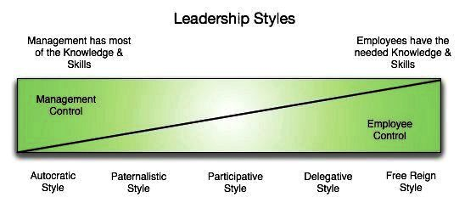

### 2.6 GROUP DYNAMICS

**Group dynamics**is a system of behaviour and psychological processes occurring within a social**group**(intragroup**dynamics**), or between social**groups**(intergroup**dynamics**).

The study of group dynamics can be useful in understanding decision-making behavior, tracking the spread of diseases in society, creating effective therapy techniques, and following the emergence and popularity of new ideas and technologies.

**GROUP:** A group is a collection of two or more people who have a common goal and interact with each other to accomplish their goal, are aware of one another and perceive themselves to be a part of the group.

**Characteristics of a Group**

1. Interaction between members
2. Awareness
3. Group perception
4. Common objectives

**TYPES OF GROUPS IN AN ORGANISATION**

**1. Small and Large Groups**

The smaller the group, the greater is the likelihood of close relationships, full participation, and consonance of aims.The larger the group, the greater is the pool of talent and experience available for solving problems or sharing the effort.It is a collection of a few small groups.

**2. Formal and Informal Groups**

Groups are majorly divided into two categories; first one is the formal groups, which are formed by the organization, to fulfill a task. The other one is an informal group, formed by the employees as per their likes, interests and attitudes.

**3. Primary and Secondary Groups**

A primary group is typically a small social group whose members share close, personal, enduring relationships. Examples include family, childhood friends, and highly influential social groups.People in a secondary group interact on a less personal level than in a primary group, and their relationships are temporary rather than long lasting.Examples of these would be employment, vendor-to-client relationships, etc.

**GROUP COHESIVENESS**

**Group cohesiveness**can be defined as a bond that pulls people toward membership in a particular group and resists separation from that group. In addition, group cohesion generally has three characteristics. They include the following:

1. **Interpersonal Attraction:** This means group members have a preference or want to interact with each other. Group members enjoy this interaction and seek it out.
2. **Group Pride:** This involves group members viewing their membership to a specific group with fondness. They feel proud of their group membership, and staying in the group feels valuable.
3. **Commitment to the Work of the Group:** Group members value the work of the group and believe in its goals. They are willing to work together to complete tasks which are aligned with these group goals, even through adversity.

Although cohesion is a multi-faceted process, it can be broken down into four main components: social relations, task relations, perceived unity, and emotions.

Members of strongly cohesive groups are more inclined to participate readily and to stay with the group. Cohesion can be more specifically defined as the tendency for a group to be in unity while working towards a goal or to satisfy the emotional needs of its members.

**FACTORS INFLUENCING GROUP COHESIVENESS**

Group size, degree of dependency, physical distances, time spent together, severity of initiation,cooperation, threat history of past successes are the major factors. These factors are influencing the group cohesiveness in an organization. We shall discuss about the above factors below:

1. Group size
2. Degree of Dependency
3. Physical Distance
4. Time spent Together
5. Severity of Initiation
6. Cooperation
7. Status
8. Threat
9. History of Past Successes