**Experiment No 4**

**SIMULATION OF SINGLE PHASE CONTROLLED RECTIFIER CONVERTER**

**Aim:** To simulate single phase controlled rectifier circuit for R load in MATLAB.

.

**SIMULATION BLOCKS** **:** AC voltage source, Thyristors, Pulse Generators (for Thyristor gate pulse) , Series RLC block (for R load) ,Voltage and Current measurement blocks, Scope and Display blocks, Powergui block (Continuous).

**Procedure:**

1. Create a new MATLAB model file and create the MATLAB model as shown in

figure 1 corresponding to the single phase controlled rectifier circuit.

2. Give the run time value as 0.08 secs to obtain simulation results for 4 input cycles

(4x1/50HZ=0.08 sec)

4. Run the simulation model and obtain the results.

5. Repeat the simulation for different values of firing angle with R loads.

**Result:**

1. Simulated single phase controlled rectifier circuit for R load using MATLAB.
2. The waveform of output dc voltage for R load is shown in figure.

**MATLAB MODEL:**

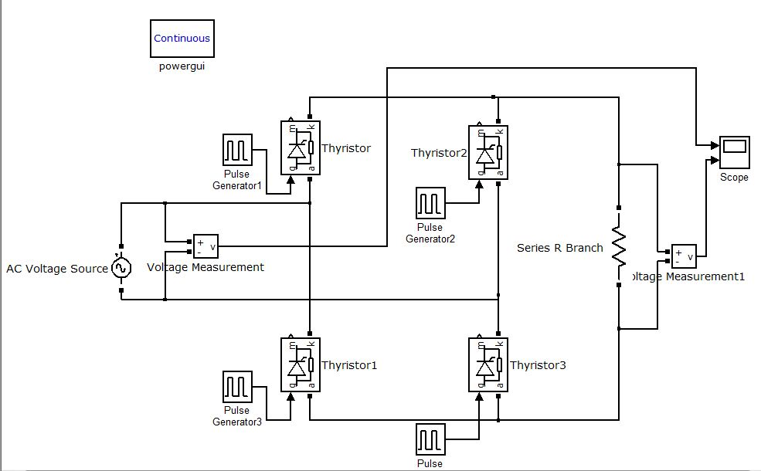

**WAVEFORMS:**

Output voltage waveform for firing angle =300 is shown in figure.

