**CHOPPER**

* A chopper is a static device which is used to obtain a variable dc voltage from a constant dc voltage source. A chopper is also known as dc-to-dc converter.
* The thyristor converter offers greater efficiency, faster response, lower maintenance, smaller size and smooth control.
* Choppers are widely used in trolley cars, battery operated vehicles, traction motor control,control of large number of dc motors, etc….. They are also used in regenerative braking of dc motors to return energy back to supply and also as dc voltage regulators.

Choppers are of two types:

*  Step-down choppers
*  Step-up choppers.

In step-down choppers, the output voltage will be less than the input voltage whereas in step-up

choppers output voltage will be more than the input voltage.

**STEP-DOWN CHOPPER WITH R-L LOAD**

Fig. 1 shows a step-down chopper with R-L load and free wheeling diode. When chopper is ON, the supply is connected across the load. Current flows from the supply to the load. When chopper is OFF, the load current *O i* continues to flow in the same direction through the freewheeling diode due to the energy stored in the inductor L. The load current can be continuous or discontinuous depending on the values of L and duty cycle, d. For a continuous current operation the load current is assumed to vary between two limits min *I* and max *I.*Figure shows the output current and output voltage waveforms for a continuous current and discontinuous current operation.



**Fig. 1: Step-down Chopper with R-L Load**

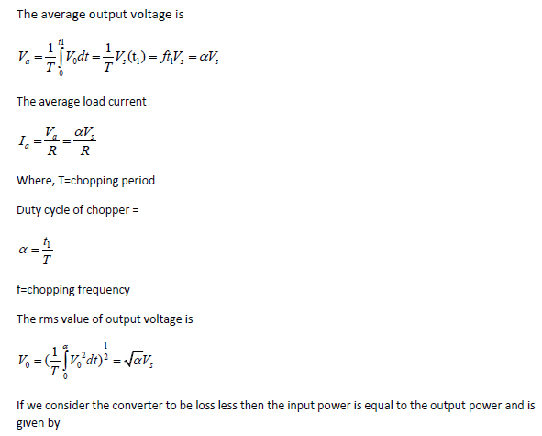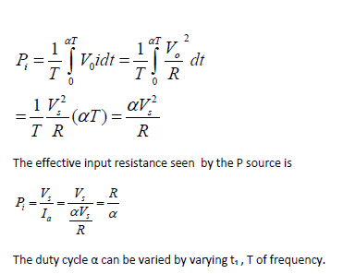

**PRINCIPLE OF STEP-UP CHOPPER**

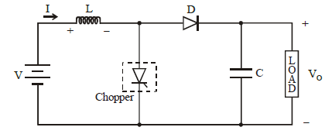

**Fig. 2: Step-up Chopper**

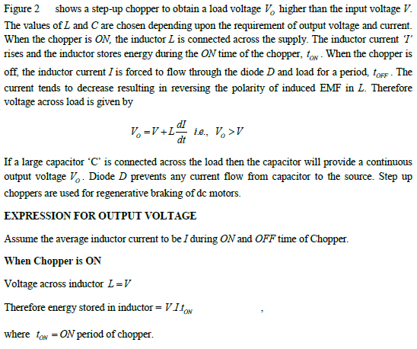

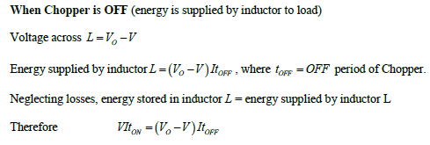

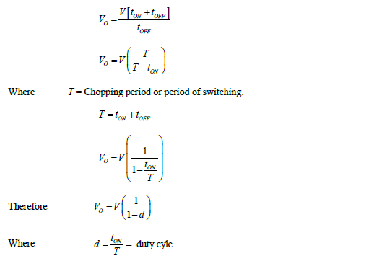

For variation of duty cycle‘d’ in the range of 0  *d* 1 the output voltage *Vo* will vary in the

range *Vo* *V*  .

**2.6 CLASSIFICATION OF CHOPPERS**

Choppers are classified as follows:

• Class A Chopper

• Class B Chopper

• Class C Chopper

* Class D Chopper

• Class E Chopper

**FIRST QUADRANT OR TYPE A CHOPPER:**

Figure 3 shows a Class A Chopper circuit with inductive load and free-wheeling diode. When

chopper is *ON,* supply voltage *Vs* is connected across the load i.e., *vo* *Vs* and current io flows as

shown in figure. When chopper is OFF, *v*o = 0 and the load current *io* continues to flow in the

same direction through the free wheeling diode. Therefore the average values of output voltage

and current i.e., *vo* and  *io* are always positive. Hence, Class A Chopper is a first quadrant

chopper (or single quadrant chopper). Class A Chopper is a step-down chopper in which power

always flows from source to load. It is used to control the speed of dc motor. The output current

equations obtained in step down chopper with R-L load can be used to study the performance of

Class A Chopper.

Figure 4 shows output voltage and current waveforms for a continuous load current.



**Fig. 3: Class A Chopper and** *vO* *iO* **Characteristic**

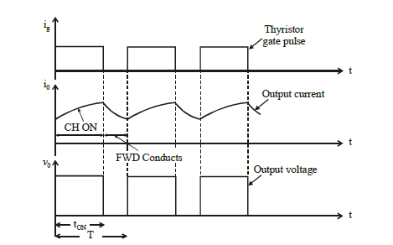

**Fig. 4: First quadrant Chopper - Output Voltage and Current Waveforms**

**SECOND QUADRANT OR TYPE B CHOPPER:**



**Fig. 5: Class B Chopper**

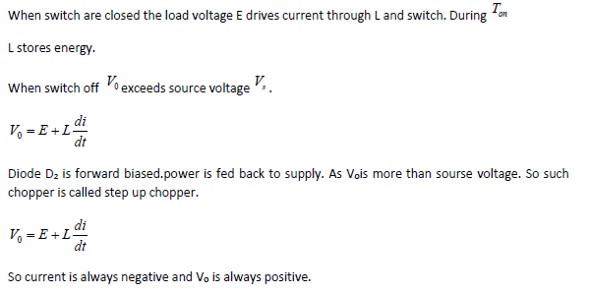

**TWO QUADRANT TYPE A CHOPPER OR, TYPE C CHOPPER:**



**Fig. 6: Class C Chopper**

Class C Chopper is a combination of Class A and Class B Choppers. Figure 6 shows a Class

C two quadrant Chopper circuit. For first quadrant operation, CH1 is ON or D2conducts and for second quadrant operation, CH2 is ON or D1conducts. When *CH1* is ON, the load current *io* is positive. i.e., *io* flows in the direction as shown in figure 6.

The output voltage is equal to s*V* *vO* *Vs*  and the load receives power from the source.

When CH1 is turned OFF, energy stored in inductance L forces current to flow through the diode D2 and the output voltage *vo*  , but *io* continues to flow in positive direction. When CH2is triggered; the voltage E forces *io* to flow in opposite direction through L and CH2. The output voltage *vo*  . On turning OFF CH2, the energy stored in the inductance drives current through diode *D1* and the supply; output voltage *vo* *Vs* the input current becomes negative and power flows from load to source.

Thus the average output voltage *vo* is positive but the average output current *io* can take both

positive and negative values. Choppers CH1 and CH2should not be turned ON simultaneously

as it would result in short circuiting the supply. Class C Chopper can be used both for dc motor

control and regenerative braking of dc motor. Figure 7 shows the output voltage and current

waveforms.

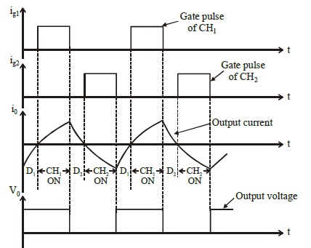

**Fig. 7: Class C Chopper - Output Voltage and Current Waveforms**

**TWO QUADRANT TYPE B CHOPPER OR TYPE D CHOPPER:**



**Fig. 8: Class D Chopper**

When CH1 and CH2 both are on then Vo=Vs. When CH1 and CH2 are off and D1 and D2 are on Vo=-Vs. The direction of current is always positive because chopper and diode can only conduct in the direction of arrow shown in fig. 8. Average voltage is positive when Ton>Toff.

**FOUR QUADRANT CHOPPER OR TYPE E CHOPPER**



**Fig. 9: Class E Chopper**

**FIRST QUADRANT:**

CH4 is kept ON

CH3 is off

CH1 is operarted

Vo=Vs

i0 = positive

when CH1 is off positive current free wheels through CH4,D2

so V0 and I2 is in first quadrant.

**SECOND QUADRANT:**

CH1, CH3, CH4 are off.

CH2 is operated.

Reverse current flows and I is negative through L CH2 D4 and E.

When CH2 off D1 and D4 is ON and current id fed back to source. So E + L di/dt is more than source voltage Vs. As io is negative and Vo is positive, so second quadrant operation.

**THIRD QUADRANT:**

CH1 OFF, CH2 ON

CH3 operated. So both V0 and i0 is negative.

When CH3 turned off negative current freewheels through CH2 and D4.

**FOURTH QUADRANT:**

CH4 is operated other are off.

Positive current flows through CH4 E L D2.

Inductance L stores energy when current fed to source through D3 and D2.Vo is negative.

Figure 9 shows a class E 4 quadrant chopper circuit. When *CH1* and *CH4* are triggered, output current *io* flows in positive direction through *CH1* and *CH4,* with output voltage *vo* *Vs* . This gives the first quadrant operation. When both CH1 and CH4are OFF, the energy stored in the inductor L drives *io* through *D3* and D2in the same direction, but output voltage *vo*  *Vs* . Therefore the chopper operates in the fourth quadrant. For fourth quadrant operation the direction of battery must be reversed. When *CH2* and *CH3* are triggered, the load current *io* flows in opposite direction and output voltage *vo*  *Vs* .

Since both  *io* and *vo* are negative, the chopper operates in third quadrant. When both *CH2* and

*CH3* are OFF, the load current *O i* continues to flow in the same direction through *D1* and *D4*

and the output voltage *vo* *Vs* . Therefore the chopper operates in second quadrant as *vo* is

positive but *io* is negative.