**SYNCHRONOUS MOTOR**

Synchronous motor mainly runs on **principle of magnetic locking between rotor and RMF (Rotating magnetic field)**.When two unlike poles are brought near each other, if the magnets are strong, there exists a tremendous force of attraction between those two poles. In such condition the two magnets are said to be magnetically locked.

Consider a 3-phase synchronous motor having two rotor poles NR and SR. Then the stator will also be wound for two poles NS and SS. The motor has direct voltage applied to the rotor winding and a 3-phase voltage applied to the stator winding. The stator winding produces a rotating field which revolves round the stator at synchronous speed Ns (= 120 f/P). The direct current sets up a two-pole field which is stationary so long as the rotor is not turning. Hence, we have a situation in which there exists a pair of revolving armature poles (i.e., NS - SS) and a pair of stationary rotor poles (i.e., NR - SR).

Suppose at any instant, the stator poles are at positions A and B as shown in Fig: 1. It is seen that poles NS and NR repel each other and so do the poles SS and SR. Therefore, the rotor tends to move in the anticlockwise direction. After a period of half-cycle, the polarities of the stator poles are reversed but the polarities of the rotor poles remain the same as shown in Fig: 1. Now SS and NR attract each other and so do NS and SR. Therefore, the rotor tends to move in the clockwise direction. Since the stator poles change their polarities rapidly, they tend to pull the rotor first in one direction and then after a period of half-cycle in the other. Due to high inertia of the rotor, the motor fails to start. Hence, a synchronous motor has no self starting torque i.e., a synchronous motor cannot start by itself.

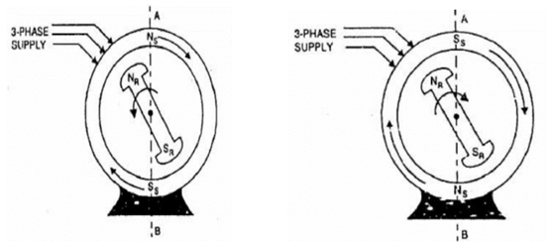

**Fig: 1.** Action of Synchronous Motor.

**Methods of Starting of Synchronous Motor**

Synchronous motor is not self starting. It is necessary to rotate the rotor at a speed very near to synchronous speed. This is possible by following methods:

**1.** Using pony motors **2.** Using damper winding **3.** Using small d.c. machine coupled to it.

**1. Using pony motors:** In this method, the rotor is brought to the synchronous speed with the help of some external device like small induction motor. Such an external device is called 'pony motor'. Once the rotor attains the synchronous speed, the d.c. excitation to the rotor is switched on. Once the synchronism is established pony motor is decoupled. The motor then continues to rotate as synchronous motor.

**2. Using Damper Winding:** In a synchronous motor, in addition to the normal field winding, the additional winding consisting of copper bars placed in the slots in the pole faces. The bars are short circuited with the help of end rings. Such an additional winding on the rotor is called damper winding. This winding as short circuited, acts as a squirrel cage rotor winding of an induction motor. The schematic representation of such damper winding is shown below-

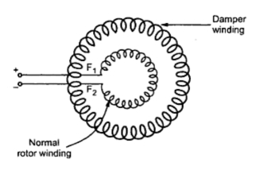

**Fig: 2.** Starting as a squirrel cage Induction Motor.

Once the rotor is excited by a three phase supply, the motors starts rotating as an induction motor at sub synchronous speed. Then d.c. supply is given to the field winding. At a particular instant motor gets pulled into synchronism and starts rotating at a synchronous speed. As rotor rotates at synchronous speed, the relative motion between damper winding and the rotating magnetic field is zero. Hence when motor is running as synchronous motor, there can not be any induced e.m.f. in the damper winding. So damper winding is active only at start, to run the motor as an induction motor at start. Afterwards it is out of the circuit. As damper winding is short circuited and motor gets started as induction motor, it draws high current at start so induction motor starters like star-delta, autotransformer etc. used to start the synchronous motor as an induction motor.

**3. Using Small D.C. Machine:** Many times, large synchronous motors are provided with a coupled d.c. machine. This machine is used as a d.c. motor to rotate the synchronous motor at a synchronous speed. Then the excitation to the rotor is provided. Once motor starts running as a synchronous motor, the same d.c. machine acts as a d.c. generator called exciter. The field of the synchronous motor is then excited by this exciter itself.

**Hunting**

The word hunting is used because after sudden application of load the rotor has to search or hunt for its new equilibrium position. This phenomena is referred as **hunting in synchronous motor**. A steady state [operation of synchronous motor](http://www.electrical4u.com/synchronous-motor-working-principle/) is a condition of equilibrium in which the electromagnetic torque is equal and opposite to load torque. In steady state, rotor runs at synchronous speed thereby maintaining constant value of torque angle (δ).

Unloaded synchronous machine has zero degree load angle. On increasing the shaft load gradually, load angle will increase. Let us consider that load P1 is applied suddenly to unloaded machine shaft, so machine will slow down momentarily. Also load angle (δ) increases from zero degree and becomes δ1. During the first swing [electrical power](http://www.electrical4u.com/electric-power-single-and-three-phase/" \o "Single and Three Phase Electric Power ) developed is equal to mechanical load P1. Equilibrium is not established so rotor swings further. Load angle exceeds δ1 and becomes δ2. Now [electrical power](http://www.electrical4u.com/electric-power-single-and-three-phase/" \o "Single and Three Phase Electric Power ) generated is greater than the previous one. Rotor attains synchronous speed. But it does not stay in synchronous speed and it will continue to increase beyond synchronous speed. As a result of rotor acceleration above synchronous speed the load angle decreases. So once again no equilibrium is attained. Thus rotor swings or oscillates about new equilibrium position. This phenomenon is known as hunting or phase swinging.

Phenomenon of oscillation of rotor about its final equilibrium position is called hunting. Since during rotor oscillation, the phase of phasor Ef changes relative to phasor V, hence hunting is also known phase swinging. When there is sudden change in load, the rotor attempts to search or hunt for its new equilibrium position.

**Causes of Hunting in Synchronous Motor:**

1. Sudden change in load.
2. Sudden change in field current.
3. A load containing harmonic torque.
4. Fault in supply system.

**Effect of Hunting:**

1. It may lead to loss of synchronism.
2. Produces mechanical stress.
3. Increases machine losses & cause temperature rise.
4. Causes greater surge in current & power flow.

**Reduction of Hunting:** Two techniques should be used to reduce hunting. These are –

1. Use of damper winding.
2. Use of fly wheels.

**Synchronous machine Excitation**

When synchronous motor is working at constant applied voltage V, the resultant air gap flux as demanded by voltage remains constant. This resultant air gap flux is established by the co-operation of both ac supply of armature winding & dc supp­­­ly of rotor winding. When motor p.f is unity, the motor dc excitation is said to be normal. Over excitation causes motor to operate as a leading p.f. Under excited causes it operates as a lagging p.f.

**Case-1:** When the field current is sufficient enough to produce air gap flux, as demanded by the supply voltage, then magnetizing current lagging reactive volt-ampere required from AC source is zero and the motor operates at unity power factor. Field current which causes this unity p.f is called normal excitation or Normal field current, i.e. Ef = V

**Case-2:** If field current is not sufficient enough to produce required air gap flux as demanded by V, additional magnetizing current or lagging reactive V-A is drawn from AC source. This magnetizing current produces the deficient flux (constant flux -flux set up by dc supply rotor winding). Hence in this case the motor operate under lagging power factor and it is said to be under excited. i.e. Ef < V.

**Case-3:** If field current is more than normal field current, motor is said to be overexcited. This excess field current produces excess flux which must be neutralize by armature winding. Hence armature winding draws leading reactive volt ampere or demagnetizing current, leading the voltage by almost 900 from AC source. Hence in this case motor operate under leading power factor. i.e. Ef > V. For a given load, the power factor is governed by the field excitation; a weak field produces the lagging armature current and a strong field produces a leading armature current.

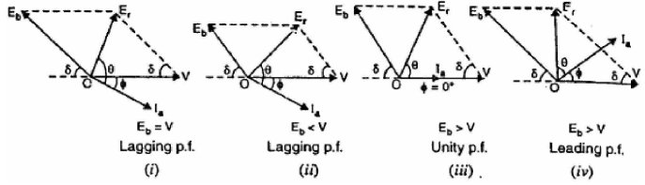

**Fig: 3**. Operation of Synchronous motor at variable excitation.

**V-Curve OF SYNCHRONOUS MOTOR**

“The whole concept of excitation & power factor of synchronous motor can be summed up in the V- curve of synchronous motor”. The power factor of a synchronous motor can be controlled by the variation of field current if. The armature current Ia changes with the change in field current If. If field current (If) increases the armature current Ia decreases. Hence variation in excitation or in field current causes the variation in armature current & the curve drawn between armature current & field current for different constant load is called V-curve. The V-curve of synchronous motor gives relation between armature current & field current for different power inputs.

Similarly variation of power factor with a variation in field current (dc excitation) for a constant load given inverted V-curve.

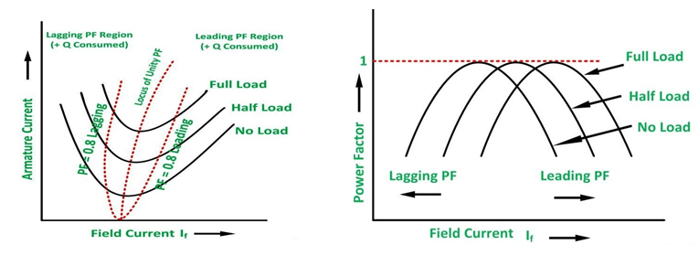

**Fig: 4.** V -Curve and Inverted V- curve for variable excitation.

**Synchronous Condenser or Compensator**

In electrical engineering, a **synchronous condenser** (sometimes called **synchronous compensator**) is a device identical to a synchronous motor, whose shaft is notconnected to anything but spins freely.

When motor is operated at no load with over excitation, it takes a current that leads voltage by nearly 900. In this way it behaves like a capacitor and under such operating condition the synchronous motor is called as synchronous capacitor. It is also known as synchronous Compensator or synchronous phase modifier. A synchronous compensator is therefore a synchronous motor running without mechanical load.

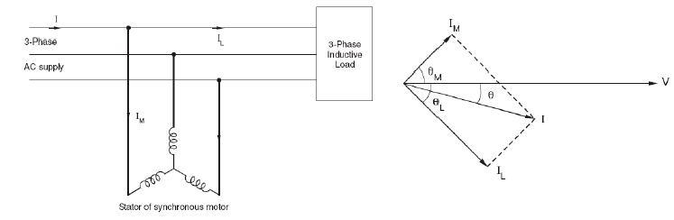

**Fig: 5.** Synchronous Motor working as a Synchronous Condenser.