**Experiment No 3**

**SIMULATION OF SPEED CONTROL OF DC MOTOR DRIVE**

**Aim:** Speed control of DC motor using MATLAB/SIMULINK.

**SIMULATION BLOCKS** **:** DC Motor, DC voltage source, Universal Bridge(IGBT) ,Voltage and Current measurement blocks, Gain block, Scope and Display blocks, Powergui block (Continuous).

**Procedure:**

1. Create a new MATLAB model file and create the MATLAB model for separately

excited dc motor.

2. Give the run time value as 2 secs.

3. Set the input dc voltage and run the simulation model and obtain the results for

constant load by varying the supply voltage.

**Result:**

1. Simulated separately excited dc motor using MATLAB.
2. The waveform of speed for different input dc voltage and constant load is shown in figure.

**MATLAB MODEL:**

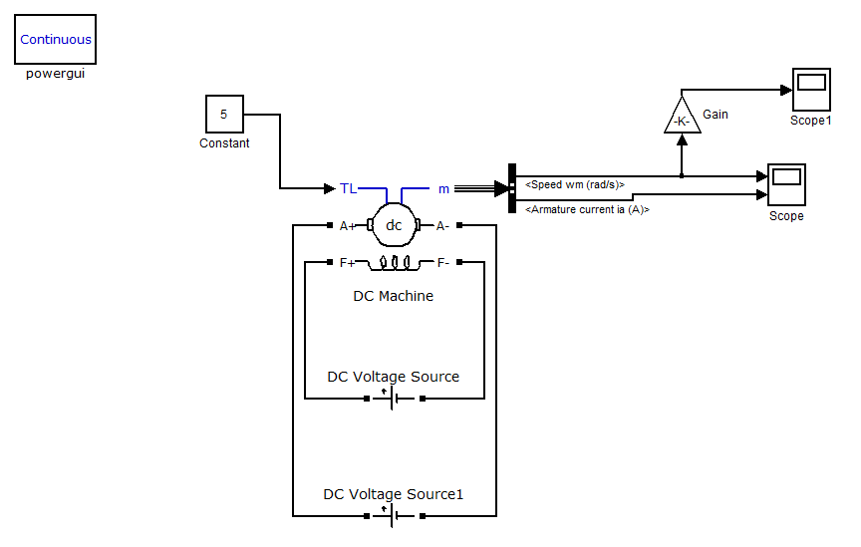

**WAVEFORMS:**

Speed waveforms at different voltage levels for constant load are shown in figure.

