**Experiment No 2**

**SIMULATION OF THREE PHASE SINE INVERTER**

**Aim:** To simulate Three Phase Sine Inverter for R-L Load in MATLAB.

**SIMULATION BLOCKS:** DC voltage source, MOSFET , Series RLC block (for RL load) ,Voltage and Current measurement blocks, Scope and Display blocks, Powergui block (Continuous).

**Procedure:**

1. Create a new MATLAB model file and create the MATLAB model as shown in

figure 1 corresponding to the three phase inverter circuit.

2. Give the run time value as 0.08 secs to obtain simulation results for 4 output ac cycles

(4x1/50HZ=0.08 sec)

3. Run the simulation model and obtain the results.

**Result:**

1. Simulated three phase sine PWM inverter circuit using MATLAB
2. The phase voltage waveform of three phase inverter for –L load is shown in figure.

**MATLAB MODEL:**

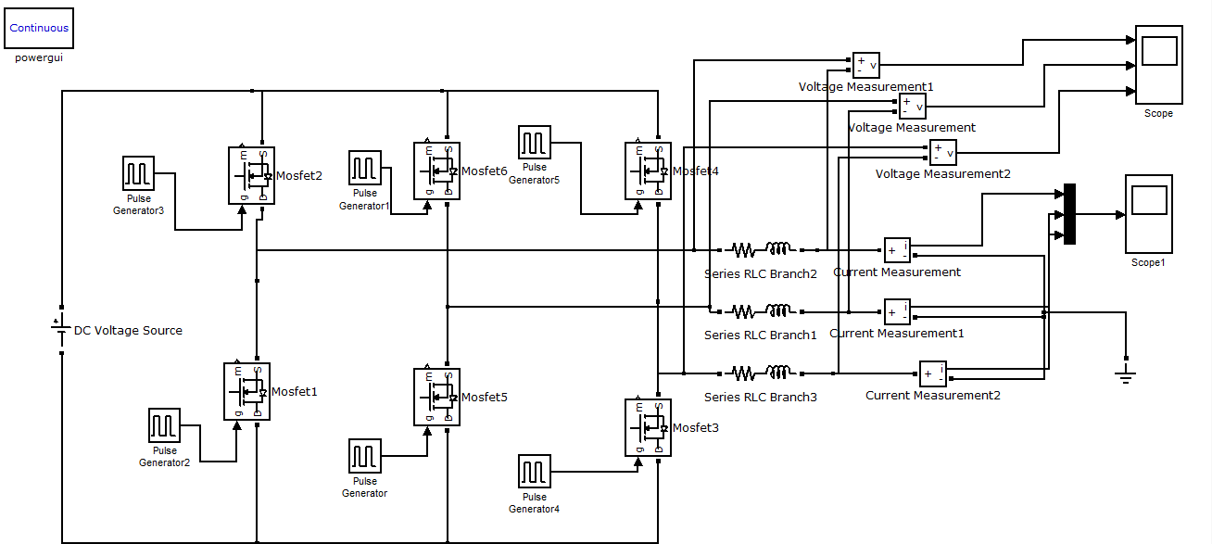

**WAVEFORMS:**

Output phase voltage waveform of three phase inverter for R-L load.

