**MOST IMPORTANT QUESTIONS 2017-18 – PHYSICS 2ND**

**Question 1**: Write meissner effect.Discuss B.C.S theory of superconductivity.

**Meissner effect**: Exlussion of magnetic line of forces from the interior of the substance in superconducting state is known as meissner effect.

At superconducting state, B=0

Again, B=µo(H+M),

⇒ 0 = µo(H+M), ⇒ H = -M

∴ magnetic susceptibility χ = $\frac{M}{H}$ = $\frac{-H}{H}$ = -1 i.e perfect diamagnetic behavior;

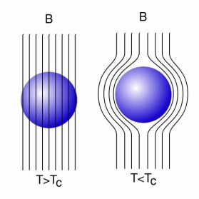

**BCS Theory of Superconductivity**

The concept of almost zero resistivity is given by Bardeen, Leon Cooper, and Robert Schrieffer in what is commonly called the BCS theory. A key conceptual element in this theory is the pairing of electrons into [Cooper pairs](http://hyperphysics.phy-astr.gsu.edu/hbase/Solids/coop.html#c1) through interaction with the positive ions vibration (called PHONON) in crystal lattice. This coupling of electrons to the lattice vibration is called a phonon interaction.

Due to the presence of cooper pair, reduces the collisions of ion and eletron which reduces the [resistivity](http://hyperphysics.phy-astr.gsu.edu/hbase/electric/resis.html#c2). For temperatures such that the [thermal energy](http://hyperphysics.phy-astr.gsu.edu/hbase/kinetic/eqpar.html#c2) is less than the band gap, the material exhibits zero resistivity.

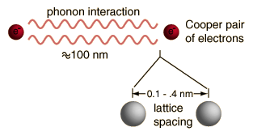

**Question 2:** What is Compton effect? Derive the formula for Compton shift. Why comption shift is not observed in visible light ?

**Answer2**: When a X rays photon is incident on an rest electron,there is a decrease in energy of the photon of X rays as a part of energy its initial energy is transferred to the electron which is scattered. This effect is called the **Compton effect or Compton Scattering.**

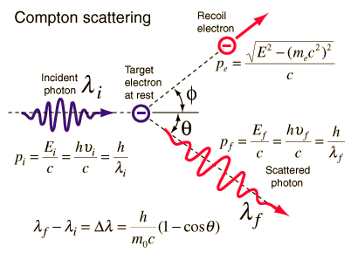

After scattering,two types of wavelengths are detected,

1. Modified wavelength
2. Unmodified wavelength

Using Conservation of energy

https://qph.fs.quoracdn.net/main-qimg-1c00e5304238cb11082b1c9c56044a40

Conservation of momentum

https://qph.fs.quoracdn.net/main-qimg-9f8c19f448ff7015d25e7992298776cc

where p=E/c is used for the photon momentum. Squaring this equation using the scalar product gives

https://qph.fs.quoracdn.net/main-qimg-d0e95cc97197fe5f6eb63d771eecc456

https://qph.fs.quoracdn.net/main-qimg-b080185a5097c9011ec8a99e0eec0686

https://qph.fs.quoracdn.net/main-qimg-aa2345bf6f612f7ffe6b412067387c02

https://qph.fs.quoracdn.net/main-qimg-bf77819b963146c72c4f5081feef5129

https://qph.fs.quoracdn.net/main-qimg-4b8ba7878c78d9f4d34db8cca9535f07

**Comption shift is not visible in visible region:**Because the energy of visible light is too small. In other words, the change in wavelength which is of the order of Compton wavelength of the electron (about 0.024 Å) may be too small compared to the frequency of the incident radiation.

**Question 3**: Explain internal field in solid dielectric. Obtain classius mossotti equation.

## Answer: Internal field inside dielectrics: The internal field or the local field may be defined as the electric field which acts at the location of a given atom subjected to an external electric field and is the resultant of the applied field and the field due to all surrounding dipoles.

Let us consider a one-dimensional solid dielectric consisting of a string of equidistant tatoms as shown in Fig. Each atom has polarizability αe. Let us consider that anelectric field E is applied in the direction parallel to the string**.**

 The aim is to determine the net internal field Ei experienced by one of the atoms (say A).From symmetry consideration, Ei will be parallel to E.

The dipole moment induced in each atom, **μ= αoΕ**

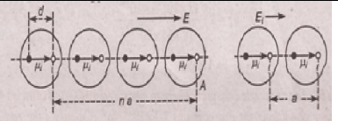

where αe is the polarizability of each atom.

The electric field at Point A due to the dipole induced in an atom located at a distance na from it is

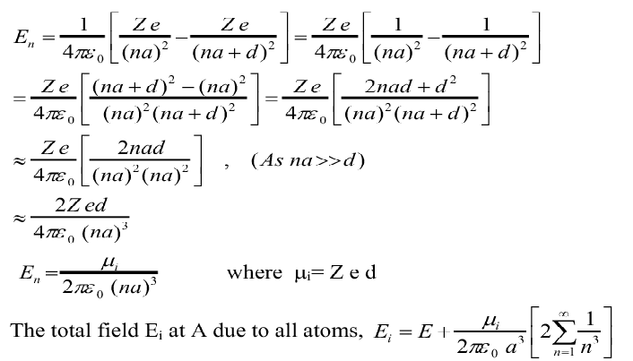

Here factor 2 in the small bracket becoz atoms are present on both side of point A.

$E_{i }≅E+ \frac{1.2μ_{i}}{πε_{o}a^{3}}$ $\left[As \sum_{n=1}^{∞}{\frac{1}{a^{3}} ≈1.2}\right]$

$E_{i }≅E+ \frac{ P}{3ε_{o}}$------------------------------(a)

This is the formula for internal field. This equation also known as Lorentz field.

## Clausius Mossotti's equation

It gives the relation between the dielectric constant and the ionic polarizability of atoms in dielectric material. If there are N number of atoms, the dipole moment per unit volume which is called Polarization is given by,

Picture

we know internal field

Picture

From above equations

Picture

Picture

Picture

we know polarization from the relation between polarization and dielectric constant

Picture

from the above two equations we get,

Picture

Picture

Picture

**Question 4:** Derive the formula for conductivity and resisitivity of intrinsic and extrinsic semiconductor.

**Answer: conductivity in semiconductors:**

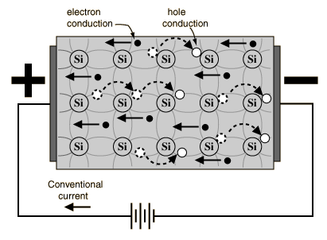

In a Semi-Conductor of length (ℓ) and area of Cross-Section. Let ne and nh be the no. of electrons and holes with drift velocities Ve and Vh respectively.

So, the total current in the semi-conductor will be the sum of current due to electrons as well as holes,

i.e.        **I = Ie + Ih                     -------------------------------------** (1)

As we know that,current density due to electron is,

J = **ne A Vd**

And currents in semiconductors due to holes and electrons is,

**Ie = ne e A Ve**

And

**Ih = nh e A Vh**

Total current in semiconductor is

**I = ne e A Ve + nh e A Vh**

**I = eA[ne  Ve + nh vh]**

**I/A = e[ne  Ve + nh vh]**  -------------------- (2)

As we know that

Ve ∝ E = μe E and Vh ∝ E = μh E Where μe  and μh is the mobility of electron and hole respectively. So eq 2 written as,

**I/A = e[ne μe E   + nh μh E ]**

**J =    e [ne μe   + nh μh ] E** --------------------------(3)**(J = I/A)**

Again we know by definition of current density

**J = σ E** ---------------------------------------(4)

Compare eq. 3 and eq. 4

**σ = e [ne μe   + nh μh ]**--------------------------------(5)

**again we know that**

**conductivity σ = $\frac{1}{resistivityρ}$**

**resistivity (ρ) = $\frac{1}{e[n_{e} μ_{e} + n_{h}μ_{h}]}$---------------(**6**)**

**case I: for intrinsic semiconductor, nh = ne =ni,**

**σi = e ni [μe  + μh ]-----------------------------------------------(7)**

**case II: for extrinsic semiconductor,**

**⇒(A) for n type ne >>> nh ⇒ ne ≈ ND**

**σn = e ND μe -------------------------------------------(8)**

**⇒(B) for P type nh >>> ne ⇒ nh ≈ NA**

**σp = e NA μh ------------------------------------------(9)**

***note: ~~langavin’s theory and e.m wave equation for free space and position of Fermi level in intrinsic semiconductor are also most important for semester exams.~~***

**Question 5:** (**a**). If the earth receives 2 cal –min-1- cm-2 solar energy. What are the amplitudes of electric and magnetic fields of radiation?

**Answer**: we have P= (E×H)

The energy flux per unit area per second is given by

⎢P⎢= ⎢(E×H) ⎢= EH sin 900= EH

The energy flux per unit area per second at the surface

⎢P⎢= 2 cal.min-1 cm-2 =

Or EH = 1400 joule m-2 sec-1 -------- (1)

= = 376.72 ohm -------- (2)

Multiplying equations 1 and 2 we get

EH × $\frac{E}{H}$ = 1400 × 376.72

Or E2 = 527408

Or E = 726.2 $\frac{V}{m}$

Substituting the value of E in equation (1) we get

726.2H = 1400

Or H = $\frac{1400}{726.2}$ = 1.928 $\frac{amp-turn}{m}$

Therefore, the amplitudes of electric and magnetic field of radiation are

E0 = E√2 = 726.2√2 = 1026.8

H0 = H√2

= 1.928 √2

= 2.726 $\frac{amp-turn}{m}$

**5(b).** The atomic weight and density of sulphur are 32 and 2.08 gm/cm3 respectively the

electronic polarizability of the atom is 3.28x10-40F-m2.what will be the relative

Permittivity?

**Answer:** we know that

$\frac{ε_{r}-1}{ε_{r}+2 }$ = $\frac{Nα_{e}}{3ε_{0}}$ = $\frac{N_{A} }{M } \frac{α_{e}}{3ε_{0}}$

$\frac{ε_{r}-1}{ε_{r}+2 }= \frac{\left(6.023{10}^{26}\right)\left(2.08{10}^{3}\right)(3.28{10}^{-40 })}{323(8.85{10}^{-12})}$

Or $\frac{ε_{r}-1}{ε_{r}+2 }$ = 0.483

Or $ε_{r}-1$ = 0.483 $ε_{r}$ + 0.966

Or $ε_{r}$ = $\frac{1.966}{0.517 }$ = 3.8

**Question6 (a).** (i) Find the Conductivity of intrinsic semiconductor Silicon at 300K. Intrinsic carrier concentration of silicon i.e. = 1.5x1016m-3. Mobilities of electrons and holes are 0.13m2/V-s and 0.05m2/V-s respectively.

(ii) If a donor type impurity is added to the extent of one impurity atom in108 silicon atom, find conductivity.

(iii) If acceptor type impurity is added to the extent of one impurity atom in108 silicon atom, find conductivity. There are 5x1028 silicon atom/m3.

**Answer:** (i) the intrinsic conductivity is given by

= e (

= (1.6 × 10-19) × (1.5× 10 16) × (0.13+0.05)

= 0.432× 10-3S

(ii) If there is one donor per 108 Si atoms, then

ND  = = 5× 1020

Now = e ND

= (1.6× 10-19 ×5××0.13)

=10.4S

(iii) If there is one acceptor/ ${10}^{8}$ Si atom

= = 5× 1020

Now e

= (1.6× 10-19 ×5××0.05)

= 4 S

**6(b):** A superconducting material has a critical temperature of 3.7 K in zero magnetic field of 0.0306 tesla at 0 K .Find the critical field at 2 K.

**Answer:**  = [ 1-)2]

= 0.0306[ 1-)2]

= 0.0217 tesla