UNIT-II

**--------------------------------------------------------------------------------------------------------**

**Plant Description**: Morphology and anatomy of leaves, woods, barks, inflorescences and flowers, fruits and seed

**--------------------------------------------------------------------------------------------------------**

# Leaf

A leaf is an [organ](https://en.wikipedia.org/wiki/Organ_%28anatomy%29) of a [vascular plant](https://en.wikipedia.org/wiki/Vascular_plant) and is the principal lateral appendage of the stem. The leaves and stem together form the [shoot](https://en.wikipedia.org/wiki/Shoot). Foliage is a [mass noun](https://en.wikipedia.org/wiki/Mass_noun) that refers to leaves collectively.

Typically a leaf is a thin, [dorsiventrally flattened](https://en.wikipedia.org/wiki/Dorsiventral) organ, borne above ground and specialized for [photosynthesis](https://en.wikipedia.org/wiki/Photosynthesis). In most leaves, the primary [photosynthetic](https://en.wikipedia.org/wiki/Photosynthesis) tissue, the ([palisade mesophyll](https://en.wikipedia.org/wiki/Palisade_mesophyll)), is located on the upper side of the blade or lamina of the leaf[[1]](https://en.wikipedia.org/wiki/Leaf#cite_note-FOOTNOTEEsau2006-1) but in some species, including the mature foliage of [*Eucalyptus*](https://en.wikipedia.org/wiki/Eucalyptus) palisade mesophyll is present on both sides and the leaves are said to be isobilateral. Most leaves have distinctive upper (adaxial) and lower (abaxial) surfaces that differ in colour, hairiness, the number of [stomata](https://en.wikipedia.org/wiki/Stomata) (pores that intake and output gases), [epicuticular wax](https://en.wikipedia.org/wiki/Epicuticular_wax) amount and structure and other features.

Broad, flat leaves with complex venation are known as [megaphylls](https://en.wikipedia.org/wiki/Megaphylls) and the species that bear them, the majority, as broad-leaved or megaphyllous plants. In others, such as the [clubmosses](https://en.wikipedia.org/wiki/Clubmosses), with different evolutionary origins, the leaves are simple, with only a single vein and are known as microphylls.

Some leaves, such as [bulb](https://en.wikipedia.org/wiki/Bulb) scales are not above ground, and in many aquatic species the leaves are submerged in water. Succulent plants often have thick juicy leaves, but some leaves are without major photosynthetic function and may be dead at maturity, as in some [cataphylls](https://en.wikipedia.org/wiki/Cataphyll), and [spines](https://en.wikipedia.org/wiki/Thorns,_spines,_and_prickles)). Furthermore, several kinds of leaf-like structures found in vascular plants are not totally homologous with them. Examples include flattened plant stems called [phylloclades](https://en.wikipedia.org/wiki/Phylloclade) and cladodes, and flattened leaf stems called [phyllodes](https://en.wikipedia.org/wiki/Petiole_%28botany%29) which differ from leaves both in their structure and origin. Many structures of non-vascular plants, such as the [phyllids](https://en.wikipedia.org/wiki/Glossary_of_botanical_terms#phyllid) of [mosses](https://en.wikipedia.org/wiki/Mosses) and [liverworts](https://en.wikipedia.org/wiki/Liverworts) and even of some [foliose lichens](https://en.wikipedia.org/wiki/Foliose_lichen), which are not [plants](https://en.wikipedia.org/wiki/Plant) at all (in the sense of being members of the kingdom [Plantae](https://en.wikipedia.org/wiki/Plant)), look and function much like leaves.

## General characteristics

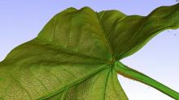[Play media](https://upload.wikimedia.org/wikipedia/commons/d/d8/3D_rendering_of_a_micro_CT_scan_of_a_piece_of_dried_leaf..ogg)

3D rendering of a [computed tomography](https://en.wikipedia.org/wiki/Computed_tomography) scan of a leaf

Typically leaves are broad, flat and thin (dorsiventrally flattened), at least in their early development, thereby maximising the surface area directly exposed to [light](https://en.wikipedia.org/wiki/Light) and enabling the light to penetrate the [tissues](https://en.wikipedia.org/wiki/Tissue_%28biology%29) and reach the [chloroplasts](https://en.wikipedia.org/wiki/Chloroplast), thus promoting [photosynthesis](https://en.wikipedia.org/wiki/Photosynthesis). They are arranged on the plant so as to expose their surfaces to light as efficiently as possible without shading each other, but there are many exceptions and complications. For instance plants adapted to windy conditions may have [pendent](https://en.wikipedia.org/wiki/Pendent) leaves, such as in many [willows](https://en.wikipedia.org/wiki/Willow) and [eucalypts](https://en.wikipedia.org/wiki/Eucalypts). Also [conifers](https://en.wikipedia.org/wiki/Conifers), whose leaves are needle shaped. The flat, or laminar, shape also maximises[thermal](https://en.wikipedia.org/wiki/Thermal_radiation) contact with the surrounding [air](https://en.wikipedia.org/wiki/Air). The leaf shape also minimises damage from wind, by creating [turbulence](https://en.wikipedia.org/wiki/Turbulence) rather than resistance.[[*citation needed*](https://en.wikipedia.org/wiki/Wikipedia:Citation_needed)] Functionally, in addition to photosynthesis the leaf is the principal site of [transpiration](https://en.wikipedia.org/wiki/Transpiration) and [guttation](https://en.wikipedia.org/wiki/Guttation). Leaves also function to store chemical [energy](https://en.wikipedia.org/wiki/Energy) and water (especially [succulents](https://en.wikipedia.org/wiki/Succulents)) and may become specialised organs serving other functions

### Basic leaf types

[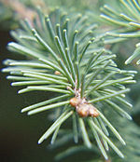](https://en.wikipedia.org/wiki/File:Fichtennadel_(crop).jpg)

Leaves of the White Spruce (*[Piceaglauca](https://en.wikipedia.org/wiki/Picea_glauca" \o "Picea glauca)*) are needle-shaped and their arrangement is spiral

* [Ferns](https://en.wikipedia.org/wiki/Fern) have [fronds](https://en.wikipedia.org/wiki/Fronds)
* [Conifer](https://en.wikipedia.org/wiki/Conifer) leaves are typically needle- or awl-shaped or scale-like
* [Angiosperm](https://en.wikipedia.org/wiki/Flowering_plant) (flowering plant) leaves: the standard form includes [stipules](https://en.wikipedia.org/wiki/Stipules), a [petiole](https://en.wikipedia.org/wiki/Petiole_%28botany%29), and a [lamina](https://en.wikipedia.org/wiki/Glossary_of_botanical_terms#lamina)
* [Lycophytes](https://en.wikipedia.org/wiki/Lycopodiophyta) have [microphyll](https://en.wikipedia.org/wiki/Microphyll) leaves.
* [Sheath](https://en.wikipedia.org/wiki/Monocotyledon) leaves (type found in most [grasses](https://en.wikipedia.org/wiki/Poaceae) and many other monocots)
* Other specialized leaves (such as those of [*Nepenthes*](https://en.wikipedia.org/wiki/Nepenthes), a pitcher plant)
* **The leaf is a part of the plant that is charge of making food for the plant. This food making process is called photosynthesis.**
* **Parts of the leaf**
* **The leaf consists of the following parts:**
* **Petiole - a thin stalk that connects the blad of the leaf to the plant's stem. These veins are called**
* **Blade - a thin, flat part of the leaf that extends off the end of the petiole. It is green as it contains cholorophyll which is necessary in making the plant's food..**
* **The blade contains veins which help bring in the water necessary for photosynthesis and to transport food out to all parts of the plant. The xylem is responsible for water transportation and the phloem for food.**
* **The blade also has several layers. The top layer is covered with a waterproof coat called the cuticle. Both the upper and lower layer contain paired cells called guard cells. These guard cells manage the stomata, little openings in the leaf that allow for the taking in of carbon dioxide and the emission of oxygen during photosynthesis. Water vapor is also emitted in a process called transpiration.**
* **In between the top and bottom layers of the blade are cells that are full of chlorophyll that is essential for the plant to make its food during photosynthesis.**
* **Leaves come in a variety of shapes, sizes, color, and textures. Leaves can be grouped as simple with one blade or compound with many leaflets. The edges of leaves can be smooth, have jagged edges referred to as toothed or scalloped edges referred to as lobed edges. Leaves can also be divided into how their veins are arranged. The leaves of plants referred to as monocots have leaves that run parallel to each other off one central vein. Those that are referred to as dicots have leaves with veins that branch out two different ways.Pinnate have one main vein called the midrib, and smaller branching veins. Palmates have several large veins branching from the leaf base into the blade.**
* **Some leaves have special features such as spines and bud scales to protect them. Some are climbing (tendrils). Others catch insects. Some store water. These are called succulents or store food such as bulb scales.**
* **Leaves contain other substances besides chlorophyll that give the leaf color. These substances are called pigments and cause leaves to turn colors in autumn. These leaves are on deciduous trees and fall off and die. New ones grow back in the spring. Conifers or trees that bear cones can keep their needles for years and grow new ones as soon as they lose them.**

**FLOWER**

Flowers usually have four rings, or **whorls**, each with different structures. The outermost whorl is made up of**sepals** and is called the **calyx**. The next whorl is called the **corolla** and contains **petals**. Both the calyx and corolla are the non-reproductive structures of a flower. The third and fourth whorls function in reproduction.

The third whorl, called the **androecium**, is made up of male reproductive units called **stamens**. They produce sperm cells packaged inside pollen grains.

The innermost whorl, called the **gynoecium**, has female reproductive units called **carpels**. In this lesson, we will focus only on this innermost whorl of a flower.

|  |
| --- |
| Flower Whorls |
| ***There are four whorls in a flower.***  ***1: The calyx is made up of sepals.***  ***2: The corolla is made up of petals.***  ***3: The androecium is made up of stamens.***  ***4: The gynoecium is made up of carpels.*** |

**Structure of the Gynoecium Unit**

The carpel is the unit of a gynoecium. At the top of a carpel is a platform called the **stigma**. It is sticky to catch pollen grains. At the bottom of a carpel is a rounded structure called an **ovary**. Connecting the stigma and ovary is a tube called a **style**. Pollen grains release sperm cells that travel down the style and into the ovary.

An ovary contains one or more **ovules**. Inside an ovule is an egg cell. When a sperm cell enters an ovary, it will fuse with the egg cell. This is called **fertilization**, and the ovule is now called a seed. The surrounding ovary will then usually develop into a fruit to protect its seeds.

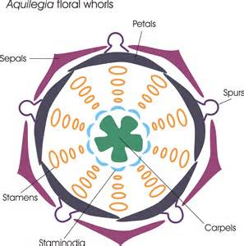

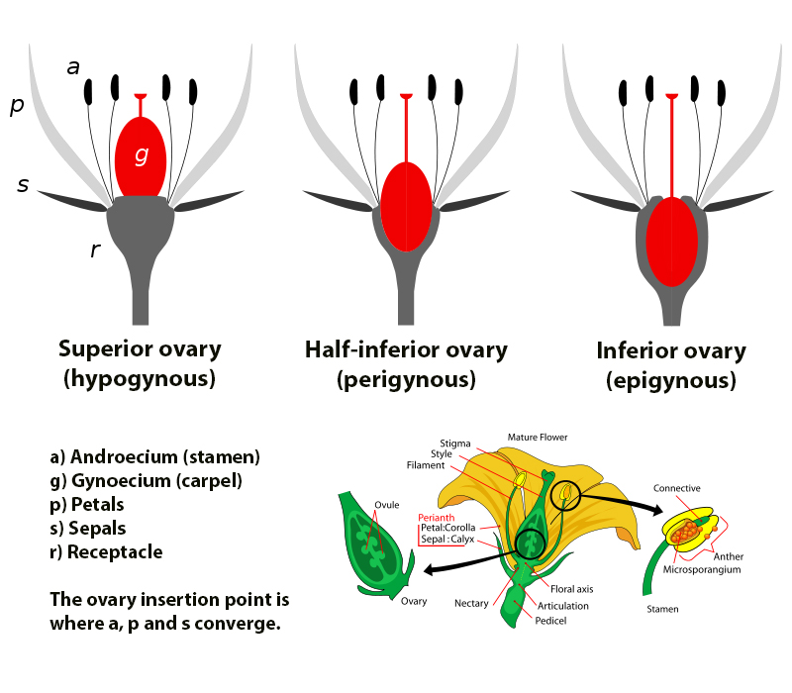

An **inflorescence** is a group or cluster of [flowers](https://en.wikipedia.org/wiki/Flower) arranged on a [stem](https://en.wikipedia.org/wiki/Plant_stem) that is composed of a main [branch](https://en.wikipedia.org/wiki/Branch) or a complicated arrangement of branches. [Morphologically](https://en.wikipedia.org/wiki/Morphology_(biology)), it is the part of the [shoot](https://en.wikipedia.org/wiki/Shoot) of [seed plants](https://en.wikipedia.org/wiki/Spermatophytes) where [flowers](https://en.wikipedia.org/wiki/Flower) are formed and which is accordingly modified. The modifications can involve the length and the nature of the [internodes](https://en.wikipedia.org/wiki/Internode_(botany)) and the [phyllotaxis](https://en.wikipedia.org/wiki/Phyllotaxis" \o "Phyllotaxis), as well as variations in the proportions, compressions, swellings, [adnations](https://en.wikipedia.org/wiki/Adnation" \o "Adnation), [connations](https://en.wikipedia.org/wiki/Connation" \o "Connation) and reduction of main and secondary axes. Inflorescence can also be defined as the reproductive portion of a plant that bears a cluster of flowers in a specific pattern.

The stem holding the whole inflorescence is called a [peduncle](https://en.wikipedia.org/wiki/Peduncle_(botany)) and the major axis (incorrectly referred to as the main stem) holding the flowers or more branches within the inflorescence is called the [**rachis**](https://en.wikipedia.org/wiki/Rachis). The stalk of each single flower is called a [pedicel](https://en.wikipedia.org/wiki/Pedicel_(botany)). A flower that is not part of an inflorescence is called a solitary flower and its stalk is also referred to as a peduncle. Any flower in an inflorescence may be referred to as a **floret**, especially when the individual flowers are particularly small and borne in a tight cluster, such as in a [pseudanthium](https://en.wikipedia.org/wiki/Pseudanthium" \o "Pseudanthium). The [fruiting](https://en.wikipedia.org/wiki/Fruit) stage of an inflorescence is known as an [infructescence](https://en.wikipedia.org/wiki/Infructescence" \o "Infructescence).

Inflorescences may be simple (single) or complex ([panicle](https://en.wikipedia.org/wiki/Panicle)). The rachis may be one of several types, including Single, Composite, Umbel, Spike or Raceme.

### Bracts

Inflorescences usually have modified shoots foliage different from the [vegetative](https://en.wikipedia.org/wiki/Vegetation) part of the plant. Considering the broadest meaning of the term, any leaf associated with an inflorescence is called a [**bract**](https://en.wikipedia.org/wiki/Bract). A bract is usually located at the node where the main stem of the inflorescence forms, joined to the main stem of the plant, but other bracts can exist within the inflorescence itself. They serve a variety of functions which include attracting pollinators and protecting young flowers. According to the presence or absence of bracts and their characteristics we can distinguish:

* **Ebracteate inflorescences**: No bracts in the inflorescence.
* **Bracteate inflorescences**: The bracts in the inflorescence are very specialised, sometimes reduced to small scales, divided or dissected.
* **Leafy inflorescences**: Though often reduced in size, the bracts are unspecialised and look like the typical leaves of the plant, so that the term **flowering stem** is usually applied instead of inflorescence. This use is not technically correct, as, despite their 'normal' appearance, these *leaves* are considered, in fact, *bracts*, so that 'leafy inflorescence' is preferable.
* **Leafy-bracted inflorescences**: Intermediate between bracteate and leafy inflorescence.

If many bracts are present and they are strictly connected to the stem, like in the family [Asteraceae](https://en.wikipedia.org/wiki/Asteraceae" \o "Asteraceae), the bracts might collectively be called an **involucre**. If the inflorescence has a second unit of bracts further up the stem, they might be called an **involucel**.

**Seed**

A **seed** is an [embryonic](https://en.wikipedia.org/wiki/Plant_embryogenesis)[plant](https://en.wikipedia.org/wiki/Plant) enclosed in a protective outer covering. The formation of the seed is part of the process of [reproduction](https://en.wikipedia.org/wiki/Reproduction) in seed plants, the [spermatophytes](https://en.wikipedia.org/wiki/Spermatophytes), including the [gymnosperm](https://en.wikipedia.org/wiki/Gymnosperm) and [angiosperm](https://en.wikipedia.org/wiki/Angiosperm) plants.

Seeds are the product of the ripened [ovule](https://en.wikipedia.org/wiki/Ovule), after [fertilization](https://en.wikipedia.org/wiki/Fertilization) by [pollen](https://en.wikipedia.org/wiki/Pollen) and some growth within the mother plant. The [embryo](https://en.wikipedia.org/wiki/Embryo) is developed from the [zygote](https://en.wikipedia.org/wiki/Zygote) and the seed coat from the integuments of the ovule.

Seeds have been an important development in the reproduction and success of gymnosperms and angiosperms plants, relative to more primitive plants such as [ferns](https://en.wikipedia.org/wiki/Fern), [mosses](https://en.wikipedia.org/wiki/Moss) and [liverworts](https://en.wikipedia.org/wiki/Marchantiophyta), which do not have seeds and use other means to propagate themselves. Seed plants now dominate biological [niches](https://en.wikipedia.org/wiki/Ecological_niche) on land, from [forests](https://en.wikipedia.org/wiki/Forest) to [grasslands](https://en.wikipedia.org/wiki/Grassland) both in hot and cold [climates](https://en.wikipedia.org/wiki/Climates).

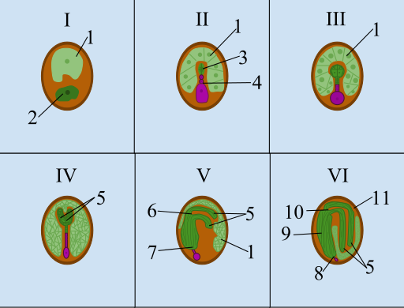

**Stages of seed development**:

|  |  |
| --- | --- |
| **I** Zygote **II**Proembryo **III** Globular  **Key**: *1. Endosperm 2. Zygote 3. Embryo 4. Suspensor 5. Cotyledons 6. Shoot Apical Meristem 7. Root Apical Meristem 8. Radicle 9. Hypocotyl 10. Epicotyl*  *11. Seed coat.* | **IV** Heart **V** Torpedo **VI** Mature Embryo |

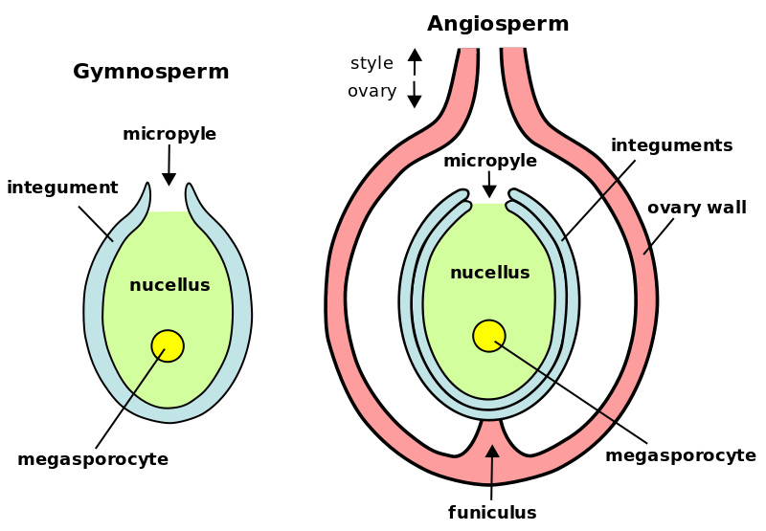

***Fruit***

Fruits are produced only by flowering plants ([angiosperms](http://www.biologyreference.com/knowledge/Angiosperms.html)). Following [pollination](http://www.biologyreference.com/knowledge/Pollination.html) of the flower, the fertilized ovules develop into seeds while the surrounding ovary wall forms the fruit tissue, or pericarp.

**Types of Fruit**

Fruits can be eaten raw, frozen, stewed, cooked, or dried. All fruits may be classified into three major groups: simple, aggregate, or multiple.

**Simple Fruits** = one fruit that has developed from the ovary of a single flower. Simple fruits may either be fleshy, like plums and peaches, or dry, such as walnuts and hazelnuts. Ex. - apples, pears, plums, tomatoes, peaches.

**Aggregate Fruits** = a fruit formed from several ovaries of one flower that produces many tiny fruits clustered tightly together. Ex.- raspberries, blackberries, strawberries.

**Multiple Fruits** = a fruit formed from the fusion of the ovaries of many different flowers which develop closely together to form one bigger fruit.Ex- pineapples, figs, breadfruit, mulberries.

|  |
| --- |
|  |
|  |

Note: **False fruits** or **accessory fruits** are another kind of fruit that is not formed from the ovary, but from a different part of the flower. These fruits may be simple, aggregate, or multiple fruits. For example, strawberries would be considered an aggregate fruit, as well as an accessory fruit since much of the fleshy fruit part does not come from the ovary.

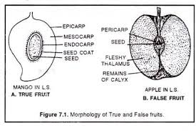

**Types of Fruit:**

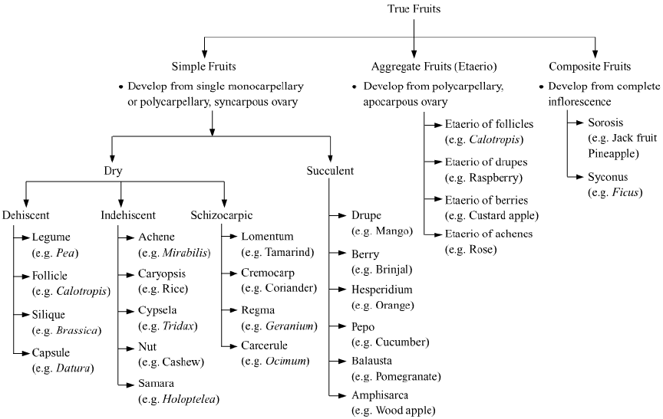

**Bark**

**Bark** is the outermost layers of [stems](https://en.wikipedia.org/wiki/Plant_stem) and [roots](https://en.wikipedia.org/wiki/Root) of [woody plants](https://en.wikipedia.org/wiki/Woody_plant). Plants with bark include [trees](https://en.wikipedia.org/wiki/Tree), woody [vines](https://en.wikipedia.org/wiki/Vine), and [shrubs](https://en.wikipedia.org/wiki/Shrub). Bark refers to all the tissues outside of the [vascular cambium](https://en.wikipedia.org/wiki/Vascular_cambium) and is a nontechnical term. It overlays the [wood](https://en.wikipedia.org/wiki/Wood) and consists of the inner bark and the outer bark. The inner bark, which in older [stems](https://en.wikipedia.org/wiki/Plant_stem) is living tissue, includes the innermost area of the **periderm**. The outer bark in older stems includes the dead tissue on the surface of the stems, along with parts of the innermost periderm and all the tissues on the outer side of the periderm. The outer bark on trees which lies external to the last formed periderm is also called the **rhytidome**.

Products derived from bark include: bark shingle siding and wall coverings, [spices](https://en.wikipedia.org/wiki/Spice) and other flavorings, [tanbark](https://en.wikipedia.org/wiki/Tanbark) for tannin, [resin](https://en.wikipedia.org/wiki/Resin), [latex](https://en.wikipedia.org/wiki/Latex), medicines, poisons, various [hallucinogenic](https://en.wikipedia.org/wiki/Hallucinogen) chemicals and [cork](https://en.wikipedia.org/wiki/Cork_(material)). Bark has been used to make cloth, canoes, and ropes and used as a surface for paintings and map making. A number of plants are also grown for their attractive or interesting bark colorations and surface textures or their bark is used as landscape [mulch](https://en.wikipedia.org/wiki/Mulch).

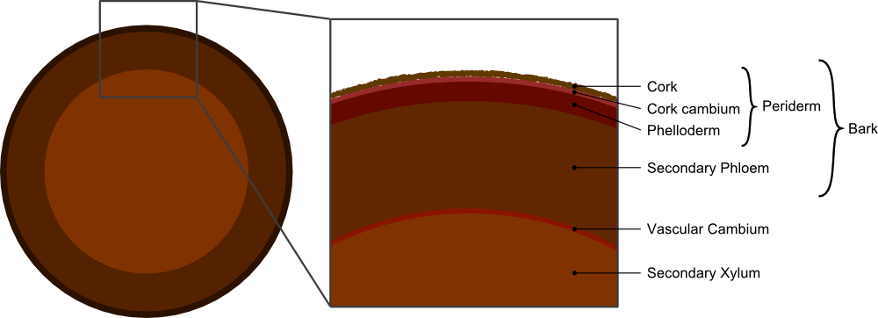

## Periderm-

Often a secondary covering called the periderm forms on small woody stems and many non woody plants, which is composed of cork (phellem), the [cork cambium](https://en.wikipedia.org/wiki/Cork_cambium) (phellogen), and the phelloderm. The periderm forms from the phellogen which serves as a lateral meristem. The periderm replaces the epidermis, and acts as a protective covering like the epidermis. Mature phellem cells have [suberin](https://en.wikipedia.org/wiki/Suberin" \o "Suberin) in their walls to protect the stem from desiccation and pathogen attack. Older phellem cells are dead, as is the case with woody stems. The skin on the [potato](https://en.wikipedia.org/wiki/Potato) tuber (which is an underground stem) constitutes the cork of the periderm.

In woody plants the epidermis of newly grown stems is replaced by the periderm later in the year. As the stems grow a layer of cells form under the epidermis, called the cork cambium, these cells produce cork cells that turn into cork. A limited number of cell layers may form interior to the cork cambium, called the phelloderm. As the stem grows, the cork cambium produces new layers of cork which are impermeable to gases and water and the cells outside of the periderm, namely the epidermis, cortex and older secondary phloem die.[

Within the periderm are [lenticels](https://en.wikipedia.org/wiki/Lenticel), which form during the production of the first periderm layer. Since there are living cells within the cambium layers that need to exchange gases during metabolism, these lenticels, because they have numerous intercellular spaces, allow gaseous exchange with the outside atmosphere. As the bark develops, new lenticels are formed within the cracks of the cork layers.

## Rhytidome-

[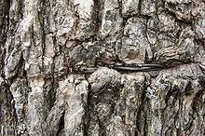](https://en.wikipedia.org/wiki/File:BarkAndWire-0308.jpg)

The rhytidome is the most familiar part of bark, it is the outer layer that covers the trunks of trees. It is composed mostly of dead cells and is produced by the formation of multiple layers of suberized periderm, cortical and phloem tissue.It is generally thickest and most distinctive at the trunk or [bole](https://en.wikipedia.org/wiki/Trunk_(botany)) (the area from the ground to where the main branching starts) of the tree.

## Chemical composition-

Bark tissues make up by weight between 10-20% of woody vascular plants and consists of various [biopolymers](https://en.wikipedia.org/wiki/Biopolymer), [tannins](https://en.wikipedia.org/wiki/Tannin), [lignin](https://en.wikipedia.org/wiki/Lignin), [suberin](https://en.wikipedia.org/wiki/Suberin" \o "Suberin), suberan and [Polysaccharides](https://en.wikipedia.org/wiki/Polysaccharide" \o "Polysaccharide).Up to 40% of the bark tissue is made of lignin which forms an important part of a plant providing structural support by crosslinking between different polysaccharides, such as cellulose.

Condensed [tannin](https://en.wikipedia.org/wiki/Tannin), which are in fairly high concentration in bark tissue, is thought to inhibit decomposition It could be due to this factor that the degradation of lignin is far less pronounced in bark tissue than it is in wood. It has been proposed that, in the cork layer (the phellogen), suberin acts as a barrier to microbial degradation and so protects the internal structure of the plant.

Analysis of the [lignin](https://en.wikipedia.org/wiki/Lignin) in bark wall during decay by the white-rot fungi *Lentinula edodes* ([Shiitake mushroom](https://en.wikipedia.org/wiki/Shiitake_mushroom)) using C NMR revealed that the lignin polymers contained more Guaiacyl [lignin](https://en.wikipedia.org/wiki/Lignin) units than Syringyl units compared to the interior of the plant.[ Guaiacyl units are less susceptible to degradation as, compared to syringyl, they contain fewer aryl-aryl bonds, can form a condensed lignin structure and have a lower [redox potential](https://en.wikipedia.org/wiki/Redox_potential). This could mean that the concentration and type of lignin units could provide additional resistance to fungal decay for plants protected by bark.

## Uses

Cork, sometimes confused with bark in colloquial speech, is the outermost layer of a woody stem, derived from the [cork cambium](https://en.wikipedia.org/wiki/Cork_cambium). It serves as protection against damage from [parasites](https://en.wikipedia.org/wiki/Parasite), [herbivorous](https://en.wikipedia.org/wiki/Herbivory) animals and [diseases](https://en.wikipedia.org/wiki/Disease), as well as dehydration and fire. Cork can contain[antiseptics](https://en.wikipedia.org/wiki/Antiseptic) like [tannins](https://en.wikipedia.org/wiki/Tannin), that protect against fungal and bacterial attacks that would cause decay.

Bark of [pine](https://en.wikipedia.org/wiki/Pine) was used as emergency food in Finland during[famine](https://en.wikipedia.org/wiki/Famine), last time during and after [civil war](https://en.wikipedia.org/wiki/Finnish_Civil_War) in 1918.

In some plants, the bark is substantially thicker, providing further protection and giving the bark a characteristically distinctive structure with deep ridges. In the cork oak (*[Quercussuber](https://en.wikipedia.org/wiki/Quercus_suber" \o "Quercus suber)*) the bark is thick enough to be harvested as a [cork product](https://en.wikipedia.org/wiki/Cork_(material)) without killing the tree;in this species the bark may get very thick (e.g. more than 20 cm has been reported. Some barks can be removed in long sheets; the smooth surfaced bark of [birch](https://en.wikipedia.org/wiki/Birch) trees has been used as a covering in the making of canoes, as the drainage layer in roofs, for shoes, backpacks etc. The most famous example of using birch bark for canoes is the birch canoes of North America.

The inner bark ([phloem](https://en.wikipedia.org/wiki/Phloem)) of some trees is edible; in Scandinavia, [bark bread](https://en.wikipedia.org/wiki/Bark_bread) is made from [rye](https://en.wikipedia.org/wiki/Rye) to which the toasted and ground innermost layer of bark of [scots pine](https://en.wikipedia.org/wiki/Scots_pine) or [birch](https://en.wikipedia.org/wiki/Birch) is added. The [Sami](https://en.wikipedia.org/wiki/Sami_people" \o "Sami people)people of far northern [Europe](https://en.wikipedia.org/wiki/Europe) used large sheets of *[Pinussylvestris](https://en.wikipedia.org/wiki/Pinus_sylvestris" \o "Pinus sylvestris)* bark that were removed in the spring, prepared and stored for use as a staple food resource and the inner bark was eaten fresh, dried or roasted.

**Root**

## Definitions

The first root that comes from a [plant](https://en.wikipedia.org/wiki/Plant) is called the [radicle](https://en.wikipedia.org/wiki/Radicle). A root's four major functions are

**1)** [absorption of water](https://en.wikipedia.org/wiki/Absorption_of_water) and inorganic nutrients,

**2)**anchoring of the plant body to the ground, and [supporting](https://en.wikipedia.org/wiki/Aerial_root) it,

**3)**storage of food and [nutrients](https://en.wikipedia.org/wiki/Nutrient),

**4)**[vegetative reproduction](https://en.wikipedia.org/wiki/Vegetative_reproduction" \o "Vegetative reproduction) and competition with other plants.

In response to the concentration of nutrients, roots also synthesise[cytokinin](https://en.wikipedia.org/wiki/Cytokinin), which acts as a signal as to how fast the shoots can grow. Roots often function in storage of food and nutrients. The roots of most vascular plant species enter into symbiosis with certain [fungi](https://en.wikipedia.org/wiki/Fungi) to form [mycorrhizae](https://en.wikipedia.org/wiki/Mycorrhiza), and a large range of other organisms including [bacteria](https://en.wikipedia.org/wiki/Bacteria) also closely associate with roots.

### Anatomy

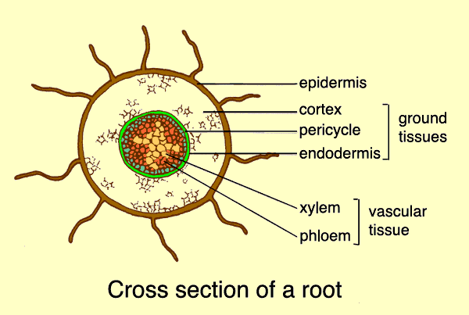

When dissected, the arrangement of the cells in a root is [root hair](https://en.wikipedia.org/wiki/Root_hair), [epidermis](https://en.wikipedia.org/wiki/Epidermis_%28botany%29), [epiblem](https://en.wikipedia.org/wiki/Epiblem), [cortex](https://en.wikipedia.org/wiki/Cortex_%28botany%29), [endodermis](https://en.wikipedia.org/wiki/Endodermis), [pericycle](https://en.wikipedia.org/wiki/Pericycle) and, lastly, the [vascular tissue](https://en.wikipedia.org/wiki/Vascular_tissue) in the centre of a root to transport the water absorbed by the root to other places of the plant.[

A true root system consists of a **primary root** and **secondary roots** (or [lateral roots](https://en.wikipedia.org/wiki/Lateral_roots)).

* The diffuse root system: the primary root is not dominant; the whole root system is fibrous and branches in all directions. Most common in [monocots](https://en.wikipedia.org/wiki/Monocots). The main function of the fibrous root is to anchor the plant.

### Specialized

[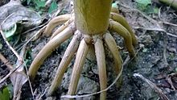](https://en.wikipedia.org/wiki/File:Prop_roots_of_Maize_plant.jpg)

**Prop roots of Maize plant**

[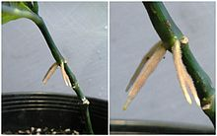](https://en.wikipedia.org/wiki/File:Adventitious_roots_on_Odontonema_aka_Firespike.jpg)

**Roots forming above ground on a cutting of an *Odontonema* ("Firespike")**

[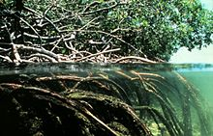](https://en.wikipedia.org/wiki/File:Mangroves.jpg)

**Aerating roots of a** [**mangrove**](https://en.wikipedia.org/wiki/Mangrove)

[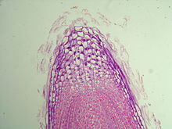](https://en.wikipedia.org/wiki/File:Root_tip.JPG)

**The growing tip of a fine root**

[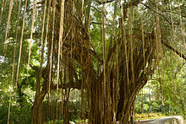](https://en.wikipedia.org/wiki/File:Aerial_root.jpg)

**Aerial root**

[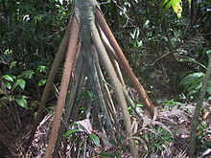](https://en.wikipedia.org/wiki/File:Socratea_exorriza2002_03_12.JPG)

The stilt roots of [*Socrateaexorrhiza*](https://en.wikipedia.org/wiki/Socratea_exorrhiza)

The roots, or parts of roots, of many plant species have become specialized to serve adaptive purposes besides the two primary functions, described in the introduction.

* **Adventitious roots** arise out-of-sequence from the more usual root formation of branches of a primary root, and instead originate from the stem, branches, leaves, or old woody roots. They commonly occur in [monocots](https://en.wikipedia.org/wiki/Monocot) and pteridophytes, but also in many [dicots](https://en.wikipedia.org/wiki/Dicot), such as [clover](https://en.wikipedia.org/wiki/Clover) (*Trifolium*), [ivy](https://en.wikipedia.org/wiki/Ivy) (*Hedera*), [strawberry](https://en.wikipedia.org/wiki/Strawberry) (*Fragaria*) and [willow](https://en.wikipedia.org/wiki/Willow) (*Salix*). Most aerial roots and stilt roots are adventitious. In some conifers adventitious roots can form the largest part of the root system.
* **Aerating roots** (or **knee root** or **knee** or **pneumatophores** or [Cypress knee](https://en.wikipedia.org/wiki/Cypress_knee)): roots rising above the ground, especially above water such as in some [mangrove](https://en.wikipedia.org/wiki/Mangrove) genera (*[Avicennia](https://en.wikipedia.org/wiki/Avicennia" \o "Avicennia),* [*Sonneratia*](https://en.wikipedia.org/wiki/Sonneratia)). In some plants like *Avicennia* the erect roots have a large number of breathing pores for exchange of gases.
* [Aerial roots](https://en.wikipedia.org/wiki/Aerial_roots): roots entirely above the ground, such as in ivy (*Hedera*) or in [epiphytic](https://en.wikipedia.org/wiki/Epiphyte)[orchids](https://en.wikipedia.org/wiki/Orchid). Many aerial roots, are used to receive water and nutrient intake directly from the air - from fogs, dew or humidity in the air. Some rely on leave systems to gather rain or humidity and even store it in scales or pockets. Other aerial roots, such as [mangrove](https://en.wikipedia.org/wiki/Mangrove) aerial roots, are used for aeration and not for water absorption. Other aerial roots are used mainly for structure, functioning as prop roots, as in [maize](https://en.wikipedia.org/wiki/Maize) or anchor roots or as the trunk in [strangler fig](https://en.wikipedia.org/wiki/Strangler_fig). In some Epiphytes - plants living above the surface on other plants, aerial roots serve for reaching to water sources or reaching the surface, and then functioning as regular surface roots.
* **Contractile roots**: they pull bulbs or corms of [monocots](https://en.wikipedia.org/wiki/Monocot), such as [hyacinth](https://en.wikipedia.org/wiki/Hyacinth_%28plant%29) and [lily](https://en.wikipedia.org/wiki/Lily), and some [taproots](https://en.wikipedia.org/wiki/Taproot), such as [dandelion](https://en.wikipedia.org/wiki/Dandelion), deeper in the soil through expanding radially and contracting longitudinally. They have a wrinkled surface.
* **Coarse roots**: Roots that have undergone secondary thickening and have a woody structure. These roots have some ability to absorb water and nutrients, but their main function is transport and to provide a structure to connect the smaller diameter, fine roots to the rest of the plant.
* **Fine roots**: Primary roots usually <2 mm diameter that have the function of water and nutrient uptake. They are often heavily branched and support mycorrhizas. These roots may be short lived, but are replaced by the plant in an ongoing process of root 'turnover'.
* **Haustorial roots**: roots of parasitic plants that can absorb water and nutrients from another plant, such as in [mistletoe](https://en.wikipedia.org/wiki/Mistletoe) (*Viscum album*) and [dodder](https://en.wikipedia.org/wiki/Dodder).
* **Propagative roots**: roots that form adventitious buds that develop into aboveground shoots, termed [suckers](https://en.wikipedia.org/wiki/Basal_shoot), which form new plants, as in [Canada thistle](https://en.wikipedia.org/wiki/Canada_thistle), [cherry](https://en.wikipedia.org/wiki/Cherry) and many others.
* [Proteoid roots](https://en.wikipedia.org/wiki/Proteoid_root) or cluster roots: dense clusters of rootlets of limited growth that develop under low [phosphate](https://en.wikipedia.org/wiki/Phosphate) or low [iron](https://en.wikipedia.org/wiki/Iron) conditions in [Proteaceae](https://en.wikipedia.org/wiki/Proteaceae) and some plants from the following families [Betulaceae](https://en.wikipedia.org/wiki/Betulaceae), [Casuarinaceae](https://en.wikipedia.org/wiki/Casuarinaceae), [Elaeagnaceae](https://en.wikipedia.org/wiki/Elaeagnaceae), [Moraceae](https://en.wikipedia.org/wiki/Moraceae), [Fabaceae](https://en.wikipedia.org/wiki/Fabaceae) and [Myricaceae](https://en.wikipedia.org/wiki/Myricaceae).
* **Stilt roots**: these are adventitious support roots, common among [mangroves](https://en.wikipedia.org/wiki/Mangrove). They grow down from lateral branches, branching in the soil.
* **Storage roots**: these roots are modified for storage of food or water, such as [carrots](https://en.wikipedia.org/wiki/Carrot) and [beets](https://en.wikipedia.org/wiki/Beet). They include some [taproots](https://en.wikipedia.org/wiki/Taproot) and tuberous roots.
* **Structural roots**: large roots that have undergone considerable secondary thickening and provide mechanical support to woody plants and trees.
* **Surface roots**: These proliferate close below the soil surface, exploiting water and easily available nutrients. Where conditions are close to optimum in the surface layers of soil, the growth of surface roots is encouraged and they commonly become the dominant roots.
* **Tuberous roots**: A portion of a root swells for food or water storage, e.g. [sweet potato](https://en.wikipedia.org/wiki/Sweet_potato). A type of storage root distinct from taproot.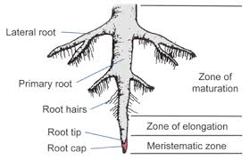Rhizome

In [botany](https://en.wikipedia.org/wiki/Botany) and [dendrology](https://en.wikipedia.org/wiki/Dendrology), a **rhizome** , from [Ancient Greek](https://en.wikipedia.org/wiki/Ancient_Greek): *rhízōma* "mass of roots",from*rhizóō* "cause to strike root") is a modified [subterranean](https://en.wikipedia.org/wiki/Subterranea_%28geography%29)[stem](https://en.wikipedia.org/wiki/Plant_stem) of a [plant](https://en.wikipedia.org/wiki/Plant) that is usually found underground, often sending out [roots](https://en.wikipedia.org/wiki/Root) and [shoots](https://en.wikipedia.org/wiki/Shoot) from its [nodes](https://en.wikipedia.org/wiki/Node_%28botany%29). Rhizomes are also called **creeping rootstalks** and **rootstocks**. Rhizomes develop from [axillary buds](https://en.wikipedia.org/wiki/Axillary_bud) and are [diageotropic](https://en.wikipedia.org/wiki/Diageotropic) or grow perpendicular to the force of gravity. The rhizome also retains the ability to allow new shoots to grow upwards.

If a rhizome is separated into pieces, each piece may be able to give rise to a new plant. The plant uses the rhizome to store [starches](https://en.wikipedia.org/wiki/Starch), [proteins](https://en.wikipedia.org/wiki/Protein), and other nutrients. These nutrients become useful for the plant when new shoots must be formed or when the plant dies back for the winter. This is a process known as [vegetative reproduction](https://en.wikipedia.org/wiki/Vegetative_reproduction) and is used by farmers and gardeners to propagate certain plants. This also allows for lateral spread of grasses like [bamboo](https://en.wikipedia.org/wiki/Bamboo) and [bunch grasses](https://en.wikipedia.org/wiki/Bunch_grasses). Examples of plants that are propagated this way include [hops](https://en.wikipedia.org/wiki/Hops), [asparagus](https://en.wikipedia.org/wiki/Asparagus), [ginger](https://en.wikipedia.org/wiki/Ginger), [irises](https://en.wikipedia.org/wiki/Iris_%28plant%29), [Lily of the Valley](https://en.wikipedia.org/wiki/Lily_of_the_Valley), [Cannas](https://en.wikipedia.org/wiki/Canna_%28plant%29), and [sympodial](https://en.wikipedia.org/wiki/Sympodial)[orchids](https://en.wikipedia.org/wiki/Orchid). Some rhizomes which are used directly in cooking include ginger, [turmeric](https://en.wikipedia.org/wiki/Turmeric), [galangal](https://en.wikipedia.org/wiki/Galangal), and [fingerroot](https://en.wikipedia.org/wiki/Fingerroot).

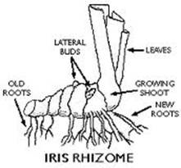

|  |  |
| --- | --- |
| Rhizomes are commonly confused with roots. Both grow underground. But a rhizome is actually a stem. If you cut a root, a rhizome, and an above-ground stem in cross section, you can see that the tissues in the rhizome look more like a stem than a root. A rhizome is in fact an underground, horizontally growing stem. | |
| There are several major differences between roots and rhizomes. Like stems, rhizomes have stomata, the breathing organ of plant, while roots do not possess these.  A rhizome also has an endodermis and a vascular bundle arrangement like a stem. |  |

# Stem

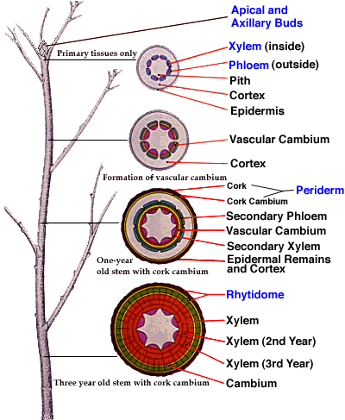

**( stem and its internal structure )**

**ANATOMY OF STEM**

• The stem has three simple [cell](https://www.boundless.com/biology/definition/cell) types: the [parenchyma](https://www.boundless.com/biology/definition/parenchyma), [collenchyma](https://www.boundless.com/biology/definition/collenchyma), and [sclerenchyma](https://www.boundless.com/biology/definition/sclerenchyma) cells that are responsible for metabolic functions, repairing and healing wounds, and storing starch.

• The stem is composed of three tissue systems that include the epidermis, vascular, and ground tissues, all of which are made from the simple cell types..

• The [xylem](https://www.boundless.com/biology/definition/xylem) and [phloem](https://www.boundless.com/biology/definition/phloem) carry water and [nutrients](https://www.boundless.com/biology/definition/nutrient) up and down the length of the stem and are arranged in distinct strands called vascular bundles.

• The epidermis is a single layer of cells that makes up the dermal tissue covering the stem and protecting the underlying tissue. Woody plants have an extra layer of protection on top of the epidermis made of cork cells known as bark.

• The vascular tissue of the stem consists of the [complex](https://www.boundless.com/biology/definition/complex) tissues xylem and phloem which carry water and nutrients up and down the length of the stem and are arranged in distinct strands called vascular bundles.

• Ground tissue helps support the stem and is called [pith](https://www.boundless.com/biology/definition/pith) when it is located towards the middle of the stem and called the [cortex](https://www.boundless.com/biology/definition/cortex) when it is between the vascular tissue and the epidermis.

