1. Double delta connection

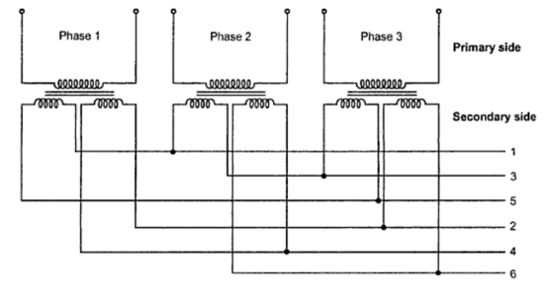

As seen from the Figure this arrangement of secondaries connections are taken from points 1, 3, 5 and in the second set, the connection are taken from points 2, 4 and 6.