**Three phase transformer connections**

[Three phase transformer](http://www.electricaleasy.com/2014/04/three-phase-transformer.html) connections In three phase system, the three phases can be connected in

either star or delta configuration. Windings of a three phase transformer can be connected in

various configurations as (i) star-star, (ii) delta-delta, (iii) star-delta, (iv) delta-star, (v) open delta

and (vi) Scott connection. These configurations are explained below.-

#### Star-Star (Y-Y)

* Star-star connection is generally used for small, high-voltage transformers. Because of star connection, number of required turns/phase is reduced (as phase voltage in star connection is 1/√3 times of line voltage only). Thus, the amount of insulation required is also reduced.
* The ratio of line voltages on the primary side and the secondary side is equal to the [transformation ratio](http://www.electricaleasy.com/2014/03/emf-equation-of-transformer.html) of the transformers.
* Line voltages on both sides are in phase with each other.
* This connection can be used only if the connected load is balanced.

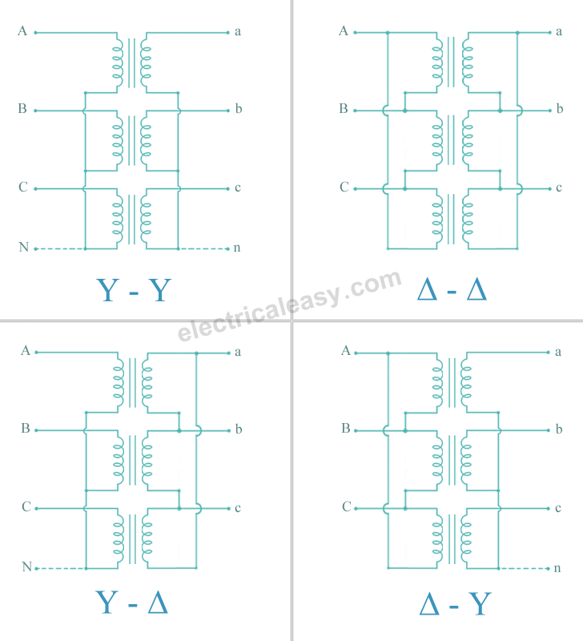

**Delta-Delta (Δ-Δ)**

* This connection is generally used for large, low-voltage transformers. Number of required phase/turns is relatively greater than that for star-star connection.
* The ratio of line voltages on the primary and the secondary side is equal to the transformation ratio of the transformers.
* This connection can be used even for unbalanced loading.
* Another advantage of this type of connection is that even if one transformer is disabled, system can continue to operate in open delta connection but with reduced available capacity.



Δ-Δ

**Star-Delta OR Wye-Delta (Y-Δ)**

* The primary winding is star star (Y) connected with grounded neutral and the secondary winding is delta connected.
* This connection is mainly used in step down transformer at the substation end of the transmission line.
* The ratio of secondary to primary line voltage is 1/√3 times the transformation ratio.
* There is 30° shift between the primary and secondary line voltages.



#### Delta-Star

* The primary winding is connected in delta and the secondary winding is connected in star with neutral grounded. Thus it can be used to provide 3-phase 4-wire service.
* This type of connection is mainly used in step-up transformer at the beginning of transmission line.
* The ratio of secondary to primary line voltage is √3 times the transformation ratio.
* There is 30° shift between the primary and secondary line voltages.



### Open Delta (V-V) Connection

Two [transformers](http://www.electricaleasy.com/2014/03/electrical-transformer-basic.html) are used and primary and secondary connections are made as shown in the

figure below. Open delta connection can be used when one of the transformers in Δ-Δ bank is

disabled and the service is to be continued until the faulty transformer is repaired or replaced. It

can also be used for small three phase loads where installation of full three transformer bank is

un-necessary. The total load carrying capacity of open delta connection is 57.7% than that would

be for delta-delta connection.

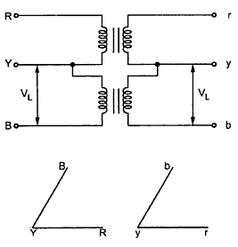

**V-V**

**Three phase to two phase conversion**

# Scott-T Transformer Connection

**Definition:** The Scott-T Connection is the method of connecting two single phase transformer to perform the 3-phase to 2-phase conversion and vice-versa. The two transformers are connected electrically but not magnetically. One of the transformers is called the main transformer, and the other is called the auxiliary or teaser transformer.

The figure below shows the Scott-T transformer connection. The main transformer is centre tapped at D and is connected to the line B and C of the 3-phase side. It has primary BC and secondary a1a2. The teaser transformer is connected to the line terminal A and the centre tapping D. It has primary AD and the secondary b1b2

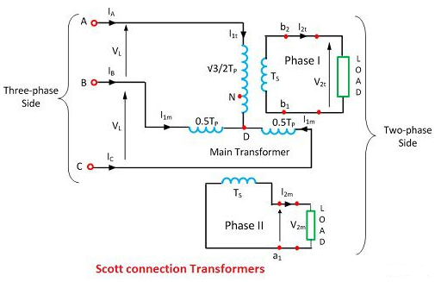

The identical, interchangeable transformers are used for Scott-T connection in which each transformer has a primary winding of Tp turns and is provided with tapping at 0.289Tp , 0.5Tpand 0.866 Tp.

### Applications of Scott Connection

The following are the applications of the Scott-T connection.

The Scott-T connection is used in an electric furnace installation where it is desired to operate two single-phase together and draw the balanced load from the three-phase supply.

1. It is used to supply the single phase loads such as electric train which are so scheduled as to keep the load on the three phase system as nearly as possible.
2. The Scott-T connection is used to link a 3-phase system with a two–phase system with the flow of power in either direction.

The Scott-T connection permits conversions of a 3-phase system to a two-phase system and vice versa. But since 2-phase generators are not available, the converters from two phases to three phases are not used in practice

Three phase to six phase conversion

In certain applications like thyristors and rectifiers six phase supply is required. Therefore it becomes necessary to convert three phase a.c. supply into six phase. By using three identical single phase transformers suitably interconnected this can be achieved. The primary winding is connected in delta whereas its secondary winding is split up into two halves. Thus conversion from 3 phase to six phase can be obtained by having two similar secondary windings for each of the primaries of the three phase transformer. This is showing in the Fig. 1.

       The three phase supply is given to primaries of the three transformers and six phase output can be obtained from the six secondaries.

There are many ways of connecting these secondaries. Some of them are

1. double delta
2. double star
3. dimetrical.

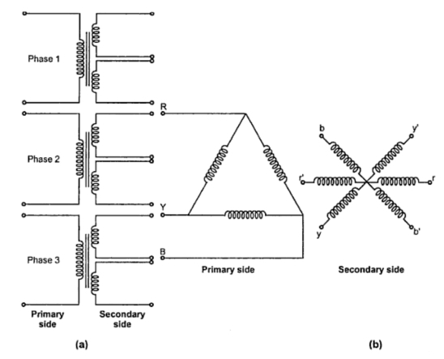

Fig. 1

1. Double delta connection

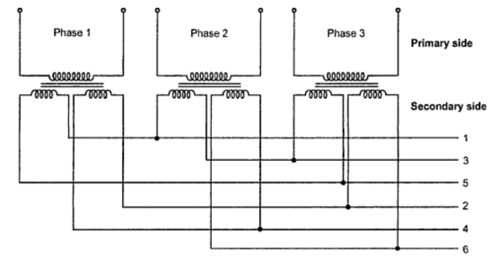

As seen from the Figure this arrangement of secondaries connections are taken from points 1, 3, 5 and in the second set, the connection are taken from points 2, 4 and 6.

1. Double star connection

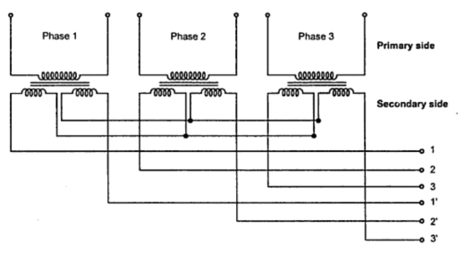

1. Diametrical connection

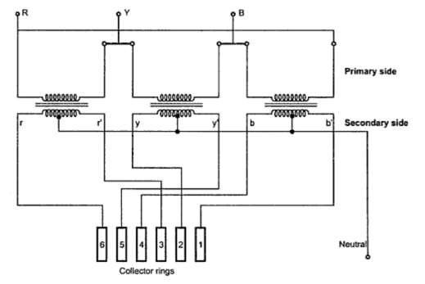

The most commonly used connection is the dimetrical connection for three phase to six phase transformers. On each single phase transformer there is only one winding on the secondary side. The two secondary leads are connected to diametrically opposite points on the armature windings of the synchronous converter. The middle points of the secondary windings may be connected together to form a neutral for the three wire circuit. The high voltage or primary windings are either connected in star or delta. But delta connection is generally preferred because of the triple frequency harmonics of voltages which are introduced in star-star connection