**EXPERIMENT NO. 1**

**Object:** To synthesize, characterize and submit Benzil from Benzoin.

**References: 1**. B.S. Furniss. A.J. Hannaford, P.W.G. Smith; “Vogel’s Textbook of Practical Organic Chemistry”, 5th edition, Longaman publication.

**Requirements:** Benzoin, Glacial acetic acid, conc. Nitric acid, RBF, beaker.etc

**Theory:** Benzil (systematically known as 1,2-diphenylethane-1,2-dione) is the [organic compound](https://en.wikipedia.org/wiki/Organic_compound) with the formula ([C6H5](https://en.wikipedia.org/wiki/Phenyl)[CO](https://en.wikipedia.org/wiki/Carbonyl))2, generally abbreviated ([Ph](https://en.wikipedia.org/wiki/Phenyl" \o "Phenyl)CO)2. This yellow solid is one of the most common [diketones](https://en.wikipedia.org/wiki/Diketone" \o "Diketone). Its main use is as a [photoinitiator](https://en.wikipedia.org/wiki/Photoinitiator" \o "Photoinitiator) in [polymer chemistry](https://en.wikipedia.org/wiki/Polymer_chemistry). Benzil is a standard building block in [organic synthesis](https://en.wikipedia.org/wiki/Organic_synthesis). It condenses with amines to give [diketimines](https://en.wikipedia.org/wiki/Diimine" \o "Diimine) ligands. A classic [organic reaction](https://en.wikipedia.org/wiki/Organic_reaction) of benzil is the [benzilic acid rearrangement](https://en.wikipedia.org/wiki/Benzilic_acid_rearrangement" \o "Benzilic acid rearrangement), in which base catalyses the conversion of benzil to benzilic acid. This reactivity is exploited in the preparation of the drug [phenytoin](https://en.wikipedia.org/wiki/Phenytoin" \o "Phenytoin). Benzil also reacts with [1,3-diphenylacetone](https://en.wikipedia.org/wiki/Dibenzyl_ketone) in an [aldol condensation](https://en.wikipedia.org/wiki/Aldol_condensation" \o "Aldol condensation) to give [tetraphenylcyclopentadienone](https://en.wikipedia.org/wiki/Tetraphenylcyclopentadienone" \o "Tetraphenylcyclopentadienone).







**Procedure:** Heat mixture of 1 gm Benzoin, 5ml Glacial acetic acid and 25ml of conc. Nitric acid in round bottom Flask for1hour 30 minute, then pour down the contents into 50 ml ice cold water with continuous stirring.A solid product will begins to separate out, filter the product, wash with cold water, air dried and then recrystallize with ethanol.

**Cautions:** Handle concentrated nitric acid with care. Avoid contact with skin. Do the reaction in the hood as brown nitric oxide fumes are released.

**Uses:** 1.Benzil is a standard building block in [organic synthesis](https://en.wikipedia.org/wiki/Organic_synthesis).

2. Benzil is used in preparation of Phenytoin and phenytoin is antepileptic drug.

**Calucation:** Theoretical Yield=

Practical Yield=

% yield=

Color-

State-

M.P. (Reported)=……. M.P. (standardd)=…….

**Result:** Benzil was synthesized, characterized and submitted.

**Experiment No.2**

**Object:** Determine Saponification value of given sample of castor oil.

# References: Singh S.P., Practical Manual of Biochemistry, 7th edition, CBS publishers, Pvt. Ltd page no. 21.

**Requirements:** Castor oil, phenolphthalein indicator, KOH solution, HCl, Burette,RBF, beaker.etc

**Theory:**

**Saponification value:** Alkaline hydrolysis of fat/oil is called Saponification because one of the products of hydrolysis is Soap (Na or K salt of fatty acid).

* Fats (triglycerides) upon alkaline hydrolysis (either with KOH or NaOH) yield glycerol and potassium or sodium salts of fatty acids (soap).

**Saponification No.:** It is defined as the number of milligrams of KOH or NaOH required to saponify one gram of the oil or fat.

**Example:** Saponification no. of coconut oil is 191.1 so 191.1 mg of KOH is required to saponify 1gm coconut oil.

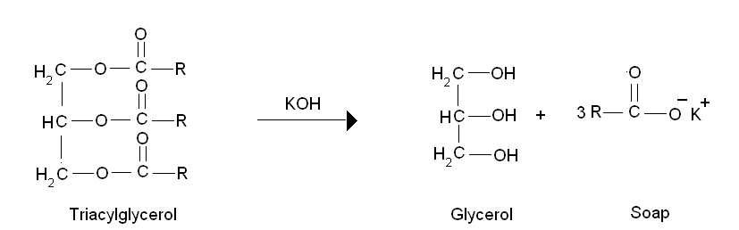

**Procedure:**

* Take 2 gm of Castor oil in RBF (round bottom flask), add 25 ml of 0.5 N ethanolic KOH and reflux the content of flask for 30 minute.
* Cool the flask, add 1-2 drops of phenolphtelein indicator pink color will appear & titrate the solution with 0.5N HCl until the pink color of the solution disappear, and determine the end point. Note down the burette reading and determine the saponification value
* Take reading of blank solution without sample (castor oil).

Formula for determination of saponification value:



V 1 = volume of sodium thiosulphate consumed for test solution

V 2 = volume of sodium thiosulphate consumed for blank solution

**Significance:**

1. The saponification value gives an idea about the molecular weight of the fatty acid.
2. It gives information concerning the character of the fatty acids of the fat- the longer the carbon chain; the less acid is liberated per gram of fat hydrolysed.
3. The long chain fatty acids found in fats have low saponification value because they have a relatively fewer number of carboxylic functional groups per unit mass of the fat and therefore high molecular weight.

**Result:** Saponification value of given sample of castor oil was found to be……