**OILS & FATS (UNIT-3)**

**Fatty acids-**Fatty acids are carboxylic acids (RCOOH) with long carbon chain of 12-20 carbon atom.

* They have many non polar C-C and C-H bonds and few polar bonds.
* The non polar part of the molecule is not soluble in water and called hydrphobic (water fearing).
* The polar part of the molecule is soluble in water and called hydrphillic (water loving).

There are two types of fatty acid:

1. **Saturated fatty acids:** They have no double bond in their long hyrocarbon chain.
2. **Unsaturated fatty acids:** They have one or more double bond in their long hyrocarbon chain.

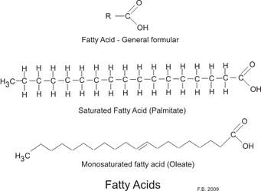 **List of Fatty acids:**

**1: Saturated fatty acids:**

|  |  |  |  |
| --- | --- | --- | --- |
| **No. of Carbon atom** | **No. of C=C** | **Name Saturated fatty acids** | **Structure** |
| 12 | 0 | Lauric acid | CH3(CH2)10COOH |
| 14 | 0 | Myristic acid | CH3(CH2)12COOH |
| 16 | 0 | Palmetic acids | CH3(CH2)14COOH |
| 18 | 0 | Stearic acid | CH3(CH2)16COOH |
| 20 | 0 | Arachidic acid | CH3(CH2)18COOH |

**2: Unaturated fatty acids:**

|  |  |  |  |
| --- | --- | --- | --- |
| **No. of Carbon atom** | **No. of C=C** | **Name Saturated fatty acids** | **Structure** |
| 12 | 1 | palmitoleic acid | CH3(CH2)5CH=CH(CH2)7COOH |
| 14 | 2 | Oleic acid | CH3(CH2)7CH=CH(CH2)7COOH |
| 16 | 3 | Linoleic acids | CH3(CH2)4CH=CHCH2CH=CH(CH2)7COOH |
| 18 | 4 | Linolenic acid | CH3CH2CH=CHCH2CH=CHCH2CH=CH (CH2)7COOH |
| 20 | 5 | Arachidonic acid | CH3(CH2)4(CH=CHCH2)4(CH2)2COOH |

* Unsaturated fatty acids is sometime called omega-n-acids.
* Linoleic acids (omega-6 fatty acid), Linolenic acid(omega-3 fatty acid) due to presence of first double bond at 6th and 3rd position respectively. Both are essential fatty acids because they must be supplemented through diet.
* In unsaturated fatty acid double bond may be cis or trans, if double bond is in cis arrangement they have low melting point and good for health, whereas if double bond is in trans arrangement they have high melting point and bad for health and the fat is called trans fat which produce cardiovascular disease such as heart attack, stroke etc. due to deposition of trans fat in arteries.
* As compare to saturated fatty acid and unsaturated fatty acid unsaturated fatty acid are good for health.

**Reaction of fatty acid (Formation oil/fat)**

Oil and fat are mostly triglyceride / triacylglycerol/ triester of glycerol. They are formed by reaction between one molecule of glycerol and 3 molecule of fatty acids.

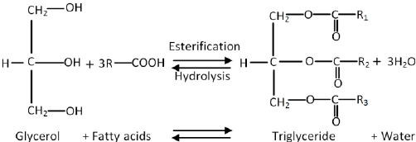

Oil/fat (R=C12-C20)

If R1, R2 and R3 are same they form simple triglycerides and if R1, R2 and R3 are different they form mixed tiglycerides.

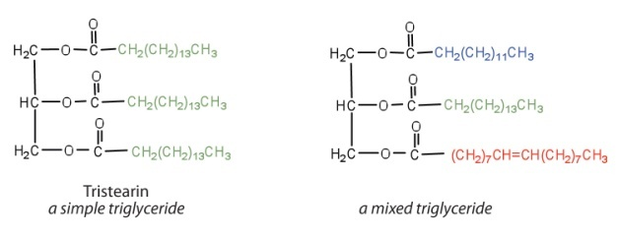

* **Difference between oil and fat**

|  |  |
| --- | --- |
| **Oil** | **Fat** |
| Oil are just fat which are liquid at room temperature | Fat are solid at room temperature |
| Oil contain high ratio of unsaturated fatty acid such as oleic acid, linolic acid etc( contain more number of double bonds) | Fat contain high ratio of saturated fatty acid such as lauric acid, stearic acid etc. ( contain of no double bondsor less no. of double bond.) |
| They have low melting point so they are liquid at room temperature. | They have high melting point so they are solid at room temperature. |

* **Reactions of oil/fat (Chemical properties):**

1. **Hydrolysis:** The fat or oil can be hydrolyzed into fatty acids and glycerol by treatment with steam under elevated pressure and temperature. The reaction is reversible and is catalyzed by inorganic catalysts (ZnO, MgO or CaO).



1. **Hydrogenation (Conversion of oil into fat)**

* This process is also called hardening of oil because it converts liquid oil into solid fat.
* The unsaturated double bonds in fatty acid chain are converted to saturated bonds by addition of hydrogen in the presence of suitable solid catalyst: nickel, platinum, copper, or palladium.
* Hydrogenation is exothermic, and leads to an increase in melting point and drop in iodine value. Partial hydrogenation can lead to isomerization of cis double bonds (geometrical isomerization).
* Hydgogenation reaction is not carried out to the completion but stop as soon as consistency of fat is comparable to GHEE,
* Example of hydrogenated oil: Vanaspati ghee is sold as DALDA, RATH etc.

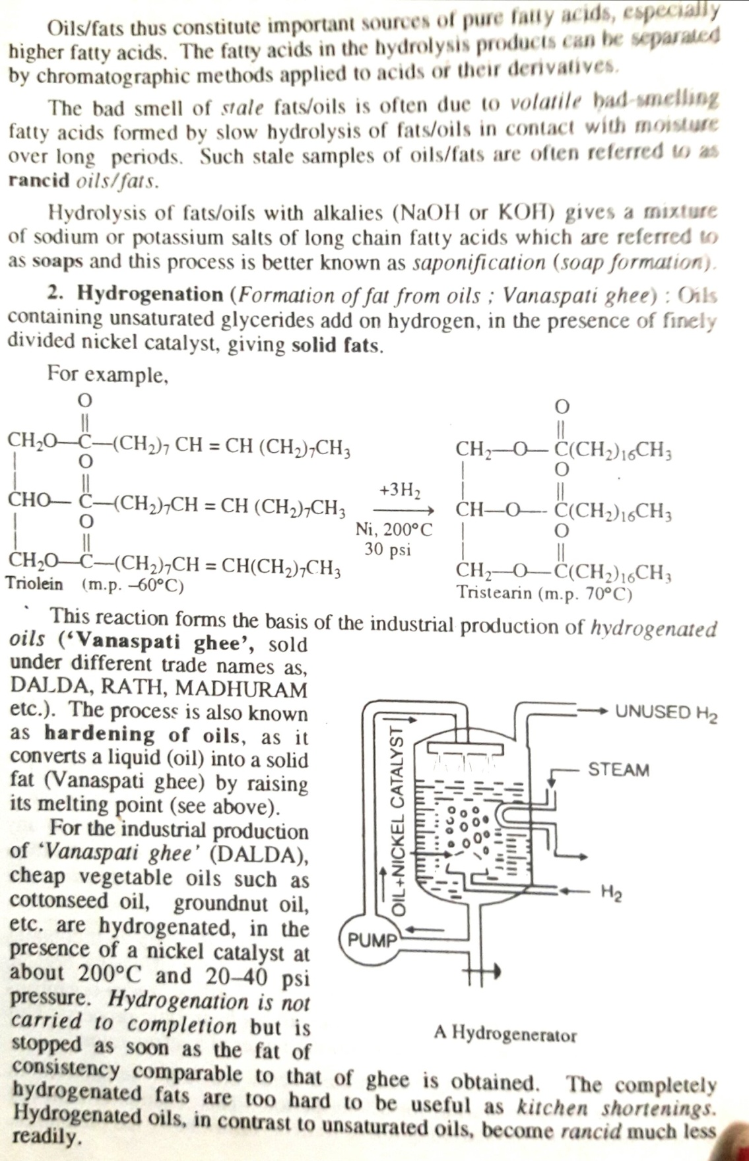

1. **Rancidity:** it is the natural process of decomposition (degradation) of fats or oils by either hydrolysis or oxidation, or both.

* Oil and fat when exposed to air they oxidized or hydrolysed t and produce volatile fatty acids.
* The term rancidity is applied to oil and fats which means development of unpleasant odor or taste due to slow decomposition of oil/fat into lower fattyacids.
* Oxygen in the air, moisture (water) in atmosphere & some microorganism cause rancidity.
* The development of rancidity is accompanied by a marked increase in the acid value of the fat and the extent of rancidity is determined by acid value.
* This converts fatty acid esters of oils into free fatty acids, by reaction with air, moisture and/or other materials. There are three causes for rancidity.

1. Oxidative rancidity
2. Hydrolytic rancidity
3. Microbial rancidity

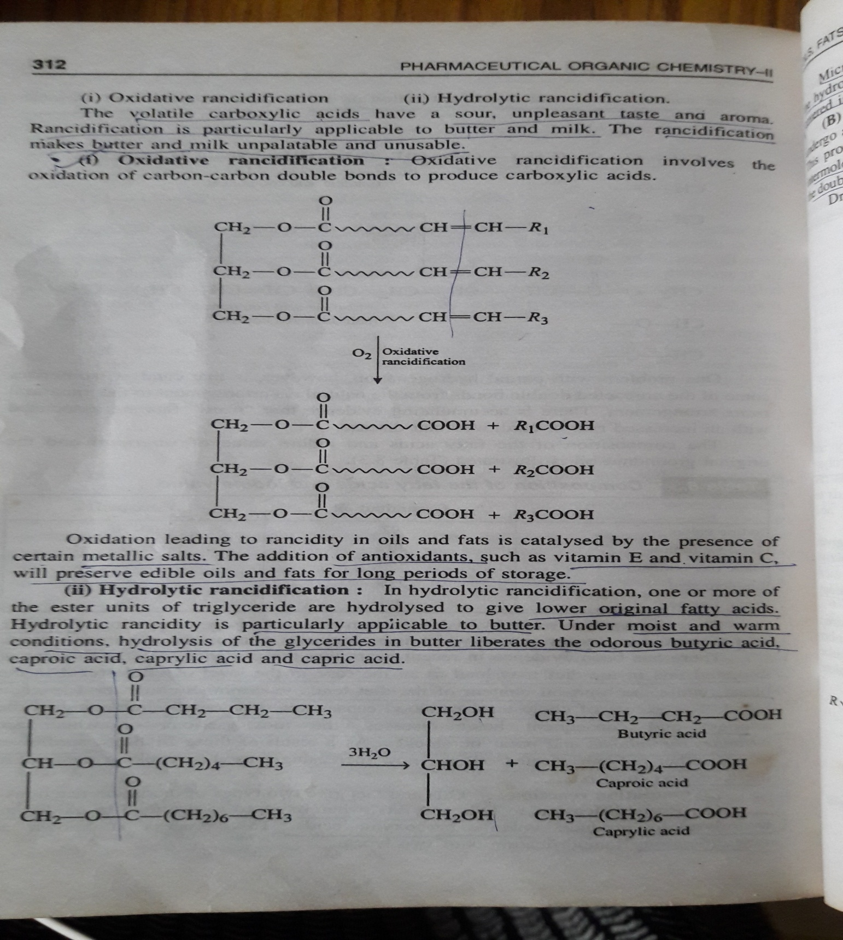

**Oxidative rancidity:** known as autoxidation, occurs when oxygen is absorbed from the environment. In the presence of oxygen and/or ultraviolet (UV) radiation, most lipids will break down and degrade, forming several other compounds.

**Hydrolytic rancidity**: also called hydrolysis or enzymatic oxidation, occurs in the absence of air, but with moisture present. This normally is accomplished through enzymatic peroxidation, where enzymes found naturally in plant oils (i.e., lipoxygenase, cyclooxygenase) and animal fats (i.e., lipase) can catalyze reactions between water and oil.

**c. Microbial rancidity:** is caused by micro-organisms such as bacteria, molds and yeast which use enzymes to break down chemical structures in the oil, producing unwanted odors and flavors.

**Drying oil**: Oil such as linseed oil form hard elastic &water insoluble coating when they are exposed to air in the form of thin layer, this phenomenon is known as drying of oil . The drying process is accelerated by certain metal salts, especially derivatives of [cobalt](https://en.wikipedia.org/wiki/Cobalt), [manganese](https://en.wikipedia.org/wiki/Manganese), or [iron](https://en.wikipedia.org/wiki/Iron).

* Drying oils are highly unsaturated oil and have high iodine value.

**Non drying oil:** their iodine value is less than 100 ex; olive oil.

**Semi drying oil:** their iodine value is between 105-114 ex: cottonseed oil.

**Dryng oil**: Their iodine value is above170-185 ex: Linseed oil.

* Drying of oil is not removal of moisture but it evolves a series of chemical reaction such as oxidation in the presence of oxygen in the air and polymerization and form cross linked polymer.

**Use:** Drying oil is used in paint industry.

**Analysis of Oils and Fats (Analytical constant)**

Oils/fats are subjected to many analytical tests for determination of their purity.

1. **Saponification value:** Alkaline hydrolysis of fat/oil is called Saponification because one of the products of hydrolysis is Soap (Na or K salt of fatty acid).

* Fats (triglycerides) upon alkaline hydrolysis (either with KOH or NaOH) yield glycerol and potassium or sodium salts of fatty acids (soap).

**Saponification No.:** It is defined as the number of milligrams of KOH or NaOH required to saponify one gram of the oil or fat.

**Example:** Saponification no. of coconut oil is 191.1 so 191.1 mg of KOH is required to saponify 1gm coconut oil.

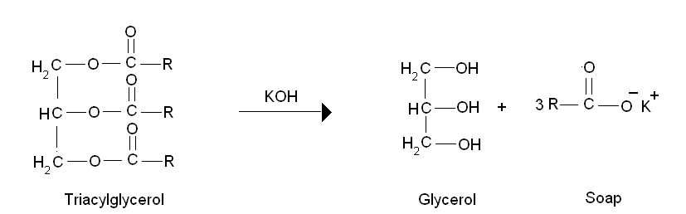

**Procedure:** It is determined by refluxing a standard amount of fat or oil with known excess of standard alcoholic caustic potash solution and back titrating with excess alkali with a standard acid.

* Take 2 gm of Castor oil in RBF (round bottom flask), add 25 ml of 0.5 N ethanolic KOH and reflux the content of flask for 30 minute.
* Cool the flask, add 1-2 drops of phenolphtelein indicator pink color will appear & titrate the solution with 0.5N HCl until the pink color of the solution disappear. Note down the burette reading.

Formula for determination of saponification value:



Where: N= normality of KOH

V1= volume of HCl consumed for determination of test sample in ml

V2= volume of HCl consumed for determination of Blank titration in ml

W= wt of oil/fat in grams

**Significance:**

1. The saponification value gives an idea about the molecular weight of the fatty acid.
2. It gives information concerning the character of the fatty acids of the fat- the longer the carbon chain; the less acid is liberated per gram of fat hydrolysed.
3. It is also considered as a measure of the average molecular weight (or chain length) of all the fatty acids present.  The long chain fatty acids found in fats have low saponification value because they have a relatively fewer number of carboxylic functional groups per unit mass of the fat and therefore high molecular weight.
4. **Acid value**: It indicates the amount of free acid present in the oil or fat.

It is defined as the number of milligrams of KOH required to neutralize the free acid present in one gram of the oil or fat.



**Procedure:**

It is determined by dissolving a weighed amount of oil or fat in alcohol and titrating it against a standard solution of KOH using phenolphthalein as an indicator.

* Take 5 gm castor oil in a conical flask add 50 ml of ethanol& ether mixture (1.1).
* Heat the content of the flask for 10 minute at low flame & add 1-2 drops of phenolphthalein indicator and titrate with 0.1 N KOH solution from burette till the pink color of the solution appear for 30 second. Note down the burette reading.
* Formula for determination of saponification value:

Acid Value = 56.1 x Vx N

Wt of oil/fat in gm

Where:

N = Normality of KOH

V = Volume of standard KOH consumed in determination of acid in test sample

**Significance:**

* It indicates the amount of free acid present in the oil or fat.
* Acid value measure the degree of hydrolytic rancidity.
* It gives an idea about edibility of oil/fat; pharmaceutical oil must not have acidity.
* Edible oil should contain acid value less than 1%.

1. **Iodine value:** It is defined as the number of grams of iodine taken up by 100 grams of fat or oil for saturation.

* Iodine value of a fat or oil is a measure of its degree of unsaturation. The degree of absorption of halogen by oil/fat is proportional to the no. of double bonds in oil/fat. If oils have large no. of double bond they have high iodine value.

**Procedure:** As iodine does not react readily, in actual practice, iodine monochloride is used. Iodine monochloride is known as Wijs’ reagent.

* 3 gram of oil/ fat is dissolved in 10 ml CCl4 (carbon tetrachloride) in iodine flask.
* Add 20 ml of iodine chloride solution kept the flask for 30 minute during which IODINE chloride will add across double bond of oil/fat.
* Add 50ml of KI (potassium iodide) Solution, the excess of iodine chloride react with KI and iodine will liberate which is back titrated with standard solution of sodium thiosulphate (Na2S2O3) using starch indicator and determine the end point.
* Formula for determination of Iodine value:

Iodine Value = 12.7 x (V2-V1) x N

Wt of oil/fat in gm

Where:

N = Normality of sodium thiosulphate (Na2S2O3) solution

V 1 = volume of sodium thiosulphate consumed for test solution

V 2 = volume of sodium thiosulphate consumed for blank solution

**Significance:**

* Iodine value of a fat or oil is a measure of its degree of unsaturation (presence of C=C double bond)
* Iodine vale of saturated fat is zero.
* Iodine value for a fat is low whereas for oil, it is high.
* If no. of C=C is more the iodine value of oil will be high and oil whose iodine value is high are used as drying oil in paint industry because drying oil is highly unsaturated oil example linseed oil.
* It gives an idea about drying characteristics of oil.
* It is helpful to find out adultration in paint industry.

1. **Reichert-Meissl value (RM value):** It indicates the amount of steam volatile fatty acids present in the oil or fat.

**“**It is defined as the number of millilitres of 0.1 N KOH solution required to neutralize the volatile water soluble acid obtained by hydrolysis of 5 gm fat or oil”.

It is determined by hydrolysing 5 grams of the fat with alkali solution (NaOH) and the mixture is acidified with dilute sulphuric acid and collect the volatile fatty acid by steam distillation. The distillate is cooled, filtered and titrated with 0.1 N KOH using phenolphthalein indicator.

* Formula for determination of Iodine value:

RM VALUE = Number of ml of 0.1 N KOH required for neutraliziation of fatty acid x 5

Wt of oil/fat in gm

**Significance**:

1. RM value gives an idea about low molecular weight volatile fatty acid example: butyric acid in butter and milk and ghee.

1. RM value is used to test the purity of butter or ghee.
2. RM value of adulterated ghee or butter is high than pure ghee or butter because adulterated butter or ghee contain high amount of butyric acid.( butyric acid is formed during hydrolytic rancidityof butter).

**5.Acetyl value**

It is the no of milligrams of KOH required to neutralize the acetic acid obtained by sapononification of 1 gm acetylated fat/oil.

**Procedure:** take 10 gram of fat or oil and 20 ml acetic anhydride in reflux condenser and boil for 2hours, cool and add 0.2gm pumic powder again boil for 30 minute then transfer into separating funnel discard the lower layer and add sodium chloride in upper layer and 20 ml warm water remove the aqueous layer and pour the substance in small dish add 1 gram sodium sulphate, filter and dry and determine the saponification value of acetylated fat or oil.

Determine the saponification vale of same fat or oil without acetylation and calculate the acetyl value by following formula-

**Acetyl value = 1335 (b-a)**

**1335-a**

Where, a = saponification value of fat or oil

b = saponification value of acetylated fat or oil

**significance:**

**6.Ester value:**

The ester value was estimated from the difference between saponification value and acid value

Ester value= saponification value- acid value

**significance:**