**NANOCHEMISTRY**

**Nano-technology (nano material)**

The word nano means dwarf. It (sometimes shortened to nanotech) is the technique of manipulating the matter on an atomic and molecular level having scale and size in the nanometer range. One nanometer is a billionth of a meter or 10-9 of meter.

Generally, it deals with structures sized between 1 to 100 nm, in at least one dimension, and involves developing materials or devices possessing at least one dimension within that size.

The Historical Concept:

* The first ever concept was presented in 1959 by the famous professor of physics Dr. Richard P. Feynman. He said that **"There’s plenty of room at the bottom"**.
* Invention of the Scanning tunneling microscope in 1981 and discovery of fullerene (C60) in 1985 lead to the emergence of nanotechnology. The term nanotechnology had been coined by Norio Taniguchi in 1974, though it was not widely known.
* Inspired by Feynman's concepts, [K. Eric Drexler](https://en.wikipedia.org/wiki/K._Eric_Drexler) used the term "nanotechnology" in his 1986 book [*Engines of Creation: The Coming Era of Nanotechnology*](https://en.wikipedia.org/wiki/Engines_of_creation), which proposed the idea of a nanoscale "assembler" which would be able to build a copy of itself and of other items of arbitrary complexity with atomic control.

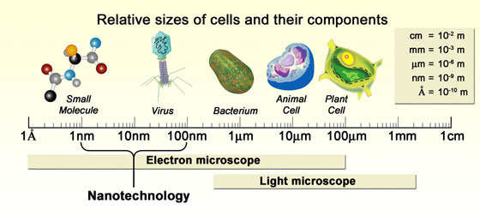

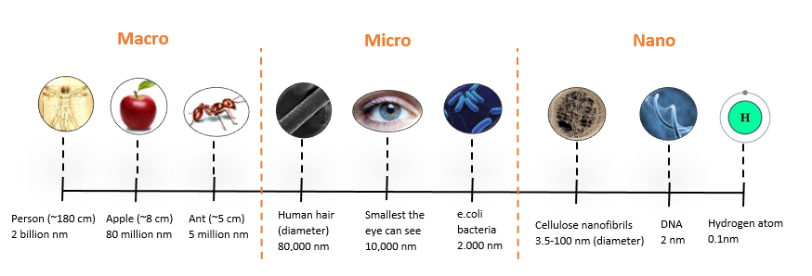

**Carbon Nanotube:-**

Carbon nanotubes (CNTs) are [allotropes of carbon](https://en.wikipedia.org/wiki/Allotropes_of_carbon) with a [cylindrical](https://en.wikipedia.org/wiki/Cylindrical) [nanostructure](https://en.wikipedia.org/wiki/Nanostructure). Nanotubes are members of the [fullerene](https://en.wikipedia.org/wiki/Fullerene) structural family. Their name is derived from their long, hollow structure with the walls formed by one-atom-thick sheets of carbon, called [**graphene**](https://en.wikipedia.org/wiki/Graphene). Carbon nanotubes are composed of carbon atoms linked in hexagonal shapes, with each carbon atom covalently bonded to three other carbon atoms. Carbon nanotubes have diameters as small as 1 nm and lengths up to several centimeters. Although, like buckyballs, carbon nanotubes are strong, they are not brittle. They can be bent, and when released, they will spring back to their original shape. Carbon nanotubes are the strongest and stiffest materials yet discovered in terms of [tensile strength](https://en.wikipedia.org/wiki/Tensile_strength) and [elastic modulus](https://en.wikipedia.org/wiki/Elastic_modulus) respectively. This strength results from the covalent sp2 bonds formed between the individual carbon atoms. Nanotubes are categorized as [single-walled nanotubes](https://en.wikipedia.org/wiki/Carbon_nanotube#Single-walled) (SWNTs) and [multi-walled nanotubes](https://en.wikipedia.org/wiki/Carbon_nanotube#Multi-walled) (MWNTs). Individual nanotubes naturally align themselves into "ropes" held together by [Van der Waals forces](https://en.wikipedia.org/wiki/Van_der_Waals_force), more specifically, [pi-stacking](https://en.wikipedia.org/wiki/Pi-stacking).

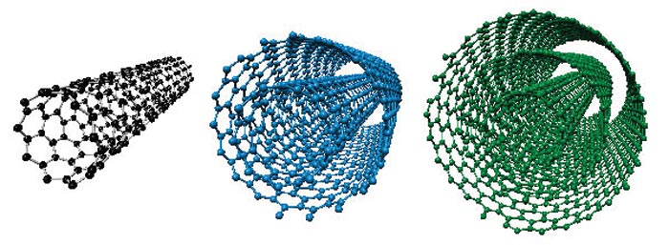

Properties-

* [CNTs have High Electrical Conductivity](https://www.cheaptubes.com/carbon-nanotubes-applications/#CNTs%20Electrical%20Conductivity)
* [CNTs have Very High Tensile Strength](https://www.cheaptubes.com/carbon-nanotubes-applications/#CNTs%20Strength%20and%20Elasticity)
* [CNTs are Highly Flexible- can be bent considerably without damage](https://www.cheaptubes.com/carbon-nanotubes-applications/#CNTs%20Strength%20and%20Elasticity)
* [CNTs are Very Elastic ~18% elongation to failure](https://www.cheaptubes.com/carbon-nanotubes-applications/#CNTs%20Strength%20and%20Elasticity)
* [CNTs have High Thermal Conductivity](https://www.cheaptubes.com/carbon-nanotubes-applications/#CNTs%20Thermal%20Conductivity%20and%20Expansion)
* [CNTs have a Low Thermal Expansion Coefficient](https://www.cheaptubes.com/carbon-nanotubes-applications/#CNTs%20Thermal%20Conductivity%20and%20Expansion)
* [CNTs are Good Electron Field Emitters](https://www.cheaptubes.com/carbon-nanotubes-applications/#CNTs%20Field%20Emission)

Applications of Nanotubes -

* The low weight % of carbon nanotubes can lead to significant improvements in the mechanical properties of biodegradable polymeric nanocomposites for applications in tissue engineering including bone, cartilage, muscle and nerve tissue.
* Adding small amounts of CNTs to metals increases tensile strength and modulus with potential in aerospace and automotive structures
* Large structures of carbon nanotubes can be used for thermal management of electronic circuits.
* One of the promising applications of single-walled carbon nanotubes (SWNTs) is their use in solar panels, due to their strong UV/Vis-NIR absorption characteristics.
* Using CNT for manufacturing of light weight boats.
* Replacing transistor from the silicon chips as they are small and emits less heat
* Use in electrical cables and wires.
* Use in fabrics.

**Application of Nanotechnology :-**

Nanotechnology in Drugs:-

* Provide new option for drug delivery and drug therapies.
* Enable drugs to be delivered to precisely the right location in the body and release drug doses on a predetermined schedule for optimal treatment.
* Attach the drug to a nano-sized carrier.
* They become localized at the disease site i.e. cancer tumor. Then they release medicine that kills the tumour.
* Current treatment is through radiotherapy or chemotherapy.
* Nanobots can clear the blockage in arteries.

Nanotechnology in Fabrics:-

* The properties of familiar materials are being changed by manufacturers who are adding nano-sized components to conventional materials to improve performance.
* In manufacturing bullet proof jackets.
* Making spill and dirt resistant antimicrobial, antibacterial fabrics.

Nanotechnology in mobile:-

* Morph, a nanotechnology concept device developed by Nokia Research centre (NRC) and the university of Cambridge (U.K.)
* It will be able to charge itself from available light sources using photovoltaic nanowire glass covering it’s surface.

Nanotechnology in Electronics:-

* Electrodes made from nanowires enable flat panel displays to be flexible as well as thinner than current flat panel displays.
* Nanolithography is used for fabrication of chips.
* The transistors are made of nanowires, that are assembled on glass or thin films of flexible plastic.
* e-paper, displays on sunglasses and map on car windshields.

Nanotechnology in computers:-

* The silicon transistors in your computers may be replaced by Carbon nanotubes.
* Nanorods is the upcoming technology in the display techniques due to less consumption of electricity and les heat emission.
* Size of the microprocessors are reduced to a greater extent.

Industrial applications of nano technology in Surface Coatings:-

* The most prominent application of nanotechnology in the household is self-cleaning or “easy to clean” surfaces on ceramics or glasses. Nanoeramic particles have improved the smoothness and heat resistance of common household equipments such as the flat iron

