**UNIT – 1**

**Introduction:** The radar is an acronym of radio detection and range. The radar is used to detect the echo signal from the target through the reflection . The radar consists of a transmitter and a receiver which are synchronized by a synchronizer and the target presence is displayed on the PPI Display. Basic radar block Diagram is shown in the following diagram.

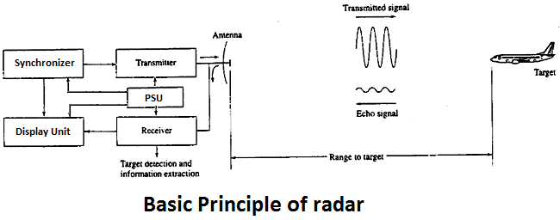

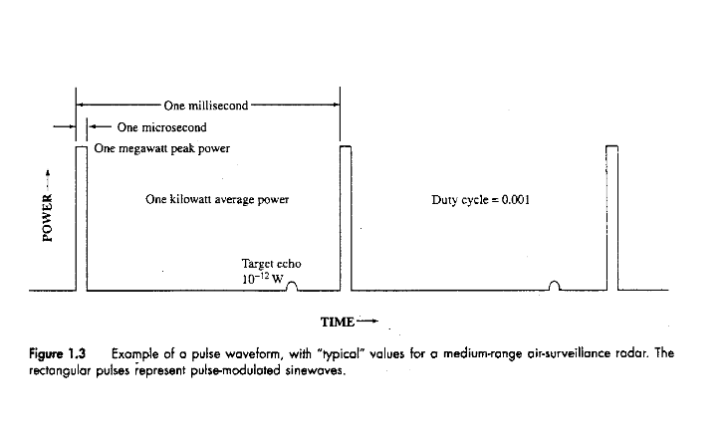

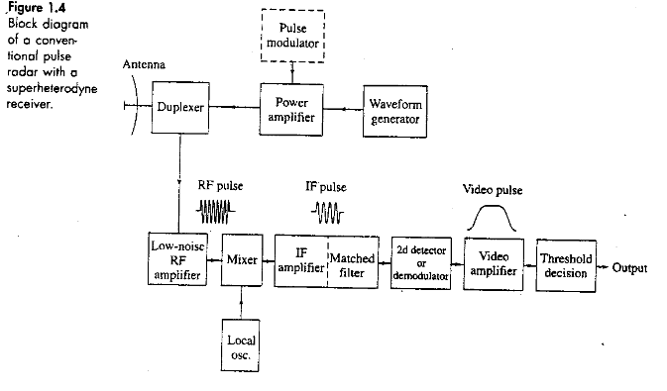

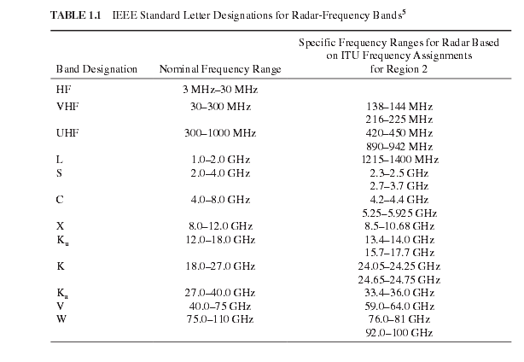**Frequency Band :**

**Applications of radar:**

1. Military
2. Remote sensing
3. Air traffic control
4. Low enforcement and high way safety
5. Aircraft safety and navigation
6. Ship safety
7. Space

**Radar Equation :**

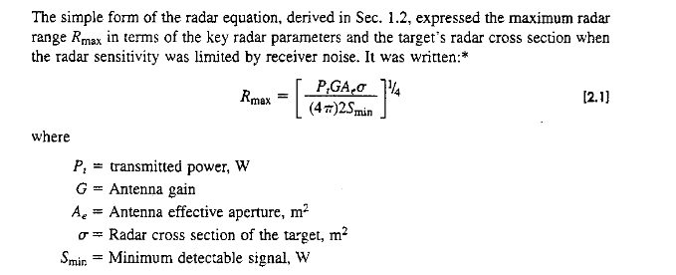

**Detection of Signals in Noise:**

The threshold level is set for detection of the echo signal from the target but when threshold level is either set higher or lower than the specified threshold level, then the problem arises. if threshold is set higher, the weak echo signal will be difficult to be detected and if the threshold level is set lower ,the false alarm will be at higher rate. In following diagram, A and B are valid detection and C is missed detection as threshold level is set at specified level.

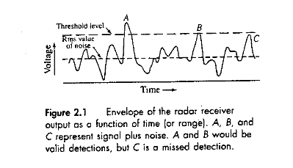

**Receiver Noise and Signal to Noise Ratio:**

The available noise power at the receiver is expressed as

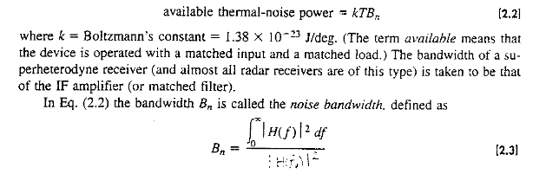











**Probabilities of detection and False alarm:**

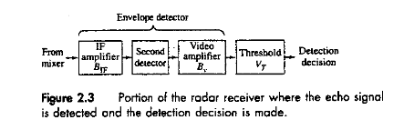

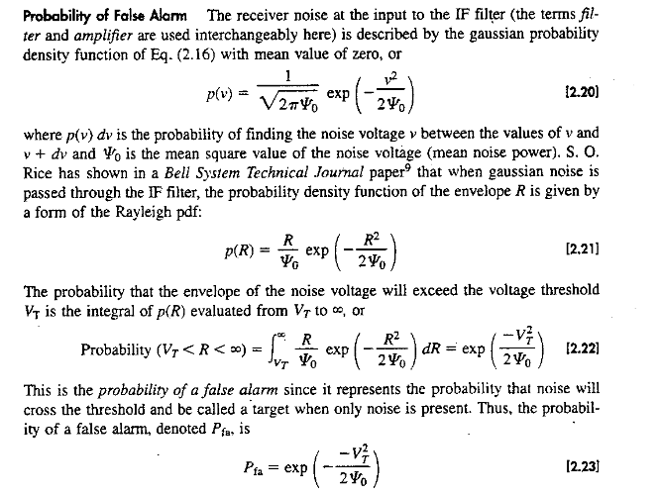



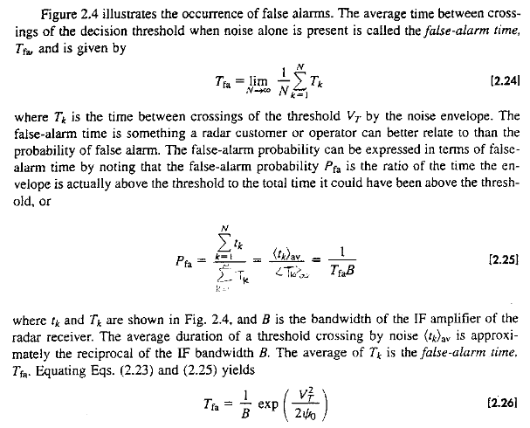

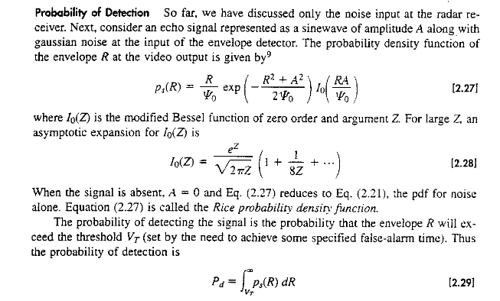

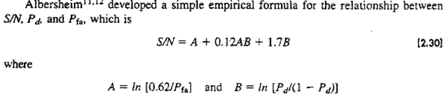

**Integration of Radar Pulses :**

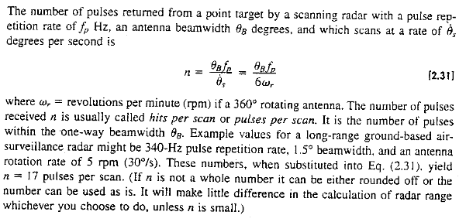

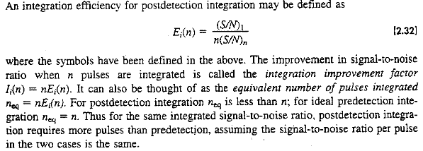

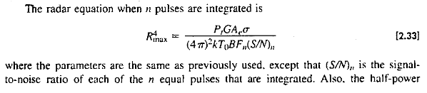

**Radar cross section of Targets :**

Radar Cross Section (RCS) accounts for the amount of power reradiated by the target back towards the radar transmitter.

Let the incident power density at the target be Qt, and the back scattered power density be Qb. If the back scattered power density has resulted from isotropic form of target,

then



and

Where as Pb is backscattered power, then from (i) & (ii)



RCS is a fictional area over which the transmitted power density Qt must be intercepted to collect a total power.

The RCS definition is usually written in terms of electric field amplitude.

In order to make the definition dependent only on the target characteristics, range is eliminated by taking the limit as R → Q

RCS can formally be defined as



Hear it is single real scalar number.

It uses single polarization of TxR and that of the receiver.

However, the polarization state of the transverse polarization is a two dimensional vector, and therefore two orthogonal polarization basis vectors are required to fully describe.

To account for polarization effects, RCS must be generalized to polarization scattering matrix (PSM) , for a radar using linear polarization.



Instead of a single real number, the target back scattering characteristics are now described by four complex numbers. If the radar transmits only vertically polarized wave and receives the vertically polarized wave then RCS a is related.



Radars can be designed to measure the full PSM. Polari metric measurements can be used for a variety of target analysis purposes.

It will be assumed that only a single fixed polarization is transmitted and a single fixed polarization received consequently the RCS is described by a scalar rather than matrix function.

Typical RCS values at microwave frequencies :

|  |  |  |
| --- | --- | --- |
| **Target** | **RCS, m2** | **RCS, dBsm** |
| Insect | 0.00001 | - 50 |
| Bird | 0.01 | - 20 |
| Man | 1 | 0 |
| Bicycle | 2 | 3 |
| Single engine aircraft | 1 | 0 |
| Larger Fighter Aircraft | 6 | 8 |
| Large ship at zero grazing angle | 10000 | 40+ |

RCS (dBsm) = 10 log10 (RCS,m2)

= 10 log10 10-5

= - 50 log10 10

= - 50 × 1

= - 50 dBsm

RCS of a complex target varies with both transmitted frequency and aspect angle.

* Correlation length is change in time frequency, or angle required to cause the echo amplitude to decorralate to a specified degree.
* If a target (rigid) such as building is illuminated with a series of identical pulses and there is no motion between radar and target, one expects the same received complex voltage y(t) from each pulse (while ignoring receiver noise).
* If motion between the two is allowed, however, the relative path length between the radar and the various scatterers comprising the target will change, one may expect the received complex voltage y(t) (from each pulse) to fluctuate.

For rigid targets, decorrelation of RCS is induced by changes in range and aspect angle on the other hand, if natural clutter such as ocean surface or a stand of tree is illuminated, the signature will decorrelate even if the target and radar do not move relative to one another. In this case, the decorrelation is caused by “internal motion” of clutter, such as the wave motion of the surface or the flowing leves and limits of the trees.

Decorrelation is unavoidable and the rate of decorrelation is influenced by factors external to radar such as wind speed.

Changes in range and aspect angles also induce decorrelation in clutter signatures.

A sense of change in frequency and angle required to decorrelate a target or clutter patch, can be obtained by the following simple argument.

Consider a target of a uniform line array of point scatterers tilted at an angle θ and separated by Δx from one another.

For simplification, assume an odd number of scatterers (2M + 1) from – M to + M.

If nominal distance to the radar Ro is much larger than the target extent (Ro >> (2M + 1) Δx) : the range to the nth scatterer.

Is approximately given by



If the target is illuminated with the waveform



AejΩt, then received signal



Let Ω = 2ITF

Z = F sin θ

α = 4πΔx / c

be placed

Then ӯ(t) can be considered as a function of ӯ(t; z). The corresponding location in variable z is of interest which includes frequency and aspect angle both, ӯ(t, z) is periodic in z with period ; the deter – ministic auto correlation function is :



The correlation length can now be determined by evaluating equation (9) to find the value of Δz which reduces ‘S’ to a given level. This value of Δz can then be converted into equivalent changes in frequency or aspect angle.

One criterion is to choose the value of Δz corresponding to the first zero of the correlation function. This occurs when the argument of the numerator equals π and defining the target length L = (2M + 1) Δx



Recall that z = F sinθ. To determine correlation length in angle, fix the transmitted frequency F so that Δz = F (Δ sin θ). Assuming θ to be very small Δ sin θ = Δθ, so z = FΔQ and equation (10) becomes the desired result for the change in angle required to decorrelate the echo Amp.



The frequency, step required to decorrelate the target is obtained by fixing the aspect angle θ so that Δz = ΔF sin θ. The result is



This is maximum when θ = 90o. L sing θ is the length of the target projected along the radar bore sight.



(i) These results are based on highly simplified target model and an assumption what constitutes “Decorrelation” to be point at which the correlation function ‘S’ drops to ½ or 1/e of its peak results in a smaller estimate of the required change in angle or frequency to decorrelate the target.

(ii) For rigid targets the amount of aspect angle rotation required to decorrelate the target echoes can be estimated from (ii)

(iii) Detection performance is improved when successive target echoes are uncorrelated for this reason, some radars use a technique called “Frequency agility” to force decorrelation of successive measurements. In this process, the radar frequency is increased by ΔF hertz or more between successive pulses.

**Radar Cross section of fluctuation :**

**Swerling Models :**

A popular method for representing the fluctuation of target are the four statistical models. Peter swirling calculated SNR as function of probability of detection, probability of false alarming and number of pulses integrated.

**Case I :** The echo pulses received from a target on any one scan are of constant amplitude throughout the entire scan but are independent (uncorrelated) from scan to scan. A target echo fluctuation of this type is called sean to scan fluctuation. It is also known as slow fluctuation. Probability of density function for the cross section σ.



Target model in case I is raylieghscatteres the exponential pdf represents the statistics of the square of a voltage that is described by rayliegh pdf.

**Case II :** The probability density is



But fluctuations are independent from pulse to pulse rather from scan to scan. This is called fast fluctuation.

**Case III :** Radar cross section is assumed to be constant within a scan and independent from scan to scan



**Case IV :** Fluctuation as is pulse to pulse pdf as in case III.

Swerling considered two extreme cases for the correlation properties of this block of M measurements of σ.

All m pulses collected on one sweep have the same value. The M new pulses collected on one sweep have the same value as one another also but their value is independent of the value measured on the first sweep.

**Pulse to pulse decorrelation :**

Each individual pulse on each sweep results in an independent value for σ.

**Clutter :**

The term clutter implies an interference signal, but in radar it refers to a component of the received signal due to echoes from volumes or surface scatterers.

Such scatterers include the earth surface, including both terrain and sea; weather echoes (for example, rain clouds); and manmade distributed clutter, such as so called chaff clouds of air borne scatterers, typically made out of light weight strips of reflecting material. Clutter echoes differs from targets and noise in that clutter echoes are sometimes interference and sometimes the desired signal.

For instance, synthetic aperture imaging radars are designed to image the earth surface, thus the terrain is the target in a SAR radar.

For an air borne or space borne surveillance radar trying to detect moving vehicles on the ground, the surrounding terrain echo is an interference signal.

Clutter is also modeled as a random process. Clutter differs from noise in two ways : Power spectrum of clutter is not white (i.e. it is correlated interference) and since clutter is the result of echo; the power is affected by such radar and scenario parameters as the antenna gain, transmitted power, signal processing gain and the range from the radar to the terrain.

In addition to temporal correlation, clutter can also exhibit spatial correlation the reflectively samples from adjacent resolution cells may be correlated. Two excellent general references on land and sea clutter phenomenology are books by ulaby and Dotson.

**Signal to clutter ratio :**



For volume scatterer, beam limited area-clutter and pulse emitted area scalteran.



Transmitted power and antenna gain both cancel out. This occurs because both the clutter and target signals are echoes of radar pulse;

Increasing power or antenna gain increases the strength of both types of echoes equally; then equation (1) is the definition.

**Temporal & Spatial Correlation :**

One model suggested to estimate the power spectrum of RCS of foliated trees or rain uses a cubic spectrum.



FC = F{wavelength, either wind speed or rain rate }

FC = corner frequency

Cubic power spectrum (Rain & Trees clutter)

|  |  |  |  |
| --- | --- | --- | --- |
| Target | Radar Frequency | | |
| 10 | 35 | 95 |
| Rain, 5 mm/hr | 35 | 80 | 140 |
| Rain, 100 mm/hr | 70 | 120 | 500 |
| Trees, 6 – 15 mph wind | 9 | 21 | 35 |

Another model frequently used to model generic power spectra is gau

ssian given by



This Gaussian model is commonly used in weather radar and is the basis of the pulse pair Doppler velocity estimation

Low order autoregressive spectrum model by Haykin et one.



Real clutter measured from ground based radars appears to be well matched using an order N of only two to four

**Advantage :** It is parameters can be completed directly from the measured data and adapted in real time using the levinson – Durbin Algorithm or similar one.

AR parameters can be used to construct optimal adaptive clutter suppression filters.

**Disadvantage :** Calculations rapidly become computationally intensive as the model increases.



Where as total noise power



**Transmitter Power:**

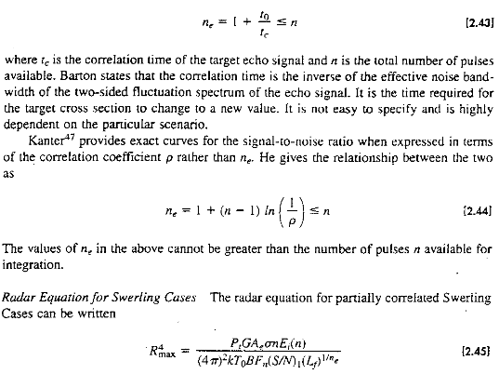

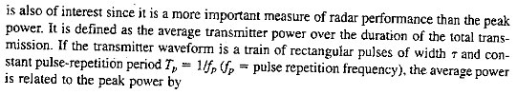

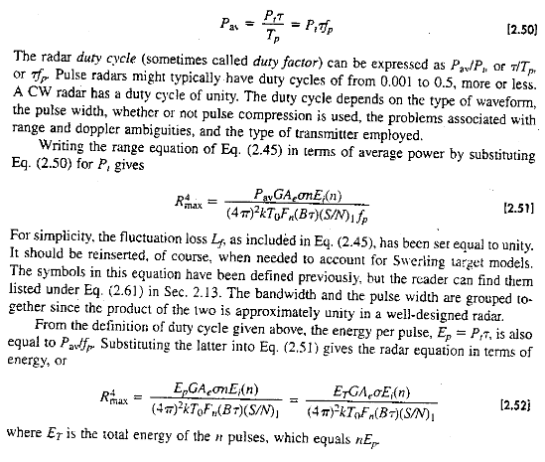

**Pulse Repetition Frequency :**

The pulse repetition frequency (prf) is often determined by the maximum unambiguous range beyond which targets are not expected.

The PRF is determined primarily by the maximum range at which targets are expected. If the PRF is made too high, the likelihood of obtaining target echoes from the wrong pulse transmission is increased. Echoes signals received after an interval exceeding the PRP (Pulse Repetitation Period) are called multiple times around echoes.

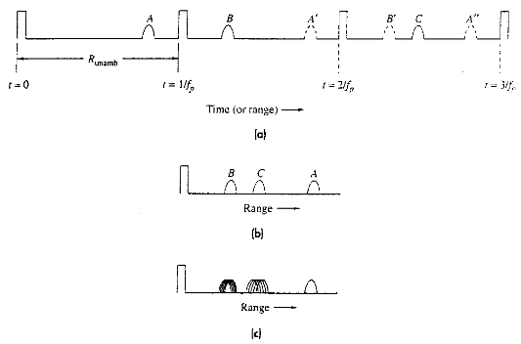

They can result in erroneous or confusing range measurement. The nature of some multiple-time-around echoes may cause them to be labeled as ghost or angel targets or even flying saucers.

(a) Three targets A, B & C where A is within Runamb and B & C are multiple time around echoes (targets); (b) appearance of the three targets on A-scope (c) appearance of three targets on the A-scope with a changing PRF.

To minimize the multiple time around targets, a staggered PRF can be used.

When a radar is scanning, it is necessary to control the scan rate so that a sufficient number of pulses will be transmitted in any particular direction in order to guarantee reliable detection. If too few pulses are used, then it will more difficult to distinguish false targets from actual ones. False targets may be present in one or two pulses but certainly not in ten or twenty in a row. Therefore to maintain a low false detection rate, the number of pulses transmitted in each direction should be kept high, usually above ten.

For systems with high pulse repetition rates (frequencies), the radar beam can be repositioned more rapidly and therefore scan more quickly. Conversely, if the PRF is lowered the scan rate needs to be reduced. For simple scans it is easy to quantify the number of pulses that will be returned from any particular target. Let t represent the dwell time, which is the duration that the target remains in the radar’s beam during each scan. The number of pulses, N, that the target will be exposed to during the dwell time is :

N = τPRF …. (2.20)

We may rearrange this equation to make a requirement on the dwell time for a particular scan

τmin = Nmin/PRF …. (2.21)

So it is easy to see that high pulse repetition rates require smaller dwell times. For a continuous circular scan, for example, the dwell time is related to the rotation rate and the beam-width.

τ = θB / θS …. (2.22)

Where θB = beam-width [degrees] θS = rotation rate [degrees/sec] which will give the dwell time (τ) in seconds. These relationships can be combined; giving the following equation from which the maximum scan rate may be determined for a minimum number of pulses per scan:

θS = θB PRF/N …. (2.23)

Scan rate may be calculated by using following equation,

Scan rate (θS) = (RPM × 360o) / 60 s …. (2.24)

**Antenna Parameters :**

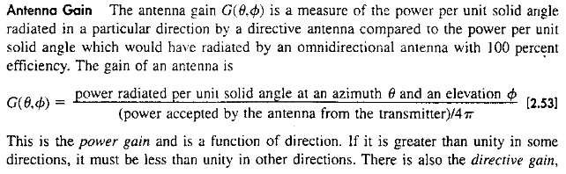

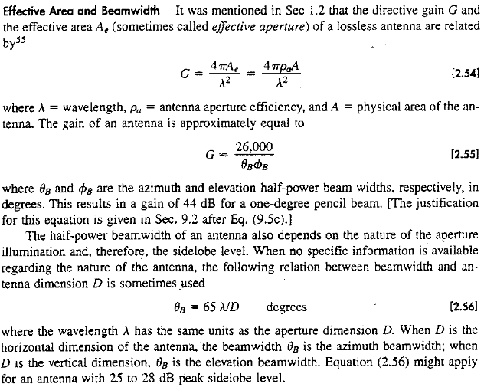

**System Losses :**

**1. Antenna Losses:**

1. **Beam Shape loss :** Beam shape loss occurs due to the different forms of beams radiated from the antenna, the beams such as fan shape and Pencil shape beams. This loss depends upon the number of pulses received within the one way half power beam width and the total number of pulses integrated.



Where nB is the number of pulses received within the one way half power beam width θB and ‘n’ is the total number of pulses integrated.

One way power antenna Beam pattern is described by

Pn = -2.78 θ2 / θB2

θB = HPBW

θ = Angle measurement from centise

1. **Scanning loss:** when antenna beam scans rapidly enough, relative to the round trip time of the echo signal. The antenna gain in the direction of the target on transmit might not be same as that on receive. This results in scanning loss.
2. **Radom Loss :** Loss introduced by radom depends on type and radar frequency. A typical ground based metal space frame radom might have two way transmission loss of 1.2 dB in α and X-band.
3. **Phased array loss:** Some phased array radars have additional transmission line losses due to distribution network that connects receiver and transmitter to each of the many elements of the array.
4. **Signal Processing loss:** The signal processing can introduce loss that has to be tolerated. The factors subscribed below can introduce significant loss.
5. Non-matched filter : It can be from 0.5 to 1.0 dB due to practical matched filter.
6. Constant false alarm rate (CFAR) receiver : This loss can be more than 2.0 dB depending on the type of CRAF.
7. Automatic integrators A binary moving window detector can have loss if 1.5 to 2.0 dB.
8. Threshold level : Depending low accurately the threshold can be set and maintained. this loss may be a fraction of a dB.
9. Limiting Loss : Some radars might use a limiter in the radar receiver.

A pulse compression processing to remove amplitude fluctuations in the signal.

A dicke fix; an electronic counter counter measure to reduce the effects of impulsive noise, hard limiting can introduce greater loss.

1. Straddling loss : It occurs when range gates are not centered on the pulse or when for practical reasons, they are wider than optimum like wise in a doplar filter bank. These can be a filter straddling loss when the signal spectral line is not centres on the filter.
2. Sampling loss if there is only one pulse per pulse width, sampling might not occur at the maximum amplitude of pulse the difference between the sampled value and the maximum pulse amplitude represents sampling loss.

**2. Plumbing Losses:**

This loss occurs due to the various joining components of the wave guide like connectors, Tees, Bends, Twists and Corners etc. They provide two way loss.

**3. Duplexer Losses:**

This loss occurs on the transmission way and the receiving way to/from the antenna. The loss occurs in different quantities of the power received from the antenna and transmitted to the antenna.

**4. Transmission losses:**

This loss occurs on the transmission line between various components and the devices such as on a receiver P.C.B. where the different components are installed and connected to each other through the microstrip transmission line and the transmission line connected from the receiver to the display unit and the transmitter to the synchronizer.

1. What is acronym of RADAR?
2. What are the blocks of a RADAR?
3. What is the function of a synchronizer?
4. What is the significance of SNR?
5. Name an RF Amp. of a radar transmitter?
6. Find the noise power in an IF Amp. of 70 Mhz bandwidth at ambient temperature of 17oC.
7. An IF Amplifier of 70 Mhz in a receiver of radar is operating at 27oC with an output signal to noise ratio of 3. Find the minimum detectable signal if the noise figure = 50.
8. Define range.
9. Define aspect angle.
10. A linear target of 15 scatterers separated by a distance of 20 cm reflects 15 watt power of 2 GHZ. Find change in aspect angle and change in frequency at the same aspect angle.
11. Derive the radar equation.
12. Draw and explain the block diagram of a conventional pulse radar.
13. A vertically polarized EM wave of 500 V/m is reflected when 2000 V/m of the same polarization is transmitted to a target at 25 km away from the radar station. Find its radar cross section and also it scattering parameter.
14. What are the parameters which should be accounted for target radar cross section of fluctuations. Explain them briefly.
15. How can an echo signal be detected from the noise? Explain it with a suitable diagram.
16. What is pulse repetition frequency? What are the effects if the pulse repetition rate is varied from its standard value?
17. What are the various applications of a radar? If a radar of 50 MHz bandwidth shows false alarm after a period of 15 minutes. Find the probability of false alarm?
18. Find the signal to noise ratio if the probability of detection of a signal and the probability of false alarm are 0.7 and 0.8, respectively.
19. What are the ways in which a radar cross section of a target be described? How it is affected by polarization and change in frequency of the EM waves.
20. Write a short who on swerling model with its different cases.
21. Explain the antenna parameters with which a radar antenna performance can be evaluated.
22. Explain system losses of a radar? Which of beam shapes is more used. What are the factors which affect the beam shape loss.
23. Find the false alarm time for an IF amp. of 50 MHz bandwidth, set at a thereshold of a 5V with a rms noise voltage of 3V.
24. What is difference between post detection integration and pre detection integration.
25. Find the SNR per pulse in the post detection integration if 500 independent (pulse) samples are integrated with probability of detection of 0.7 and that of false alarm of 10-4.
26. Calculate the minimum receivable signal in a radar receiver which has an IF BW of 1 MHz and noise figure of 6 dB.
27. A radar is operated at 100 GHz, if the antenna diameter is 2m. Calculate the beamwidth of the antenna.
28. Calculate the average power when peak power is 200 kw, pulse width is 2μs and the rest time is 2000 s.
29. A radar operating at 10 GHz with the peak power of 500 kw, the power gain of antenna is 5000 and minimum power of receiver is 10-14. Calculate the maximum range of radar if the effective area of antenna is 10m2 and radar cross section is 4m2.
30. What is the peak power of a radar whose average power is 200w, pulse width (pw) is 1μs, and has PRF of 1000 Hz? Also calculate the range of this ground based air surveillance radar if it has to detect a target with a radar cross section of 2m2 when it operates at a frequency of 2.9 Ghz with a rectangular shaped antenna that is 5m wide, 2.7m height, antenna aperture efficiency of 0.6 and the minimum detectable is 10-12 w.