**HOME ASSIGNMENT-4**

1. An air filled waveguide with cross section 2x1cm can transport energy in **TE10** mode at **30 MHz** with a rate of **0.5**hp. Compute peak value of electric field occurring in wave guide.
2. A shielded strip line has the following parameters: Dielectric constant of the insulator **εr =2.56**, strip width **w=25mils**, strip thickness **t=14mils**, shield depth **=70mils**.

calculate (i)K-factor(ii)the fringe capacitance (iii) characteristics impedance.

1. What is microstrip transmission line? Explain briefly each of the type and losses.
2. Determine the S- matrix for E-plane tee .and power delivered to collinear port **1** and port **2** if port **3** is impressed with input power.
3. Explain **Faraday Rotation Isolator**. What is the signification of VSWR?
4. A symmetric directional coupler with infinite directivity and a forward attenuation of 20dB is used to monitor the power delivered to load **ZL** in figure shown below. Bolometer 1 introduces a VSWR of **2.**0 on arm **4**; bolometer 2 is matched to arm3.if bolometer 1 reads 8mW and bolometer **2** reads **2 mW**, Find (i) power dissipated in the load **ZL**(ii) the VSWR on **arm 2**.

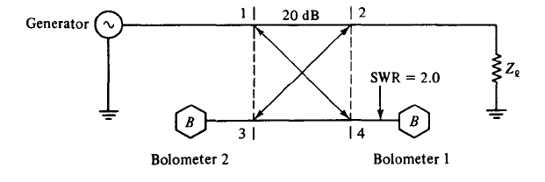

*Figure Q3(c) power measurement by directional coupler*

1. Explain a working of travelling wave tube with its applications and schematic diagram.
2. Derive the expression for optimum distance for bunching in two cavity klystron.

**HOME ASSIGNMENT-5**

1. Describe the operation **IMPATT** diode and its applications.
2. Describe the operation of **TRAPAT**T diode with its characteristics.
3. Explain the low power, medium power measurement and high power measurement techniques.
4. Explain **VSWR** measurement with its set up and impedance measurement by **reflectometer**.