**Solution of Optical Network (first sessional examination(2019-20) :REC070**

**Section A**

**ANS(Q1 (a)) FBG (fiber Bragg grating) is a periodic circuit created in a fiber core. It has a capability to reflect certain emission wavelengths and transmit the others**. The refraction index periodic variation in the fiber core causes the reflection generating a wavelength-specific dielectric mirror. Hence, fibre Bragg grating performs as an inline fiber optic filter blocking or reflecting specific wavelengths.

**ANS(Q1 (b))** Signal regeneration was not initially implemented in transponders. At first, these transponders were only used to convert **the wavelengths of incoming external signals into wavelengths that worked with DWDM systems**: namely, those in the C-Band. But now, this conversion also serves to stabilize the frequencies and amplify the power of these signals into something compatible with the erbium doped fiber amplifiers (EDFA) in DWDM system. The sophistication of the signal regeneration components in transponders grew as they progressed from 1R to 3R.

**ANS(Q1 (C)) 1310 nm and 1550 nm.**

**ANS(Q1 (d)) NA = Sinθ= r/(r2 +d2)0.5**

**ANS(Q1 (e)) 30 sheath miles.**

**Section B**

**ANS(Q2 (a))** A fiber optic coupler is an optical device capable of connecting one or more fiber ends in order to allow the transmission of light waves in multiple paths. The device is capable of combining two or more inputs into a single output and also dividing a single input into two or more outputs. Compared to a splice or connector, the signal can be more attenuated by fiber optic couplers, as the input signal can be divided amongst the output ports.

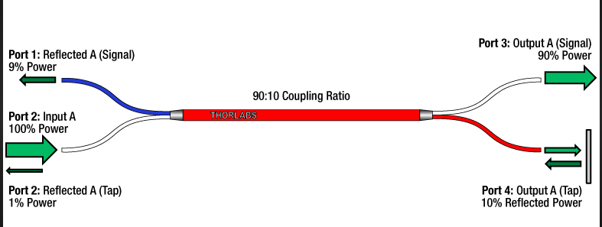

**FigQ2(a)**

**ANS(Q2 (b))** An optical network is a type of data communication network built with optical fiber technology. It utilizes optical fiber cables as the primary communication medium for converting data and passing data as light pulses between sender and receiver nodes. An optical Through its use of light as a transmission medium, an optical network is one of the fastest communication networks. It works by using an optical transmitter device to convert an electrical signal received from a network node into light pulses, which are than placed on a fiber optic cable for transport to a receiving device. Unlike copper based networks, the light pulses of an optical network may be transported quite a distance until the pulses are regenerated through an optical repeater device. After a signal is delivered to a destination network, it is converted into an electrical signal through an optical receiver device and sent to a recipient nodenetwork is also known as an optical fiber network, fiber optic network or photonic network.

**ANS(Q2 (c))** SONET stands for Synchronous Optical Network. SONET is a communication protocol, developed by Bellcore – that is used to transmit a lage amount of data over relatively large distances using optical fibre. With SONET, multiple digital data streams are transfered at the same time over the optical fibre.

**SONET Layers:** SONET includes four functional layers and there are main four configurations:

1. Point to multi point configuration. This configuration sends data from one end to multi point receivers through Add /drop multiplexers. The configuration is shown in figure Q(c) (i) and layers are shown in figure Q2(ii) .

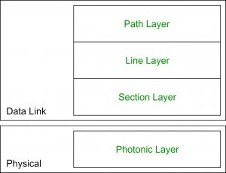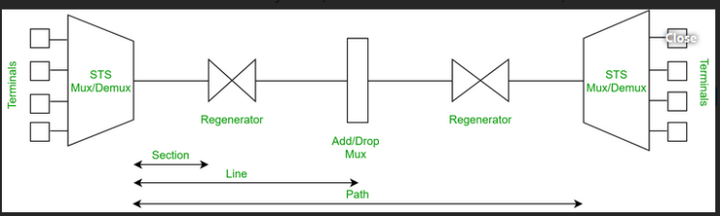

FigQ2(C) (i) (ii)

1. **Path Layer:**It is responsible for the movement of signal from its optical source to its optical destination.STS Mux/Demux provides path layer functions.
2. **Line Layer:**It is responsible for the movement of signal across a physical line.STS Mux/Demux and Add/Drop Mux provides Line layer functions.
3. **Section Layer:**It is responsible for the movement of signal across a physical section.Each device of network provides section layer functions.
4. **Photonic Layer:**It corresponds to the physical layer of the OSI [model.it -](http://model.it) includes physical specifications for the optical fibre channel (presence of light = 1 and absence of light = 0).
5. Point to point configuration : this configuration does not include Add/ Drop mux.

This is shown in figureQ2© (iii)

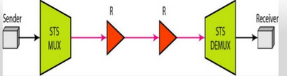

FigureQ2© (iii) Point to point configuration

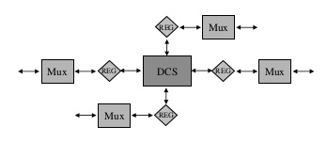 (ii) Hub configuration : this configuration is designed with point to point configuration connected through Digitalcross connect switch. It is shown in figureQ2© (iv)

FigureQ2© (iv) Hub configuration

(iii) Ring configuration: this architecture is widely used. In the nodes (ADMs) are connected in ring topology. It has better (a) survivability (b) Flexibility (c) protection mechanism. It is shown in figureQ2© (v). Ring architecture can be UPSRs ( Unidirectional path switched rings) and BLSRs( Bidirectional switched rings).

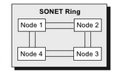

FigureQ2© (v) Ring configuration

**ANS(Q2 (d))** The STS-1 frame format The base transmission rate in SONET is Mb/s. This frame is called the synchronous transport signal (STS). Since the frame is the first level of the synchronous digital hierarchy, it is known as STS-1. Following figure shows the format of this frame. It is made up from a byte matrix of 9 rows and 90 columns. The first three columns are reserved for the transport overhead (TOH), while the remaining 87 rows are for transporting the synchronous payload envelope (SPE). Transmission is row by row, starting with the byte in the upper left corner and ending with the byte in the lower right corner. The frame repetition rate is 125 ms. The payload capacity enables transport of one DS-3 signal, 28 DS-1 signals or 21 2 Mb/s signals. When this bit rate is transmitted via a fiber system, it is known as OC-1 (Optical Carrier). Figure Q2(d): Schematic diagram of STS-1 frame 3 90 Bytes (columns) SOH STS pointer LOH SPE (payload) 9 rows µs 17

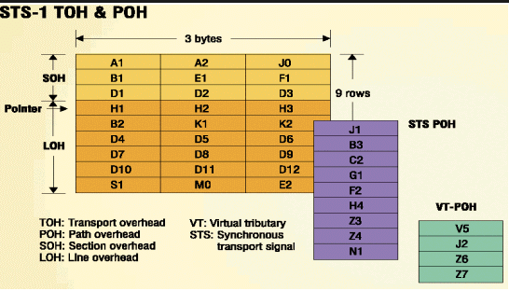

FigureQ2(d)

**Section-C**

**ANS(Q3(a)** )Raman and Brillouin scattering are inelastic processes in which part of the power is lost from an optical wave and absorbed by the transmission medium. The remaining energy is then re-emitted as a wave of lower frequency. Raman and Brillouin scattering processes can become nonlinear in optical fibres due to the high optical intensity in the core and the long interaction lengths afforded by these waveguides. *Stimulated Raman Scattering* (SRS) and *Stimulated Brillouin Scattering* (SBS) occur when the light launched into the fibre exceeds a *threshold power* level for each process. Under the conditions of stimulated scattering, optical power is more efficiently converted from the input pump wave to the scattered *Stokes* wave.The scattered wave is frequency-shifted from the pump and in the case of SBS propagates in the opposite direction. This means that the amount of optical power leaving the far end of the fibre no longer increases linearly with the input power. The maximum launch power becomes clamped and the excess is simply reflected back out of the fibre. For long distance or highly-branched fibre links, it is important that as much power as possible can be launched into the fibre to compensate for attenuation and power splitting. Limits on the maximum output power due to SBS must therefore be avoided.

**ANS(Q3(b))**

A form of data transmissions that allows voice, video and data to be sent along the same network.Transmits data in fixed-length packets, called cells, each of which is 53 bytes long, containing 48 bytes of payload and 5 bytes of header.

* A technology defined by protocol standards created by the ITU-T, ANSI, ETSI and the ATM Forum.
* Is asynchronous because cells are not transferred periodically (at regular intervals).
* Is scalable and flexible. It can support megabit to gigabit transfer speeds and is not tied to a specific physical medium.

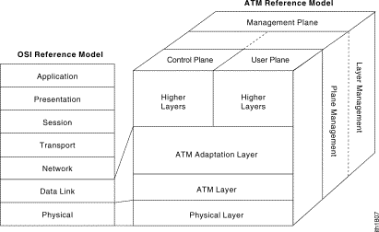

* Is connection-oriented, using a virtual circuit to transmit cells that share the same source and destination over the same route.
* ATM protocol reference model:

1. Physical Layer

(i)Divided into 2 sublayers: physical medium sublayer and transmission convergence(TC) sublayer.

(ii)Physical medium sublayer defines the exact electrical and optical interface, the line code and the bit timing.

(ii)TC sublayer provides for framing of cells, for cell delineation, for cell rate adaptation to the information carriage capacity of the line, and for operational monitoring of the various line components.

    2. ATM Layer

(i)Service provided by physical layer is the physical transport of a valid flow of cells.

(ii) Controls the transport of cells across the ATM Network, setting up virtual channel connections and controlling the submission rate (generic flow control) of cells from user equipment.

.

    3. ATM Adaptation Layer (AAL)

(i)Provides for the conversion of the higher layer information provided to it by the higher layers into a format suitable for transport by an ATM transport network.

    4. Higher Layers

(i)Are information, devices or functions of unspecific type which require to communicate across the ATM network.

    5. Control Plane and User Plane

(i)When an end-user device wishes to establish (i.e. dial up) a new connection across an ATM network then it must signal to the network its desire to do so (equivalent to dialling a telephone no. in a telephone network). This signaling takes place on the control plane.

(ii)When the connection to the other end has been established, then the two end-user devices communicate with one another on the user plane.

    6. Management Plane

(i)Layer Management

(a)Ex. Meta signaling procedure: an administrational procedure of the network itself, used to set up signaling connections between customers end-user equipment (CEQ) and signaling point(SP) in the network for control plane communication.

(b)Handles the operation and maintenance (OAM) information flows as specific to the layer concerned.

* Plane Management

(a)Performs the management of the network as a whole, coordinating the actions of the layer management, control and user planes.

**AnsQ4(a)☹(** i). At the inputs to the network, lower-speed data streams are multiplexed optically into a higher speed stream, and at the outputs of the network, the lower-speed streams must be extracted from the higher-speed stream optically by means of a demultiplexing function.

ii. Functionally, optical TDM (OTDM) is identical to electronic TDM. The only difference is that the multiplexing and demultiplexing operations are performed entirely optically at high speeds. The typical aggregate rate in OTDM systems is on the order of 100 GB/s.

iii. OTDM is illustrated in Figure Q4(a). Optical signals representing data streams from multiple sources are interleaved in time to produce a single data stream. The interleaving can be done on a bit-by-bit basis as shown in Figure 4(a). Assuming the data is sent in the form of packets, it can also be done on a packet-by-packet basis, as shown in Figure 4(b).

iv. If the packets are of fixed length, the recognition of packet boundaries is much simpler. We will assume that fixed-length packets are used. In both the bit-interleaved and the packet-interleaved case, framing pulses can be used.

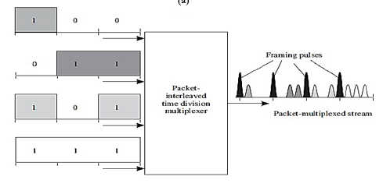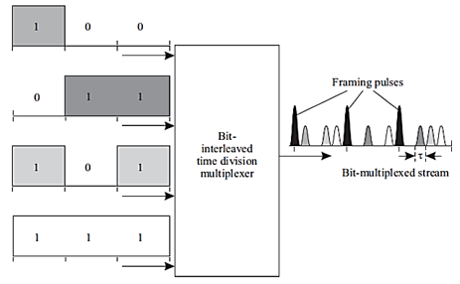v. In the packet-interleaved case, framing pulses mark the boundary between packets. In the bit-interleaved case, if n input data streams are to be multiplexed, a framing pulse is used every n bits. These framing pulses will turn out to be very useful for demultiplexing individual packets from a multiplexed stream of packets.

**FigQ4(a) bit interleaved multiplexing (b) Packet interleaved multiplexing**

**AnsQ4(b)**

|  |  |
| --- | --- |
| **FDM** | **WDM** |
| FDM is a transmission technique in which multiple data signals are combined for simultaneous transmission via a shared communication medium. | WDM is a transmission technique that modulates numerous data streams, optical carrier signals of varying wavelengths into a single light beams through a single optical fiber. |
| FDM divides the bandwidth into smaller frequency ranges antransmitsser transmit data simultaneously through a common channel within their frequency range. | WDM combines multiple light beams from several channels and combine them to a single light beam and sends through a fiber optic strand similar to FDM |
| FDM stands for Frequency Division Multiplexing. | WDM stands for Wave Length Multiplexing. |
| FDM uses analog signals. | WDM uses optical signals |

AnsQ(a) Wide sense non blocking switch is one when any unused input can be connected to any an unused input can be connected to any unused output without requiring any existing connection to be rerouted . this makes use of specific routing algorithm to route connections so that future connection and strict sense nonblocking switches allow any unused input to be connected to any unused output regardless of how previous connections were made through the switch . there are four wide classes of non blocking switch which are explained briefly as follows.

* 1. Cross-bar switch: It provides interconnection between inputs and outputs by setting states of 2x2 switches. It is a wide sense nonblocking switch. An nxn crossbar switch requires n2 2x2 switches.the length of shortest path is 1 and the longest path is 2nX1.
  2. CLOS Switch: It is a strict sense nonblocking swtch and widely used in practice to build large port count switches. It has advantage of better loss uniformity between input and output combination than that of crossbar.
  3. Spanke Switch: It is a strict sense non blocking architecture. In many cases 1xn optical switch can be built by using a single switch and does not need to be built out of 1x2 or 2x2 switch. Insertion loss is very less,than that of multistage designs.
  4. Benes Switch: this switch is a rearrange able non blocking type switch . If nxn switch is designed, The 2x2 switches required to be employed are n/2( 2log2n -1) with maximum loss and minimum loss to be ( 2log2n -1)

**AnsQ5(b) A**coustooptic tunable filter : The structure of an acoustooptic tunable filter based on [surface-acoustic-wave](https://www.sciencedirect.com/topics/engineering/surface-acoustic-wave) (SAW) principle is shown in Fig. Q5(b) The incoming beam goes through a polarization splitter, separating the horizontally polarized beam from the vertically polarized beam. Both of these beams travel down the [waveguide](https://www.sciencedirect.com/topics/materials-science/waveguide) with a grating established by the surface acoustic wave generated by a transducer. The [resonant structure](https://www.sciencedirect.com/topics/engineering/resonant-structure) established by the grating rotates the polarization of the [selected wavelength](https://www.sciencedirect.com/topics/engineering/selected-wavelength) while leaving the other wavelength unchanged. Another polarization beam splitter at the output collects the signals with rotated polarization to output 1 while the rest is passed to output 2.

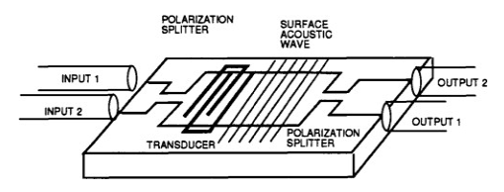

FigQ5(b) Acoustic tunable filter

Limitations of this filter are high loss, large cross talk and bulky passband greater than 100 GHz.

------------------------------------------END--------------------------------------------------------------------