EXP NO1
NETWORKING COMMANDS
Object: AIM To study the basic networking commands.
1)C:\>arp –a: ARP is short form of address resolution protocol, It will show the IP address of your
computer along with the IP address and MAC address of your router.
2)C:\>hostname: This is the simplest of all TCP/IP commands. It simply displays the name of your
computer.
3)C:\>ipconfig: The ipconfig command displays information about the host (the computer your
sitting at)computer TCP/IP configuration.
4)C:\>ipconfig /all: This command displays detailed configuration information about your TCP/IP
connection including Router, Gateway, DNS, DHCP, and type of Ethernet
adapter in your system.
5)C:\>Ipconfig /renew: Using this command will renew all your IP addresses that you are currently
(leasing) borrowing from the DHCP server. This command is a quick
problem solver if you are having connection issues,but does not work if you
have been configured with a static IP address.
6) C:\>Ipconifg /release: This command allows you to drop the IP lease from the DHCP server.
7)C:\>ipconfig /flushdns: This command is only needed if you’re having trouble with your networks
DNS configuration. The best time to use this command is after network
configuration frustration sets in, and you really need the computer to reply
with flushed.
8)C:\>nbtstat –a: This command helps solve problems with NetBIOS name resolution. (Nbt stands
for NetBIOS over TCP/IP)
9)C:\>netdiag: Netdiag is a network testing utility that performs a variety of network diagnostic tests,
allowing you to pinpoint problems in your network. Netdiag isn’t installed by default,
but can be installed from the Windows XP CD after saying no to the install. Navigate
to the CD ROM drive letter and open the support\tools folder on the XP CD and click
the setup.exe icon in the support\tools folder.
10)C:\>netstat: Netstat displays a variety of statistics about a computers active TCP/IP connections.
This tool is most useful when you’re having trouble with TCP/IP applications such as
HTTP, and FTP.
11)C:\>nslookup: Nslookup is used for diagnosing DNS problems. If you can access a resource by
specifying an IP address but not it’s DNS you have a DNS problem.
12)C:\>pathping: Pathping is unique to Window’s, and is basically a combination of the Ping and
Tracert commands. Pathping traces the route to the destination address then
launches a 25 second test of each router along the way, gathering statistics on the
rate of data loss along each hop.
12C:\>ping: The ping command, built into both Windows and UNIX operating systems, is a
universal way of testing network response time and performance. The ping command
is used by system administrators for diagnostic problems, particularly for testing,
measuring, and managing networks

EXP NO2

Aim: To do the following
a) Cable Crimping
b) Standard Cabling
c) Cross Cabling
d)IO connector crimping
e) Testing the crimped cable using a cable tester Apparatus/Tools/Equipments/Components: RJ-45 connector,
IO Connector, Crimping Tool, Twisted pair Cable, Cable Tester.
Principle: Standard Cabling:
1. 10BaseT and 100BaseT are most common mode of LAN. You can use UTP category-5 cable for both modes.
2. A straight cable is used to connect a computer to a hub
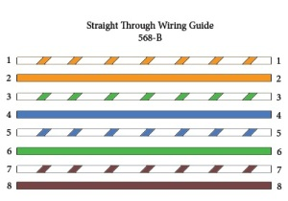

Cross Cabling: A cross cable is used to connect 2 computers directly (with ONLY the UTP cable). It is also used then you connect 2 hubs with a normal port on both hub
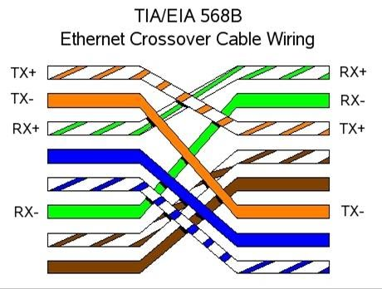

Procedure: Cable Crimping steps:
1. Remove the outmost vinyl shield for 12mm at one end of the cable (we call this side A-side).
2. Arrange the metal wires in parallel
3. Insert the metal wires into RJ45 connector on keeping the metal wire arrangement.
4. Set the RJ45 connector (with the cable) on the pliers, and squeeze it tightly.
5. Make the other side of the cable (we call this side B-side) in the same way.
6. After you made it, you don't need to take care of the direction of the cable.
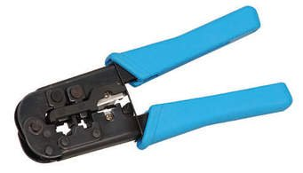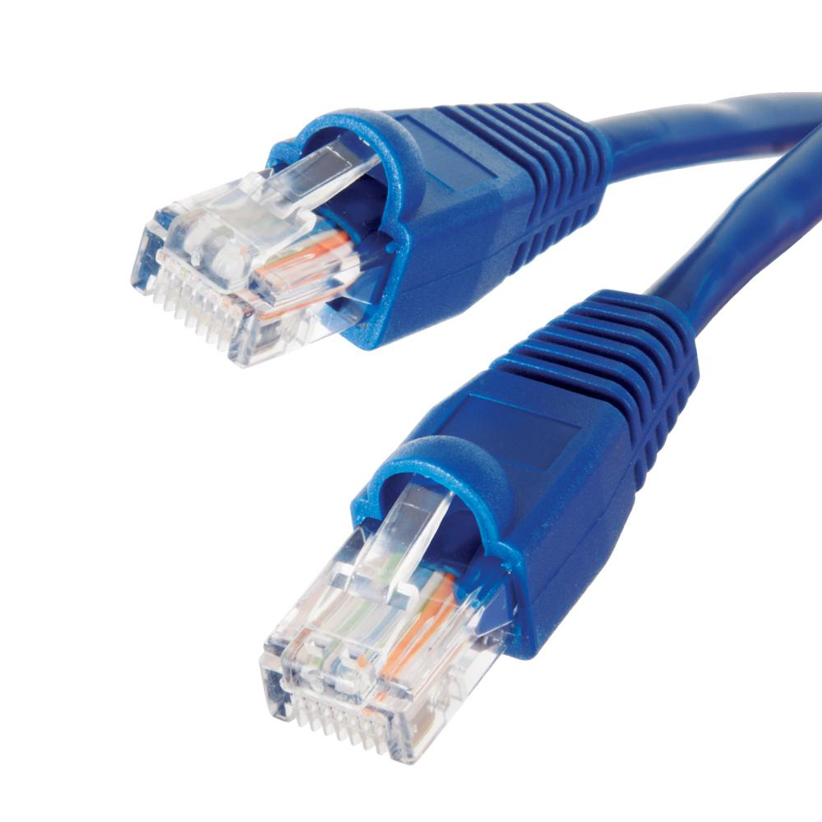

Testing the crimped cable using a cable tester:
Step 1 : Skin off the cable jacket 3.0 cm long cable stripper up to cable
Step 2: Untwist each pair and straighten each wire 190 0 1.5 cm long.
Step 3 : Cut all the wires
Step 4 : Insert the wires into the RJ45 connector right white orange left brown the pins facing up
Step 5 : Place the connector into a crimping tool, and squeeze hard so that the handle reaches its full swing.
Step 6: Use a cable tester to test for proper continuity
