EXPERIMENT 3
Aim :Study of the following Devices in Detail
1)Repeater
2)Hub
3)Switch
4)Bridge
5)Router
6)Gateway
7)DNS(Domain Name System)
Procedure:
1) Repeater:-

EXPERIMENT-4
Aim:-Draw a Network Topology using packet tracer software .
Apparatus (Software):- Packet tracer Software
Procedure:-
To add PCs in Cisco Packet Tracer, you need to perform the following
Steps:
1) In the Cisco Packet Tracer console, click on the PC icon, click Generic, and then click
in the logical view area to add a Generic PC.
2) Repeat the same step to add three more Generic PCs in the logical view area,
as shown in the following figure.
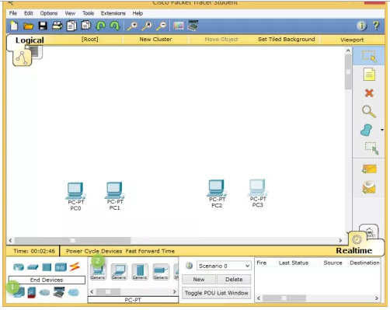

Adding Switches in Cisco Packet Tracer
- To add a switch in Cisco Packet Tracer, click the Switch icon, select a switch type, such as 2960, and then add the selected switch in the logical view area.
- Repeat the same step to add one more switch.

Adding Routers in Cisco Packet Tracer
- To add a router in Cisco Packet Tracer, click the Router icon, select a router type, such as 1841, and then add the selected router in the logical view area.
- Repeat the same step to add one more router.
To connect devices in Cisco Packet Tracer, first, you need to understand the various types of cables (connections) used to connect network devices. Some of the common types of cables are:
- Straight-through: Used to connect different types of devices (devices that use different wiring standards), such as Router-to-Switch and Switch-to-PC.
- Cross-over: Used to connect same types of devices, such as router-to-router, PC-to-PC, and switch-to-switch.
- Serial DCE: Used to connect router-to-router in a WAN network.
- Console: Used to take console (using hyper terminal) of a router on a PC.
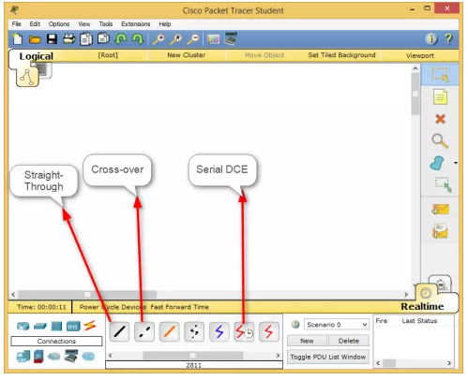

Connecting Devices in Cisco Packet Tracer
- To connect devices in Cisco Packet Tracer, click the connection type icon, and select an appropriate cable. For example, to connect PC0 to Switch0, select the straight-through cable, click on PC0, select the FastEthernet0 interface.
- Next, click on Switch0, and then select the FastEthernet0/1 interface. The following figure displays how to connect a PC to a switch in Cisco Packet Tracer.
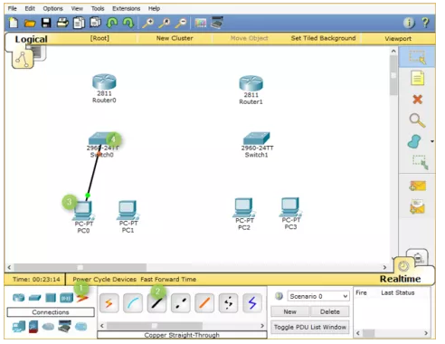
3.Now, add PC1 to Switch0 using the FastEthernet0/2 interface. Also, add PC2 and PC3 to
the FastEthernet0/1 and FastEthernet0/2 interfaces of Switch1,respectively.

4.If you have connected a wrong device to a wrong interface, you can use the Delete option to
delete a connection or device. The following figure displays how to use the Delete option to
delete a device or connection in Cisco Packet Tracer.

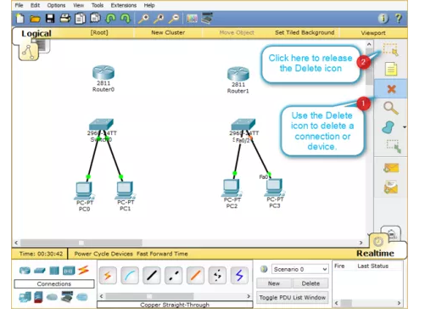
5.Once, you have connected all the PCs to switches,
now, connect Switch0 to Router0, and Switch1 to Router1 using the straight-through cables
.
6Select the straight-through cable, click on Switch0, and then selectFastEthernet0/3 interface
.
7Click Router0 and select the FastEthernet0/0 interface.

8Select again the straight-through cable, click on Switch1, and selectFastEthernet0/3 interface.

9Next, click Router1 and then select the FastEthernet0/0 interface.

The following figure displays how to connect routers to switches to create a network topology.

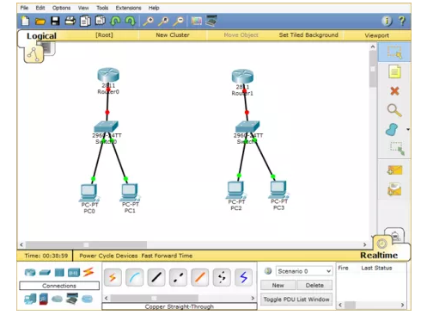

Interconnecting Routers in Cisco Packet Tracer
Now, connect Router0 to Router1 using the serial connection. To do this, you need to perform the following steps:
- Select the Serial DCE cable, click on Router0, and select the Serial1/0 interface.
- Click on Router1 and select the Serial1/0 interface, as shown in the following figure.
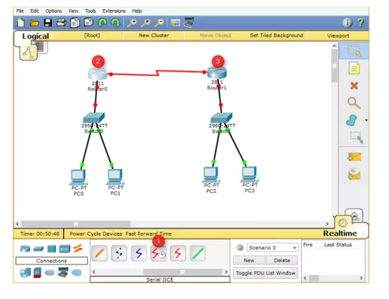
- In Cisco Packet Tracer, click File, and select Save As.

- In the File name text box, type a name of the topology, and then click Save.

