**SHAMBHUNATH INSTITUTEOF ENGINEERING AND TECHNOLOGY**

**MANUFACTURING SCIENCE II (RME-503)**

**B. Tech. V- SEMESTER**

**FIRST SESSIONAL EXAMINATION, ODD SEMESTER, (2019-20)**

**Branch: Mechanical Engineering**

**Solutions**

**Question 1**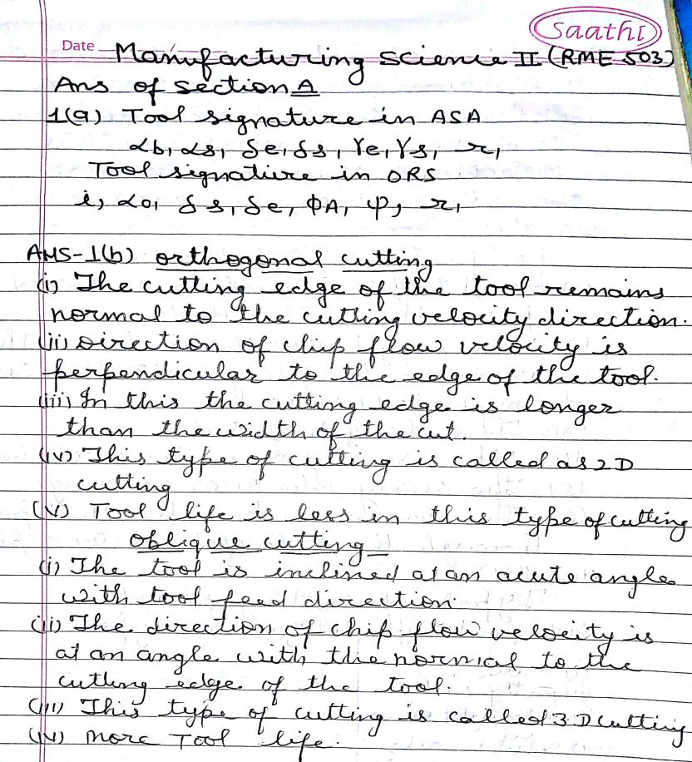

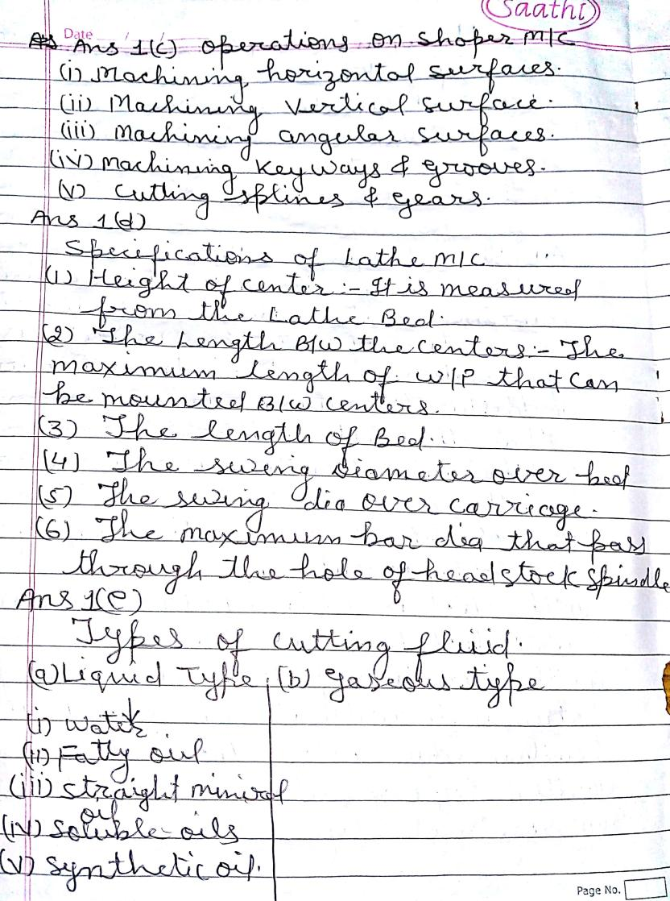

**Question 2(a)**

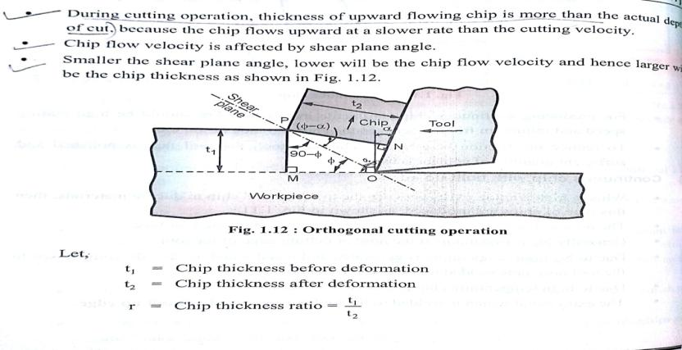

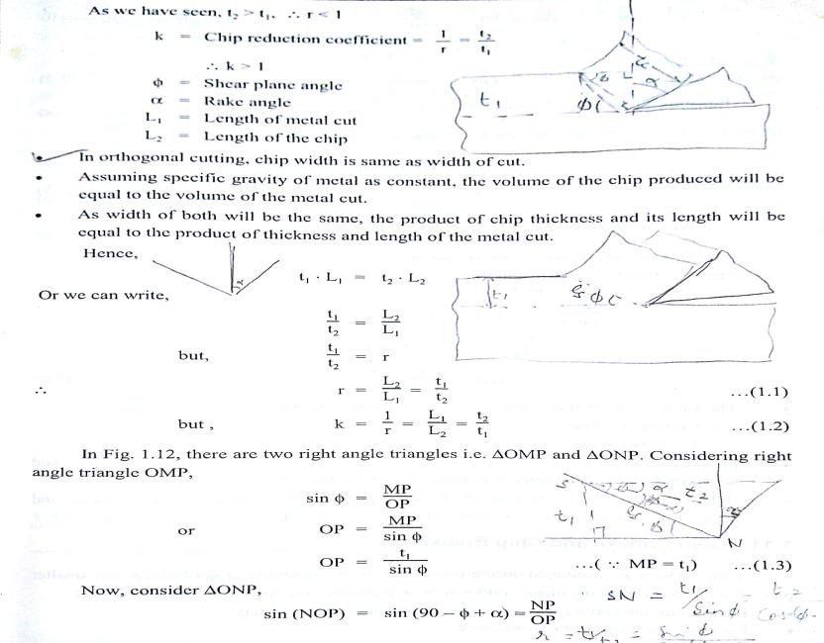

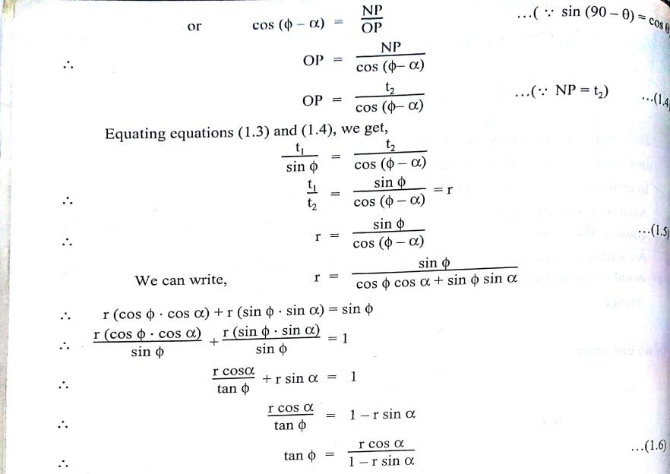

**(b)** 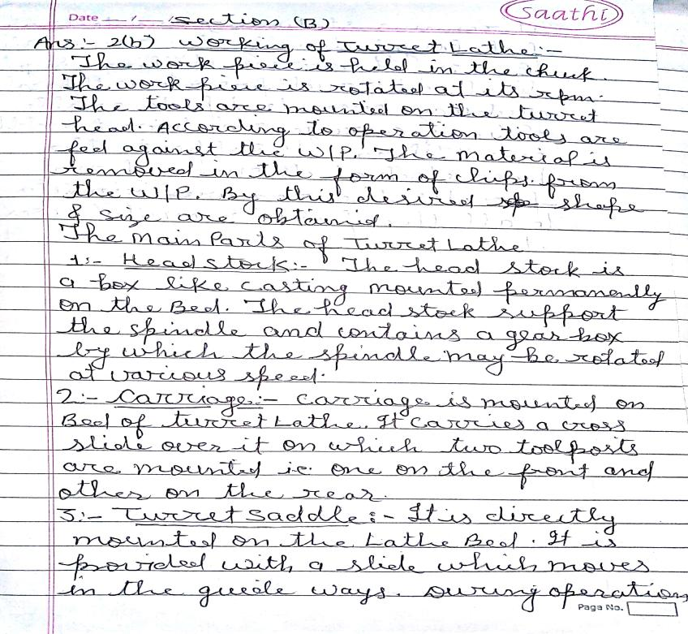

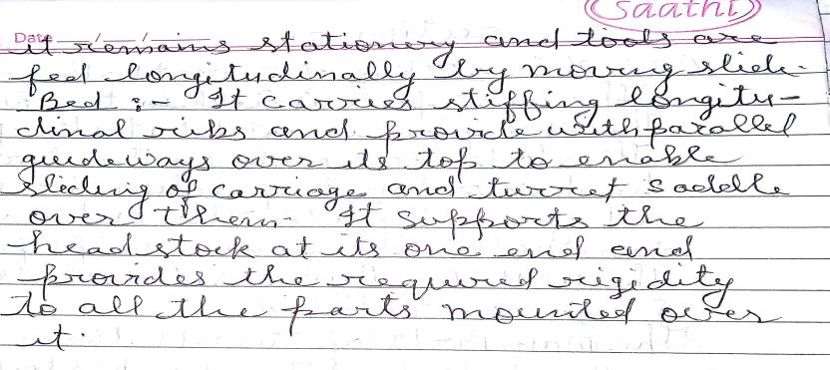

**(c)** 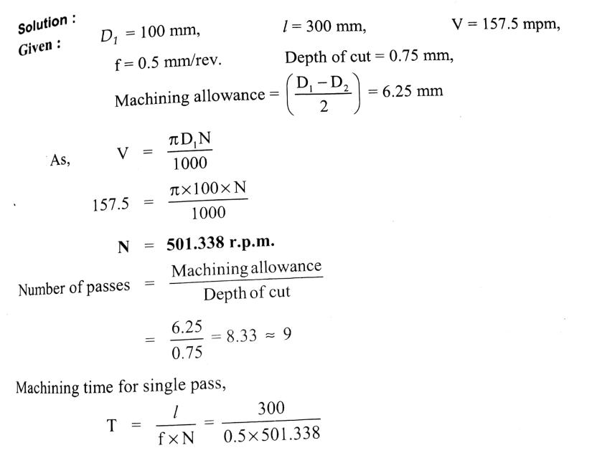



**(d)** 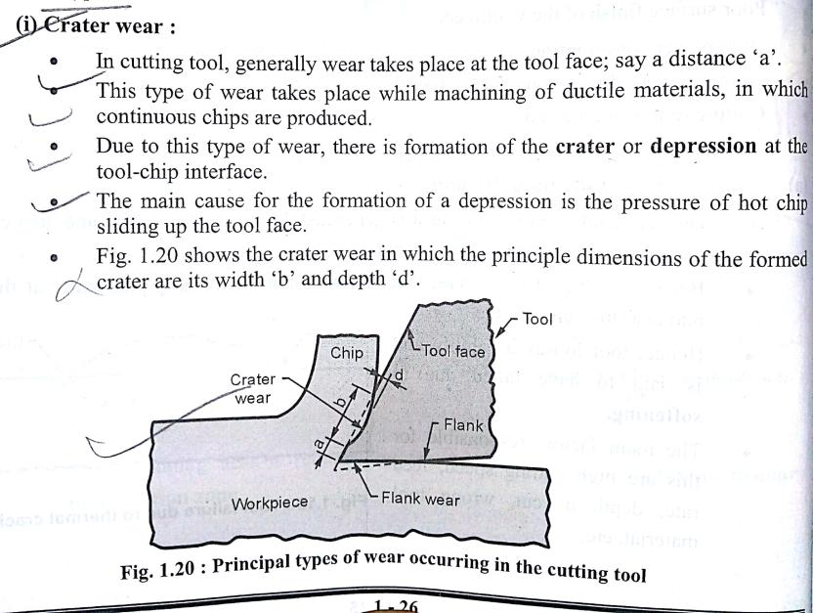

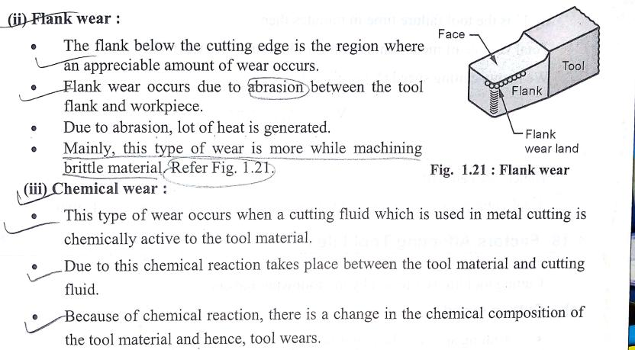

**Question 3(a)**

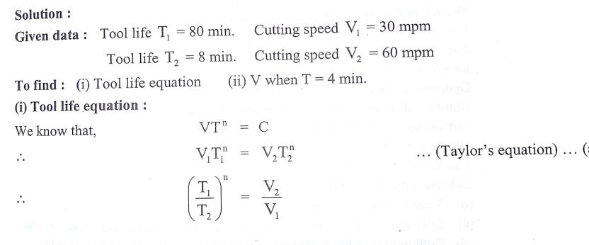

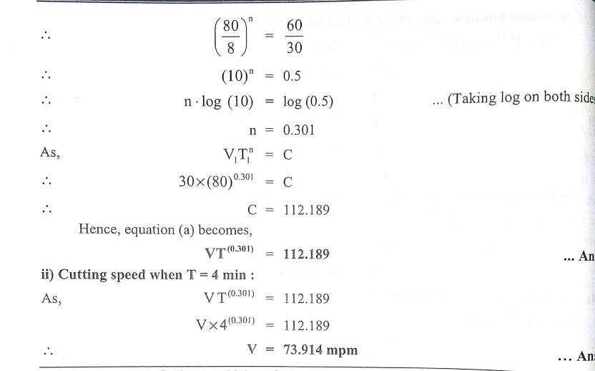

(b)

()

()

**(b)** 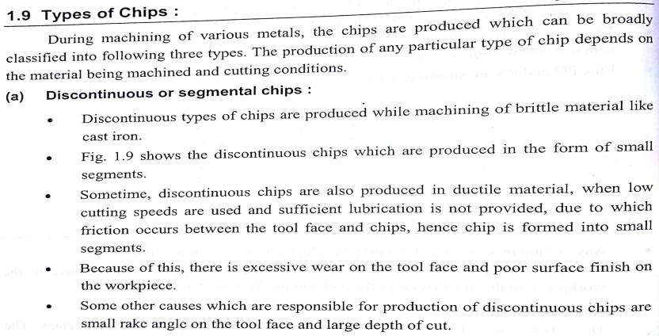

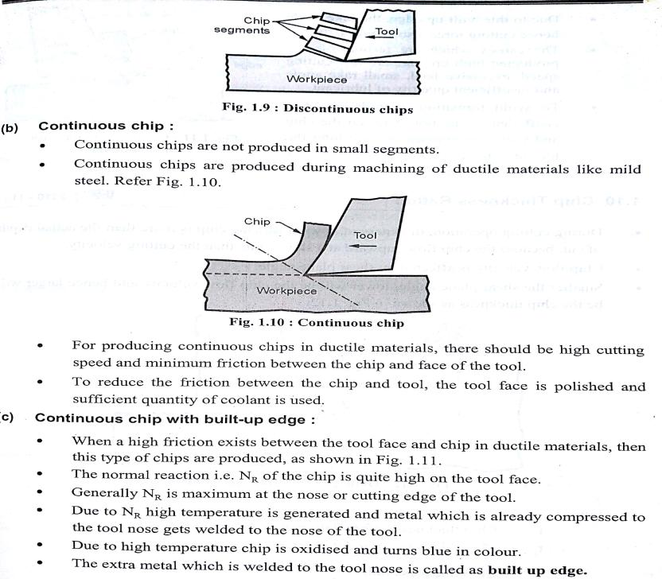

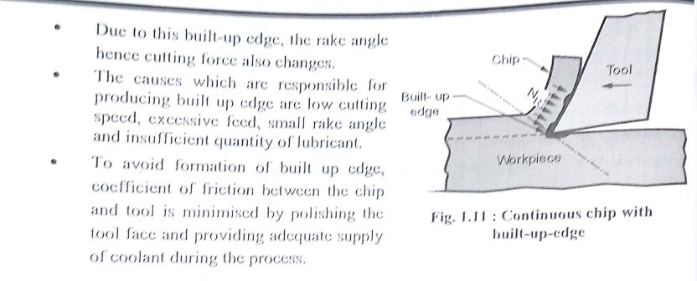

**Question 4(a)**

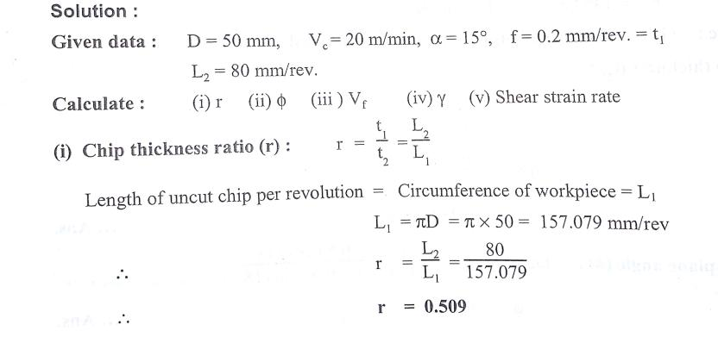

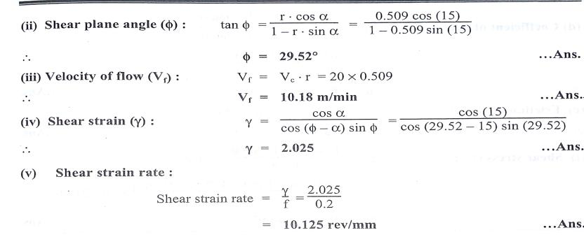

**(b)** 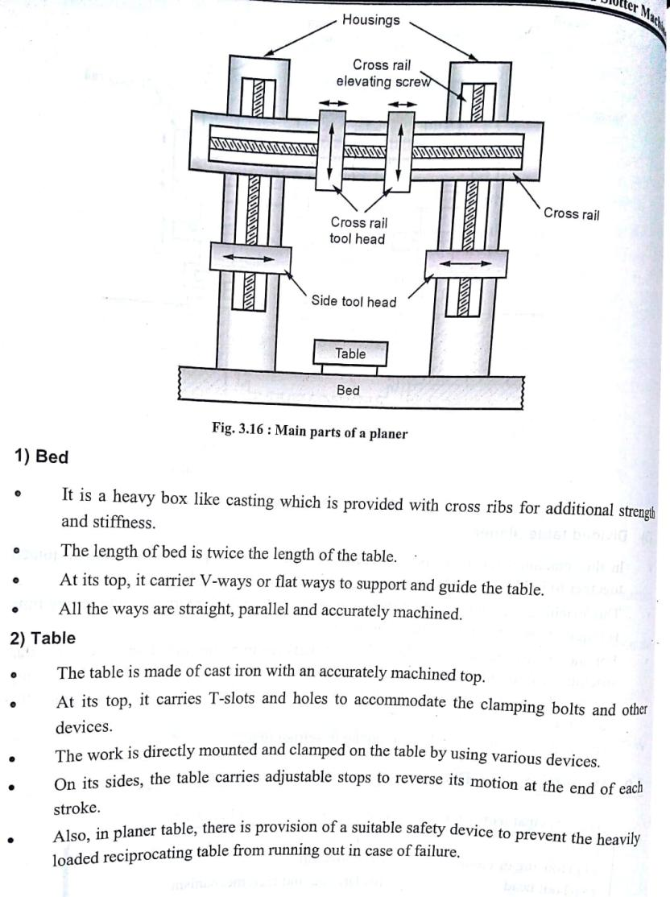

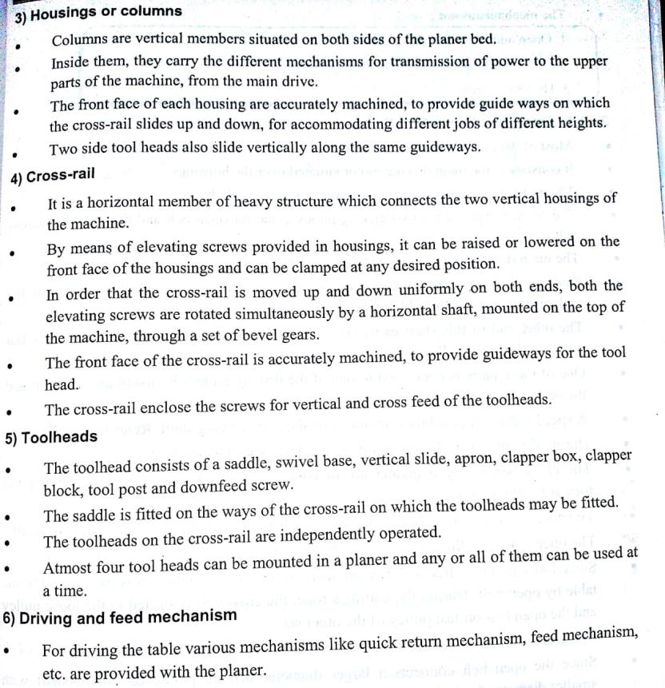 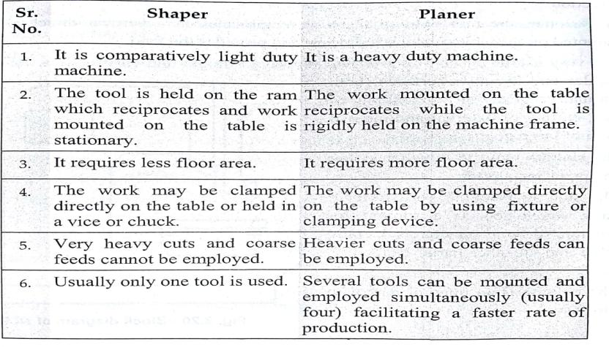 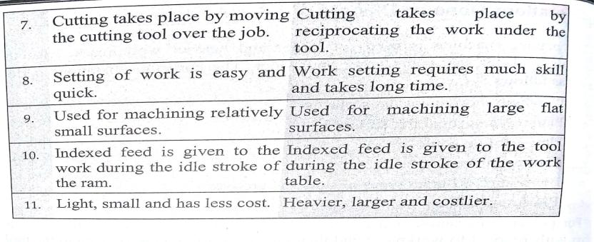

**Question 5**

**(a )Step turning** is an operation performed on lathe machine where the excess material is removed from the work piece to obtain various **steps** of different diameters.

(b) In machining, **boring** is the process of enlarging a hole that has already been drilled (or cast) by means of a single-point cutting tool (or of a **boring** head containing several such tools), such as in **boring** a gun barrel or an engine cylinder.

(c) **Reaming** is a cutting **operation** with a multi-edged cutting tool which is constantly in action. **Reaming** is applied to finish drilled holes accurately to size and with a good surface finish.

(d) **Knurling** is a **process** of impressing a diamond shaped or straight line pattern into the surface of a workpiece by using specially shaped hardened metal wheels to improve its appearance and to provide a better gripping surface.

(e)  **Drilling** is the **operation** of producing a cylindrical hole of required diameter and depth by removing metal by the rotating edge of a cutting tool called **drill**. **Drilling** is one of the simplest methods of producing a hole. **Drilling** does not produce an accurate hole in a workpiece.

**(b)Geometry**

[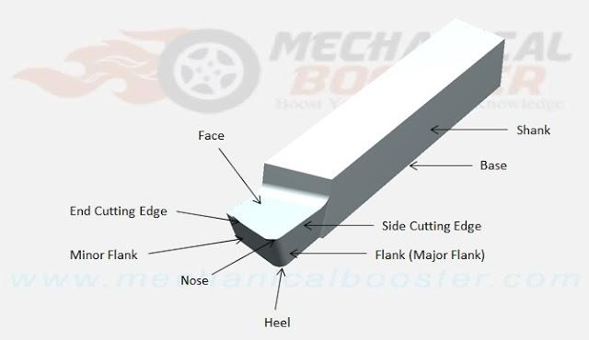](https://4.bp.blogspot.com/-SEK01a86ctc/WFN2VoGAc4I/AAAAAAAAHok/qWQsyGeVUGQChG4XrHvZrGPQnKouP56KwCLcB/s1600/single+point+cutting+tool+geometry.jpg)

**1. Shank:** It is that part of single point cutting tool which goes into the tool holder. Or in simple language shank is used to hold the tool.  
**2. Flank:** It is the surface below and adjacent of the cutting edges. There are two flank surfaces, first one is major flank and second one is minor flank. The major flank lies below and adjacent to the side cutting edge and the minor flank surface lies below and adjacent to the end cutting edge.  
**3. Base:** The portion of the shank that lies opposite to the top face of the shank is called base.  
**4. Face:** It is the top portion of the tool along which chips slides. It is designed in such a way that the chips slides on it in upward direction.

**5. Cutting edge: The edge on the tool which removes materials from the work piece is called cutting edges. It lies on the face of the tool. The single point cutting tool has two edges and these are  
(i) Side cutting edge: The top edge of the major flank is called side cutting edge.  
(ii) End cutting edge: The top edge of the minor flank is called end cutting edge.  
6. Nose or cutting point: The intersection point of major cutting edge and minor cutting edge is called nose.  
7. Nose radius: It is the radius of the nose. Nose radius increases the life of the tool and provides better surface finish.  
8. Heel: It is a curved portion and intersection of the base and flank of the tool.**