Q1(a)

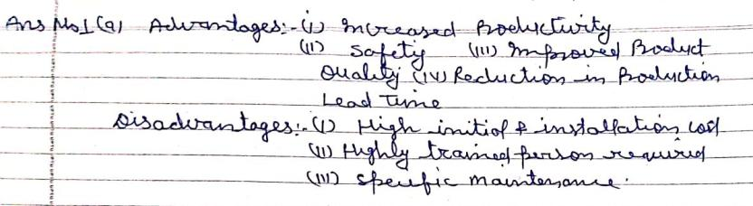

(b) 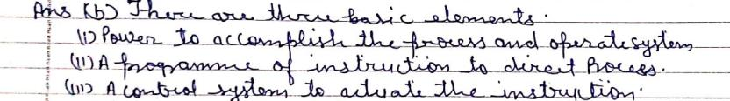

(c) 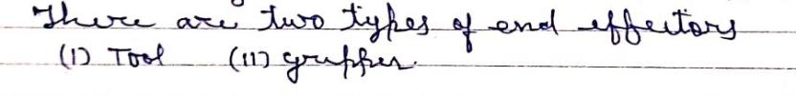

(d) 



(e) 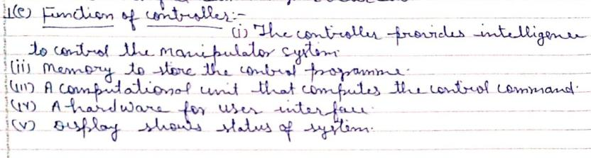

Q2(a)

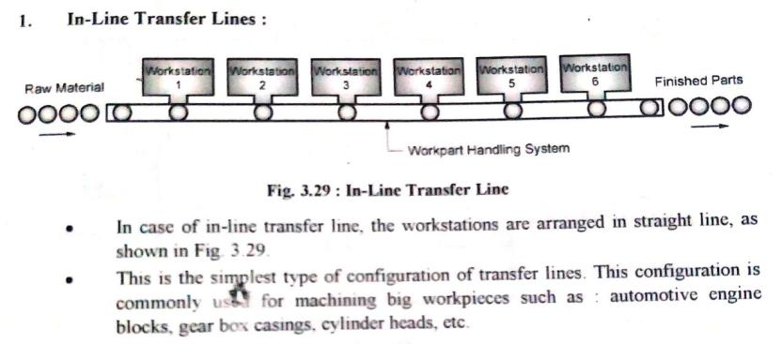

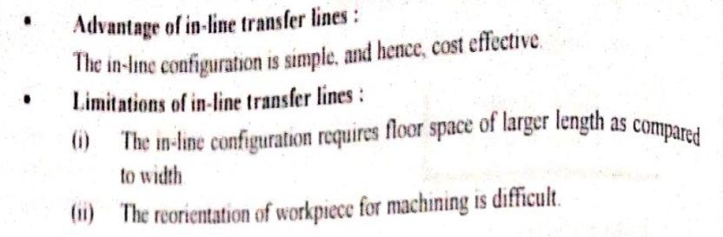

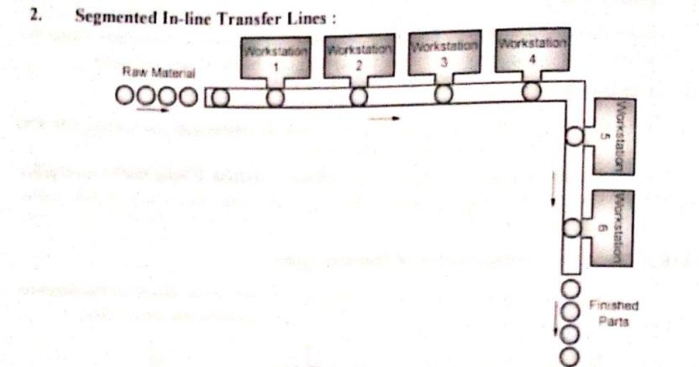

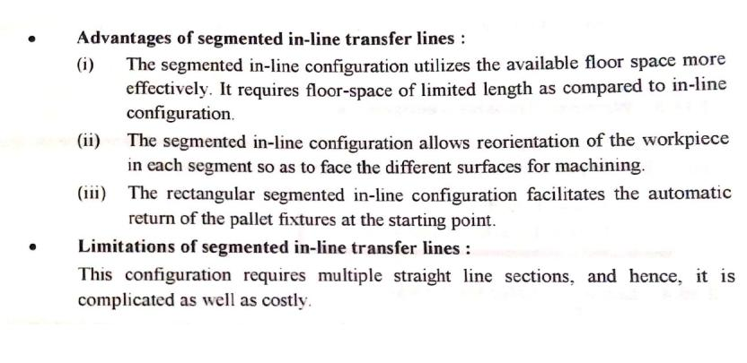

Q2(b) **AUTOMATED STORAGE AND RETRIEVAL SYSTEM**

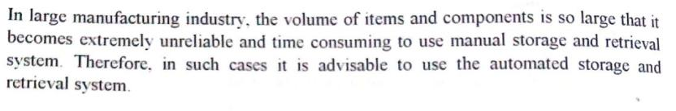

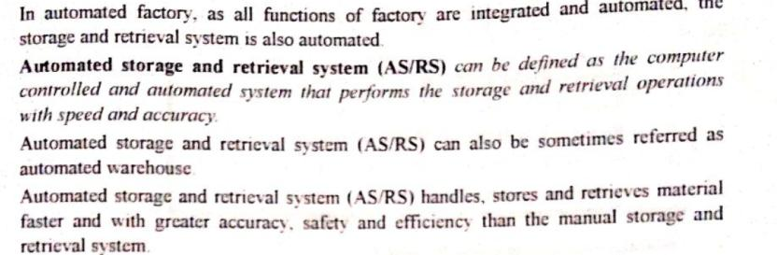



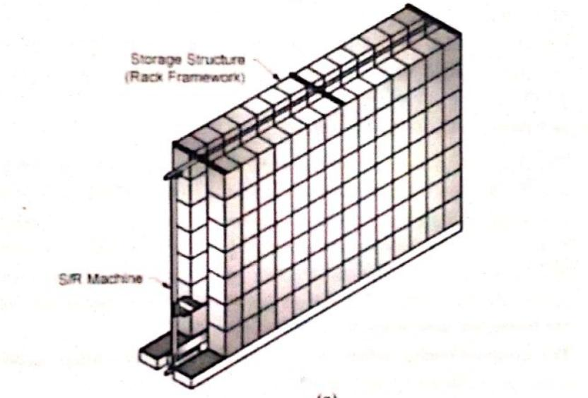MAJOR COMPONENT-

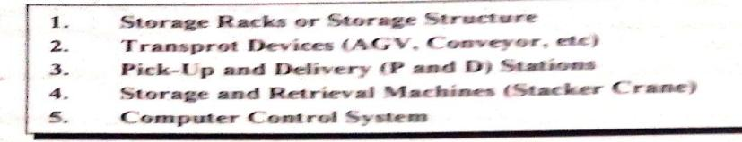

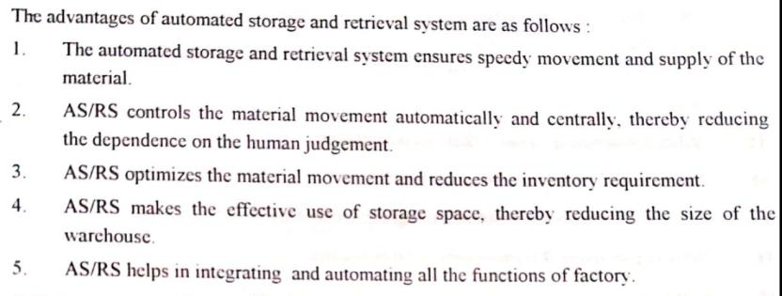

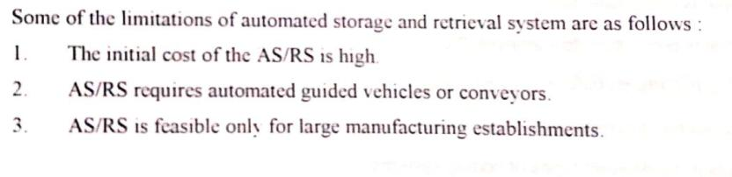

Q2(c**) NC-**

1-Here NC stands for Numerical Control

2-It is defined as the machine which is controlled by the set of instructions in the form of numbers, letters and symbols. The set of instructions is called as program.

3-In NC machine the programs are fed into the punch cards.

4-Modification in the program is difficult.

**CNC-**

**1-**CNC stands for Computer Numerical Control.

2-It is defined as the machine which is used to control the motions of the workpiece and tool with the help of prepared program in computer. The program is written in alphanumeric data.

3-In CNC machine the programs are fed directly into the computer by a small key board similar to our traditional keyboard.

4-Modification in the program is very easy.

DNC-

1-It stand for direct numeric control

2-the part program is fed to the machine through the main computer.

3-in order to modify the program single computer is used .

4-same part program can run on different machine at the same time.

Q2(d) 

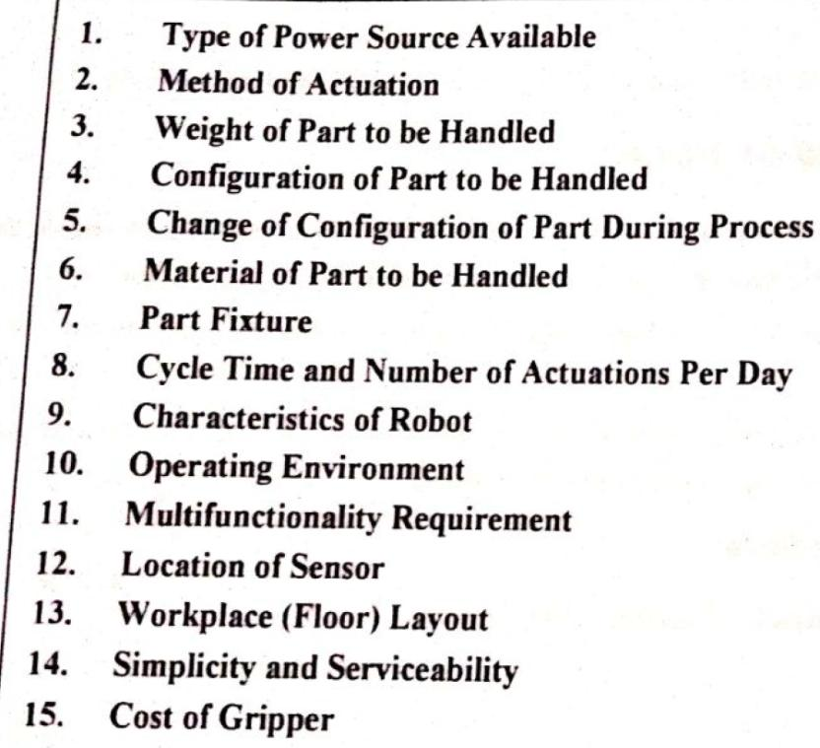

**Q3(a)** The **Role of Robots** in Creating More Efficient Manufacturing Operations. The production of **industrial robots** and **automation** systems has grown tremendously over the past few decades. ... **Robotics** improve the overall efficiency of a manufacturing process by creating efficient means of completing production tasks. Robot perform following task in industry-----

1. **TIG welding**
2. **MIG Welding**
3. **Submerged arc welding**
4. **In spray painting**
5. **Machine loading and unloading**
6. **Material handling etc.**

**3(b)**

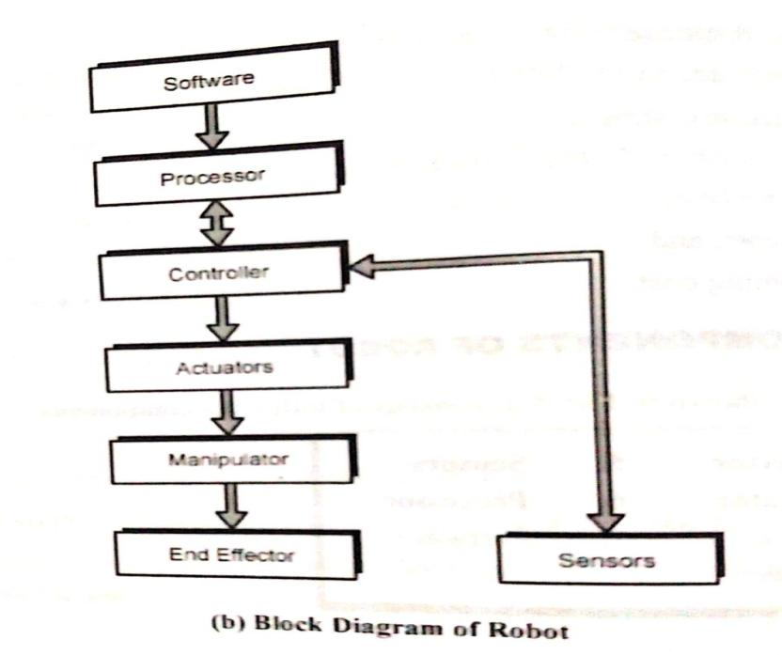

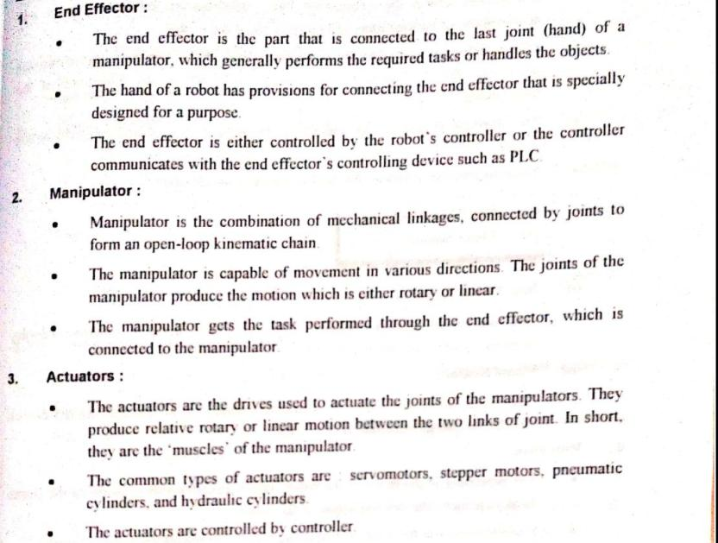

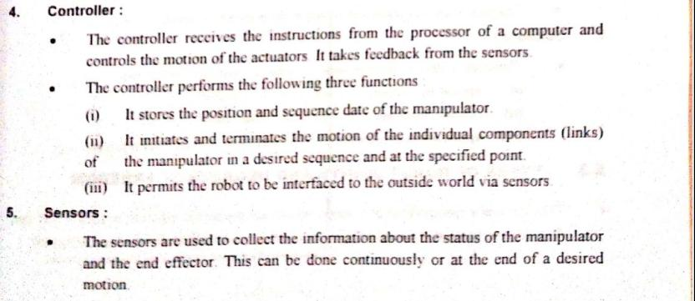

**Q4(a)** 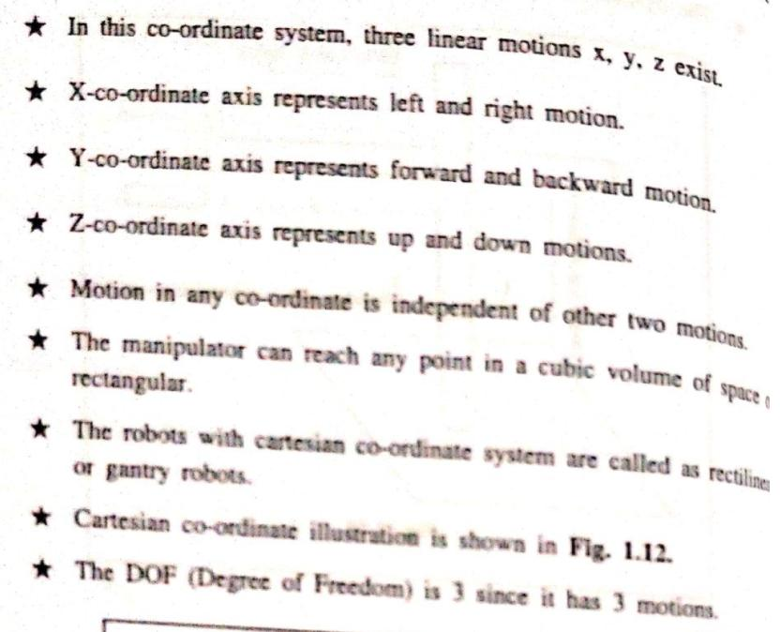

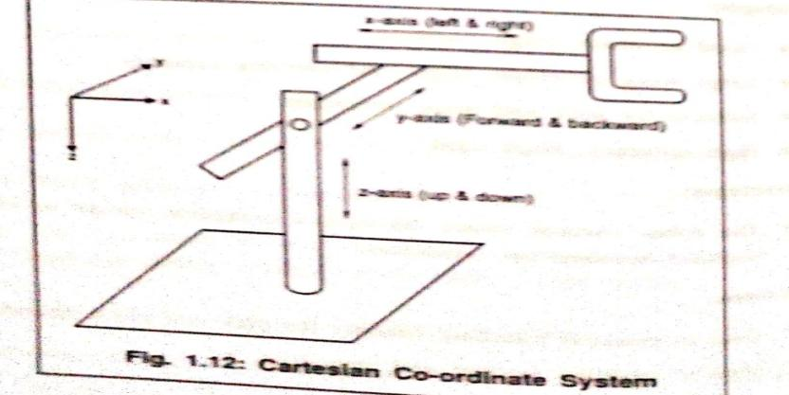

**Q4(b)** Automation is the creation and application of technology to monitor and control the investment which requires mass production for quick return on investment. Hence Large

Scale Industries can afforded and opt the option of automation, whereas medium and small

scale industries find it very difficult adopt automation. Low cost automation (LCA) is one

solution especially for medium and small scale industries. Automation demands replacement

of conventional machines by CNC, VMC, SPM’s, etc, manual material handling by

conveyor’s, AGV’s and many more things. Low cost automation concept by replacing conventional Radial Drilling Machine by Special Purpose Horizontal Multi Spindle Drilling Machine. This SPM was in-house designed and developed by using the spare parts of old machines which were declared as scrap by other industries.

Due this there was a huge saving in the manufacturing cost of this SPM. This newly developed SPM not only increased the production rate by about 85% but also made it possible the machine operator to operate another machine along with it with no compromise in quality requirements.

Advantages-

1. Automation reduce production cost.
2. Decrease in Part Cycle Time
3. A lean manufacturing line is crucial for increasing efficiency.

LIMITATIONS-

1-Initial cost is high

2-Trained operator are required

3-High maintinance cost

Q5(a)

**Degree of freedom**- Degrees of freedom, is, defined modes in which a mechanical device or system can move. The number of degrees of freedom is equal to the total number of independent displacements or aspects of motion. ... Such a robot arm has five to six degrees of freedom.

**Work envelop/work volume-**is the volume of space in which a robotic arm can reach.

**Rolling-**wrist roll is the rotation or rolling motion of the wrist about its longitudinal axis

**Pitching-**is the up and down rotation or pitching of the wrist about the horizontal axis of the wrist.

**Yawing-**wrist yaw is the rotation of the wrist in horizontal plane about the vertical axis of the wrist.

**Q5(b)** 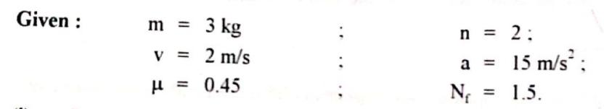

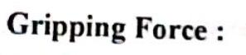 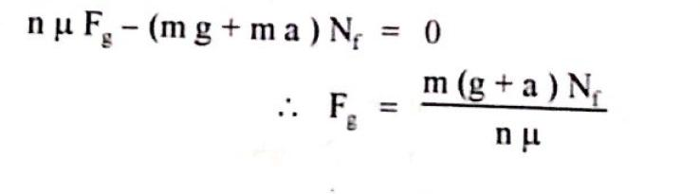

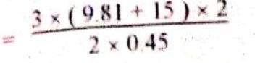

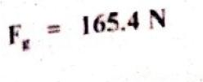

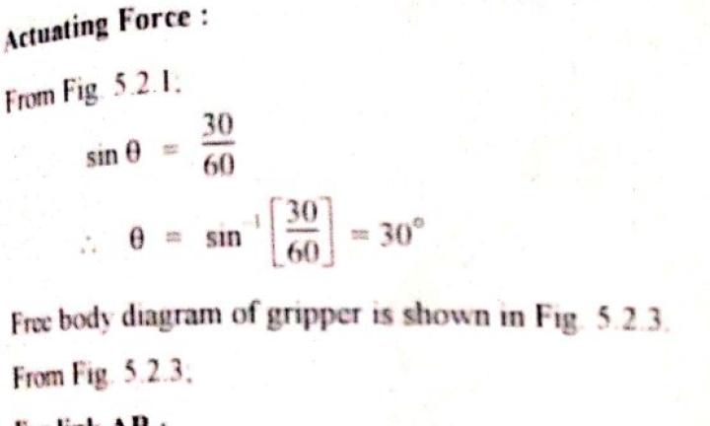

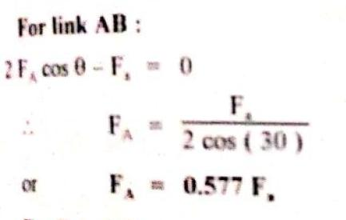 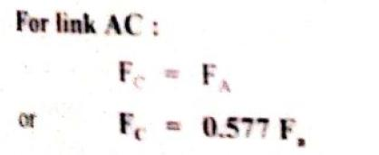

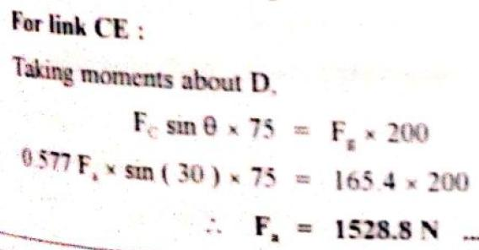

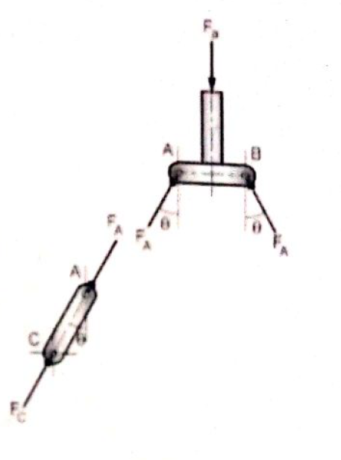 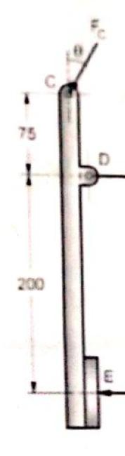

production and delivery of products and services. In today’s world for any industry to surviin the competitive market, must go for automation. Automation demands huge capital