RCS653-COMPUTER GRAPHICS LAB

**RCS654-DATA MINING AND DATA WAREHOUSING LAB**

1. I**mplementation of OLAP operations .**

**a..List all the categorical (or nominal) attributes and the real-valued attributes separately.**

**Sol.**

**Introduction:**

WEKA - an open source software provides tools for data preprocessing, implementation of several Machine Learning algorithms, and visualization tools so that you can develop machine learning techniques and apply them to real-world data mining problems. What WEKA offers is summarized in the following diagram:

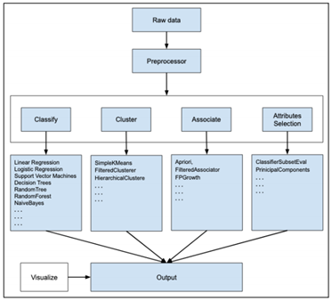

Steps to perform preprocessing the data:

**1.3 PROCEDURE:**

1) Open the Weka GUI Chooser.

2) Select EXPLORER present in Applications.

3) Select Preprocess Tab.

4) Go to OPEN file and browse the file that is already stored in the system “weather.csv”.

5) Clicking on any attribute in the left panel will show the basic statistics on that selected attribute.

**Analysis:**

* As per the database shown here we can see through explorer that red area of the data shows the possibilities of the playing outside is negative and blue area shows the possibilities of playing outside is positive.
* If you withdraw any data i.e. data is incomplete then that data will be shown as black area and not will be taken into consideration for the data analysis.

**Source Code:**

**Write the code of the weather nominal from the data tab as shown in lab and do write here.**

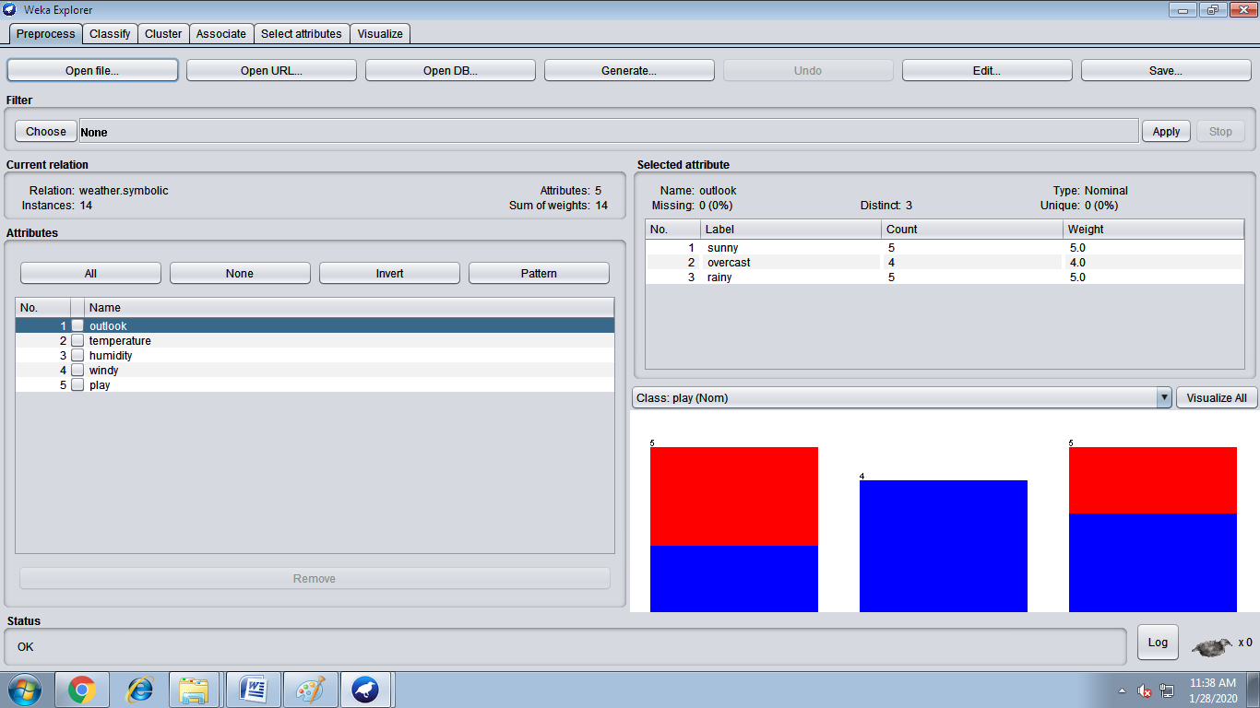**Syntax:**

**@ relation table_name**

**@attribute attribute _name{arguments allowed for}**

**@attribute attribute _name{arguments allowed for}**

**@data(Some data as per the table taken.)**

2. Implementation of Varying Arrays

3. Implementation of Nested Tables

4. Demonstration of any ETL tool

5. Write a program of Apriori algorithm using any programming language.

6. Create data-set in .arff file format. Demonstration of preprocessing on WEKA data-set.

7. Demonstration of Association rule process on data-set contact lenses.arff /supermarket (or any other data set) using apriori algorithm.

8. Demonstration of classification rule process on WEKA data-set using j48 algorithm.

9. Demonstration of classification rule process on WEKA data-set using Naive Bayes algorithm.

10. Demonstration of clustering rule process on data-set iris.arff using simple k-means.