**SHAMBHUNATH INSTITUTE OF ENGG. & TECH. Jhalwa, Allahabad**

14

**Visually Operated Online Examination**

**A Solution to make Exam more Exciting**

**Abhishek Bhardwaj, Anupam Dinesh, Harsh Srivastva**



**ACKNOWLEDGEMENT**

In this project I have received inspiration and guidance from a number of experts and it is our pleasant duty to express our sincere gratefulness to all of them.

I would like to begin my acknowledgement by thanking the almighty GOD.

I owe special thanks to **Mr. Parikshit Agrawal** for giving me permission to do my project work in such a recognized institute and issuing me a request letter for the same.

It gives me great pleasure to acknowledge **Mr. Prashant Srivastava** for their guidance and providing me all the required materials for my project work.

I am thankful to the whole staff of the Computer Science & Engineering department especially to **Mr. Radha Raman Chandan, Mr. Ashish Pandey, Mr. Pankaj Tiwari, Mr. Vibhav Ananad, Mr. Santosh and Ms. Shivali Srivastava** for their co ordinance.

I owe special thanks to my Friends for their collaboration which helped me to complete the project successfully.

I am also very grateful to my sister for their valuable guidance which has helped me to learn a lot.

Last but not the least; I thank my parents to whom the work is dedicated, for their many unselfish sacrifices and pain which helped to get an education that has made all the difference.

*Abhishek Bhardwaj (1016210002)*

*Anupam Dinesh (1016210019)*

*Harsh Srivastva (10162100--)*

**ABSTRACT**

Visually Operated Online Examination System is very useful for an educational institute to conducting an exam, save the time that is used to check the paper and prepare mark sheets. It will help the institute in testing the students and developing their skills. But the disadvantages of this system, it takes a lot of times when conducting the exam first time and we need number of computers with the same number of students.

* **Online Examination System**is used for conducting online objective test; the test will be customized such that system will have automated checking of answers based on the user interaction.
* This project helps the faculties to create their own test based on the subject.
* The purpose of the project is to design and build a system that can be able to understand the appearance of the applicant as well as their behavior during the examination automatically.

In this program we will consider the entire possible situation that may be happened during the examination time as well as the action that can be taken according to the situation. This system consists of a dynamic pattern recognition system that can be able to identify the appearance of the examinee.

**Contents**

**Chapter 1: INTRODUCTION**

* 1. Overview……………………………………………………….….… 2
  2. Objective.……………………………………………………….…… 3
  3. Motivation…………………………………………………….….…...3
  4. Limitations……………………………………………………………4

**Chapter 2: DESIGINING PHASE**

2.1 How to design ………………………………………………………..5

2.2 Architecture of Admin Panel………………………………….….......6

2.3 Architecture of Student Panel.......................................................7

2.4 Architecture of Database………………………………………………8

2.5 Dataflow………………………………………………………….9

**Chapter 3: REQUIREMENT ANALYSIS**

3.1 Hardware Requirement……………………………...………………………..11

3.2 Software Requirement……………………………………………………....12

**Chapter 4: DETAILED DESCRIPTION**

4.1 Description of Admin panel & control ………………...……………………..14

4.2 Description of Student pane……………………………………………….…20

4.3 Detailed description of Database…………………………………..…………..24

4.4 Detailed description of controls……………………………………………32

**Chapter 5: RESULT AND CONCLUSIONS**

5.1 Recommendation…………………………………………………….36

5.2 Conclusion…………………………………………………………...38

**Chapter6: REFERENCES**…………………………………………………….39

## Introduction:

This document will propose all features and procedures to develop the system.

Online Exams is being launched because a need for a destination that is beneficial for both institutes and students. With this site, institutes can register and host online exams. Students can give exams and view their results. This site is an attempt to remove the existing flaws in the manual system of conducting exams.

This document specially containing details about objectives, scope limitation, process model, primary requirements, team development, possible project risks, project schedule, and finally monitoring and reporting mechanisms.

On-line Exam System is very useful for Educational Institute to prepare an exam, safe the time that will take to check the paper and prepare mark sheets. It will help the Institute to testing of students and develop their skills. But the disadvantages for this system, it takes a lot of times when you prepare the exam at the first time for usage. And we are needs number of computers with the same number of students.

The effective use of "On-line Exam System", any Educational Institute or training centers can be use it to develop their strategy for putting the exams, and for getting better results in less time.

1.1 Overview:

Corporate between the data stored in the server of the Institution and our On-line Exam system. To deal with On-line System in an easy way and an efficient mannered. (Connection process)

Create strong and secrete data base that allow for any connection in a secret way, to prevent any outside or inside attacks.

Specify a privilege for each person to allow each person use this system to create his own exam. And have a complete control on his exam.

Allow each person to create more than one exam with different way to create variant questions.

1.2 Objective:

**What is Online Exams System all about**?

Online Exams System is a web application that establishes a network between the institutes and the students. Institutes enter on the site the questions they want in the exam. These questions are displayed as a test to the eligible students. The answers enter by the students are then evaluated and their score is calculated and saved. This score then can be accessed by the institutes to determine the passes students or to evaluate their performance.

Functional Requirements: It deals with the functionalities required from the system which are as follows:

The website will help the colleges/organizations/companies to conduct their online exams.

Only authorized person can access related details.

The organization will register themselves on the website for conducting their exams.

Organizations can change their information regarding themselves.

The students can login through TEST-ID and PASSWORD and give their exams.

Administrator will be responsible for updating the site.

The organization can change questions and test papers whenever they want.

1.3 Motivation:

Online Exams is being launched because a need for a destination that is beneficial for both institutes and students. With this site, institutes can register and host online exams. Students can give exams and view their results. This site is an attempt to remove the existing flaws in the manual system of conducting exams.

Now-a-days Online Exams is being preferred than offline exams because it facilitates the institute to conducting exams easily with full proof security. It also because it s a need for a destination that is beneficial for both institutes and students. With this type exam system institutes can register and host online exams. Students can give exams and view their results. This site is an attempt to remove the existing flaws in the manual system of conducting exams.

Will Increase Efficiency and Save Time.

Simplified system maintenance since the system is based on Window/Server architecture; the teacher can update the system or the question database or examine the student’s database only in Server. It is not necessary to update the client system as the Client/Server must do.

1.4 Limitations:

On-line Exam system is designed for Educational Institutes (like schools, universities, training centers).

The system handles all the operations, and generates reports as soon as the test is finish, that includes name, mark, time spent to solve the exam.

Allow students to see or display his answers after the exam is finish.

The type of questions is only multiple choice or true and false.

Continue power supply is needed during the examination period.

**DESIGNING PHASE**

2.1 Introduction of Visual Basic:

Visual Basic is a programming language that is designed especially for windows programming. This tutorial will step through and demonstrate some of the features of Visual Basic. It will explain most of the tools available for implementing GUI based programs. After introducing the basic facilities and tools provided by Visual Basic, we apply our knowledge to implementing a small VB program. Our program will implement a visual interface for a commonly know “stack” abstract data type.

Visual Basic has gone through many phases of development since the days of BASIC that was built for DOS . BASIC stands for Beginners' All-purpose Symbolic Instruction Code. The program code in Visual Basic resembles the English language. Different software companies had produced many different versions of BASIC for DOS, such as Microsoft

QBASIC, QUICKBASIC, GWBASIC, and IBM BASICA and more. Then, Microsoft launched the first graphical BASIC which was known as Visual Basic Version1 in 1991. It is GUI based and especially developed for MS window. Since then the DOS versions of BASIC were slowly phased out and almost completely replaced by Visual Basic. Visual Basic was initially a functional or procedural programming language until the popular Visual Basic 6. Then, Microsoft decided to make Visual Basic into more powerful object oriented programming language, Visual Basic 2005 was launched with that purpose in mind. Visual Basic 2005 is an object oriented programming language and it was to be taken over by Visual Basic 2008. Visual Basic 2008 is a full-fledged Object-Oriented Programming (OOP) Language, so it has caught up with other OOP languages such as C++, Java, C# and others. However, you don't have to know OOP to learn VB2008. In

fact, if you are familiar with Visual Basic 6, you can learn VB2008 effortlessly

because the syntax and interface are almost similar. Visual Basic 2008

Express Edition is available free for download from the Microsoft site.

With its release for the .NET platform, the Visual Basic language has undergone dramatic changes. For example:

• The language itself is now fully object-oriented.

• Applications and components written in Visual Basic .NET have full access to the .NET Framework, an extensive class library that provides system and application services.

• All applications developed using Visual Basic .NET run within a managed runtime environment, the .NET common language runtime.

It is a new infrastructure for managing application execution. To provide a number of sophisticated new operating-system services—including code-level security, cross-language class inheritance, cross-language type compatibility, and hardware and operating-system independence, among others—Microsoft developed a new runtime environment known as the Common Language Runtime (CLR). The CLR includes the Common Type System (CTS) for cross-language type compatibility and the Common Language Specification (CLS) for ensuring that third-party libraries can be used from all .NET-enabled languages.

To support hardware and operating-system independence, Microsoft developed the Microsoft Intermediate Language (MSIL, or just IL). IL is a CPU-independent machine language-style instruction set into which .NET Framework programs are compiled. IL programs are compiled to the actual machine language on the target platform prior to execution (known as just-in-time, or JIT, compiling). IL is never interpreted.

2.2How to design:

The designing of this system is based upon the interaction of the peoples who are involved in the examination. The first thing in this system that will considered most significant is the database of the whole examination system .In the next phase of designing of the system includes the control of administrator. In the last phase of designing we will consider the interaction of the examinee.

The preparation system is used to manage question storage, assign test ID and schedule the test. The question database is composed of the questions, a set of possible answers, the question types and other metadata, which are indexed by several factors, such as topics, keywords, complexity and difficulty, etc. The database is open to teachers, allowing them to add questions and answers by template.

We use application as our user’s interface. The window interface has a uniform and consistent user interface. Almost everyone is able to use it skill fully. Therefore it can eliminate the differences of various exam systems and guarantee a fair test.

The real-time monitoring system requires students not to leave the computer during the test by face tracking technology. The data transmission encryption system transmits the examination question and result in secret form through the network to the server. The examination monitor system is also the manager of the examination system, by which we can monitor the test processing, carry out test ID statistic and collect the answers, etc.

2.3 Architecture of Admin Panel:

Visually Operated Online Examination System profiting from the central controlled system, the teacher can easily control the examination process, such as the beginning and end of the exam, collecting the answers and monitoring the students’ conditions on the teacher’s screen. The database is open to teachers, allowing them to add questions and answers by template.

**The features that are available to the Administrator are:**

* The administrator has the full fledged rights over the VOOES.
* Can create/delete an account.
* Can view the accounts.
* Can change the password.
* Can hide any kind of features from the both of users.
* Insert/delete/edit the information of available on VOOES.
* Can access all the accounts of the faculty members/students.

The architecture can be defined by fallowing:

* The application will have a user friendly and menu based interface.
* Following screens will be provided:

1. A login screen for entering the username, password will be provided. Access to different screens will be based upon the user.
2. There is a screen for displaying information regarding entries to be made by institutes.
3. There is a screen for displaying information regarding entering student list for the particular exam.
4. There is a screen for displaying information menu regarding what options the institutes will select while filling entries (entering questions, student list, deleting questions, entering exam details, etc.).
5. There is a screen for displaying exam details to the students when they are taking exams.
6. There is a screen for taking exam for the students.
7. There is a screen for tracking activities of the students.
8. There is a screen for displaying of results of students after taking the exam.

2.4 Architecture of Student Panel:

The website will allow access only to authorised users with specific roles. Students-Get registered for the examination, Give the exams online, and See the Results.

A summary of the major functions that the system will perform for student interaction can be given as fallowing:

1. Various fields available on this screen will be:

*User

* Id

*Password

1. Students can login and give the tests.
2. Student should be comfortable with the English language.
3. Student should have prior information regarding the online examinations.
4. There is small screen that will capture the appearance of student.
5. Users should have basic knowledge and should be comfortable using general purpose applications on computers.
6. The examinations are all objective. Students can give each exam just once.
7. On the start of examination entering Questions: Various Fields are there for Exam Details Screen

* Questions (Aptitude, Mathematics, General Knowledge, etc.)
* Time Limit
* Display Of Question With Options
* Control Buttons To switch Questions
* Attempted Question.
* Unattempted Questions.
* Questions marked for review.

25 Architecture of Database:

Only authorized Admin/users will be able to access the database by entering the correct login name and corresponding password. The database can be maintained in present or future. It will be easy to incorporate new requirements in the individual modules. As the system is online so will be easily portable on various systems . The system will be also easily portable on any windows based system that has MS- ACCESS installed.

The following information will be placed in the database:

1. Organization Details: ID, Login Name, Email, Password, Institute Name.
2. Institute Exam Details: ID, Ename, Tlimit, Passmarks, No. Of Questions, Pmarks, Nmarks.
3. Institute Student List: Sid, Sname, Emailid, Marks, Result.
4. Institute Question Details: QID, Question, A, B, C, D, Answer.
5. Student Detail List: User (Student), Id, Password.

There are some data flow diagrams are also given that can be able to explain the data processing in this examination system.

2.6DATA FLOW DIAGRAM:

The data flow is used to describe the movement of information from one part of the system to another part. Flows represent data in motion. It is a pipe line through which information flows.

Data flow is represented by an arrow.

PROCESS: - A circle or bubble represents a process that transforms incoming data to outgoing data. Process shows a part of the system that transforms inputs to outputs.



EXTERNAL ENTITY: - A square defines a source or destination of system data. External entities represent any entity that supplies or receive information from the system but is not a part of the system.

External Entity

DATA STORE: - The data store represents a logical file. A logical file can represent either a data store symbol which can represent either a data structure or a physical file on disk. The data store is used to collect data at rest or a temporary repository of data. It is represented by open rectangle.

* Data store

OUTPUT:-The output symbol is used when a hard copy is produced and the user of the copies cannot be clearly specified or there are several users of the output.

Output

Level 1 DFD for Examination System:-

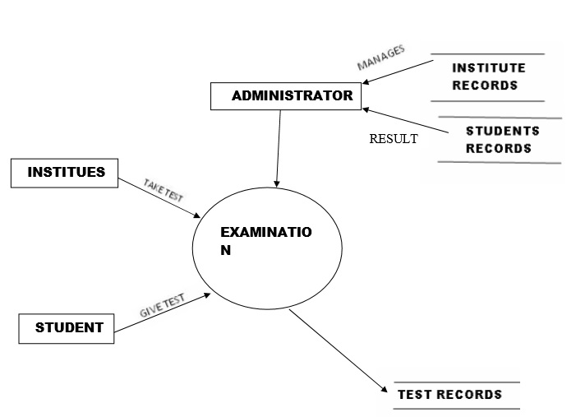

Level 1 DFD:-

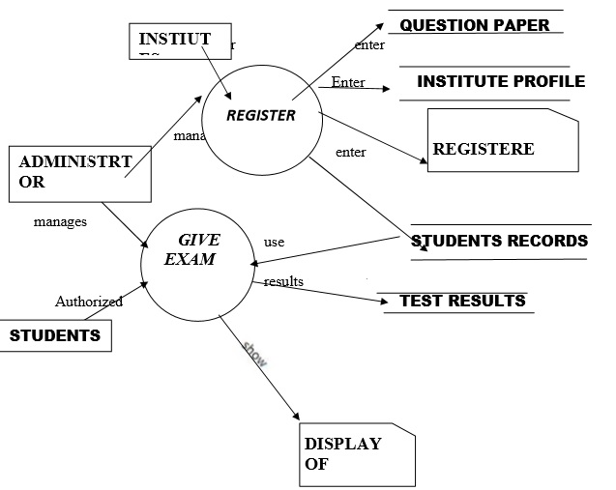

Level 2 DFD for Student:-

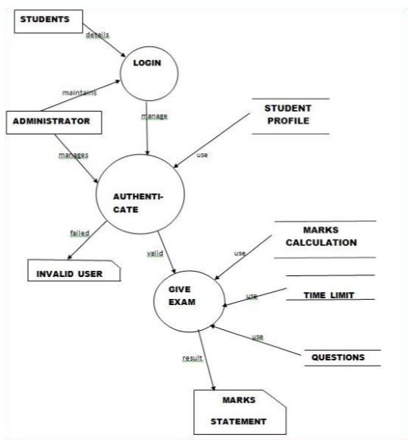

Level 2 DFD for Institution:-

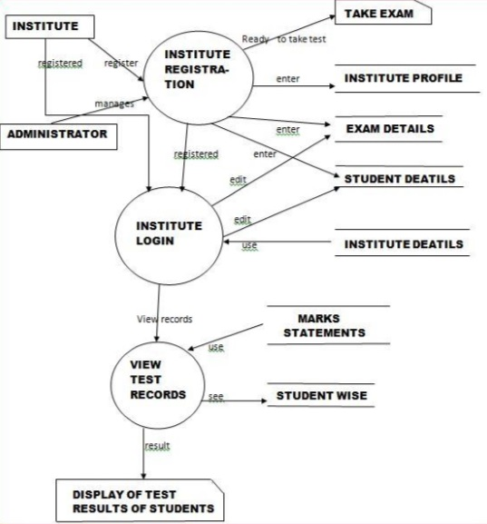

2.6 Project management approach:

* Software Process Model:

To solve an actual problems in an industry, software developer or a team of developers must integrate with a development strategy that include the process, methods and tools layer and generic phases. This strategy is often referred to a process model or a software developing paradigm. []

Our project follows the waterfall model.

The steps of waterfall model are:

* Requirement Definition
* System and Software Design
* Implementation
* Integration and System Testing
* Operation and Maintenance

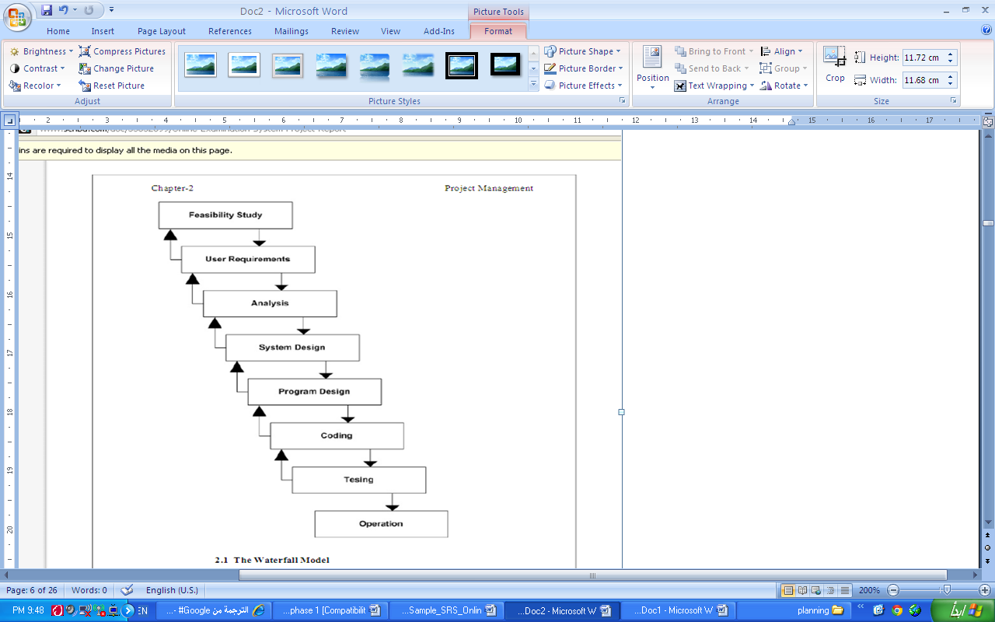

Figure (2.1): Waterfall model

**REQUIREMENT ANALYSIS**

Hardware Requirement:

**Platform**: Operating System, Computer Architecture

* Windows Operating System
* 264MB(512 MB RAM Recommended)
* 2GB free fixed disk
* Processor : 800 MHz (above)

Software Requirement:

* Front End
* .NET Framework
* C# language
* Back End
* Sql server 2000
* Tools
* Visual studio 2005

**DETAILED DISCRIPTION**

The Important Components For detailed design

Web Browser

Login

Role checking

Form & Menu Manager

Data Validation

Security Manager

OES Appointment Manager

Data Import & Export

Report Generation

Transaction Management for OES Database

System architecture for VOOES

The system can be divided into four layers in which the whole process of this examination system can be executed.

Further details can be given as

4.1Detailed Description of Admin Panel:

Code for Utility Class

using System;

using System.Collections.Generic;

using System.Linq;

using System.Text;

using System.Data;

using System.Data.SqlClient;

using System.Windows;

using System.Windows.Forms;

namespace exm

{

class utility

{

public SqlConnection getconnection()

{

string source = "server= ADMIN-PC; initial catalog=onl9_exm; integrated security=true";

SqlConnection con = new SqlConnection(source);

con.Open();

return con;

}

public void inupdel(string str, SqlConnection con)

{

SqlCommand cmd = new SqlCommand(str, con);

cmd.ExecuteNonQuery();

}

public DataSet fillds(string str, SqlConnection con)

{

DataSet ds = new DataSet();

SqlDataAdapter da = new SqlDataAdapter(str, con);

da.Fill(ds);

return ds;

}

public void fillcmb(ComboBox cb, string str, string field_name, SqlConnection con)

{

DataSet ds = new DataSet();

SqlDataAdapter da = new SqlDataAdapter(str, con);

da.Fill(ds);

cb.DataSource = ds.Tables[0];

cb.DisplayMember = field_name;

}

public String dupl(string str, SqlConnection con)

{

string s = null;

DataSet ds = new DataSet();

SqlDataAdapter da = new SqlDataAdapter(str, con);

da.Fill(ds);

int lenth = ds.Tables[0].Rows.Count;

if (lenth > 0)

{

s = ds.Tables[0].Rows[0][0].ToString();

}

return s;

}

public TextBox filltext(TextBox txt, string str, SqlConnection con)

{

SqlDataAdapter da = new SqlDataAdapter(str, con);

DataSet ds = new DataSet();

da.Fill(ds);

int lnth = ds.Tables[0].Rows.Count;

if (lnth > 0)

{

txt.Text = ds.Tables[0].Rows[0][0].ToString();

}

return txt;

}

}

}

Design of Admin Panel

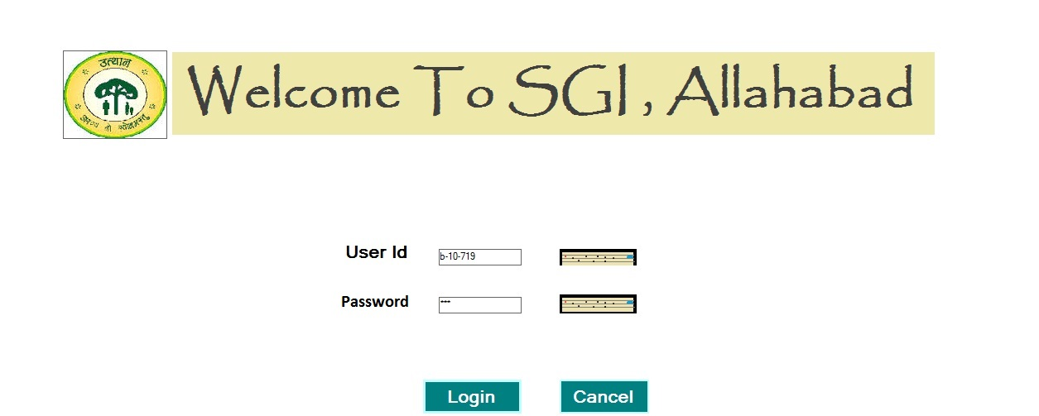

Description of Admin Panel:

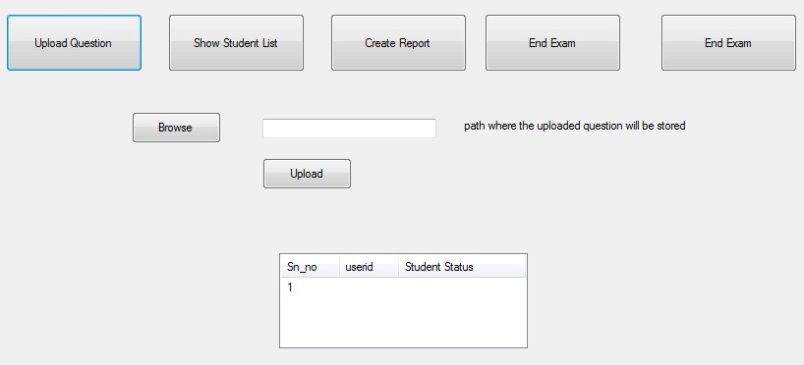

4.2Detailed Description of Student Panel:

* Student Login Window

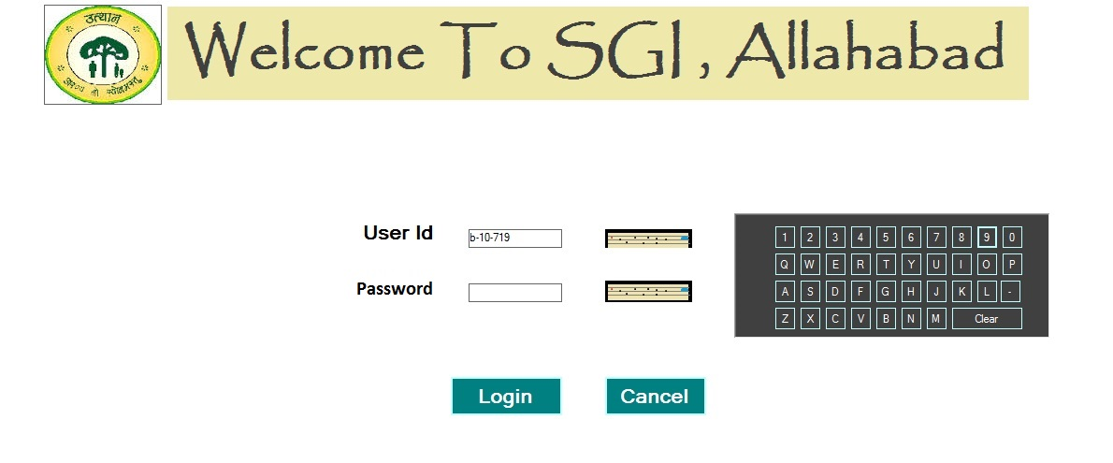

* Student Information Window

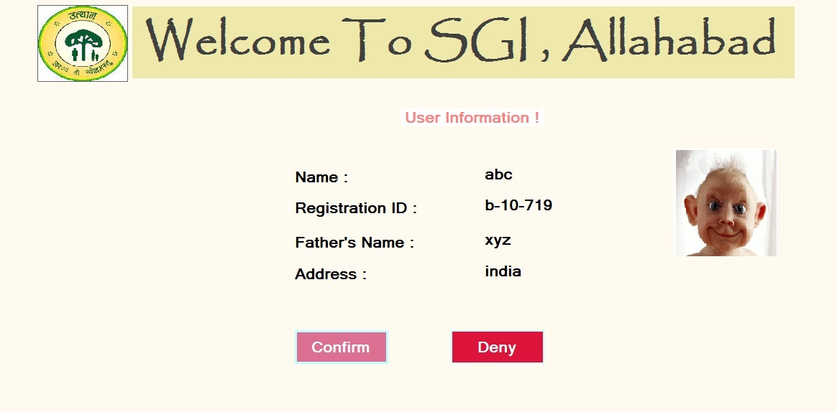

* Student Instruction Window

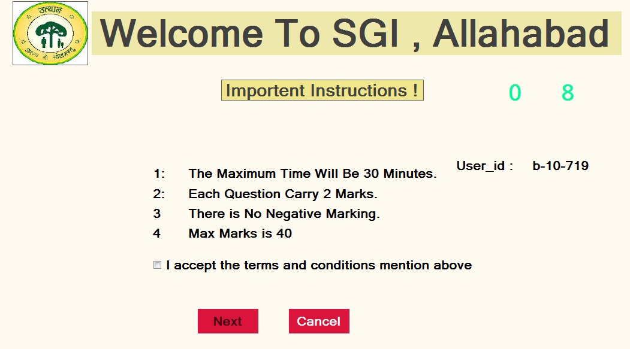

* Student Examination Window

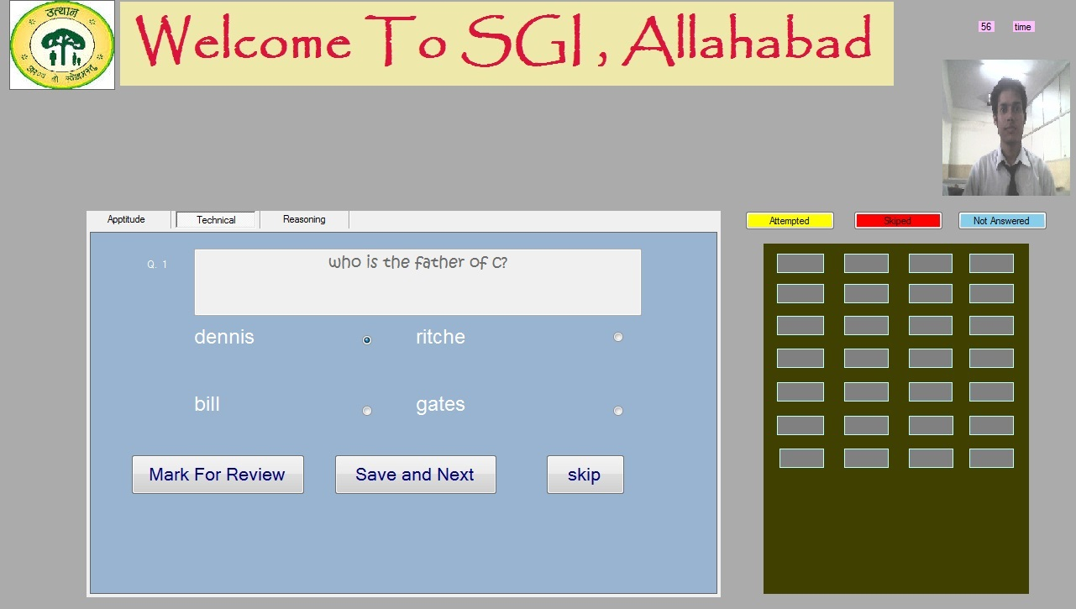

* Student Examination Submission Window

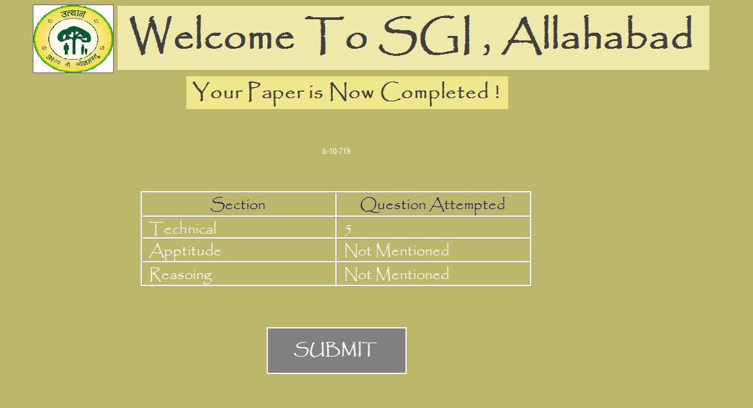

Tables Used in Database

All the information stored can be in tabular for since it can be an easy way for the searching and managing the whole database. There is some description given that define the database used in this examination system.

* Table Detail of Admin

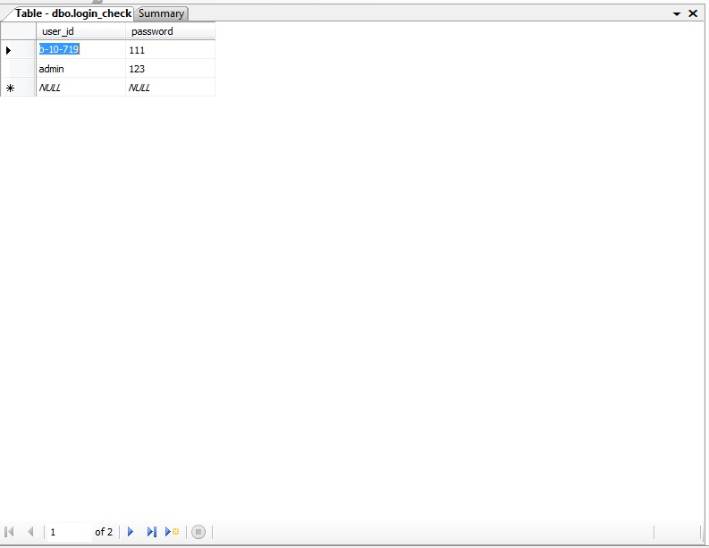

* Table detail for question of the examination

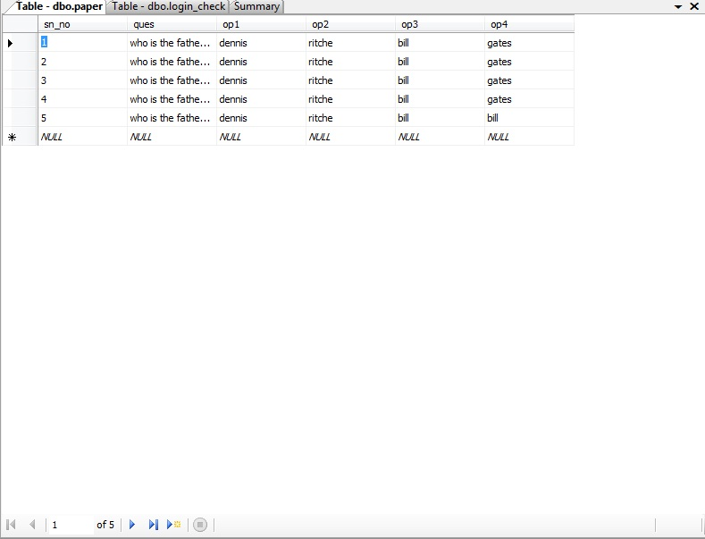

* Table Detail of questions attempted by student

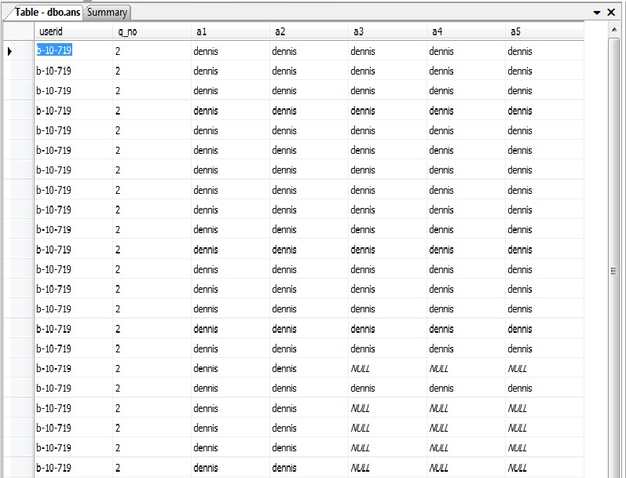

* List of all students who are pass in the Exam
* 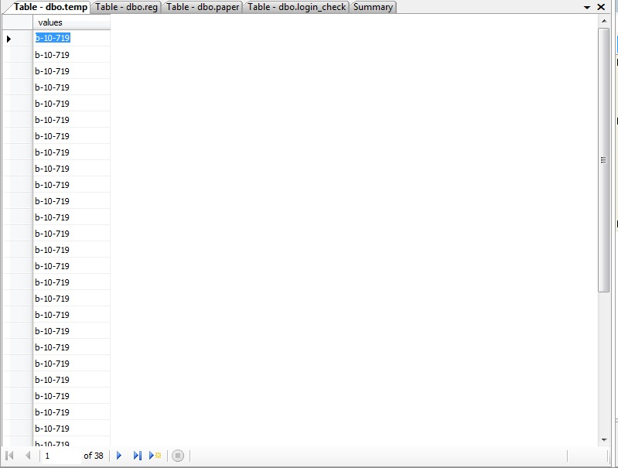 **RESULT AND CONCLUTION**

This Window Application provides facility to conduct online examination worldwide. It saves time as it allows number of students to give the exam at a time and displays the results as the test gets over, so no need to wait for the result. It is automatically generated by the server. Administrator has a privilege to create, modify and delete the test papers and its particular questions. User can register, login and give the test with his specific id, and can see the results as well.

**REFERENCES**

The following books were very helpful during the completion of project:

Software Engineering

-K.K. Agrawal and Yogesh Singh

Web Enabled Commercial Application Development

-Ivan Bayross

Head First Servlets and JSP

-Bryan Basham,Kathy Sierra and Bert Bates

IEEE Recommended Practice for Software Requirements Specifications, Software Engineering Standards Committee of the IEEE Computer Society. 1998

Software Requirements Specification for PPDP Contact Management System (CMS)

<http://www.youtube.com/watch?v=54bo1qaHAfk><http://www.ehow.com/facts_5156877_preface-book.html>**,**

<http://www.deftinfosystems.com/index.php/application/e-education-system/online-examination-system.html>.

http:// [www.scribd.com/doc/33852099/on-line-examiniation-system-project-report](http://www.scribd.com/doc/33852099/on-line-examiniation-system-project-report)